Supplementary Material

Shifts and importance of viable bacteria in treatment of DSS-induced ulcerative colitis mice with FMT
Jinglong Liu^{1†}, Hao Lin^{2†}, Man Cao^{3,4†}, Tan Lin², Aiqiang Lin³, Wei Xu^{2,3}, Han Wang³, Jianquan He³, Yuantao Li^{3*}, Hailing Tang^{5*}, Bangzhou Zhang^{3,4,6*}
¹Department of Gastroenterology, Shanxi Provincial People's Hospital, Shanxi, China
²Xiamen Institute of Union Respiratory Health, Xiamen, China
³Center for Research and Development, Xiamen Treatgut Biotechnology Co., Ltd., Xiamen, China
⁴Department of Gastroenterology, The Second Affiliated Hospital of Fujian University of Traditional Chinese Medicine, Fuzhou, China
⁵Division of Gastroenterology, Xi'an Central Hospital, Xi'an, China
⁶School of Pharmacy, Fujian University of Traditional Chinese Medicine, Fuzhou, China

†These authors have contributed equally to this work and share first authorship
* Correspondence:
Corresponding Author
liyuantao@treatgut.com (YT. Li), tanghl@yeah.net (HL. Tang), geebzbz@xmu.edu.cn (BZ. Zhang)

Supplementary Data
In this study of absolute quantification of live bacteria using the PMA-qPCR technique, we explored the correlation between bacterial load and CT values. Twelve donor faecal samples were collected and the activity and bacterial load of the donor faeces were first measured by flow cytometry, and tenfold gradient dilutions were performed based on the bacterial content obtained by flow cytometry. Five gradient samples (10, 10², 10³, 10⁴, 10⁵) were prepared by dilution, 1 ml per gradient, in sterile 1.5 ml centrifuge tubes for PMA treatment, and faecal samples were extracted after treatment DNA was then measured using qPCR to obtain CT values. A standard curve was obtained based on the CT values from qPCR and flow cytometry bacterial counts, which were validated for viability and total bacterial counts.
Construction of a Standard Curve
The fluorescent stains samples with a LIVE/DEAD™ BacLight™ Bacterial Viability Kit. The bacteria per milliliter were transformed using the functions of log represented on the abscissa. After qPCR, similar Ct values ordinate was established.

Supplementary Figures and Tables

Supplementary Figures

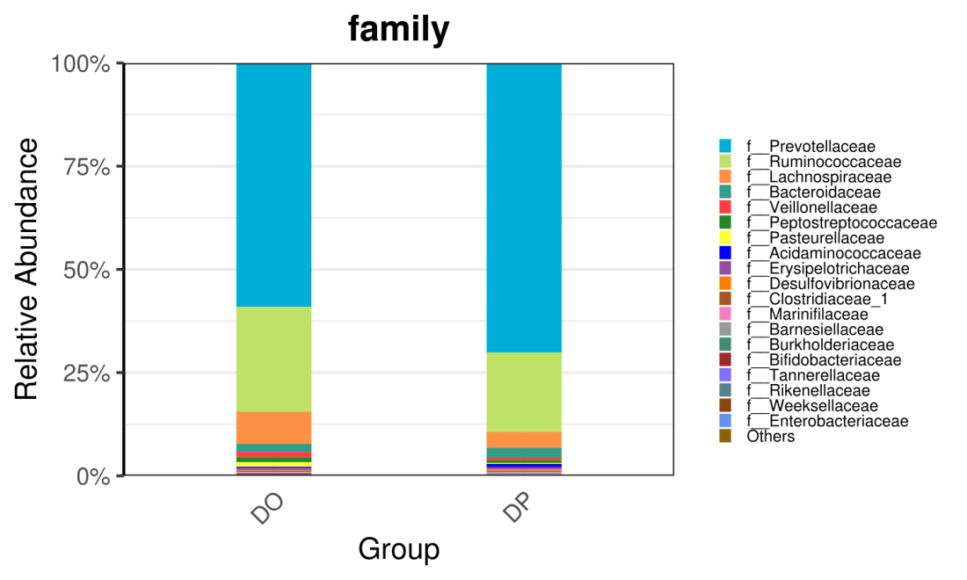
Supplementary Figure 1. The composition of the gut microbiota between DO and DP group at the family level (the abundance of Top 20 are shown).

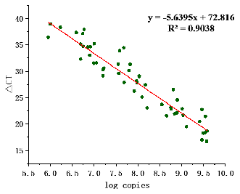
Supplementary Figure 2. Establishment of the fitted standard curve. The horizontal coordinate is the logarithm of the total number of bacteria per mL (cells/mL) and the vertical coordinate is the ct value after qPCR with sample DNA gradient dilution as template.

Supplementary Figure 3. (a) Alpha diversity based on species richness, the Shannon diversity index, and the Inverse Simpson diversity index(J) in DSSHF and HF.(b)Bacterial beta diversity. Principal Coordinates Analysis based on Bray-Curtis distances between the gut microbiota profiles of individuals from the two groups. (c) The SPEC-OCCU plots show the most abundant OTUs corresponding genera in HF; the x-axis represents occupancy; and the y-axis represents specificity.

Supplementary Figure 4. (a) Alpha diversity based on species richness, the Shannon diversity index, and the Inverse Simpson diversity index(J) in DSSIF and IF.(b)Bacterial beta diversity. Principal Coordinates Analysis based on Bray-Curtis distances between the gut microbiota profiles of individuals from the two groups. (c) The SPEC-OCCU plots show the most abundant OTUs corresponding genera in IF; the x-axis represents occupancy; and the y-axis represents specificity.

Supplementary Figure 5. (a) Alpha diversity based on species richness, the Shannon diversity index, and the Inverse Simpson diversity index(J) in DSSNF and NF.(b)Bacterial beta diversity. Principal Coordinates Analysis based on Bray-Curtis distances between the gut microbiota profiles of individuals from the two groups. (c) The SPEC-OCCU plots show the most abundant OTUs corresponding genera in NF; the x-axis represents occupancy; and the y-axis represents specificity.

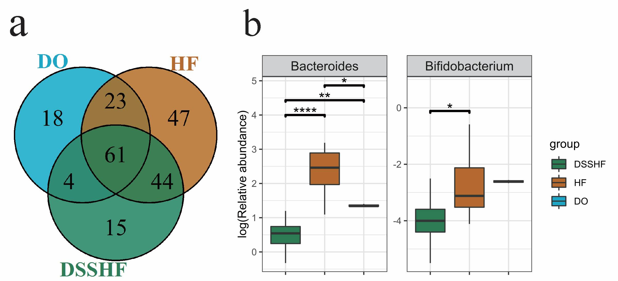
Supplementary Figure 6. (a) The Venn diagram illustrates all overlapping genera identified in the DO, DSSHF (samples from the mice that would receive the DO transplant (before transplant)) and HF groups. (b) The relative abundance of 2 specific genera among DO, DSSHF and HF groups.

Supplementary Tables
Table 1. Compared to HF and NF groups, the IF group was able to annotate to the genus level with a specific display of the unique 70 OTUs.
OTUs | taxonomy
OTU_1191 | f__Lachnospiraceae;g__[Eubacterium]_ventriosum_group;s__un_g_[Eubacterium]_ventriosum_group
OTU_1355 | f__Lachnospiraceae;g__[Ruminococcus]_torques_group;s__un_g_[Ruminococcus]_torques_group
OTU_593 | f__Lachnospiraceae;g__[Ruminococcus]_torques_group;s__un_g_[Ruminococcus]_torques_group
OTU_784 | f__Ruminococcaceae;g__[Eubacterium]_coprostanoligenes_group;s__un_g_[Eubacterium]_coprostanoligenes_group
OTU_501 | f__Acidaminococcaceae;g__Acidaminococcus;s__un_g_Acidaminococcus
OTU_654 | f__Spirosomaceae;g__Arcicella;s__un_g_Arcicella
OTU_1141 | f__Bacteroidaceae;g__Bacteroides;s__un_g_Bacteroides
OTU_1296 | f__Bacteroidaceae;g__Bacteroides;s__un_g_Bacteroides
OTU_1415 | f__Bacteroidaceae;g__Bacteroides;s__un_g_Bacteroides
OTU_568 | f__Bacteroidaceae;g__Bacteroides;s__un_g_Bacteroides
OTU_1456 | f__Lachnospiraceae;g__Blautia;s__un_g_Blautia
OTU_1619 | f__Lachnospiraceae;g__Blautia;s__un_g_Blautia
OTU_521 | f__Lachnospiraceae;g__Blautia;s__un_g_Blautia
OTU_1551 | f__Brevibacteriaceae;g__Brevibacterium;s__un_g_Brevibacterium
OTU_420 | f__Burkholderiaceae;g__Burkholderia-Caballeronia-Paraburkholderia;s__un_g_Burkholderia-Caballeronia-Paraburkholderia
OTU_630 | f__Ruminococcaceae;g__Butyricicoccus;s__un_g_Butyricicoccus
OTU_758 | f__Marinifilaceae;g__Butyricimonas;s__un_g_Butyricimonas
OTU_652 | f__Christensenellaceae;g__Christensenellaceae_R-7_group;s__un_g_Christensenellaceae_R-7_group
OTU_1304 | f__Barnesiellaceae;g__Coprobacter;s__un_g_Coprobacter
OTU_529 | f__Lachnospiraceae;g__Coprococcus_2;s__un_g_Coprococcus_2
OTU_338 | f__Propionibacteriaceae;g__Cutibacterium;s__un_g_Cutibacterium
OTU_295 | f__Erysipelotrichaceae;g__Dubosiella;s__un_g_Dubosiella
OTU_749 | f__Eggerthellaceae;g__Eggerthella;s__un_g_Eggerthella
OTU_1151 | f__Rhizobiaceae;g__Ensifer;s__un_g_Ensifer
OTU_371 | f__Eggerthellaceae;g__Enterorhabdus;s__un_g_Enterorhabdus
OTU_874 | f__Eggerthellaceae;g__Enterorhabdus;s__un_g_Enterorhabdus
OTU_565 | f__Erysipelotrichaceae;g__Erysipelatoclostridium;s__un_g_Erysipelatoclostridium
OTU_1378 | f__Enterobacteriaceae;g__Escherichia-Shigella;s__un_g_Escherichia-Shigella
OTU_700 | f__Family_XIII;g__Family_XIII_AD3011_group;s__un_g_Family_XIII_AD3011_group
OTU_414 | f__Family_XIII;g__Family_XIII_UCG-001;s__un_g_Family_XIII_UCG-001
OTU_1649 | f__Lachnospiraceae;g__Howardella;s__un_g_Howardella
OTU_581 | f__Melioribacteraceae;g__IheB3-7;s__un_g_IheB3-7
OTU_354 | f__Lachnospiraceae;g__Lachnospiraceae_NK4A136_group;s__un_g_Lachnospiraceae_NK4A136_group
OTU_472 | f__Lachnospiraceae;g__Lachnospiraceae_NK4A136_group;s__un_g_Lachnospiraceae_NK4A136_group
OTU_738 | f__Lachnospiraceae;g__Lachnospiraceae_NK4A136_group;s__un_g_Lachnospiraceae_NK4A136_group
OTU_886 | f__Lachnospiraceae;g__Lachnospiraceae_NK4A136_group;s__un_g_Lachnospiraceae_NK4A136_group
OTU_364 | f__Lachnospiraceae;g__Lachnospiraceae_UCG-001;s__un_g_Lachnospiraceae_UCG-001
OTU_1065 | f__Veillonellaceae;g__Megasphaera;s__un_g_Megasphaera
OTU_1221 | f__Thermaceae;g__Meiothermus;s__un_g_Meiothermus
OTU_466 | f__Beijerinckiaceae;g__Methylobacterium;s__un_g_Methylobacterium
OTU_832 | f__Beijerinckiaceae;g__Methylobacterium;s__un_g_Methylobacterium
OTU_1376 | f__Muribaculaceae;g__Muribaculum;s__un_g_Muribaculum
OTU_525 | f__Isosphaeraceae;g__Paludisphaera;s__un_g_Paludisphaera
OTU_739 | f__Tannerellaceae;g__Parabacteroides;s__un_g_Parabacteroides
OTU_682 | f__Moraxellaceae;g__Perlucidibaca;s__un_g_Perlucidibaca
OTU_1548 | f__Prevotellaceae;g__Prevotella_9;s__un_g_Prevotella_9
OTU_940 | f__Rikenellaceae;g__Rikenellaceae_RC9_gut_group;s__un_g_Rikenellaceae_RC9_gut_group
OTU_491 | f__Lachnospiraceae;g__Roseburia;s__un_g_Roseburia
OTU_713 | f__Lachnospiraceae;g__Roseburia;s__un_g_Roseburia
OTU_829 | f__Lachnospiraceae;g__Roseburia;s__un_g_Roseburia
OTU_478 | f__Acetobacteraceae;g__Roseomonas;s__un_g_Roseomonas
OTU_626 | f__Micrococcaceae;g__Rothia;s__un_g_Rothia
OTU_764 | f__Ruminococcaceae;g__Ruminiclostridium_9;s__un_g_Ruminiclostridium_9
OTU_1538 | f__Ruminococcaceae;g__Ruminococcaceae_NK4A214_group;s__un_g_Ruminococcaceae_NK4A214_group
OTU_976 | f__Ruminococcaceae;g__Ruminococcaceae_NK4A214_group;s__un_g_Ruminococcaceae_NK4A214_group
OTU_667 | f__Ruminococcaceae;g__Ruminococcaceae_UCG-002;s__un_g_Ruminococcaceae_UCG-002
OTU_963 | f__Ruminococcaceae;g__Ruminococcaceae_UCG-002;s__un_g_Ruminococcaceae_UCG-002
OTU_1712 | f__Ruminococcaceae;g__Ruminococcaceae_UCG-009;s__un_g_Ruminococcaceae_UCG-009
OTU_572 | f__Ruminococcaceae;g__Ruminococcaceae_UCG-010;s__un_g_Ruminococcaceae_UCG-010
OTU_229 | f__Ruminococcaceae;g__Ruminococcus_1;s__un_g_Ruminococcus_1
OTU_1449 | f__Eggerthellaceae;g__Slackia;s__un_g_Slackia
OTU_645 | f__Spirosomaceae;g__Spirosoma;s__un_g_Spirosoma
OTU_373 | f__Family_XVII;g__Thermaerobacter;s__un_g_Thermaerobacter
OTU_1145 | f__Xanthomonadaceae;g__Thermomonas;s__un_g_Thermomonas
OTU_528 | f__Thermaceae;g__Thermus;s__un_g_Thermus
OTU_253 | f__Chitinophagaceae;g__Vibrionimonas;s__un_g_Vibrionimonas
OTU_1111 | f__Lachnospiraceae;g__Lachnospiraceae_NK4A136_group;s__un_g_Lachnospiraceae_NK4A136_group
OTU_1190 | f__Peptostreptococcaceae;g__Peptostreptococcus;s__un_g_Peptostreptococcus
OTU_1014 | f__Lachnospiraceae;g__Tyzzerella_3;s__un_g_Tyzzerella_3

