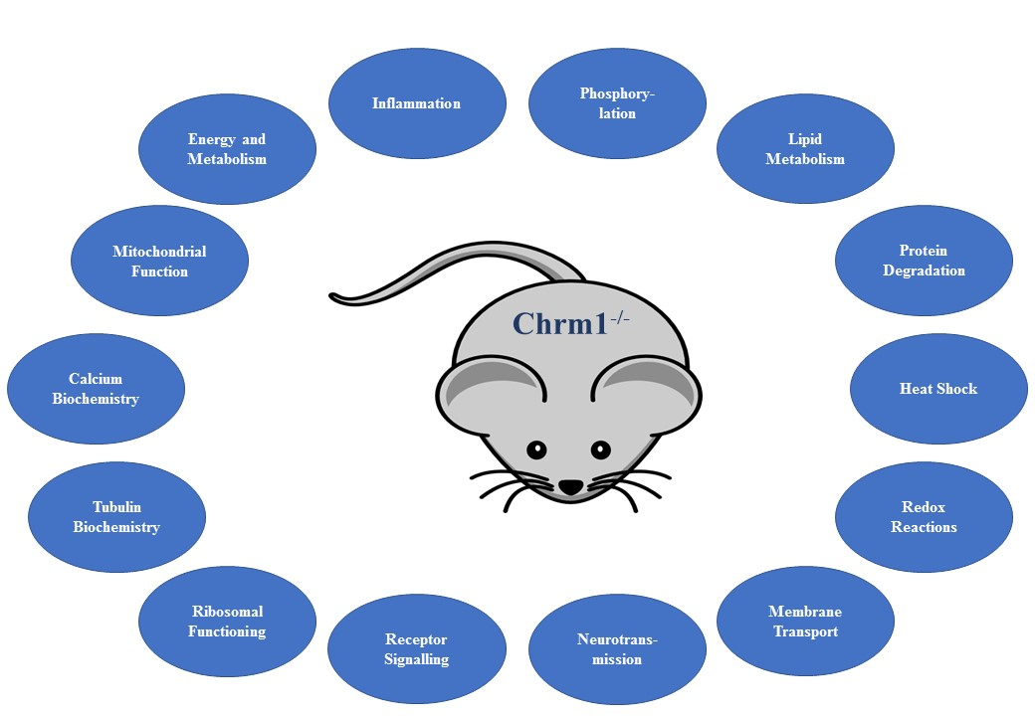

Supplementary Figure 1: A schematic showing the many pathways and functions predicted to be affected by changes in gene expression in the frontal cortex of the CHRM1^{-/-} mouse compared to the background strain wild type mouse.

