Supplementary Material
- Jie Wang^{1*}, Liang Yuan², Jiaxing Tang^{1,3}, Jiongyu Liu¹, Cheng Sun⁴, Michael W. Itgen⁵, Guiying Chen³, Jianping Jiang¹, Stanley K. Sessions⁶, Guangpu Zhang^{1,3*}, Rachel Lockridge Mueller^{5*}
Correspondence: Jie Wang, wangjie@cib.ac.cn, Guangpu Zhang, zgp1122@outlook.com, Rachel Lockridge Mueller, rlm@colostate.edu
S1 Samples and data used in this experiment
Tissue | Code | Sex | Mass:  g | STL:  cm | Collection  date | Source | Genomic sequencing |  | RNA quality |  |  |  | mRNA |  | small RNA
 |  |  |  |  |  |  | Raw reads | Accession code¹ | OD260/280 | OD260/230 | 28S/18S | RIN | Raw reads | Accession code² | Raw reads | Accession code³
Testis#1 | WQ07 | ♂ | 16.83 | 17.252 | 2017.8.22. | wild |  |  | 1.77 | 2.75 | 1.7 | 9.6 | 37,888,360 | CRR610084 | 19,717,749 | CRR610091
Testis#2 | WQ08 | ♂ | 19.79 | 18.192 | 2017.8.22. | wild |  |  | 1.73 | 0.95 | 1.1 | 8.9 | 35,386,396 | CRR610085 | 21,815,001 | CRR610092
Testis#3 | WQ10 | ♂ | 12.02 | 16.441 | 2017.8.22. | wild |  |  | 2.00 | 3.22 | 1.7 | 9.4 | 34,854,594 | CRR610086 | 16,177,680 | CRR610093
Testis#4 | WQ05 | ♂ | 20.48 | 15.591 | 2017.8.22. | captive |  |  | 1.70 | 2.13 | 1.7 | 9.3 | 31,732,246 | CRR610083 | 19,005,099 | CRR610090
Ovary#1 | WQ03 | ♀ | 32.85 | 21.001 | 2017.8.22. | captive | 11,960,858 | CRR609958 | 1.96 | 0.68 | 1.1 | 9.3 | 38,466,202 | CRR610080 | 17,965,762 | CRR610088
Ovary#2 | WQ02 | ♀ | 28.61 | 20.804 | 2017.8.22. | captive |  |  | 1.64 | 0.49 | 1.5 | 9.6 | 40,660,732 | CRR610079 | 15,836,634 | CRR610087
Ovary#3 | WQ04 | ♀ | 35.37 | 20.437 | 2017.8.22. | captive |  |  | 1.64 | 0.22 | 0.8 | 8.7 | 39,418,784 | CRR610081 | 14,063,357 | CRR610089
Ovary#4 | WQ06 | ♀ | 23.57 | 18.149 | 2017.8.22. | captive |  |  | 1.66 | 0.15 | 0.1 | 7.7⁴ | 39,229,748 | CRR610082
¹https://ngdc.cncb.ac.cn/gsa/browse/CRA008892
²https://ngdc.cncb.ac.cn/gsa/browse/CRA008899
³https://ngdc.cncb.ac.cn/gsa/browse/CRA008900
⁴This individuals was deleted from the small RNA analysis because of its low RIN value.

S2 Types of genomic repeats annotated by PASTEC
Type | No. of Contigs
Potential multiple host gene | 275
SSR | 2,448
Potential Chimeric | 1,088
Conflicting evidence | 20
noCat (unknown repeats) | 51,857
known TEs | 54,221
in total | 109,909

S3 Expression levels of genes and TEs (left, females; right, males)
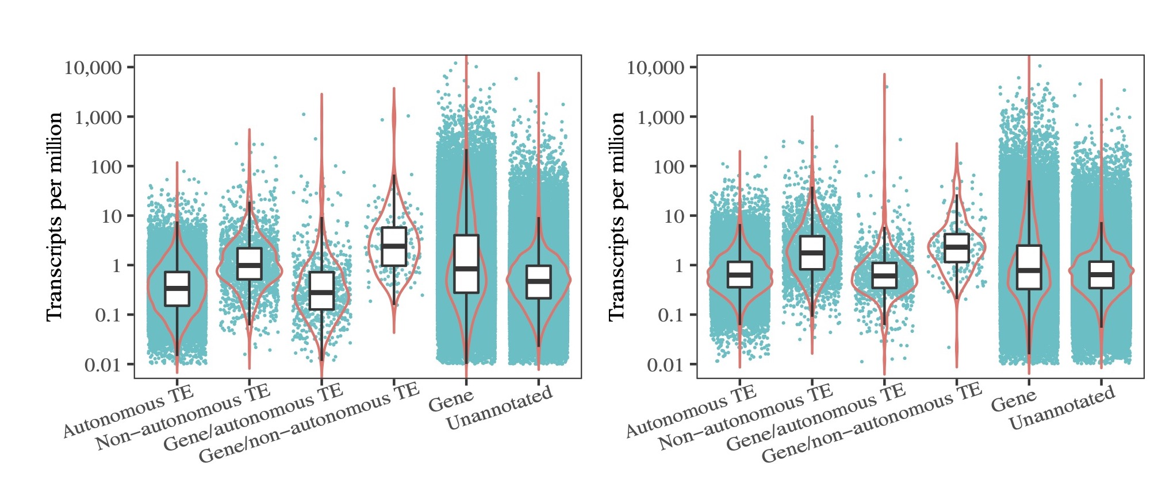

S4 Genomic content, expression level of TEs, and putative piRNAs mapping to TEs superfamilies
Superfamily | TE Content in genome: % |  | TE expression |  |  | Putative piRNAs mapping to TEs
 |  |  | females (TPM) | males (TPM) |  | female (RPM) | males (RPM)
LTR/Gypsy | 3.85 |  | 826.9 | 3024.4 |  | 69264.4 | 59,160.3
LTR/ERV | 0.41 |  | 391.9 | 693.9 |  | 45,392.8 | 39,045.4
LTR/Copia | 0.1 |  | 30.9 | 25.7 |  | 111.3 | 99.7
LTR/Retrovirus |  |  | 0.7 | 9.9 |  | 635.8 | 1,074
DIRS/DIRS | 4.44 |  | 5427 | 11961.7 |  | 40,038.7 | 88,936.7
PLE/Penelope | 0.09 |  | 122.8 | 351.6 |  | 17,211.8 | 17,062.2
LINE/Jockey | 9.69 |  | 6206.5 | 15535.2 |  | 214,022.6 | 142,910.1
LINE/L1 | 5.04 |  | 2954.2 | 7609.5 |  | 123,807.1 | 225,250.5
LINE/I | 0.09 |  | 41.5 | 124.8 |  | 2,625.7 | 2,454.6
LINE/RTE | 0.12 |  | 130 | 360.1 |  | 34,633.8 | 13,732
SINE/5S | 0.23 |  | 5.3 | 1.3 |  | 110,673.1 | 16,152.2
TRIM | 3.8 |  | 1650.8 | 5846.7 |  | 74,725.9 | 163,669.3
LARD | 0.15 |  | 515.1 | 2643.3 |  | 37,826.3 | 63,559.3
TIR/PIF-Harbinger | 2.98 |  | 575.2 | 1358.8 |  | 26,374.9 | 21,717.9
TIR/hAT | 1.15 |  | 83.3 | 26.3 |  | 501.5 | 1,006.6
TIR/Tc1-Mariner | 0.18 |  | 57.9 | 87.2 |  | 3,417.5 | 1,310.2
TIR/PiggyBac | 0.05 |  | 21.2 | 14.8 |  | 1,901.3 | 7,152.2
TIR/MuDR |  |  | 3.8 | 9.9 |  | 4,291.2 | 12,449.1
MITE | 0.56 |  | 465.1 | 1188.4 |  | 8,138.3 | 8,119.6
Maverick/Maverick | 0.05 |  | 44.2 | 761.9 |  | 22,994.6 | 9,898.3
Helitron/Helitron | 0.18 |  | 2.1 | 10.3 |  | 726.5 | 9,262.4
LTR/Retrovirus | - |  | 0.7 | 9.9
LINE/R2 | - |  | 0 | 0.6
SINE/7SL (Alu) | - |  | 1.2 | 0.3
TIR/ISL2EU | - |  | 17.7 | 16.1
TIR/Ginger1 | - |  | 10.2 | 6
TIR/Academ | - |  | 5.1 | 8.5
TIR/MuDR | - |  | 3.8 | 9.9
TIR/CACTA |  |  | 1.9 | 0.8
TIR/P | - |  | 0.6 | 0.6
S5 The number of retained small RNA molecules after each processing step
Tissue | RIN value of RNA | Clean reads  (after FastX) | After  adapter cut  (18-40 nt) | riboRNA fragments removed | sRNA molecules  (22 nt) | miRNAs  (22nt, hit in miRBase) | miRNAs mapped to genes  (21-24 nt) | piRNAs  (25-30 nt) | Unique piRNAs  (25-30 nt) | piRNAs  mapped to TEs (25-30 nt) | ping pong occurrence  (10 bp overlap)
Testis#1 | 9.6 | 18,628,420 | 18,387,280 | 1,393,269 | 416,693 | 169,873 | 297,076 | 14,491,636 | 5,844,245 | 3,045,727 | 114,173
Testis#2 | 8.9 | 20,632,085 | 20,127,121 | 702,889 | 743,042 | 306,713 | 360,612 | 14,928,178 | 5,812,644 | 2,443,896 | 90,569
Testis#3 | 9.4 | 15,341,619 | 15,148,223 | 1,731,806 | 343,516 | 128,145 | 244,710 | 11,028,768 | 4,724,341 | 2,319,293 | 86,486
Testis#4 | 9.3 | 18,141,749 | 18,022,557 | 682,282 | 220,515 | 84,628 | 124,381 | 15,672,237 | 2,598,248 | 1,264,088 | 37,855
Ovary#1 | 9.3 | 17,133,153 | 16,652,089 | 2,708,832 | 1,619,086 | 959,868 | 852,065 | 7,423,955 | 2,535,654 | 2,503,814 | 31,837
Ovary#2 | 9.6 | 15,112,304 | 14,382,824 | 2,298,340 | 2,025,800 | 1,191,104 | 601,043 | 5,576,455 | 1,023,454 | 1,805,324 | 3,567
Ovary#3 | 8.7 | 13,323,488 | 11,664,671 | 4,260,265 | 1,226,450 | 504,288 | 482,384 | 2,820,885 | 882,817 | 897,586 | 5,151

S6 The ratios of the summed expression of (A) piRNA pathway genes, (B) NuRD and associated repressive complex genes, and (C) TRIM28 to the summed expression of miRNA pathway genes in species with diverse genome sizes. Only genes that occurred in all species were included. The species and their genome sizes (in Gb) from left to right are: Platyplectrum ornatum (1), Gallus gallus (1.3), Danio rerio (1.4), Xenopus tropicalis (1.7), Anolis carolinensis (2.2), Mus musculus (2.5), Geotrypetes seraphini (3.8), Rhinatrema bivittatum (5.3), Caecilia tentaculate (5.5), Pleurodeles waltl (20), Ranodon sibiricus (21), Ambystoma mexicanum (32), Protopterus annectens (43), Cynops orientalis (44), and Protopterus aethiiopicus (~130).
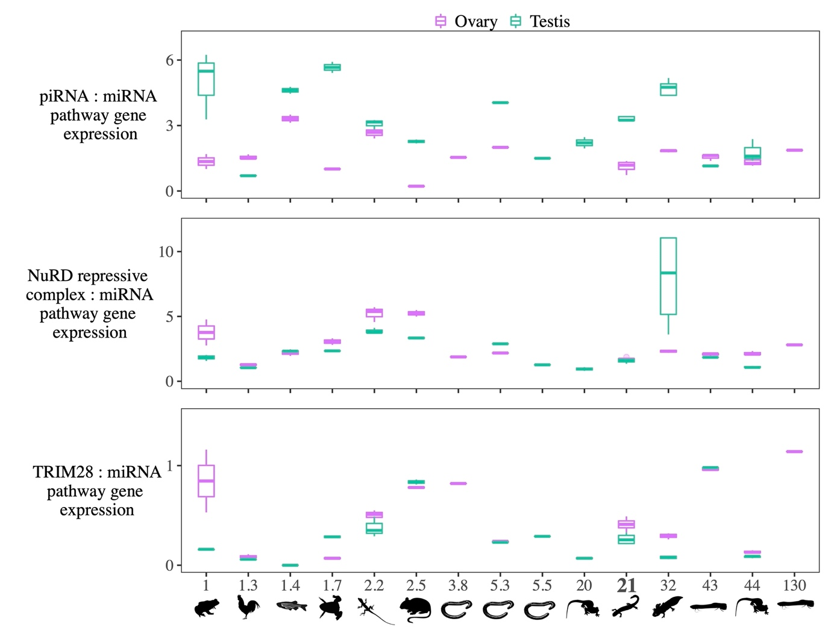

S7 The summed expression of (A) piRNA pathway genes, (B) NuRD and associated repressive complex genes, (C) TRIM28, and (D) miRNA pathway genes in species with diverse genome sizes measured as TPM. The species and their genome sizes from left to right are: Platyplectrum ornatum (1), Gallus gallus (1.3), Danio rerio (1.4), Xenopus tropicalis (1.7), Anolis carolinensis (2.2), Mus musculus (2.5), Geotrypetes seraphini (3.8), Rhinatrema bivittatum (5.3), Caecilia tentaculate (5.5), Pleurodeles waltl (20), Ranodon sibiricus (21), Ambystoma mexicanum (32), Protopterus annectens (43), Cynops orientalis (44), and Protopterus aethiiopicus (~130).
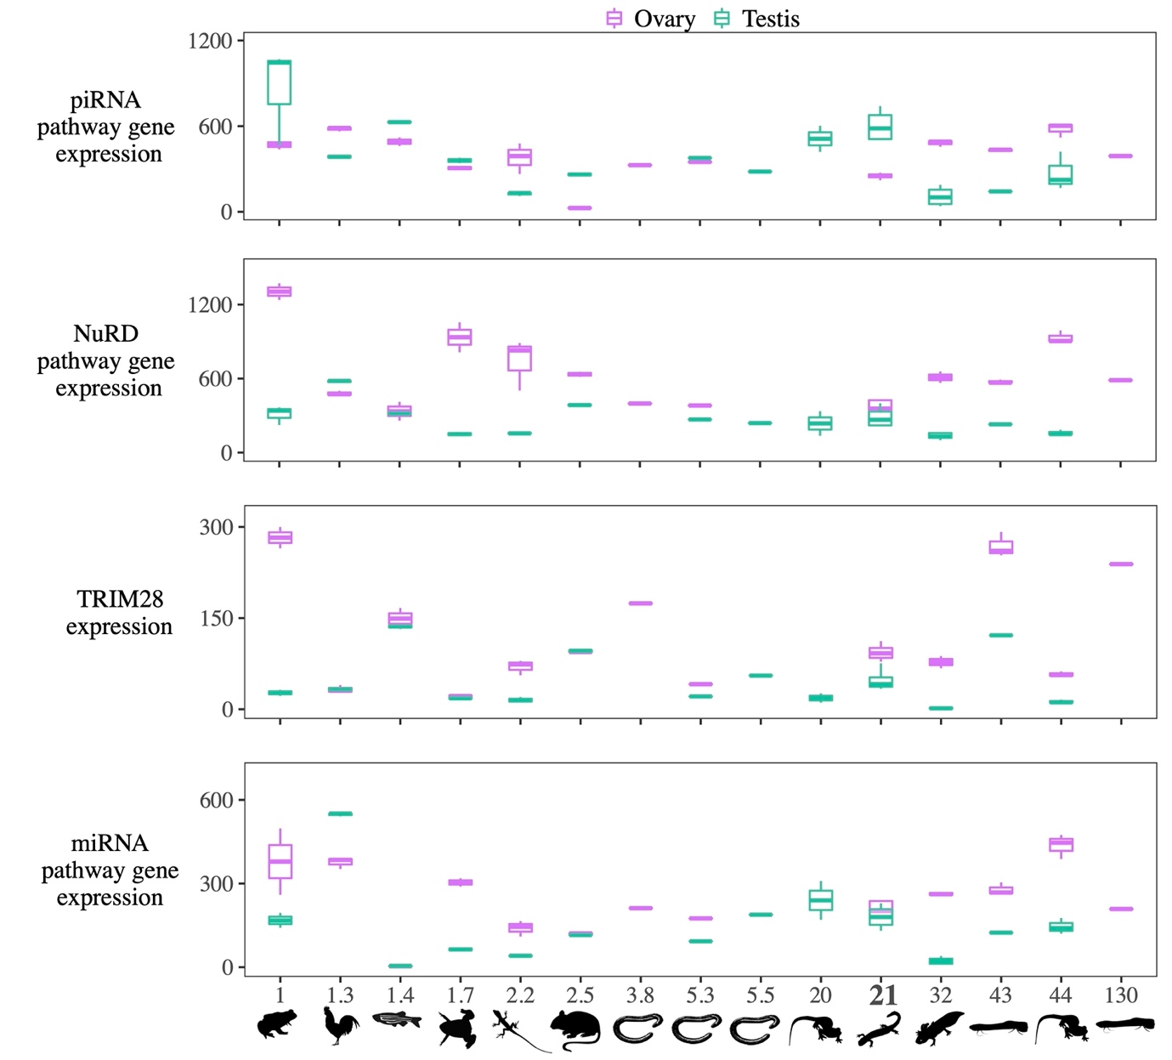

S8 Species used for the analysis of piRNA pathway, miRNA pathway, NuRD and associated repressive complex genes, and TRIM28 genes
Animal type | Species name | Genome Size: Gb | No. of Testis samples | No. of ovary samples | Number of De novo assembled contigs | N50 of contigs
lungfish | Protopterus aethiopicus | 130 |  | 1 | 80,874 | 2,584
salamander | Cynops orientalis | 44 | 3 | 3 | 287,540 | 1,909
lungfish | Protopterus annectens | 43 | 2 | 3 | 191,206 | 2,290
salamander | Ambystoma mexicanum | 32 | 4 | 3 | 250,353 | 1,995
salamander | Ranodon sibiricus | 21 | 4 | 4 | 510,439 | 1,250
salamander | Pleurodeles waltl | 20 | 2 |  | 303,910 | 2,232
caecilian | Caecilia tentaculata | 5.5 | 1 |  | 129,038 | 1,790
caecilian | Rhinatrema bivittatum | 5.3 | 1 | 1 | 542,424 | 1,119
caecilian | Geotrypetes seraphini | 3.8 |  | 1 | 334,360 | 1,527
mouse | Mus musculus | 2.5 | 2 | 2 | 327,400 | 983
lizard | Anolis carolinensis | 2.2 | 3 | 3 | 262,759 | 1,040
frog | Xenopus tropicalis | 1.7 | 2 | 2 | 246,914 | 1,068
fish | Danio rerio | 1.4 | 2 | 2 | 168,654 | 1,757
bird | Gallus gallus | 1.3 | 3 | 3 | 757,972 | 2,154
frog | Platyplectrum ornatum | 1.07 | 3 | 2 | 367,023 | 1,370

S9 Samples used for the analysis of piRNA pathway, miRNA pathway, NuRD and associated repressive complex genes, and TRIM28 genes
Species | Individuals | Code of dataset | Sequencing strategy | Total length of clean paired reads
Platyplectrum ornatum | Female_F1 | SRR13734432 | PE126 | 6,884,372,718
Platyplectrum ornatum | male_M1 | SRR13734436 | PE126 | 3,519,736,155
Platyplectrum ornatum | female_F2 | SRR13734440 | PE126 | 3,684,200,728
Platyplectrum ornatum | male_M2 | SRR13734445 | PE126 | 3,159,099,352
Platyplectrum ornatum | male_M3 | SRR13734453 | PE126 | 5,591,344,200
Gallus gallus | M1 | SRR21413816 | PE150 | 6,801,083,731
Gallus gallus | M2 | SRR21413817 | PE150 | 6,570,577,470
Gallus gallus | M3 | SRR21413818 | PE150 | 7,021,840,670
Gallus gallus | FM1 | SRR21413813 | PE150 | 6,709,497,312
Gallus gallus | FM2 | SRR21413814 | PE150 | 6,570,023,137
Gallus gallus | FM3 | SRR21413815 | PE150 | 6,800,803,540
Danio rerio | M1 | SRR6841469 SRR6841470 SRR6841471 | PE76 | 14,132,566,824
Danio rerio | M2 | SRR6841472 SRR6841473 SRR6841474 | PE76 | 12,451,819,259
Danio rerio | FM1 | SRR6841457 SRR6841458 SRR6841459 | PE76 | 15,041,093,899
Danio rerio | FM2 | SRR6841460 SRR6841461 SRR6841462 | PE76 | 14,383,695,630
Xenopus tropicalis | M1 | SRR5412279 | SR101 | 4,491,825,839
Xenopus tropicalis | M2 | SRR5412280 | SR101 | 4,959,481,791
Xenopus tropicalis | FM1 | SRR5412277 | SR101 | 3,522,394,964
Xenopus tropicalis | FM2 | SRR5412278 | SR101 | 3,433,990,644
Anolis carolinensis | M1 | SRR5412171 | SR101 | 2,037,335,955
Anolis carolinensis | M2 | SRR5412172 | SR101 | 2,328,660,042
Anolis carolinensis | M3 | SRR5412173 | SE90 | 3,429,516,547
Anolis carolinensis | FM1 | SRR5412168 | SR101 | 2,473,892,259
Anolis carolinensis | FM2 | SRR5412169 | SR101 | 2,352,520,907
Anolis carolinensis | FM3 | SRR5412170 | SE90 | 3,531,532,320
Mus musculus | M1 | SRR5412203 | SR101 | 1,955,779,276
Mus musculus | M2 | SRR5412204 | SR101 | 3,318,896,675
Mus musculus | FM1 | SRR5412201 | SR101 | 2,277,704,981
Mus musculus | FM2 | SRR5412202 | SR101 | 2,023,556,350
Rhinatrema bivittatum | M1 | SRR5591432 | PE101 | 5,014,521,076
Rhinatrema bivittatum | FM1 | ERR3132330 | PE150 | 22,243,030,188
Ambystoma mexicanum | M1 | SRR2885287 | PE100 | 3,557,193,043
Ambystoma mexicanum | M2 | SRR2885288 | PE100 | 3,018,140,755
Ambystoma mexicanum | M3 | SRR2885289 | PE100 | 6,947,066,098
Ambystoma mexicanum | M4 | SRR2885290 | PE100 | 2,254,388,959
Ambystoma mexicanum | FM1 | SRR2885284 | PE100 | 3,046,610,392
Ambystoma mexicanum | FM2 | SRR2885285 | PE100 | 2,480,135,684
Ambystoma mexicanum | FM3 | SRR2885286 | PE100 | 2,806,064,782
Protopterus annectens | M1 | SRR2028017 | PE90 | 7,004,563,990
Protopterus annectens | FM1 | SRR2027978 | PE90 | 6,124,764,166
Protopterus annectens | FM2 | SRR2027979 | PE90 | 6,518,099,880
Protopterus annectens | FM3 | SRR2027980 | PE90 | 6,494,872,072
Protopterus aethiopicus | FM1 | SRR7240708 | PE150 | 6,493,306,793
Cynops orientalis | Ovary3_FG3 | SRR10305546 | PE122 | 4,994,921,293
Cynops orientalis | Ovary2_FG2 | SRR10305545 | PE122 | 5,326,272,623
Cynops orientalis | Ovary1_FG1 | SRR10305544 | PE122 | 4,550,235,130
Cynops orientalis | Testis3_M3 | SRR10305543 | PE122 | 5,720,828,649
Cynops orientalis | Testis2_M2 | SRR10305542 | PE122 | 5,634,805,471
Cynops orientalis | Testis1_M1 | SRR10305541 | PE122 | 4,972,425,431
Ranodon sibiricus | Testis_WQ05 | CRR610083 | PE150 | 4,468,359,749
Ranodon sibiricus | Testis_WQ07 | CRR610084 | PE150 | 5,354,698,049
Ranodon sibiricus | Testis_WQ08 | CRR610085 | PE150 | 5,054,882,981
Ranodon sibiricus | Testis_WQ10 | CRR610086 | PE150 | 4,940,685,042
Ranodon sibiricus | Ovary_WQ02 | CRR610079 | PE150 | 5,771,046,105
Ranodon sibiricus | Ovary_WQ03 | CRR610080 | PE150 | 5,466,338,283
Ranodon sibiricus | Ovary_WQ04 | CRR610081 | PE150 | 5,716,393,060
Ranodon sibiricus | Ovary_WQ06 | CRR610082 | PE150 | 5,612,656,781
Pleurodeles waltl | M3 | DRR138635 | PE106 | 3,580,009,573
Pleurodeles waltl | M4 | DRR138637 | PE106 | 3,397,990,304
Caecilia tentaculata | Testis | SRR5591445 | PE101 | 5,326,917,714
Geotrypetes seraphini | Ovary | ERR3849999 | PE150 | 27,001,609,155

