A dual-amplification strategy-intergated SERS biosensor for ultrasensitive hepatocellular carcinoma-related telomerase activity detection

**Kang Shen1,3†, Weiwei Hua3†, Shengjie Ge3,4, Yu Mao3, Yuexing Gu3, Gaoyang Chen2** and Youwei Wang1\***

1 Department of neurosurgery, The Affiliated Hospital of Yangzhou University, Yangzhou, 225000, P. R. China

2 Department of Oncology, The second People’s Hospital of Taizhou City, Taizhou, 225300, P. R. China

3 Institute of Translational Medicine, Medical College, Yangzhou University, Yangzhou, 225001, P. R. China

4 Department of Otorhinolaryngology Head and Neck Surgery, The Affiliated Hospital of Yangzhou University, Yangzhou University, Yangzhou, 225001, P. R. China

* wangyouwei19@126.com

** taizhouchengaoyang@163.com

**†** These two authors contributed to this manuscript equally

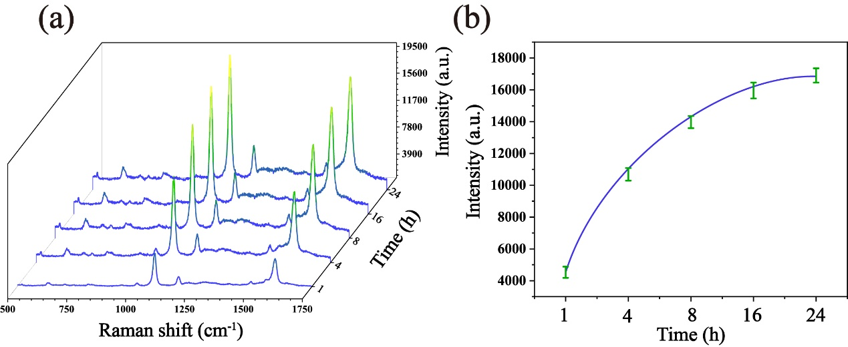

**Fig. S1.** (a) The average SERS spectra obtained after incubation of the probes and Au@SiO2 array for different times (1h, 4h, 8h, 16h and 24h). (b) The corresponding bar graph of the signal strength at 1592 cm-1.