Supplementary Material

The impacts of biomass burning emissions on aerosol concentrations and depositions in the northern South China Sea region

# Supplementary Figures

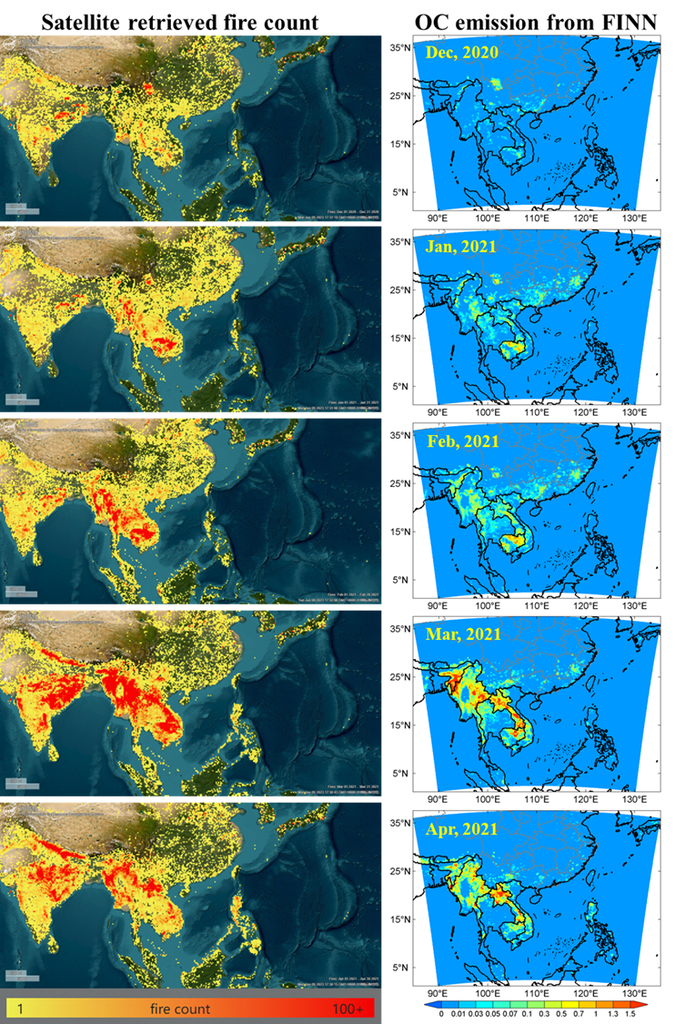

**Figure S1.** Monthly satellite retrieved fire count (left column) and monthly mean OC emission fluxes from the FINN inventory (right column, units: μg/m2/s). The fire count pictures were generated online by the Fire Information for Resource Management System (FIRMS) (https://firms.modaps.eosdis.nasa.gov/, last access, 2023/01/09). Note that fire count just indicates the location and frequency of fire but not reflects the fire strength for a certain grid

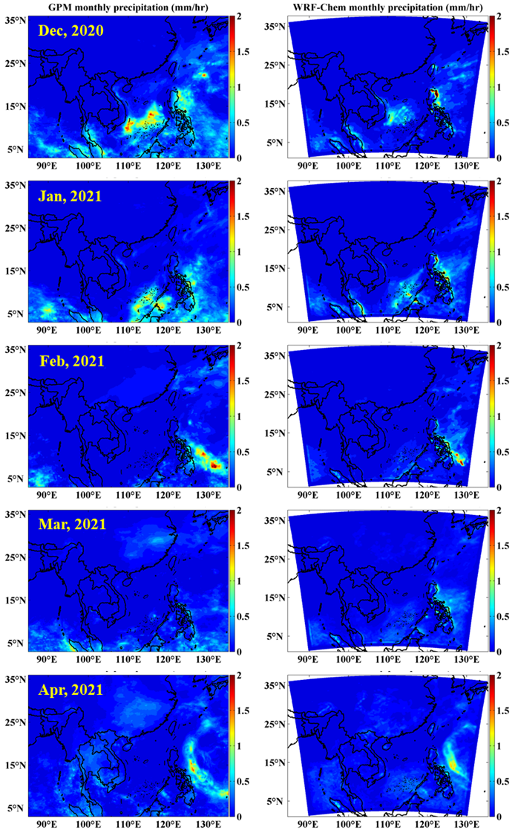

**Figure S2.** Comparison of monthly mean precipitations (units: mm/hr) between observation (left column) and model simulation (right column). Precipitation observations are from the Level 3 product of the Global Precipitation Measurement (GPM) mission (Huffman et al., 2019)

**Reference**

Huffman, G.J., Stocker, E.F., Bolvin, D.T., Nelkin, E.J., Jackson Tan, 2019. GPM IMERG Final Precipitation L3 1 month 0.1 degree x 0.1 degree V06, Greenbelt, MD, Goddard Earth Sciences Data and Information Services Center (GES DISC), Accessed: 9 January 2023, 10.5067/GPM/IMERGDF/DAY/06.