Supplementary Material

SARS-CoV-2 Infection Dysregulates the Expression of Clinically Relevant Drug Metabolizing Enzymes in Vero E6 Cells and Membrane Transporters in Human Lung Tissues
Chukwunonso K. Nwabufo^{1, 2}*, Md. Tozammel Hoque¹, Lily Yip³, Maliha Khara ^{4, 5}, Samira Mubareka^{3, 5}, Michael S Pollanen^{4, 5}, and Reina Bendayan¹
¹Department of Pharmaceutical Sciences, Leslie Dan Faculty of Pharmacy, University of Toronto, Toronto, ON, Canada.
²OneDrug, Toronto, ON, Canada.
³Sunnybrook Research Institute, Toronto, ON, Canada.
⁴Ontario Forensic Pathology Service, Toronto, ON, Canada.
⁵Department of Laboratory Medicine and Pathobiology, University of Toronto, Toronto, ON, Canada.
*Corresponding Author
Chukwunonso Nwabufo:mailto: Chukwunonso.nwabufo@usask.ca; Chukwunonso.nwabufo@mail.utoronto.ca
Department of Pharmaceutical Sciences
Leslie Dan Faculty of Pharmacy, University of Toronto
144 College Street, Toronto, ON, M5S 3M2

Supplementary Information

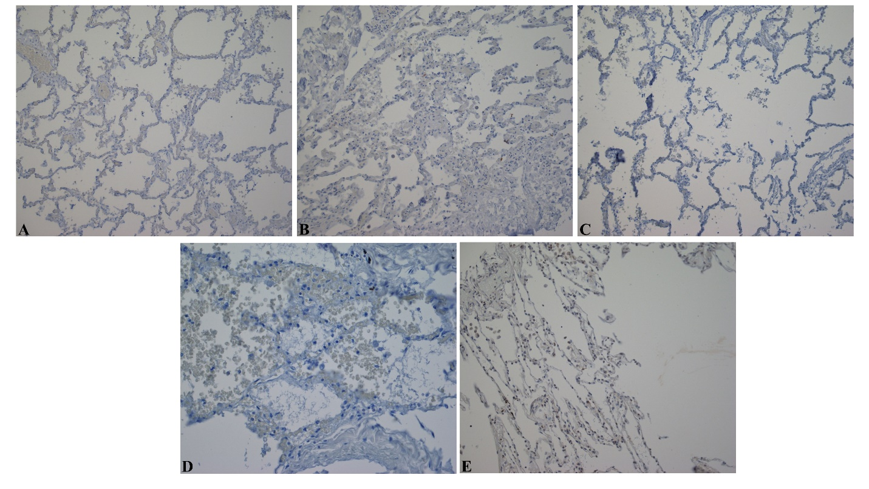
Supplementary Figure S1. Micrographs showing reagent negative control human lung tissues (40x magnification with an Olympus BX43 microscope) that indicated no positive staining in the absence of primary antibody. Some reagent negative control slides are a representation of other investigated biomarkers that had the same pre-treatment reagents as shown in Table S5, including: A (CYP1A2, CYP2C19, ENT2, MRP1, IL-1β, IL-6, CAR, and SARS-CoV2 spike protein); B (CYP2B6, CYP2C8, CYP2C9, CYP2D6, CYP3A4, MRP2, P-gp, NF-kβ); C (BCRP, pSTAT3, PXR); D (ENT1); E (SARS-CoV-2 nucleocapsid protein)
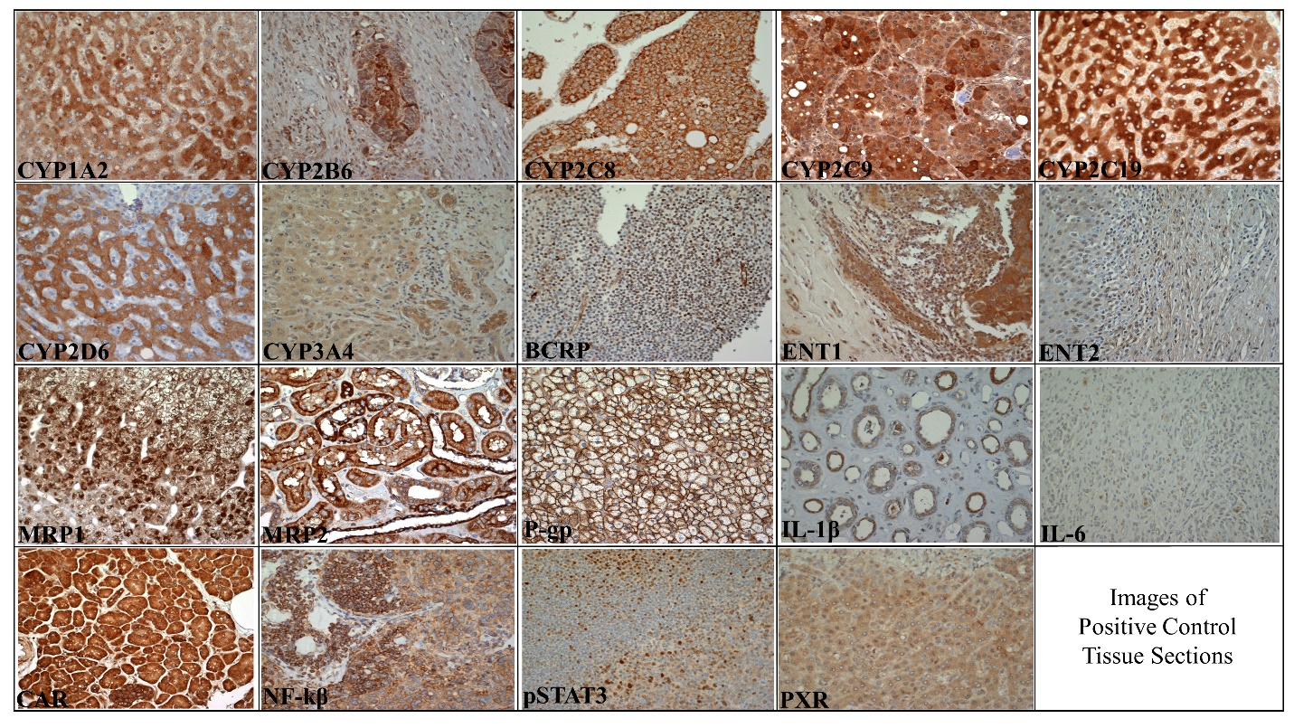Supplementary Figure S2. Micrographs showing positive staining in brown for the investigated biomarkers (40x magnification with an Olympus BX43 microscope). The positive control tissues include normal liver (CYP1A2, CYP2C19, CYP2D6, CYP3A4, and PXR); liver tumor (CYP2C8, and CYP2C9); colon tumor (CYP2B6, NF-kβ); bladder (ENT2 and IL-6); adrenal (P-gp and MRP1); breast tumor (ENT1); tonsil (BCRP and pSTAT3); kidney (MRP2 and IL-1β); and pancreas (CAR)
Supplementary Figure S3. Effect of SARS-CoV-2 infection on the mRNA expression of selected (A) inflammatory markers and (B) membrane-associated drug transporter in Vero E6 cells. Relative mRNA expression was determined using qRT-PCR with normalization to the housekeeping gene and the mock. Results are expressed as mean ± SD from 3 independent experiments, and unpaired t-test was used to determine significant differences.

Supplementary Table S1. List of Observed Single Nucleotide Variations and their Frequencies

S357_P2_LY
Position | Mutation | Frequency | Annotation | Gene | Description
241 | C→T | 100% | intergenic (–/-25) | – / → orf1ab | –/orf1ab polyprotein
686 | Δ9 bp | 100% | coding (421-429/13203 nt) | orf1ab → | orf1ab polyprotein
1059 | C→T | 100% | T265I (ACC→ATC) | orf1ab → | orf1ab polyprotein
3037 | C→T | 100% | F924F (TTC→TTT) | orf1ab → | orf1ab polyprotein
8092 | C→T | 100% | L2609L (CTC→CTT) | orf1ab → | orf1ab polyprotein
14408 | C→T | 100% | P314L (CCT→CTT) | orf1ab → | orf1ab polyprotein
23403 | A→G | 100% | D614G (GAT→GGT) | S → | surface glycoprotein
23525 | C→T | 10% | H655Y (CAT→TAT) | S → | surface glycoprotein
23598 | Δ21 bp | 7% | coding (2036-2056/3822 nt) | S → | surface glycoprotein
23628 | Δ9 bp | 10% | coding (2066-2074/3822 nt) | S → | surface glycoprotein
25324 | C→A | 17% | C1254* (TGC→TGA) | S → | surface glycoprotein
25325 | A→T | 7% | K1255* (AAA→TAA) | S → | surface glycoprotein
25563 | G→T | 100% | Q57H (CAG→CAT) | ORF3a → | ORF3a protein
27059 | C→T | 13% | Y179Y (TAC→TAT) | M → | membrane glycoprotein
29234 | G→A | 100% | G321S (GGC→AGC) | N → | nucleocapsid phosphoprotein

Supplementary Table S2. Panel of Biomarkers Investigated in Mock and SARS-CoV-2 infected Vero E6 Cells
Drug Metabolizing Enzymes | Membrane-associated Drug Transporters | Inflammatory Markers
CYP1A2 | P-gp | IL-6
CYP2B6 | MRP1 | IL-1β
CYP2C8 | MRP2 | IFN- γ
CYP2C9 | BCRP | TNF-α
CYP2D6 | MRP4 | iNOS
CYP3A4 | — | CCL2
UGT1A1 | — | CXCL10
— | — | CRP
— | — | IL-10

Supplementary Table S3. Primers used for qRT-PCR Analyses
Gene Symbol | Protein | Assay identification Number
Inflammatory markers
IL6 | IL-6 | Rh02621719_u1
IL1β | IL-1β | Rh02621711_m1
IFN- γ | IFN- γ | Rh02621721_m1
TNF | TNF-α | Rh02621718-s1
NOS | iNOS | Rh01075507_m1
CCL2 | CCL2 | Rh02621753_m1
CXCL10 | CXCL10 | Rh02788358-m1
CRP | CRP | Rh02902752_m1
IL10 | IL-10 | Rh00961619_m1
Drug Metabolizing Enzymes
CYP1A2 | CYP1A2 | Mf04946246_m1
CYP2B6 | CYP2B6 | Rh03043066_m1
CYP2C8 | CYP2C8 | Rh02790965_uH
CYP2C9 | CYP2C9 | Rh02789928-m1
CYP2D6 | CYP2D6 | Rh02826836_m1
CYP3A4 | CYP3A4 | Rh02872540_m1
UGT1A1 | UGT1A1 | Rh02828741_m1
Membrane-associated drug transporters
ABCB1 | P-gp | Rh01070639_m1
ABCC1 | MRP1 | Rh01561504_m1
ABCC2 | MRP2 | Rh00960504_m1
ABCG2 | BCRP | Rh01053786_m1
ABCC4 | MRP4 | Rh00988713_m1
Housekeeping genes
PPIB | Peptidylprolyl isomerase B | Rh01018503_m1
GAPDH | Glyceraldehyde-3-phosphate dehydrogenase | Rh02621745_g1

Drug Metabolizing Enzymes | Membrane-associated Drug Transporters | Regulatory Markers | Inflammatory Marker
CYP1A2 | P-gp | PXR | IL-6
CYP2B6 | MRP1 | CAR | IL-1β
CYP2C8 | MRP2 | NF-kβ | —
CYP2C9 | BCRP | pSTAT3 | —
CYP2C19 | ENT1 | — | —
CYP2D6 | ENT2 | — | —
CYP3A4 | — | — | —
Supplementary Table S4. Panel of Biomarkers Investigated in COVID-19 and Control Postmortem Human Lung Tissues

Supplementary Table S5. Antibodies, Dilutions, and Pre-treatment Conditions used for Chromogenic Immunohistochemistry Analyses
Antibody Name | Antibody Type (Clonality) | Supplier (Catalog #) | Dilution | Pretreatment | Incubation
Anti-P-gp | Mouse Monoclonal (D-11) | Santa Cruz Biotechnology (sc-55510) | 1:300 | HIER Tris-EDTA, LT | Overnight, RT
Anti-MRP1 | Rat Monoclonal (MRPr1) | Kamiya Biomedical Company (MC-201) | 1:200 | HIER Citrate, LT | Overnight, RT
Anti-MRP2 | Mouse Monoclonal (M2III-6) | Kamiya Biomedical Company (MC-206) | 1:300 | HIER Tris-EDTA, LT | Overnight, RT
Anti-BCRP | Rat Monoclonal (BXP-53) | Enzo (ALX-801-036-C050) | 1:500 | HIER Tris-EDTA | Overnight, RT
Anti-CYP1A2 | Rabbit Polyclonal | Proteintech (19936-1-AP) | 1:500 | HIER Citrate, LT | Overnight, RT
Anti-CYP2B6 | Rabbit Polyclonal | Abcam (ab198870) | 1:200 | HIER Tris-EDTA , LT | 1 h, RT
Anti-CYP2C8 | Rabbit Polyclonal | Proteintech (16546-1-AP) | 1:1000 | HIER Tris-EDTA , LT | 1 h, RT
Anti-CYP2C9 | Rabbit Polyclonal | Abcepta (AP7881c) | 1:300 | HIER Tris-EDTA , LT | 1 h, RT
Anti-CYP3A4 | Rabbit Polyclonal | Abcam (ab135813) | 1:250 | HIER Tris-EDTA , LT | Overnight, RT
Anti-CYP2D6 | Rabbit Monoclonal (EPR17868) | Abcam (ab185625) | 1:500 | HIER Tris-EDTA , LT | 1 h, RT
Anti-CYP2C19 | Rabbit Polyclonal | Invitrogen (PA5-114368) | 1:500 | HIER Citrate, LT | Overnight, RT
Anti-NF-Kb p65 | Rabbit Monoclonal (E379) | Abcam (ab32536) | 1:2000 | HIER Tris-EDTA , LT | 1 h, RT
Anti-STAT3 (phospho Y705) | Rabbit Monoclonal (EP2147Y) | Abcam (ab76315) | 1:100 | HIER Tris-EDTA | Overnight, RT
Anti-CAR | Rabbit Polyclonal | Abcam (ab186869) | 1:1000 | HIER Citrate, LT | 1 h, RT
Anti-PXR (G-11) | Mouse Monoclonal IgG | Santa Cruz Biotechnology (sc-48403) | 1:50 | HIER Tris-EDTA | Overnight, RT
Anti-SARS-CoV-2 Nucleocapsid protein | Rabbit Polyclonal | Novus (NB100-56576SS) | 1:500 | Citrate, Pepsin, LT | Overnight, RT
Anti-SARS-CoV-2 Spike protein | Rabbit Polyclonal | Abcam (ab272504) | 1:5000 | HIER Citrate, LT | Overnight, RT
Anti-ENT1 | Rabbit Polyclonal | Proteintech (11337-1-AP) | 1:200 | NPTM | Overnight, RT
Anti-ENT2 | Rabbit Polyclonal | Invitrogen (PA5-38006) | 1:500 | HIER Citrate, LT | 1 h, RT
Anti-IL-6 | Rabbit Polyclonal | Abcam (ab216492) | 1:300 | HIER Citrate, LT | 1 h, RT
Anti-IL-1β | Rabbit Polyclonal | Abcam (ab2105) | 1:500 | HIER Citrate, LT | 1 h, RT
HIER, heat induced epitope retrieval; LT, low temperature antigen retrieval; RT, room temperature; NPTM, no pretreatment

