**Supplemental materials**

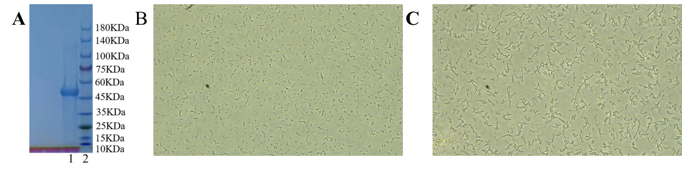

**Supplemental Fig. 1**. Expression, purification and activity validation of rMaINTL protein. (A) rMaINTL protein expression and purification. Lane 1: purified rMaINTL protein. lane 2: protein markers. (B) Validation of the agglutinative activity of inactivated rMaINTL protein against *Aeromonas hydrophila*. (C) Validation of the agglutinative activity of rMaINTL protein against *A. hydrophila.*