***Supplementary material***

**Structural characteristics, antioxidant, and hypoglycemic activities of polysaccharides from *Mori Fructus* based on different extraction methods**

**Yuanyuan Huang, Wen Xie, Ting Tang, Huaguo Chen*, Xin Zhou\***

**\* Corresponding authors:**

Xin Zhou, E-mail: alice9800@sina.com.

Huaguo Chen, E-mail: [chenhuaguo1981@163.com](mailto:chenhuaguo1981@163.com).

**Contents**

* Figure S1. Standard curve.
* Figure S2. 1H-NMR spectrum of six MFP.
* Figure S3. 13C-NMR spectrum of six MFP.
* Figure S4. TGA thermograms of six MFP.
* Table S1. Gradient elution conditions of mobile phase.
* Table S2. Comparative analysis of different extraction methods on IC50 by LSD (DPPH).
* Table S3. Comparative analysis of different extraction methods on IC50 by LSD (ABTS).
* Table S4. Second-order polynomial of MFP polysaccharide concentration and ABTS radical scavenging activity.
* Table S5. Comparative analysis of different extraction methods on IC50 by LSD (α -glucosidase).
* Table S6. Second-order polynomial of MFP polysaccharide concentration and α -glucosidase inhibitory activity.
* Table S7. Comparative analysis of different extraction methods on IC50 by LSD (α-amylase).
* Table S8. Second-order polynomial of MFP polysaccharide concentration and α-amylase inhibitory activity.

**A**



**B**



**C**



**Figure S1** Standard curve (A: Standard curve of Glucose, B: Standard curve of protein, C: Standard curve of uronic acid).

**A B**

 

**C D**

 

**E F**

 

**Figure S2** 1H-NMR spectrum of six MFP (A, B, C, D, E, F).

**A B**

 

**C D**

 

**E F**

 

**Figure S3** 13C-NMR spectrum of six MFP (A, B, C, D, E, F).

**A B**

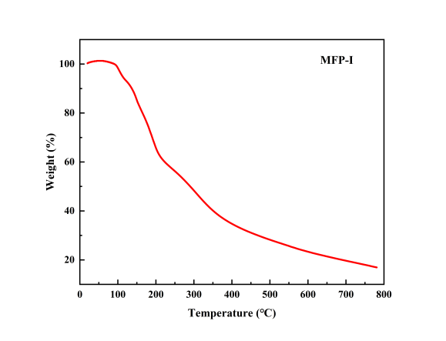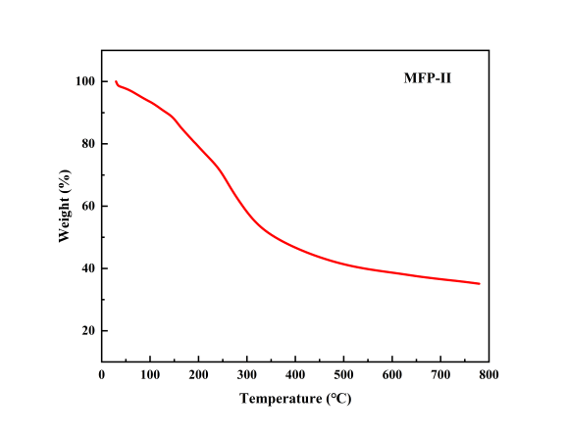

**C D**

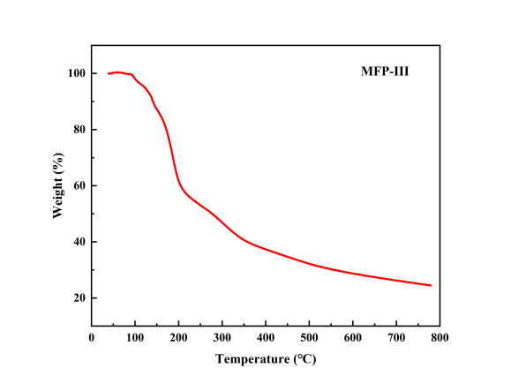

**E F**

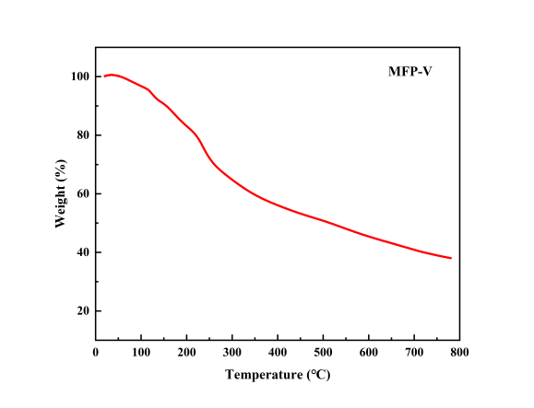

**Figure S4** TG thermograms of six MFP (A, B, C, D, E, F).

**Table S1** Gradient elution conditions of mobile phase.

|  |  |  |  |  |  |
| --- | --- | --- | --- | --- | --- |
| **Time/min** | **0** | **28** | **45** | **48** | **55** |
| A% | 84 | 84 | 81 | 75 | 75 |
| B% | 16 | 16 | 19 | 25 | 25 |

**Table S2** Comparative analysis of different extraction methods on IC50 by LSD (DPPH).

|  |  |  |  |  |  |  |  |
| --- | --- | --- | --- | --- | --- | --- | --- |
| **Samples** | **IC50** | ***X*i*-X*VC** | ***X*i*-X*MFP-IV** | ***X*i*-X*MFP-I** | ***X*i*-X*MFP-VI** | ***X*i*-X*MFP-V** | ***X*i*-X*MFP-II** |
| MFP-III | 0.1259 | 0.1225ab | 0.1084ab | 0.0744ab | 0.0715ab | 0.0640ab | 0.0614ab |
| MFP-II | 0.0645 | 0.0611ab | 0.0470ab | 0.0130ab | 0.0101ab | 0.0026a |  |
| MFP-V | 0.0619 | 0.0585ab | 0.0444ab | 0.0104ab | 0.0075ab |  |  |
| MFP-VI | 0.0544 | 0.0510ab | 0.0369ab | 0.0029a |  |  |  |
| MFP-I | 0.0515 | 0.0481ab | 0.0340ab |  |  |  |  |
| MFP-IV | 0.0175 | 0.0141ab |  |  |  |  |  |
| Ascorbic acid | 0.0034 |  |  |  |  |  |  |

Data were presented as mean ± SD (n=3). a, b designate P < 0.05 and P < 0.01 between them, respectively.

**Table S3** Comparative analysis of different extraction methods on IC50 by LSD (ABTS).

|  |  |  |  |  |  |  |  |
| --- | --- | --- | --- | --- | --- | --- | --- |
| **Samples** | **IC50** | ***X*i*-X*VC** | ***X*i*-X*MFP-IV** | ***X*i*-X*MFP-I** | ***X*i*-X*MFP-VI** | ***X*i*-X*MFP-V** | ***X*i*-X*MFP-II** |
| MFP-III | 0.8368 | 0.7562ab | 0.7152ab | 0.6520ab | 0.6157ab | 0.4656ab | 0.4105ab |
| MFP-II | 0.4263 | 0.7562ab | 0.3047ab | 0.2415ab | 0.2052ab | 0.0551ab |  |
| MFP-V | 0.3712 | 0.2907ab | 0.2496ab | 0.1864ab | 0.1501ab |  |  |
| MFP-VI | 0.2211 | 0.1405ab | 0.0995ab | 0.0363ab |  |  |  |
| MFP-I | 0.1848 | 0.1043ab | 0.0632ab |  |  |  |  |
| MFP-IV | 0.1216 | 0.0410ab |  |  |  |  |  |
| Ascorbic acid | 0.0805 |  |  |  |  |  |  |

Data were presented as mean ± SD (n=3). **a, b** designate P < 0.05 and P < 0.01 between them, respectively.

**Table S4** Second-order polynomial of MFP polysaccharide concentration and ABTS radical scavenging activity.

|  |  |  |
| --- | --- | --- |
| **Samples** | **Second-order polynomial** | **R2** |
| MFP-I | y = −61.3574x2+159.50429x+20.382 | 0.9916 |
| MFP-II | y = 91.64286x2+29.24429x+20.764 | 0.9914 |
| MFP-III | y = −12.78571x2+60.10143x+16.722 | 0.9880 |
| MFP-IV | y = −191.71429x2+228.76857x+24.886 | 0.9845 |
| MFP-V | y = 25.85714x2+67.68571x+20.694 | 0.9844 |
| MFP-VI | y = −60.28571x2+149.91143x+18.458 | 0.9997 |

**Table S5** Comparative analysis of different extraction methods on IC50 by LSD (α-glucosidase).

|  |  |  |  |  |  |  |  |
| --- | --- | --- | --- | --- | --- | --- | --- |
| **Samples** | **IC50** | ***X*i*-X*Acarbose** | ***X*i-*X*MFP-III** | ***X*i*-X*MFP-I** | ***X*i*-X*MFP-IV** | ***X*i*-X*MFP-II** | ***X*i*-X*MFP-V** |
| MFP-VI | 5.3853 | 3.8757ab | 2.2910ab | 1.6637ab | 1.5313ab | 1.3270ab | 0.3740ab |
| MFP-V | 5.0113 | 3.5017ab | 1.9170ab | 1.2897ab | 1.1573ab | 0.9530ab |  |
| MFP-II | 4.0583 | 2.5487ab | 0.9640ab | 0.3367ab | 0.2043a |  |  |
| MFP-IV | 3.8540 | 2.3443ab | 0.7597ab | 0.1323 |  |  |  |
| MFP-I | 3.7217 | 2.2120ab | 0.6273ab |  |  |  |  |
| MFP-III | 3.0943 | 1.5847ab |  |  |  |  |  |
| Acarbose | 1.5097 |  |  |  |  |  |  |

Data were presented as mean ± SD (n=3). **a, b** designate P < 0.05 and P < 0.01 between them, respectively.

**Table S6** Second-order polynomial of MFP polysaccharide concentration and α-glucosidase inhibitory activity.

|  |  |  |
| --- | --- | --- |
| **Samples** | **Second-order polynomial** | **R2** |
| MFP-I | y = −0.54071x2+10.93157x+15.54 | 0.9981 |
| MFP-II | y = −0.53857x2+10.40186x+16.158 | 0.9975 |
| MFP-III | y = −0.58607x2+12.82386x+13.29 | 0.9899 |
| MFP-IV | y = −0.39661x2+8.64179x+21.854 | 0.9964 |
| MFP-V | y = −0.54196x2+10.07607x+14.046 | 0.9793 |
| MFP-VI | y = −0.61571x2+11.21857x+9.094 | 0.9303 |

**Table S7** Comparative analysis of different extraction methods on IC50 by LSD (α-amylase).

|  |  |  |  |  |  |  |  |
| --- | --- | --- | --- | --- | --- | --- | --- |
| **Samples** | **IC50** | ***X*i*-X*Acarbose** | ***X*i-*X*MFP-III** | ***X*i*-X*MFP-V** | ***X*i*-X*MFP-IV** | ***X*i*-X*MFP-VI** | ***X*i*-X*MFP-I** |
| MFP-II | 28.5233 | 28.2008ab | 17.9400ab | 11.6200ab | 8.8700ab | 8.2966ab | 5.0866ab |
| MFP-I | 23.4367 | 23.1142ab | 12.8534ab | 6.5334ab | 3.7834ab | 3.2100ab |  |
| MFP-VI | 20.2267 | 19.9042ab | 9.6434ab | 3.3234ab | 0.5734a |  |  |
| MFP-IV | 19.6533 | 19.3308ab | 9.0700ab | 2.7500ab |  |  |  |
| MFP-V | 16.9033 | 16.5808ab | 6.3200ab |  |  |  |  |
| MFP-III | 10.5833 | 10.2608ab |  |  |  |  |  |
| Acarbose | 0.3225 |  |  |  |  |  |  |

Data were presented as mean ± SD (n=3). **a, b** designate P < 0.05 and P < 0.01 between them, respectively.

**Table S8** Second-order polynomial of MFP polysaccharide concentration and α-amylase inhibitory activity.

|  |  |  |
| --- | --- | --- |
| **Samples** | **Second-order polynomial** | **R2** |
| MFP-I | y = −0.23518x2+5.51564x+1.428 | 0.9825 |
| MFP-II | y = 0.21357x2−0.25386x+8.156 | 0.9149 |
| MFP-III | y = 0.41518x2−0.69064x+19.418 | 0.9037 |
| MFP-IV | y = −0.37643x2+7.25014x−0.69 | 0.9638 |
| MFP-V | y = 0.02536x2+3.02971x+0.638 | 0.9515 |
| MFP-VI | y = −0.22018x2+5.47764x+0.41 | 0.9877 |