**Supplemental Appendix**

**Method 1**

$Asy(\%)=\left(\frac{V_{larger}-V_{lower}}{V_{larger}}\right)×100$

asymmetry index was calculated using this equation.

*Asy:* asymmetery index; *Vlarger*: larger value; *Vlower*: lower value.

**Figure1**

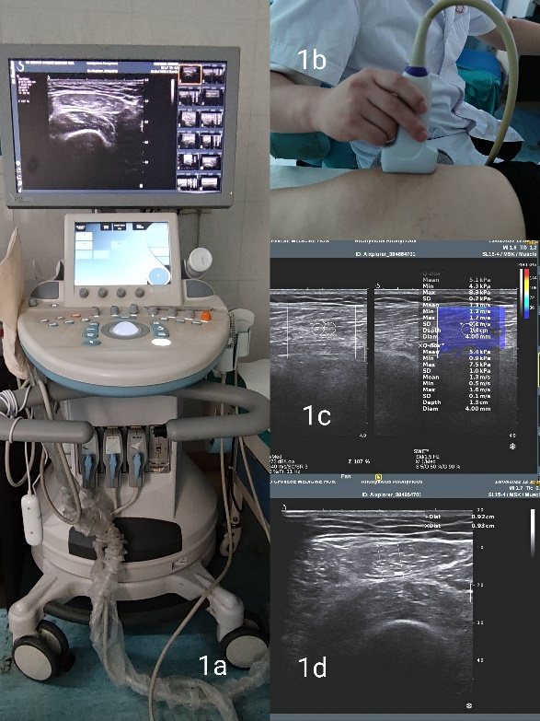

1a: Supersonic Imaging Aixplorer(French) color Doppler ultrasound diagnostic instrument

1b: Expert sonographers use ultrasound to perform muscle measurements

1c: Measurements in SWE mode

1d: Measurement of muscle thickness

**Figure 2**

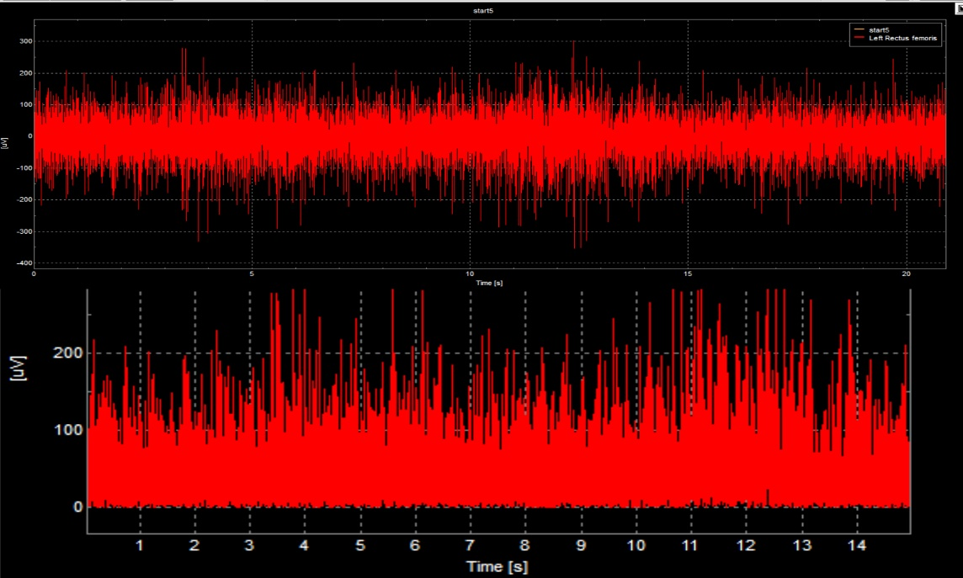

Raw sEMG signal acquisition, interception, filtering, smoothing and other processing

**Table 1.** Correlation between muscle thickness asymmetry index, muscle sEMG asymmetry index during straight leg raising, and VAS score

|  |  |  |  |  |
| --- | --- | --- | --- | --- |
|  | UG | | BG | |
| r | p | r | p |
| Asythick(RF) | 0.315 | 0.090 | 0.264 | 0.192 |
| Asythick(VI) | 0.389 | 0.034* | 0.134 | 0.515 |
| Asythick(VM) | 0.453 | 0.012* | 0.384 | 0.053 |
| Asythick(VL) | 0.321 | 0.084 | 0.008 | 0.968 |
| SLR AsyRMS(RF) | 0.416 | 0.022* | 0.434 | 0.027* |
| SLR AsyRMS(VM) | 0.494 | 0.006** | 0.544 | 0.004** |
| SLR AsyRMS(VL) | 0.368 | 0.046* | 0.392 | 0.048* |

*UG: unilateral group; BG: bilateral group;Asythick(RF):asymmetry index of rectus femoris thickness;Asythick(VI):asymmetry index of vastus medialis thickness;Asythick(VM): asymmetry index of vastus medialis thickness;Asythick(VL):asymmetry index of vastus lateralis thickness;SLR:straight leg raising task;Asy-RMS(RF):asymmetry index of rectus femoris’s RMS; Asy-RMS(VM): asymmetry index of vastus medialis’sRMSs; Asy-RMS(VL): asymmetry index of vastus lateralis’sRMS;* indicates P < 0.05; ** indicates P < 0.01.*