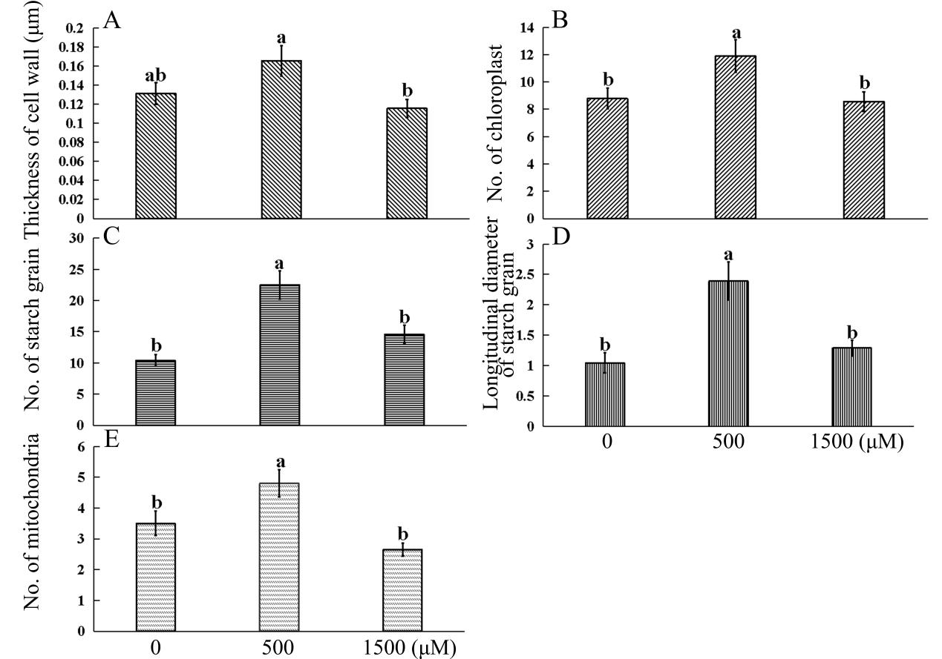

Melatonin concentration

Melatonin concentration

**FIGURE S2**: Effects of melatonin of different concentration on subcellular structure of mesophyll cell of radish “JNYB”.

Five replicates of sample from each treatment were collected and 20 cell replicates of each treatment were measured by H-7500 TEM (Hitachi, Tokyo, Japan). the values are the means ± SE, letters indicate significant difference, statistical analyses were performed by one-way ANOVA, *p* < 0.05.