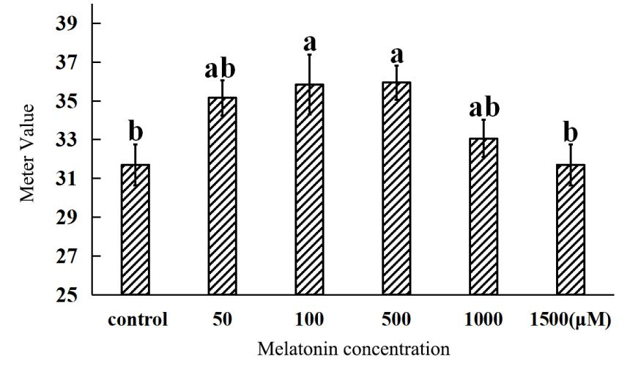

**FIGURE S3**: Effect of exogenous melatonin on total chlorophyll content of radish “JNYB”leaves.

A portable chlorophyll meter (HED-YB, Horde, China) was used. At least 3 repeats of 20 samples were taken, the values are the means ± SE, letters indicate significant difference, statistical analyses were performed by one-way ANOVA, *p* < 0.05.