**SUPPLEMENTARY**

**Antibiofilm Activity and NMR-based Metabolomic Characterization of Cell Free Supernatant of *Limosilactobacillus reuteri* DSM 17938**

Irene Vitale1ɸ, Mattia Spano2,ɸ, Valentina Puca1, Simone Carradori1, Stefania Cesa2, Beatrice Marinacci1, Francesca Sisto3, Stefan Roos4,5, Gianfranco Grompone5, Rossella Grande1,6,*

1Department of Pharmacy, “G. d’Annunzio” University of Chieti-Pescara, 66100 Chieti, Italy.

2Department of Drug Chemistry and Technology, Sapienza University of Rome, Piazzale Aldo Moro 5, 00185 Rome, Italy.

3Department of Biomedical, Surgical and Dental Sciences, University of Milan, 20133 Milan, Italy.

4Department of Molecular Sciences, Swedish University of Agricultural Sciences, 750 07 Uppsala, Sweden.

5BioGaia, SE-103 64 Stockholm, Sweden.

6Center for Advanced Studies and Technology (CAST), “G. d’Annunzio” University of Chieti-Pescara, 66100 Chieti, Italy.

ɸIV and MS equally contributed to the work.

*Corresponding author: Rossella Grande, Department of Pharmacy, “G. d’Annunzio” University of Chieti-Pescara, 66100 Chieti, Italy; rossella.grande@unich.it

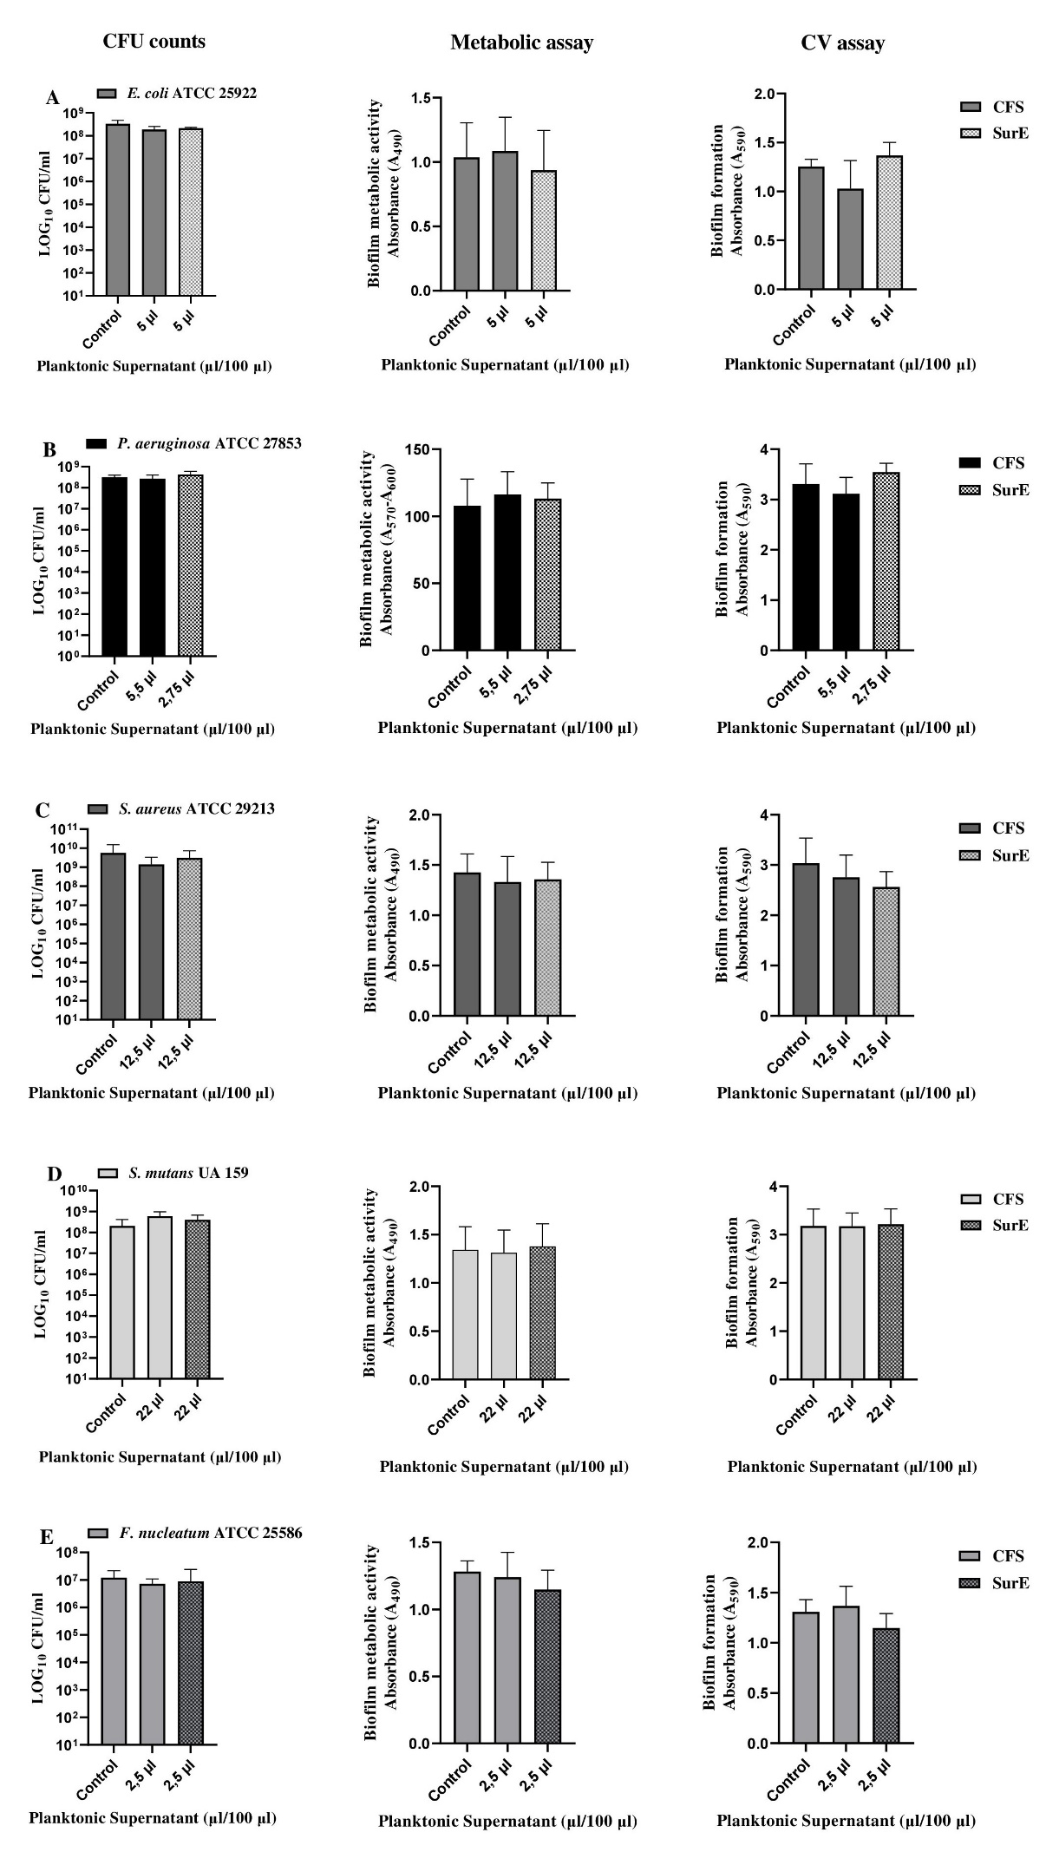

**Figure S1**. Determination of MBIC of CFS and SurE 10K through CFU counts, metabolic assay and CV assay versus *E. coli* ATCC 25922 (**A**), *P. aeruginosa* ATCC 27853 (**B**), *S. aureus* ATCC 29213 (**C**), *S. mutans* UA 159 (**D**) and *F. nucleatum* ATCC 25585 (**E**). Data are presented as the mean of three replicates of two independent experiments. The statistical comparison between control and treated samples was determined with one way ANOVA. The control was composed by media with the supplement of MRSB.

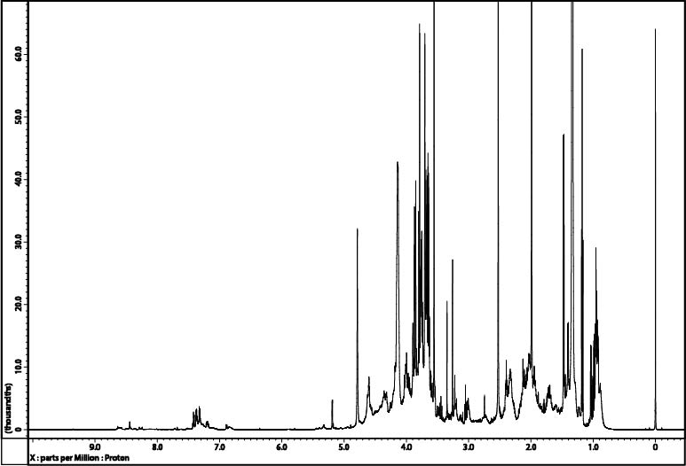

**Figure S2.** 600.17 MHz 1H NMR spectrum of CFS sample dissolved in 200 mM phosphate buffer/D2O containing TSP 1.4 mM.

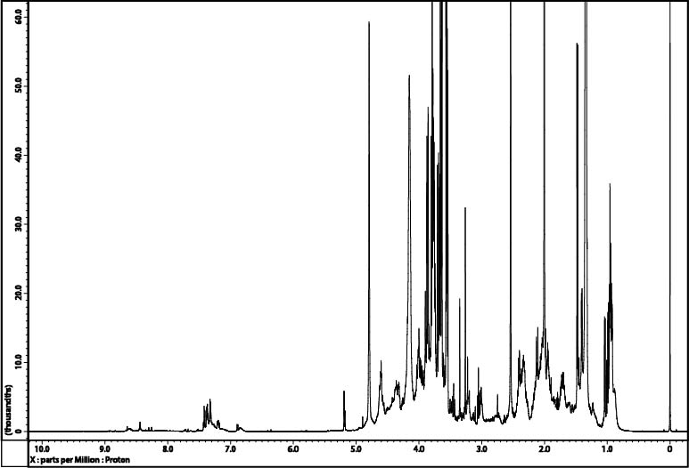

**Figure S3.** 600.17 MHz 1H NMR spectrum of SurE 10K sample dissolved in 200 mM phosphate buffer/D2O containing TSP 1.4 mM.

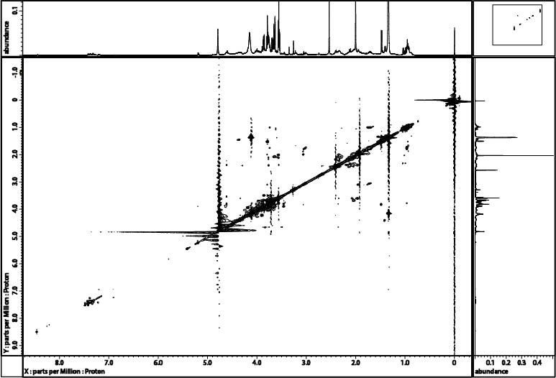

**Figure S4.** 1H-1H TOCSY spectrum of SurE 10K sample dissolved in 200 mM phosphate buffer/D2O containing TSP 1.4 mM.

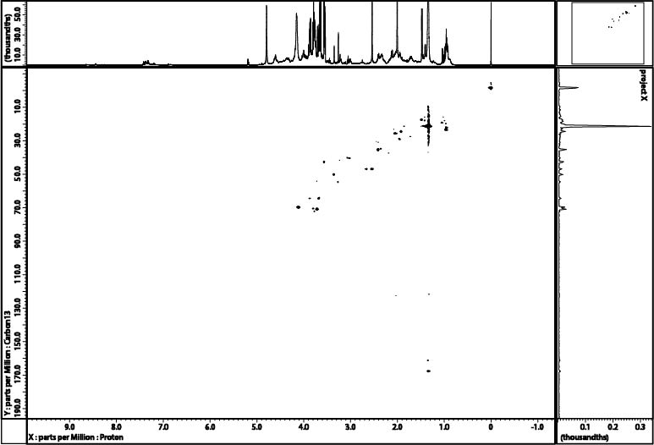

**Figure S5.** 1H-13C HSQC spectrum of SurE 10K sample dissolved in 200 mM phosphate buffer/D2O containing TSP 1.4 mM.

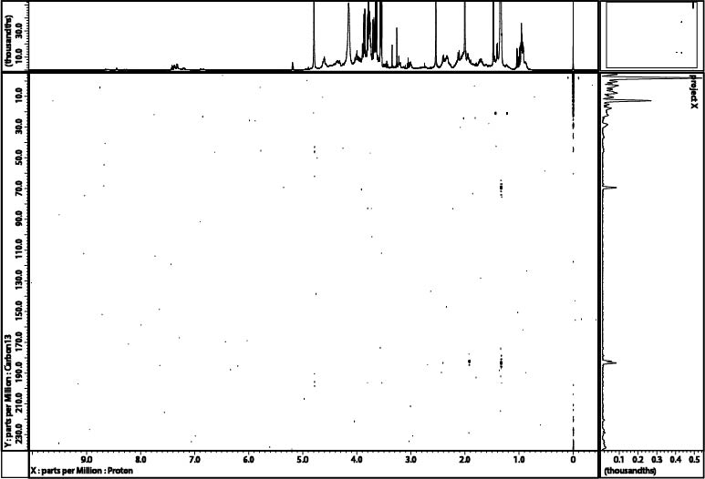

**Figure S6.** 1H-13C HMBC spectrum of SurE 10K sample dissolved in 200 mM phosphate buffer/D2O containing TSP 1.4 mM.

**Table S1.** Metabolites identified in the 600.17 MHz 1H NMR spectra of CFS and SurE 10K dissolved in 200 mM phosphate buffer/D2O containing TSP 1.4 mM. Asterisks (*) indicate signals selected for integration.

|  |  |  |  |  |
| --- | --- | --- | --- | --- |
| **Metabolite** | **Assignment** | **1H (ppm)** | **Multiplicity [*J*(Hz)]** | **13C (ppm)** |
|  |  |  |  |  |
| **Organic acids** |  |  |  |  |
|  |  |  |  |  |
| Lactatea,b | β-CH3 | *1.33 | d [6.9] | 21.4 |
|  | α-CH | 4.12 | q [6.9] | 69.6 |
|  |  |  |  |  |
| Formatea | HCOOH | *8.46 | s |  |
|  |  |  |  |  |
| **Amino acids** |  |  |  |  |
|  |  |  |  |  |
| Alaninea,b | α-CH | 3.80 |  |  |
|  | β-CH3 | *1.49 | d [7.2] | 17.4 |
|  |  |  |  |  |
| Valinea,b | β-CH | 2.28 |  | 30.5 |
|  | γ-CH3 | 1.00 | d [7.7] | 17.8 |
|  | γ’-CH3 | *1.05 | d [7.1] | 19.2 |
|  |  |  |  |  |
| Glycinebetainea,b | N(CH3)3+ | *3.27 | s | 55.1 |
|  |  |  |  |  |
| Isoleucinea,b | β-CH | 1.99 |  |  |
|  | γ-CH3 | *1.01 | d [6.9] | 15.8 |
|  |  |  |  |  |
| Leucinea,b | γ-CH | 1.74 |  |  |
|  | δ-CH3 | *0.97 | d [6.2] | 23.2 |
|  | δ’-CH3 | 0.96 | d [6.2] | 22.3 |
|  |  |  |  |  |
| Glycinea | α-CH2 | *3.56 | s | 42.5 |
|  |  |  |  |  |
| Phenylalaninea,b | CH-2,6 | 7.33 | m |  |
|  | CH-4 | 7.38 | m |  |
|  | CH-3,5 | *7.43 | m |  |
|  |  |  |  |  |
| Tyrosinea,b | CH-3,5 | 7.20 | d [8.6] |  |
|  | CH-2,6 | *6.90 | d [8.6] |  |
|  |  |  |  |  |
| Tryptophana,b | CH-4 | *7.74 | d [7.9] |  |
|  | CH-7 | 7.55 | d [8.2] |  |
|  |  |  |  |  |
| **Miscellaneous metabolites** |  |  |  |  |
|  |  |  |  |  |
| Cholinea,b | +N(CH3)3 | *3.21 | s |  |

ametabolite quantified in CFS; bmetabolite quantified in SurE 10K.

**Table S2.** Colorimetric CIEL*a*b* parameters of analyzed samples.

|  |  |  |  |  |  |  |  |  |  |  |  |
| --- | --- | --- | --- | --- | --- | --- | --- | --- | --- | --- | --- |
|  | **L\*** | **a\*** | **b\*** | **C\*** | **h°** | **ΔL\*** | **Δa\*** | **Δb\*** | **ΔC*ab** | **Δhab** | **ΔE** |
| **CFS t°** | 47.91 | 6.92 | 44.25 | 44.79 | 81.11 |  |  |  |  |  |  |
| **CFS t2w** | 49.74 | 17.88 | 65.16 | 67.57 | 74.65 | 1.84  Lighter | 10.96  More red | 20.91  More yellow | 22.78  Brighter | -6.20  More red | 23.68 |
| **CFS t4w** | 58.84 | 3.98 | 43.79 | 43.97 | 84.81 | 10.94  Lighter | -2.95  More green | -0.46  More blue | -0.82  Opaque | 2.87  More green | 11.34 |
|  | | | | | | | | | | | |
| **MRSB t°** | 47.37 | 7.36 | 44.76 | 45.36 | 80.66 |  |  |  |  |  |  |
| **MRSB t2w** | 48.44 | 21.43 | 68.23 | 71.51 | 72.56 | 1.06  Lighter | 14.07  More red | 23.47  More yellow | 26.16  Brighter | -8.05  More red | 27.39 |
| **MRSB t4w** | 56.23 | 12.17 | 60.24 | 61.45 | 78.58 | 8.86  Lighter | 4.81  More red | 15.48  More yellow | 16.10  Brighter | -1.92  More red | 18.47 |

Each reported value is the mean of four measurements. ΔE, calculated as: [(L*2–L*1)2 + (a*2–a*1)2 + (b*2–b*1)2]1/2, represents the overall color variation, respect to the corresponding samples at t°, used as references.