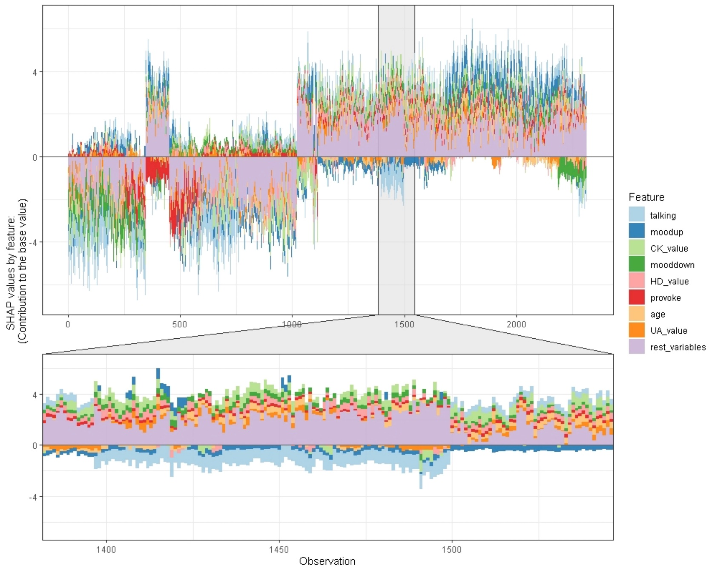
Figure S1: Individual predictions of Xgboost in binary classification between BD manic and depressive clinical states.
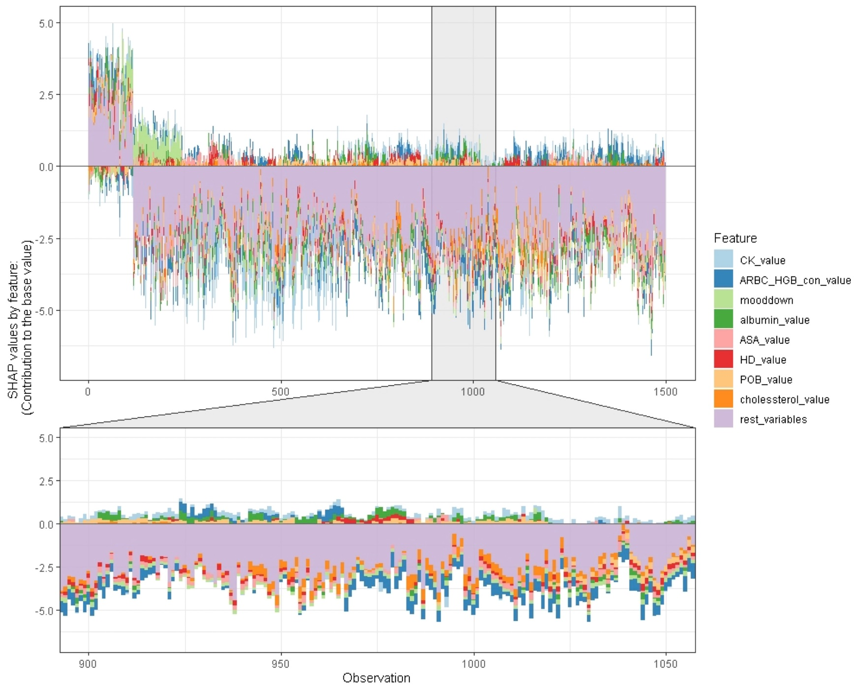
Figure S2: Individual predictions of Xgboost in binary classification between BD mixed and depressive clinical states.
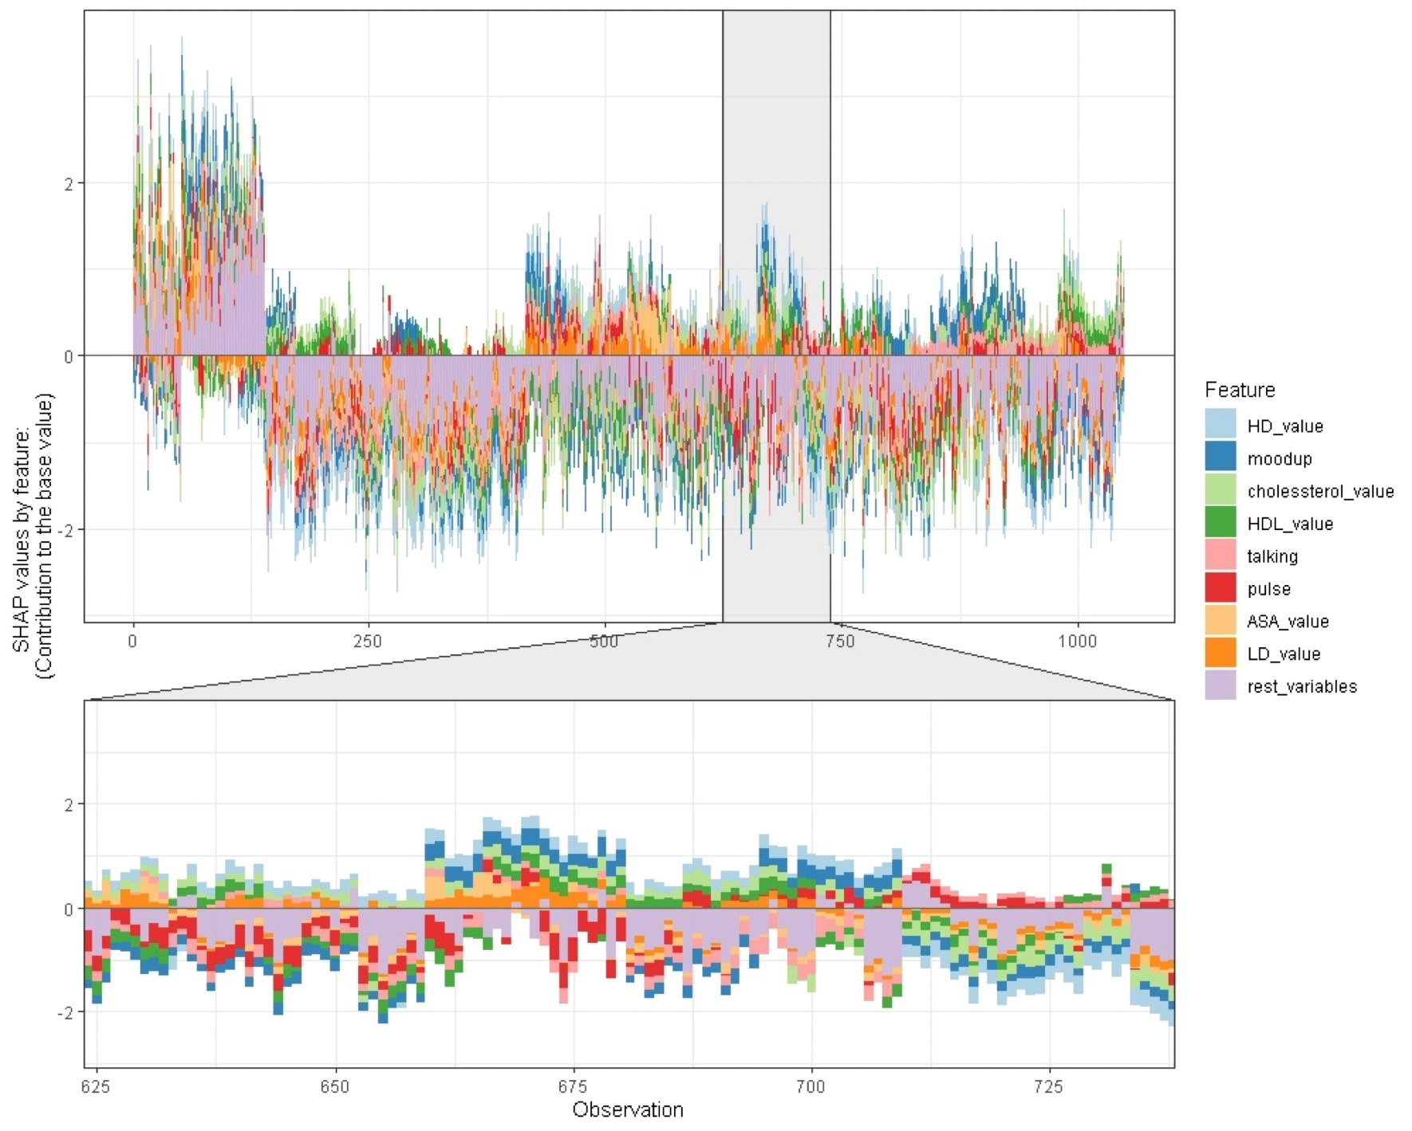
Figure S3: Individual predictions of Xgboost in binary classification between BD manic and mixed clinical states.

