**Supplementary Material**

**Text S1:** Bacterial 16S rRNA gene PCR and Illumina sequencing

DNA extractions were amplified for bacterial 16S rRNA genes in a single-step dual-indexed PCR amplification and library construction with primers targeting the V4 variable region (Caporaso et al., 2011), in a 96-well PCR plate as described (Kozich et al., 2013). Each primer consisted of the Illumina adapter, an 8-nucleotide index sequence (i5 or i7, Illumina), a 10-nucleotide pad sequence, a 2-nucleotide linker, and 16S rRNA gene-specific primer (Forward primer: 5’-AATGATACGGCGACCACCGAGATCTACACNNNNNNNNTATGGTAATTGTGTGCCAGCMGCCGCGGTAA-3’; Reverse primer: 5’-CAAGCAGAAGACGGCATACGAGATNNNNNNNNAGTCAGTCAGCCGGACTACHVGGGTWTCTAAT-3’). Each well contained 17 μL of AccuPrime Pfx SuperMix (Invitrogen), 1 μL of template DNA, and 2 μL of each paired set of index primers. A negative control, consisting of 1 µl of sterile nuclease-free molecular grade water (Severn Biotech Ltd) was also performed, while the positive control utilized 1 µl of Microbial Mock Community A (obtained through BEI Resources, NIAID, NIH as part of the Human Microbiome Project). The thermocycler programme was as follows: 2 mins at 95°C; 30 cycles of 95°C for 20 s, 55°C for 15 s and 72°C for 5 mins, followed by a final step of 72°C for 10 mins. PCR amplifications were performed in triplicate for each sample, pooled, purified with SPRIselect magnetic beads (Beckman Coulter) and quantified. The purified amplicons were then pooled in equimolar concentrations and the final concentration of the library was determined using a Qubit fluorometer. Libraries were mixed with Illumina-generated PhiX control library and sequenced using an Illumina MiSeq instrument (Illumina) in 2x 250 bp paired-end mode with Illumina MiSeq Reagent Kit v2. Sequencing and bioinformatics were performed at the School of Biosciences Genomics Research Hub, Cardiff University.

In brief, the data generated from the Illumina sequencing was analyzed using Mothur v1.38.1 and the MiSeq standard operating procedure (Kozich et al., 2013); <http://mothur.org/>). Contigs were generated from the paired reads and filtered to remove ambiguous reads shorter than 245 bp and longer than 275 bp. Sequences were aligned with the SILVA database, assigned taxonomy, and grouped into operational taxonomic units (OTU) with a 97% sequence similarity threshold. An OTU abundance and taxonomy table for all samples was produced and investigated further using the phyloseq package (McMurdie and Holmes, 2013) implemented in R and Past software v4.0 (Hammer et al., 2001) to calculate diversity metrics.

**Text S2:** Statistical analysis

Table S1 Mean TN and COD removal efficiency comparisons via ANOVA for the for the step-fed system evaluated at the Phases 2-4.

|  |  |  |  |  |  |
| --- | --- | --- | --- | --- | --- |
| ANOVA- TN removal for step-feeding Phases 2-4 | | | | | |
|  | Sum of Squares | df | Mean Square | F | Significance |
| Between Groups | 556.2 | 2 | 278.1 | 21.1 | <0.001 |
| Within Groups | 157.8 | 12 | 13.2 |  |  |
| Total | 714.0 | 14 |  |  |  |
| ANOVA - COD removal for step-feeding Phases 2-4 | | | | | |
|  | Sum of Squares | df | Mean Square | F | Significance |
| Between Groups | 27.8 | 2 | 13.9 | 9.6 | 0.003 |
| Within Groups | 17.3 | 12 | 1.4 |  |  |
| Total | 45.0 | 14 |  |  |  |

Table S2 Pairwise comparison of TN and COD removal efficiency under the step-feeding condition evaluated at Phases 2-4.

|  |  |  |  |  |  |  |  |  |  |
| --- | --- | --- | --- | --- | --- | --- | --- | --- | --- |
| **Paired Samples Test TN removal** | | | | | | | | | |
| Pairs | Paired Differences | | | | | t | df | Significance | |
| Mean | Std. Deviation | Std. Error Mean | 95% Confidence Interval of the Difference | | One-Sided p | Two-Sided p |
| Lower | Upper |
| Phase 2 & 3 | 14.92 | 1.65 | 0.74 | 12.87 | 16.96 | 20.25 | 4 | <0.001 | <0.001 |
| Phase 2 & 4 | -7.48 | 3.30 | 1.48 | -11.59 | -3.38 | -5.06 | 4 | 0.004 | 0.007 |
| Phase 3 & 4 | -7.43 | 2.92 | 1.31 | -11.06 | -3.80 | -5.69 | 4 | 0.002 | 0.005 |
| **Paired Samples Test COD removal** | | | | | | | | | |
| Pairs | Paired Differences | | | | | t | df | Significance | |
| Mean | Std. Deviation | Std. Error Mean | 95% Confidence Interval of the Difference | | One-Sided p | Two-Sided p |
| Lower | Upper |
| Phase 2 & 3 | -2.01 | 2.22 | 0.99 | -4.77 | 0.74 | -2.03 | 4 | 0.06 | 0.11 |
| Phase 2 & 4 | -3.31 | 2.12 | 0.95 | -5.94 | -0.67 | -3.48 | 4 | 0.01 | 0.03 |
| Phase 3 & 4 | -1.29 | 0.40 | 0.18 | -1.78 | -0.80 | -7.31 | 4 | <0.001 | 0.002 |

Table S3 Pairwise comparison of NO₃⁻-N concentrations evaluated at Phases 1-4.

|  |  |  |  |  |  |  |  |  |  |
| --- | --- | --- | --- | --- | --- | --- | --- | --- | --- |
| **Paired Samples Test - NO₃⁻-N stage 4 concentration** | | | | | | | | | |
| Pairs | Paired Differences | | | | | t | df | Significance | |
| Mean | Std. Deviation | Std. Error Mean | 95% Confidence Interval of the Difference | | One-Sided p | Two-Sided p |
| Lower | Upper |
| Phase 1 & 2 | -0.14 | 2.63 | 1.18 | -3.41 | 3.13 | -0.12 | 4 | 0.46 | 0.91 |
| Phase 1 &3 | 1.50 | 1.98 | 0.89 | -0.96 | 3.96 | 1.69 | 4 | 0.08 | 0.17 |
| Phase 1 & 4 | 0.38 | 2.77 | 1.24 | -3.06 | 3.82 | 0.31 | 4 | 0.39 | 0.77 |
| Phase 2 & 3 | 1.64 | 1.86 | 0.83 | -0.67 | 3.95 | 1.97 | 4 | 0.06 | 0.12 |
| Phase 2 & 4 | 0.52 | 1.53 | 0.68 | -1.38 | 2.42 | 0.76 | 4 | 0.24 | 0.49 |
| Phase 3 & 4 | -1.12 | 1.25 | 0.56 | -2.67 | 0.43 | -2.00 | 4 | 0.06 | 0.12 |

Table S4 Mean NH₄⁺-N and NO₃⁻-N concentration comparisons via ANOVA for the for the step-fed system evaluated at the Phase 1-4.

|  |  |  |  |  |  |  |
| --- | --- | --- | --- | --- | --- | --- |
| **NH₄⁺-N internal stage-wise dynamics** | | | | | | |
|  | | Sum of Squares | df | Mean Square | F | Significance |
| Phase 1 | Between Groups | 2404.5 | 3 | 801.5 | 8.0 | 0.002 |
| Within Groups | 1609.6 | 16 | 100.6 |  |  |
| Total | 4014.1 | 19 |  |  |  |
| Phase 2 | Between Groups | 6766.7 | 3 | 2255.6 | 373.7 | <0.001 |
| Within Groups | 96.6 | 16 | 6.0 |  |  |
| Total | 6863.3 | 19 |  |  |  |
| Phase 3 | Between Groups | 3375.1 | 3 | 1125.0 | 272.8 | <0.001 |
| Within Groups | 66.0 | 16 | 4.1 |  |  |
| Total | 3441.1 | 19 |  |  |  |
| Phase 4 | Between Groups | 3395.7 | 3 | 1131.9 | 27.9 | <0.001 |
| Within Groups | 649.1 | 16 | 40.6 |  |  |
| Total | 4044.8 | 19 |  |  |  |
| **NO₃⁻-N internal stage-wise dynamics** | | | | | | |
|  | | Sum of Squares | df | Mean Square | F | Significance |
| Phase 1 | Between Groups | 133.85 | 3 | 44.617 | 14.478 | <0.001 |
| Within Groups | 49.308 | 16 | 3.082 |  |  |
| Total | 183.158 | 19 |  |  |  |
| Phase 2 | Between Groups | 6.757 | 3 | 2.253 | 0.761 | 0.532 |
| Within Groups | 47.368 | 16 | 2.961 |  |  |
| Total | 54.126 | 19 |  |  |  |
| Phase 3 | Between Groups | 17.354 | 3 | 5.785 | 5.203 | 0.011 |
| Within Groups | 17.788 | 16 | 1.112 |  |  |
| Total | 35.142 | 19 |  |  |  |
| Phase 4 | Between Groups | 16.948 | 3 | 5.649 | 3.498 | 0.04 |
| Within Groups | 25.84 | 16 | 1.615 |  |  |
| Total | 42.788 | 19 |  |  |  |

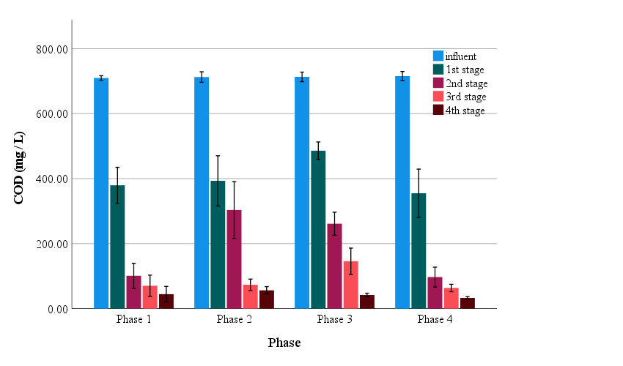

**Fig. S1.** COD profile in individual stages of the constructed wetland for all tested phases 1-4.

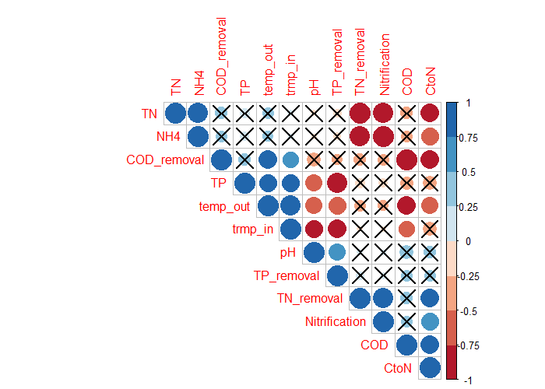**Fig. S2**. Correlation matrix with TFCW performance variables. TN, COD, TP and NH4 are concentrations values observed in the final effluent (stage 4) of the system; CtoN – carbon to nitrogen ratio; temp_in/temp_out – water temperature in the inflow and outflow of the system. Crossed out correlations are not significant (p>0.05).

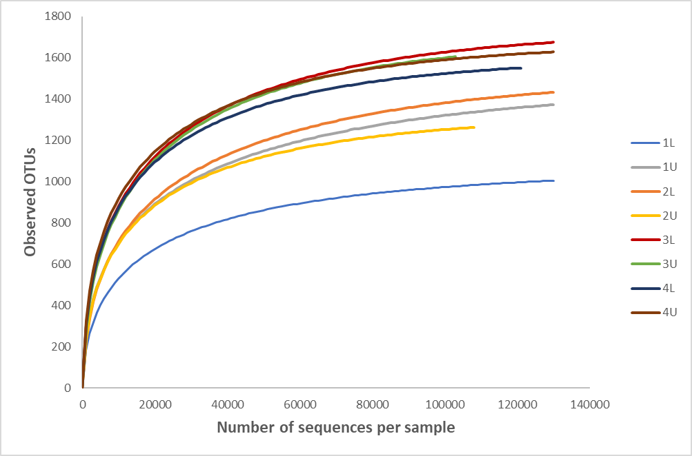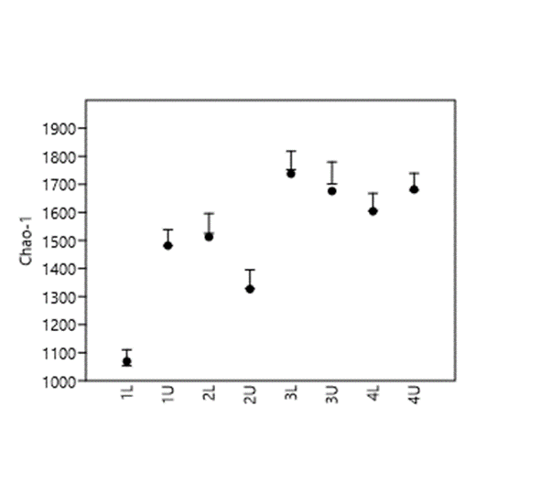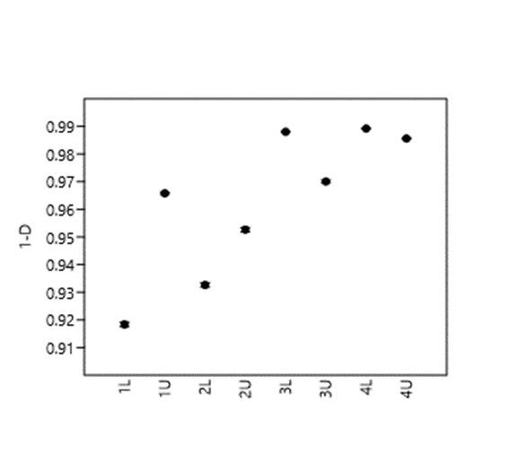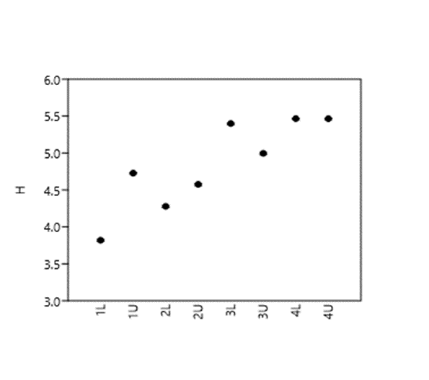

**(d)**

**(c)**

**(b)**

**(a)**

**Fig. S3**. Rarefaction curves and diversity indices for bacterial 16S rRNA genes retrieved from the multistage constructed wetland. (a) Observed OTUs for all samples. (b) *S*chao1 estimate of species richness. (c) Simpson’s diversity index (1-*D*). (d) Shannon’s diversity index (*H’*). 1L = stage 1 lower position, 1U = stage 1 upper position, 2L = stage 2 lower position, 2U = stage 2 upper position, 3L = stage 3 lower position, 3U = stage 3 upper position, 4L = stage 4 lower position, 4U = stage 4 upper position.

**Table S5**

Diversity indices for the multistage constructed wetland system bacterial 16S rRNA gene amplicon libraries

|  |  |  |  |  |  |  |  |  |
| --- | --- | --- | --- | --- | --- | --- | --- | --- |
| **Diversity indices** | **Constructed wetland system samples** | | | | | | | |
| **1L** | **1U** | **2L** | **2U** | **3L** | **3U** | **4L** | **4U** |
| **Number of reads** | 131873 | 191610 | 148073 | 109440 | 139466 | 104118 | 122708 | 131726 |
| **Unique taxa (OTUs)** | 1006 | 1428 | 1452 | 1264 | 1684 | 1606 | 1552 | 1629 |
| **Good's coverage (%)** | 99.24 | 99.25 | 99.02 | 98.85 | 98.79 | 98.46 | 98.74 | 98.76 |
| **Simpson's diversity index (1-*D*)** | 0.92 | 0.97 | 0.93 | 0.95 | 0.99 | 0.97 | 0.99 | 0.99 |
| **Shannon's diversity index (*H*')** | 3.82 | 4.73 | 4.28 | 4.58 | 5.40 | 4.99 | 5.47 | 5.47 |
| ***S*Chao1** | 1069 | 1482 | 1512 | 1327 | 1738 | 1676 | 1604 | 1682 |

Samples from upper (U) and lower (L) positions wihtin the 4 stages of the multistage constructed wetland system (see Fig. 1) after 420 days (end of Phase 4).

OTU, operational taxonomic unit.

Shannon's and Simpson's diversity indices are measures of species diversity and both increase with increasing genetic diversity.

*S*Chao1 represents the expected number of OTUs present in an environment if sampling was complete.

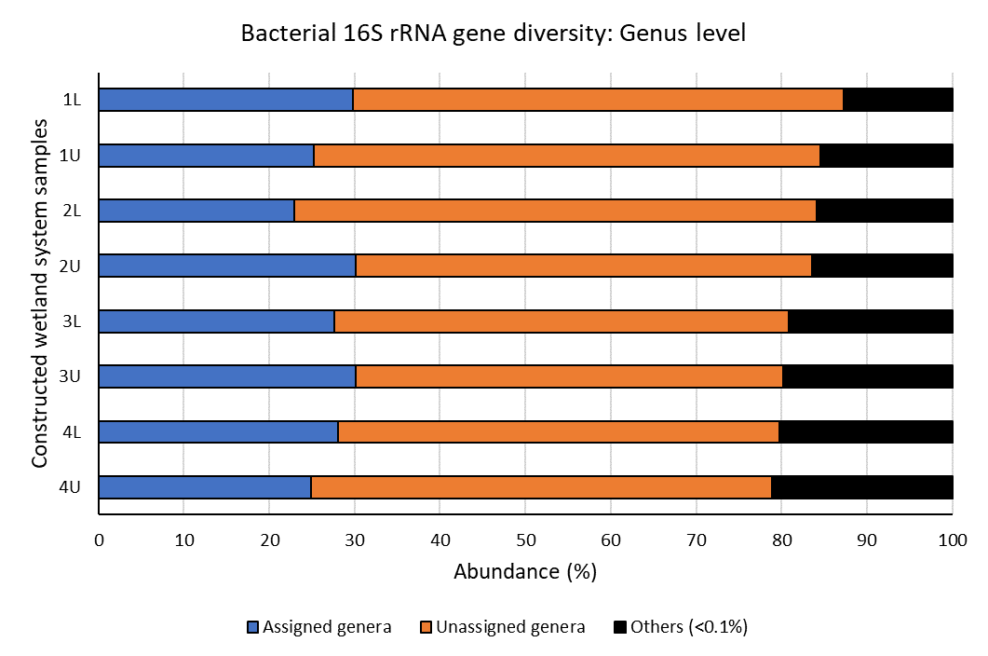

(a)

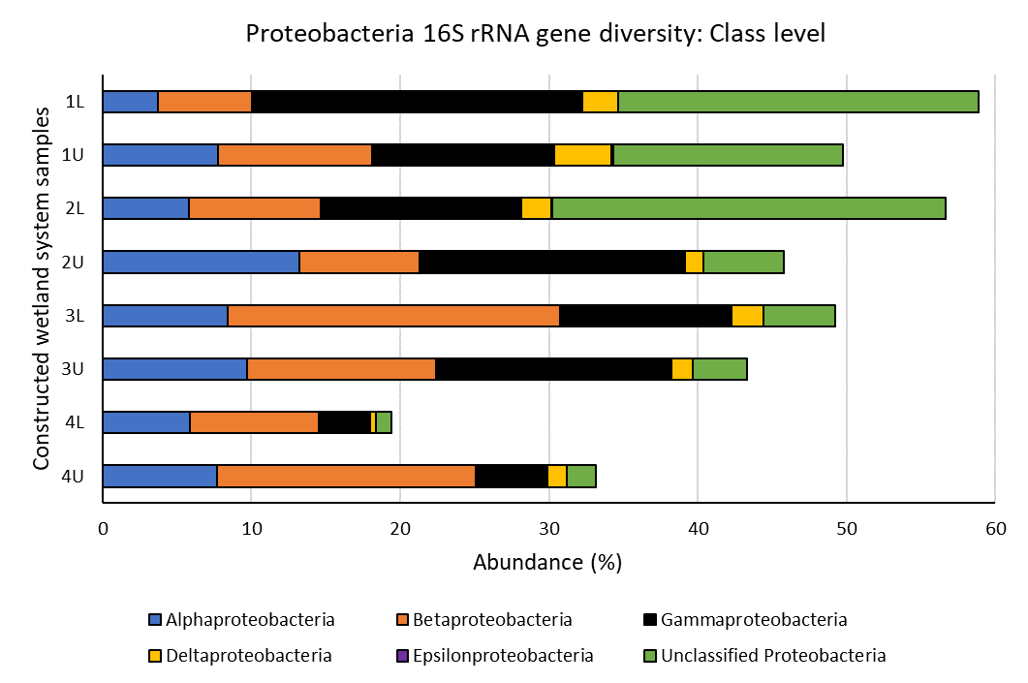

(b)

**Fig. S4.** Bacterial 16S rRNA gene diversity in the multistage constructed wetland system at the end of Phase 4 assigned at the genus level (a) and the proteobacterial class level (b). 1L = stage 1 lower position, 1U = stage 1 upper position, 2L = stage 2 lower position, 2U = stage 2 upper position, 3L = stage 3 lower position, 3U = stage 3 upper position, 4L = stage 4 lower position, 4U = stage 4 upper position. Others (<0.1%) represents bacteria with less than 0.1% abundance in each sample.

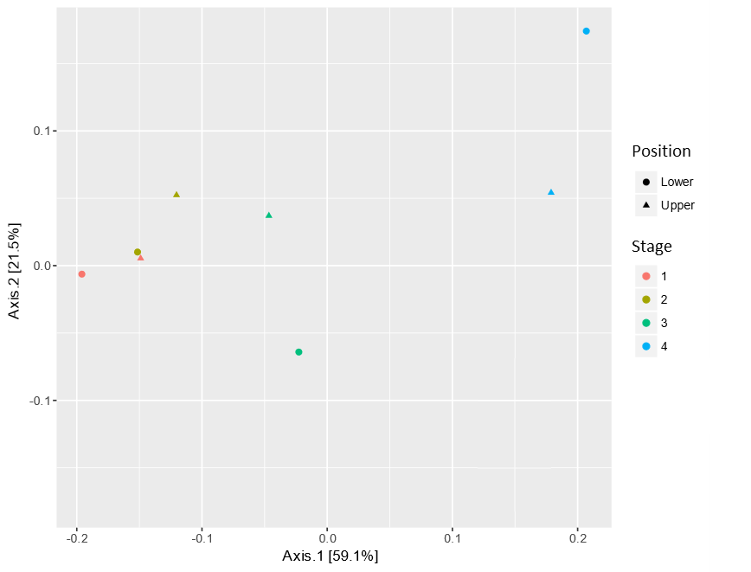

Stage 1 & 2

Stage 3

Stage 4

**Fig. S5.** Principal coordinate analysis (PCA) of 16S rRNA gene data in constructed wetland system. Samples were taken from stages 1 to 4 and at different positions (uper and lower) at each stage. PCA was calculated based on the weighted UniFrac distances. PCA with weighted UniFrac was used to visualize and compare microbial community at each sampling stage in the CW system using a similarity matrix and assigning each sample a location in a multi-dimensional space (Lozupone et al., 2011). The first two principal coordinate (Tu et al., 2014) axes (dimensional spaces) explain >80% of the variability in the microbial community compositions with the system. Stages 1 and 2 grouped together, suggesting these stages have similar microbial communities, with stage 3 samples clustering together separately and stage 4 samples also forming a separate group apart other stage samples. PCA further corroborates the evolution and distinct changes in the microbial community at each stage throughout the CW system. Note that in all cases the upper and lower position results for PCA for each stage grouped closely together.

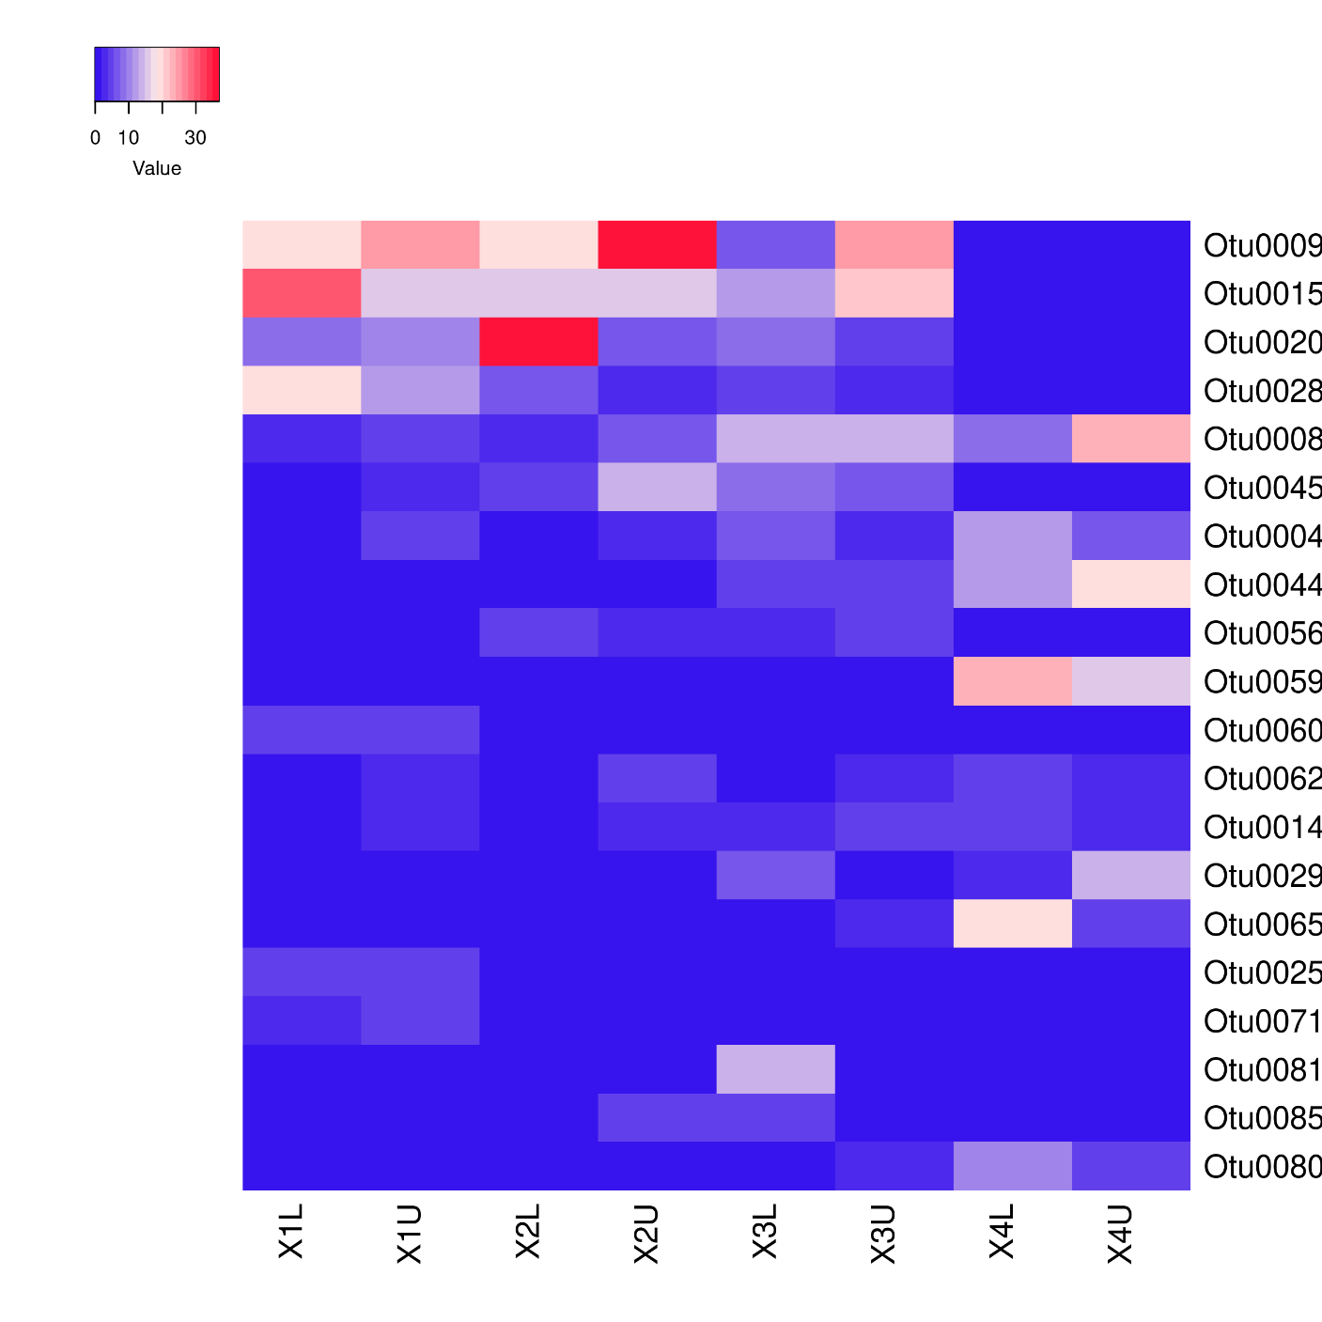

1L

1U

2L

2U

3L

3U

4L

4U

OTU0009_*Veillonellaceae* (F) *-*

OTU0015_*Thiothrix* (G) *-*

OTU0020_*Proteobacteria* (P) *-*

OTU0028_*Proteobacteria* (P) *-*

OTU0008_*Azonexus* (G) *-*

OTU0045_*Pseudoxanthomonas* (G) *-*

OTU0004_*Comamonadaceae* (F) *-*

OTU0044_*Acidobacteria* group 4 (O) *-*

OTU0056_*Hydrogenophaga* (G) *-*

OTU0059_*Planctomyces* (G) *-*

OTU0060_*Proteobacteria* (O) *-*

OTU0062_*Planctomycetaceae* (F) *-*

OTU0014_*Gemmobacter* (G) *-*

OTU0029_*Rhodocyclaceae* (F) *-*

OTU0065_*Planctomycetaceae* (F) *-*

OTU0025_*Bacteroidetes* (P) *-*

OTU0071_*Desulfomicrobium* (G) *-*

OTU0081_*Rhodocyclaceae* (F) *-*

OTU0085_*Flavobacteriaceae* (F) *-*

OTU0080_*Planctomycetaceae* (F) *-*

OTU abundance (% of top 20)

Constructed wetland system samples

**Fig.** **S6.** Heat map of abundance (%) for the twenty most abundant OTUs found in the constructed wetland system. 1L = stage 1 lower position, 1U = stage 1 upper position, 2L = stage 2 lower position, 2U = stage 2 upper position, 3L = stage 3 lower position, 3U = stage 3 upper position, 4L = stage 4 lower position, 4U = stage 4 upper position. Letters in paraenthesis show the level of taxonomy the OTU was identified. P = phylum, O = order, F = family, G = genus.

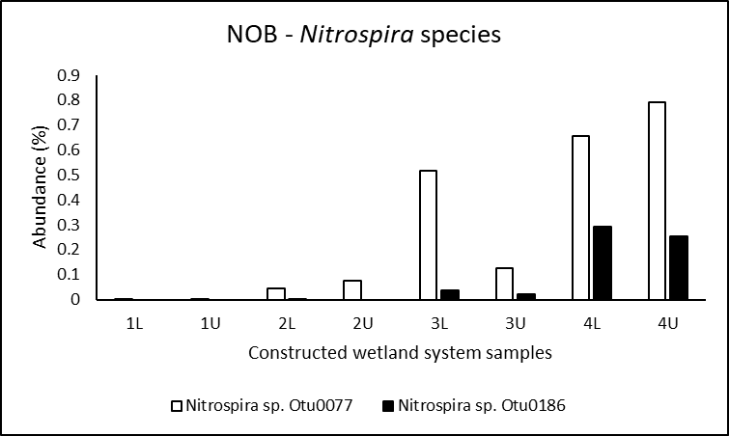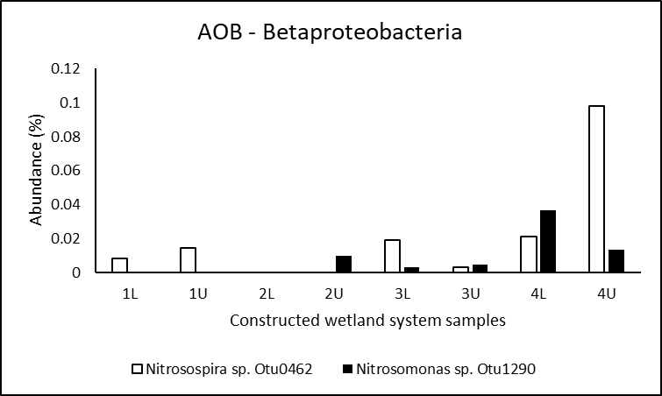

(d)

(c)

(b)

(a)

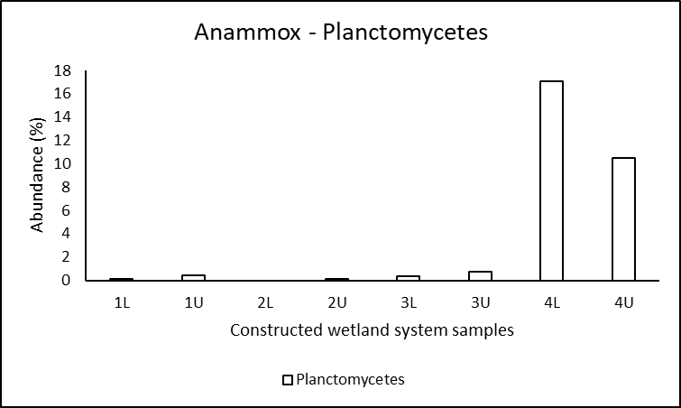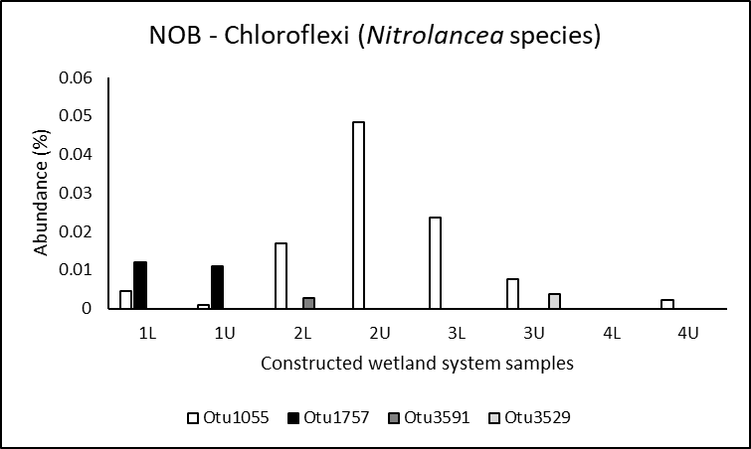

**Fig. S7.** Abundance of important nitryfying bacteria OTUs found in the multistage constructed wetland at the end of Phase 4. (a) Ammonia oxidising bacteria (AOB) belonging to the Betaproteobacteria, *Nitrosospira* and *Nitrosomonas* species. (b) Nitrite oxidising baceria (NOB) belonging to the *Nitrospira* species. (c) Nitrite oxidising baceria (NOB) belonging to the Chloroflexi, *Nitrolancea* species. (d) Putative annamox bacteria belonging to the Planctomycetes. 1L = stage 1 lower position, 1U = stage 1 upper position, 2L = stage 2 lower position, 2U = stage 2 upper position, 3L = stage 3 lower position, 3U = stage 3 upper position, 4L = stage 4 lower position, 4U = stage 4 upper position.

**Text S3:**

Regarding the formulas in Fig. 4:

Reduction (NH₄⁺-N):

Reduction metrics informs about the amount of NH4-N being removal at the given stage in reference to the previous stage. The amount of ammonium at each stage is subtracted from the amount of ammonium in the influent divided by the amount ammonium in the influent.

Reduction (NH₄⁺-N) = $(\frac{(Influent of N{H₄}^{+}-N)-(amoumt of N{H₄}^{+}-N of each stage)}{(Influent of {NH₄}^{+}-N)}$) *100

Accumulation (NO₃⁻-N):

Accumulation rate is indicative on the effectiveness of nitrate removal in the respective column taking into account both NO3 inflow from the previous treatment stage as well as internal NO3 production due to NH4 oxidation. The amount of nitrate at given stage is subtracted from the amount of nitrate in the previous stage divided by the amount of ammonium at given stage subtracting the amount of ammonium at the next stage.

Accumulation (NO₃⁻-N) (examples for stage 1) = ($\frac{\left(N{O₃}^{-}-N\right)(n+1)-\left(N{O₃}^{-}-N\right)n}{\left({NH₄}^{+}-N\right)n-\left({NH₄}^{+}-N\right)(n+1)}$) *100

n= stage number

Contributions (NH₄⁺-N):

Contribution metric is calculated to show how much does the given treatment stage contributed to the total removal of NH4-N in the system. The amount of ammonium at the influent is subtracted from the amount of ammonium in the next stage divided by the amount of ammonium at the influent subtracting the amount of ammonium at the final effluent (stage 4).

Contributions (NH₄⁺-N) (examples for stage 1) = $(\frac{\left({NH₄}^{+}-N\right)influent-\left({NH₄}^{+}-N\right)stage 1}{\left(NH₄⁺-N\right) influent-\left(N{H₄}^{+}-N\right)stage 4}$) *100

Contributions (NH₄⁺-N) (examples for stage 2) = $(\frac{\left({NH₄}^{+}-N\right)stage 1-\left({NH₄}^{+}-N\right)stage 2}{\left(NH₄⁺-N\right) influent-\left(N{H₄}^{+}-N\right)stage 4}$) *100

Contributions (NH₄⁺-N) (examples for stage 3) = $(\frac{\left({NH₄}^{+}-N\right)stage 2-\left({NH₄}^{+}-N\right)stage 3}{\left(NH₄⁺-N\right) influent-\left(N{H₄}^{+}-N\right)stage 4}$) *100

Contributions (NH₄⁺-N) (examples for stage 4) = $(\frac{\left({NH₄}^{+}-N\right)stage 3-\left({NH₄}^{+}-N\right)stage 4}{\left(NH₄⁺-N\right) influent-\left(N{H₄}^{+}-N\right)stage 4}$) *100

**References**

Caporaso, J. G. and Lauber, C. L. and Walters, W. A. and Berg-Lyons, D. and Lozupone, C. A. and Turnbaugh, P. J. and Fierer, N. and Knight, R. 2011. Global patterns of 16S rRNA diversity at a depth of millions of sequences per sample. *Proceedings of the national academy of sciences* 108(Supplement 1), pp. 4516-4522. <https://doi.org/10.1073/pnas.1000080107>.

Hammer, Ø. and Harper, D. A. and Ryan, P. D. 2001. PAST: Paleontological statistics software package for education and data analysis. *Palaeontologia electronica* 4(1), p. 9.

Kozich, J. J. and Westcott, S. L. and Baxter, N. T. and Highlander, S. K. and Schloss, P. D. 2013. Development of a dual-index sequencing strategy and curation pipeline for analyzing amplicon sequence data on the MiSeq Illumina sequencing platform. *Applied and environmental microbiology* 79(17), pp. 5112-5120. <https://doi.org/10.1128/AEM.01043-13>.

Lozupone, C. and Lladser, M. E. and Knights, D. and Stombaugh, J. and Knight, R. 2011. UniFrac: an effective distance metric for microbial community comparison. *The ISME journal* 5(2), pp. 169-172. <https://doi.org/10.1038/ismej.2010.133>.

McMurdie, P. J. and Holmes, S. 2013. phyloseq: an R package for reproducible interactive analysis and graphics of microbiome census data. *PloS one* 8(4), p. e61217. <https://doi.org/10.1371/journal.pone.0061217>.

Tu, Y. and Chiang, P. and Yang, J. and Chen, S. and Kao, C. 2014. Application of a constructed wetland system for polluted stream remediation. *Journal of Hydrology* 510, pp. 70-78. <https://doi.org/10.1016/j.jhydrol.2013.12.015>.