Supplementary Material

Construction of high-resolution precipitation dataset based on multi-source data and its implication to drought: a case study in the Tianshan Mountains, Northwest China
Xiaoqian Li^{1,2}, Xinlin He^{1,2*}, Xiaolong Li^{1,2*}, Yongjun Du^{1,2}, Guang Yang^{1,2}, Hao Tian^{1,2}, Jiawen Yu^{3,4}
* Correspondence: Xinlin He: hxinl2022@163.com ; Xiaolong Li: lxlong2022@163.com

Supplementary Figures and Tables

Supplementary Figures
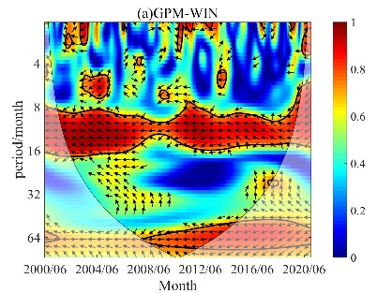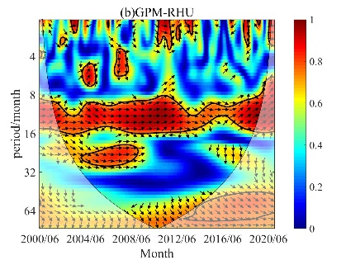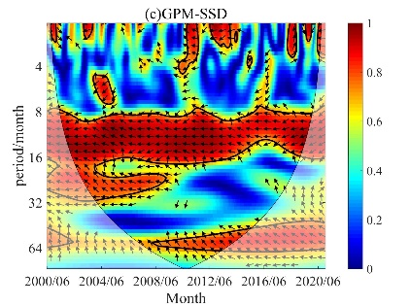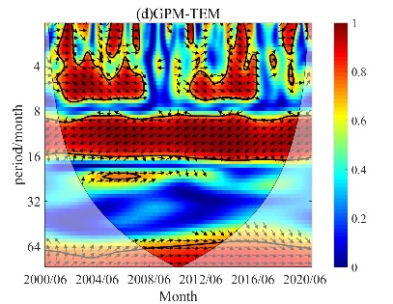
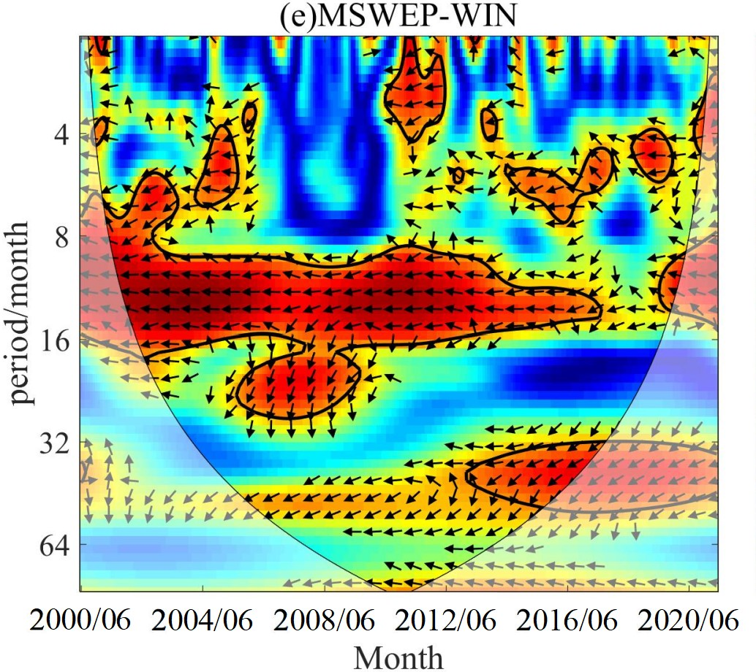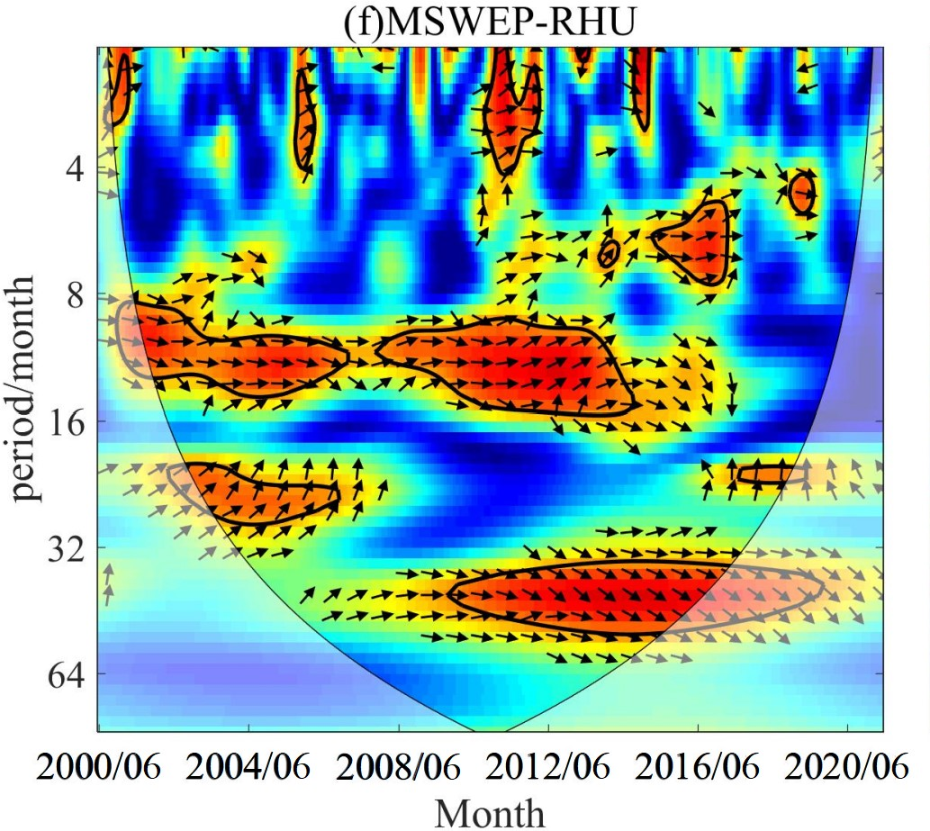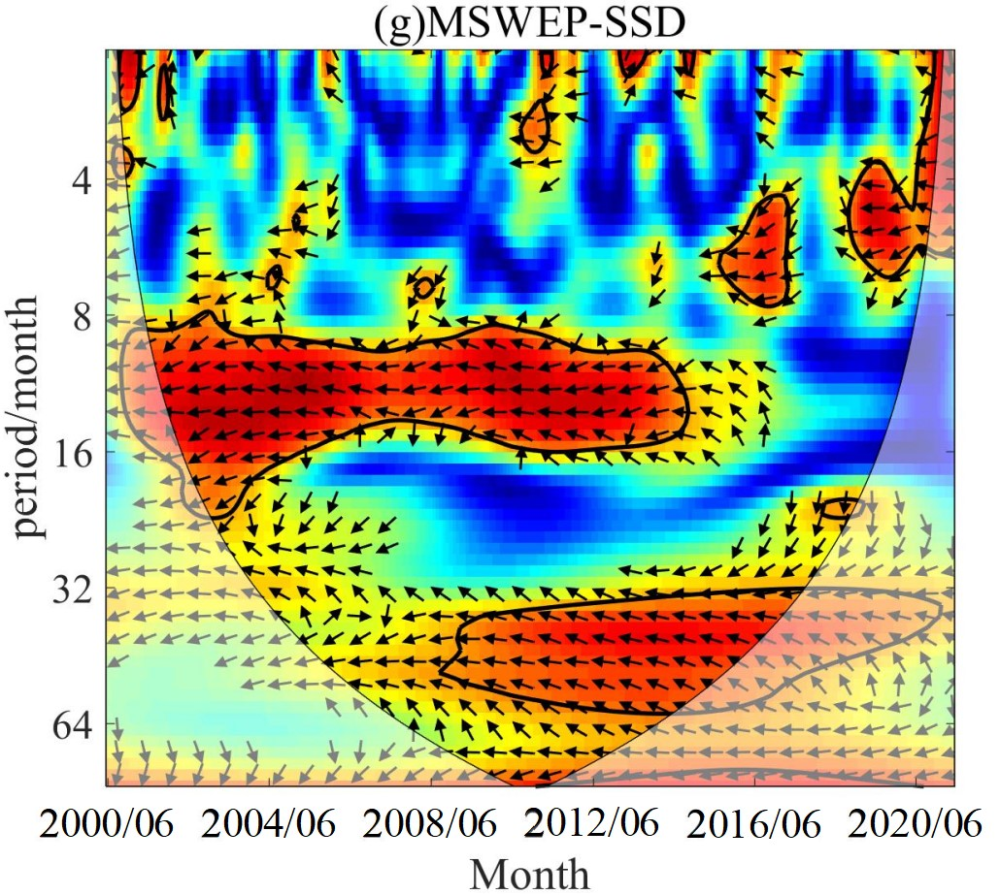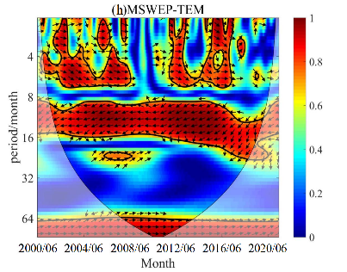
Supplementary Figure 1. Wavelet transform coherence map of monthly precipitation and WIN (a, d), RHU (b, e), SSD (c, f), TEM (d, g) during 2000-2020 (GPM: A-d; MSWEP: e-f)
Considering that the selected climate factors have the same characteristics of periodic changes as precipitation, the wavelet transform correlation graph of GPM and MSWEP precipitation and climate factors in each month of the year is drawn in Supplementary Figure 1 to further explore the phase relationship between monthly precipitation and climate factors in time-frequency and space -frequency. For GPM, there was a significant negative phase relationship between precipitation and WIN (Figure 5a), SSD (Figure 5c) and TEM (Figure 5d) during the whole study period. Precipitation and RHU (Figure 5b) showed a significant positive phase in most years. For MSWEP, the phase relationship between precipitation and WIN (Figure 5e) and SSD (Figure 5g) in the study period is similar: there is a significant negative correlation (Figure 5G) in the range of 8-16 months from 2000 to 2016, and a significant negative correlation between 32-64 months from 2012 to 2020. There was a significant positive correlation between precipitation and RHU (Figure 5f) in the scale of August to 16 months during 2000-2016. The phase relationship between precipitation-TEM (Figure 5h) and GPM (Figure 5d) is similar. It is worth noting that the correlation changes in Figure 5 and its periodic characteristics are dynamic changes rather than simple linear relationships, which need to be further verified by comparing the results of GWR and MGWR models. According to Figure 4 and Figure 5, DEM, WIN, RHU, SSD, TEM and DEM, ASPECT, SLOPE, WIN, RHU, SSD, TEM are closely correlated with GPM and MSWEP, no matter from the general rule (mean value) or multi-year periodicity. It is shown that these environmental variables can help to downscale precipitation products (0.1°×0.1°) to high spatial resolution (1km×1km).
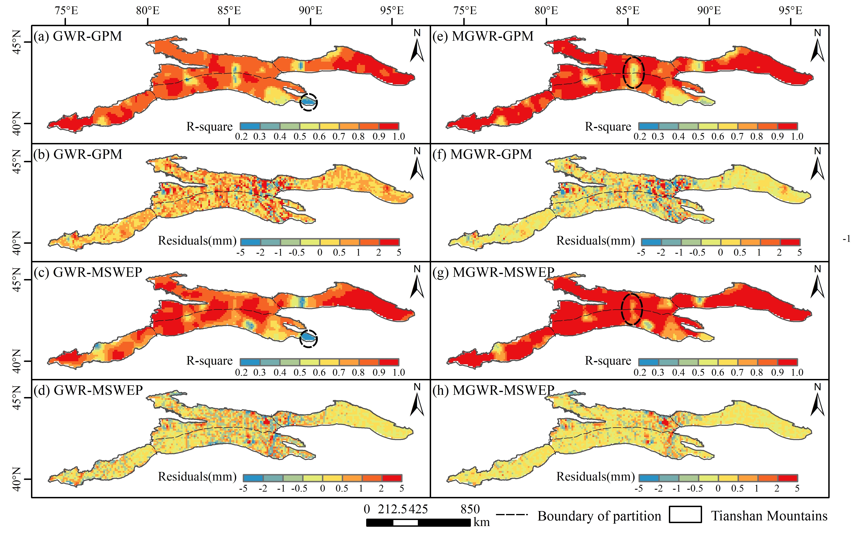
Supplementary Figure 2. Spatial distribution of R² and residuals of precipitation estimates based on GWR(a-d) and MGWR(e-h) models.
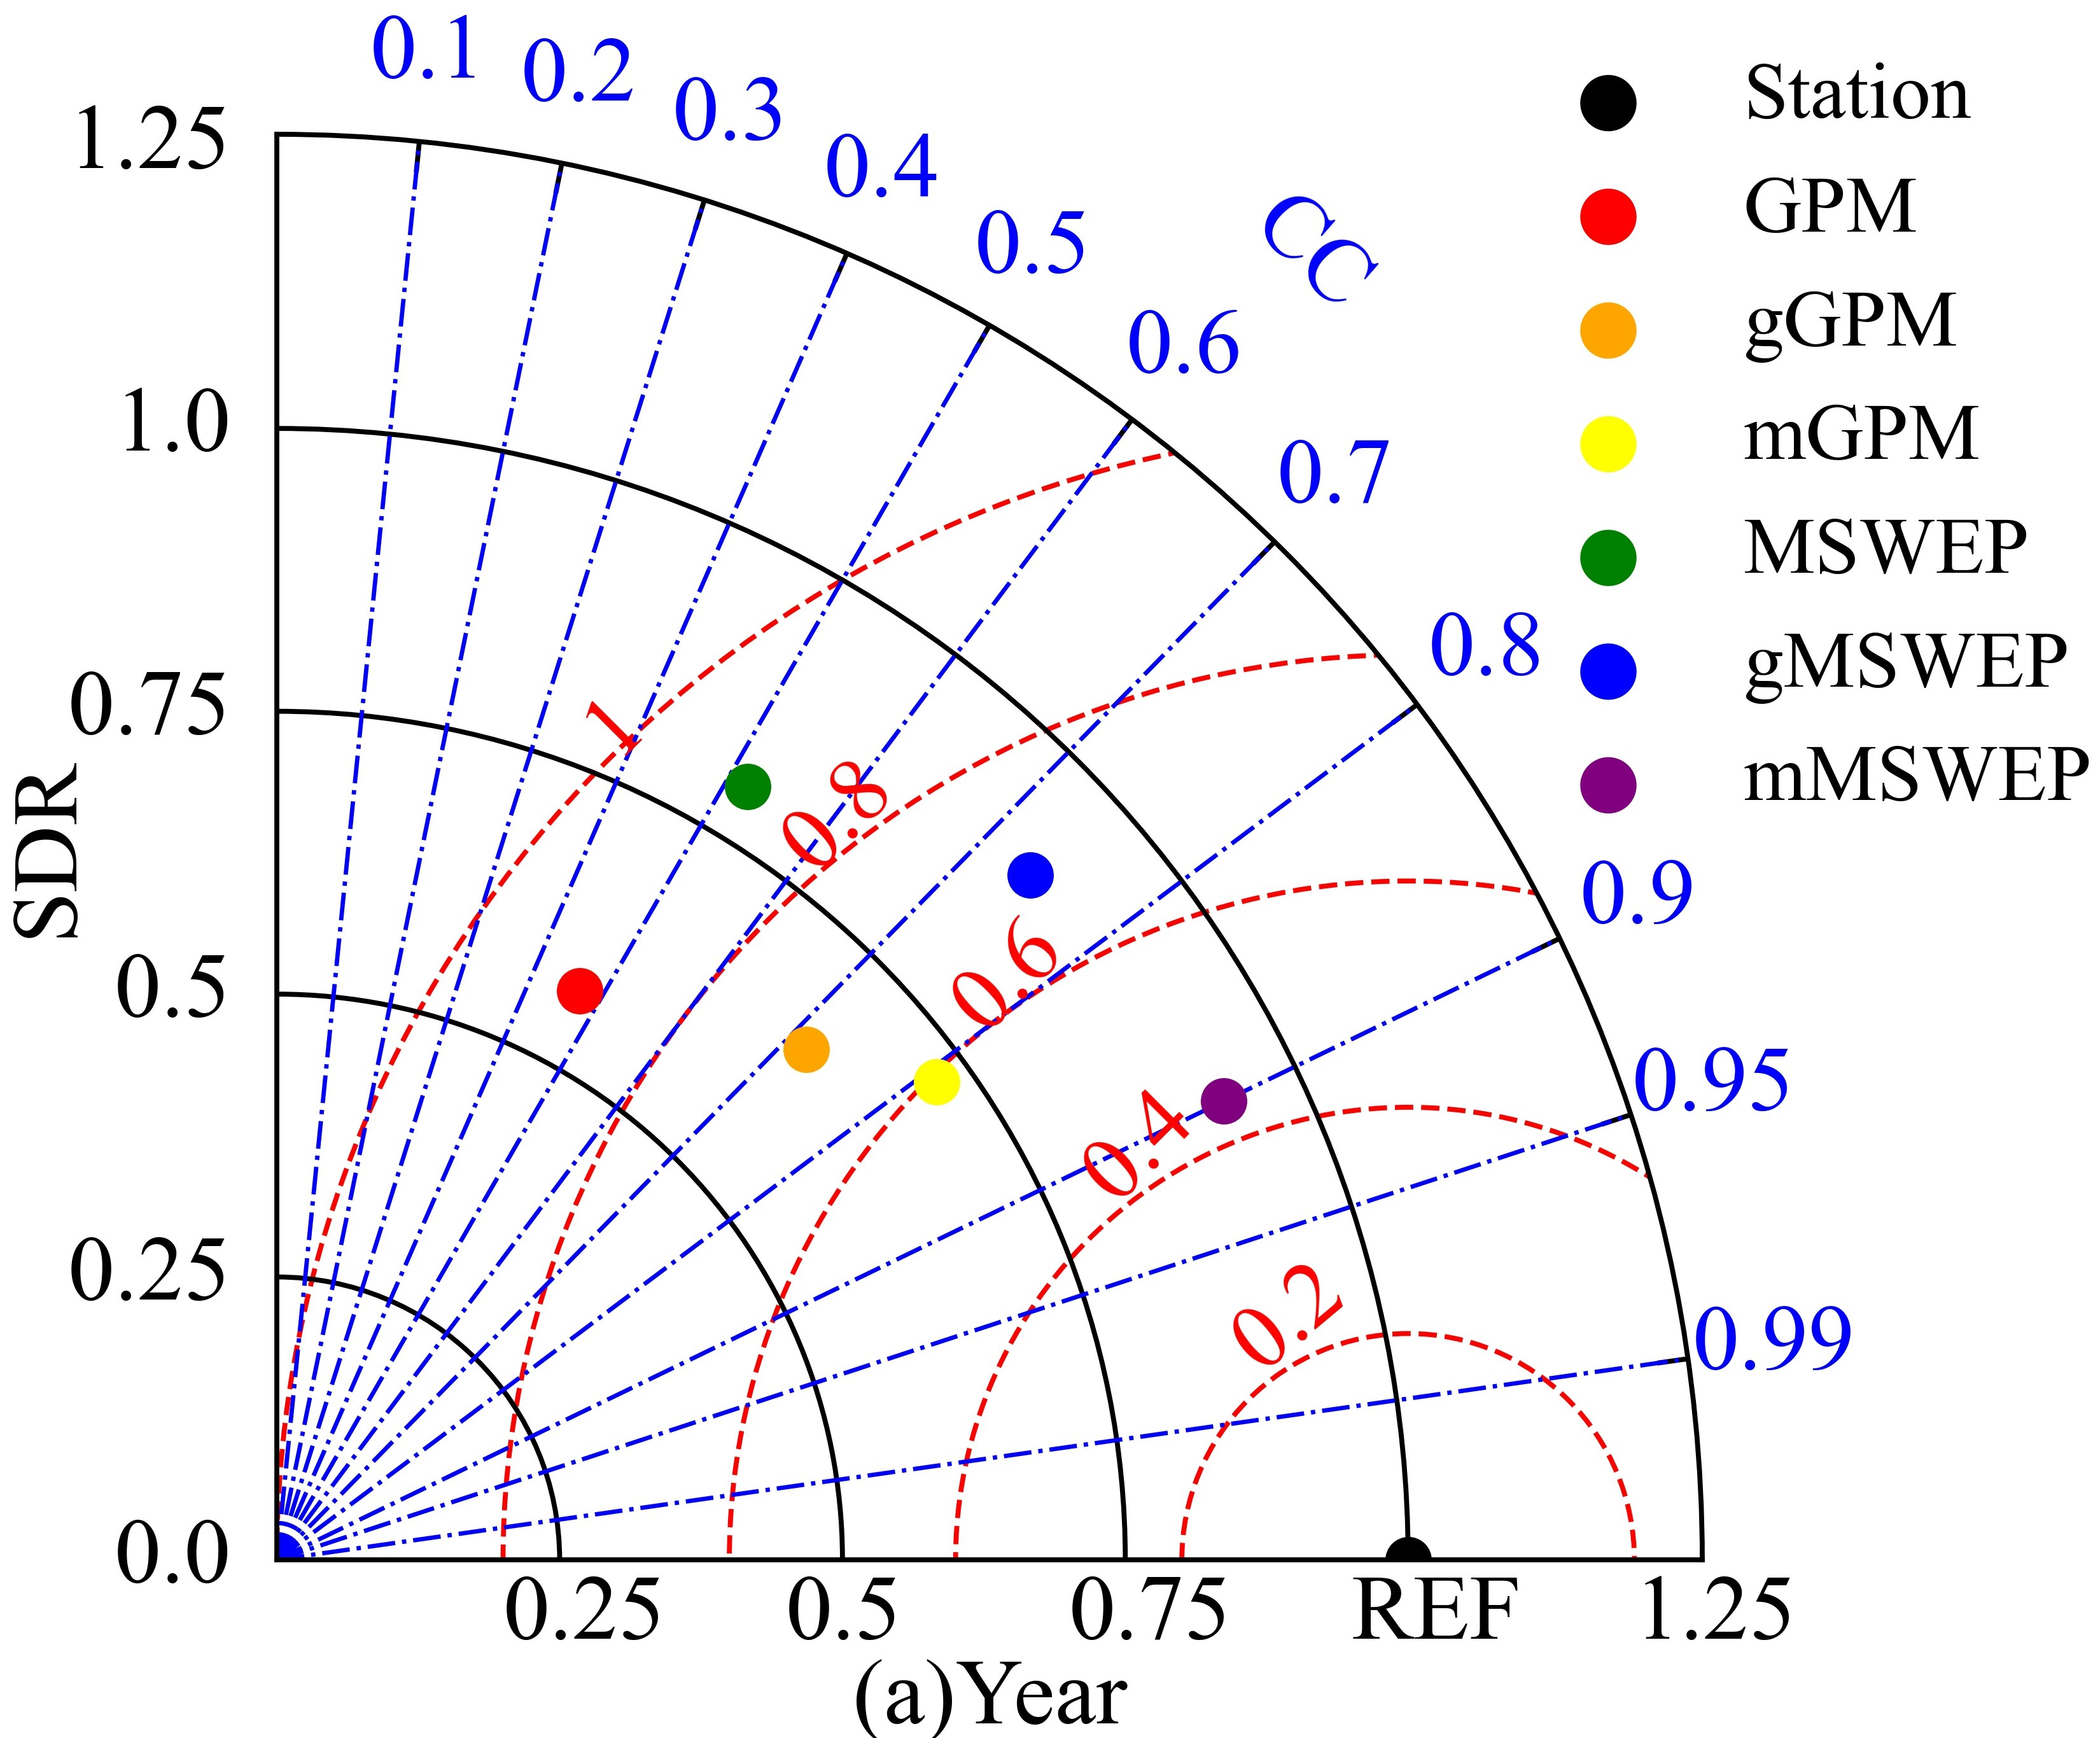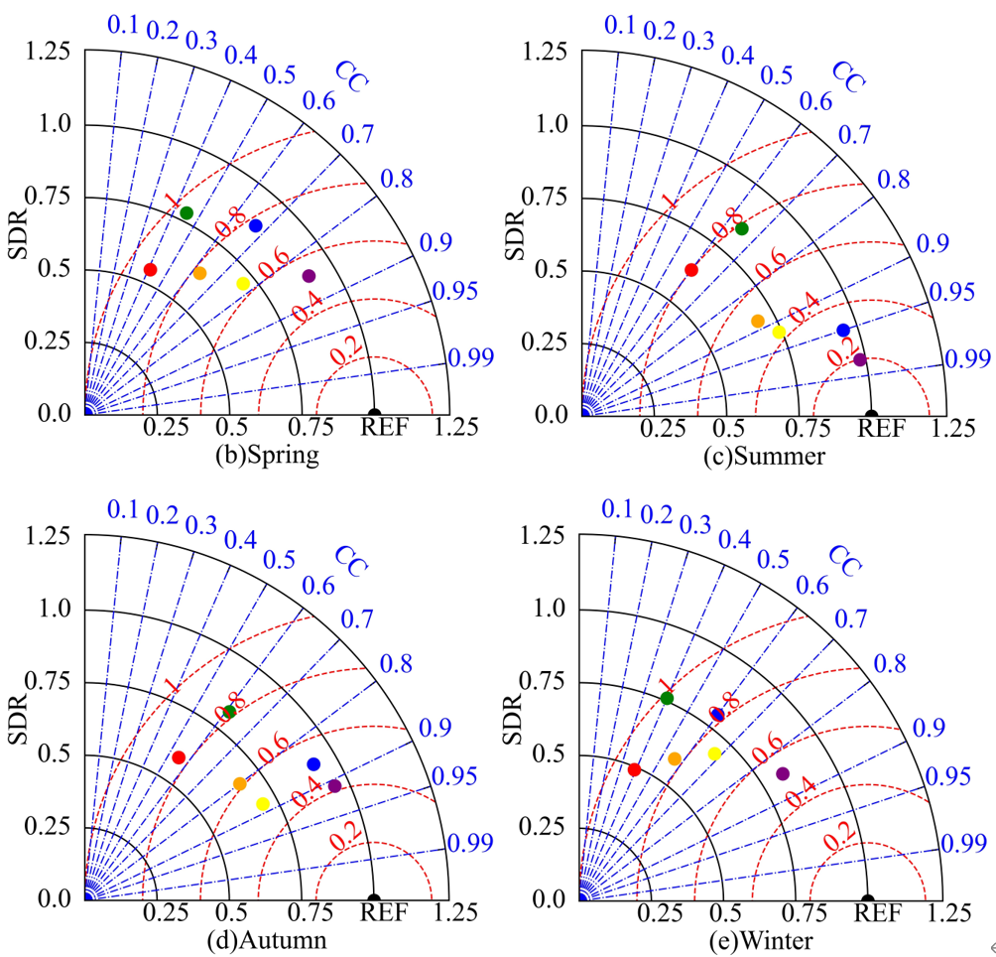
Supplementary Figure 3. Taylor Chart of GPM, MSWEP and their downscaling results in different time scales (a. Annual scale; b. Spring; c. Summer; d. Autumn; e. Winter)

Supplementary Tables
Supplementary Table 1. SPI Classification
SPI | Dry and wet classification
>2 | Extreme Wet
1.5~2 | Severe Wet
1~1.5 | Moderate Wet
0~1 | Mild Wet
-1~0 | Mild Drought
-1.5~-1 | Moderate Drought
-2~-1.5 | Severe Drought
<-2 | Extreme Drought
Note: Supplementary Table 1 is the drought grade table of SPI of standardized precipitation index obtained according to the the national standard of Meteorological Drought Grade GB/T20481-2006. Its range is [-3,3], where the value represents the degree of dry and wet, positive value represents humidity, negative value represents drought, and the larger the value is, the wetter it is, while a smaller value means drier.
Supplementary Table 2. Multicollinearity diagnosis results of explanatory variables.
Explanatory Variables | VIF | Tolerance
DEM | 6.89 | 0.23
ASPECT | 4.67 | 0.45
SLOPE | 4.33 | 0.65
WIN | 1.35 | 0.26
RHU | 3.22 | 0.77
SSD | 2.67 | 0.34
TEM | 7.32 | 0.43
Note: Supplementary Table 2 is used to judge whether collinearity exists between factors, and explanatory variables with collinearity are eliminated. When tolerance >0.2 and variance inflation factor (VIF) <7.5, no collinearity is considered.
Supplementary Table 3. The difference of the relationship between downscaling results and DEM at different resolution.
Resolution /km | GWR-GPM |  | MGWR-GPM |  | GWR-MSWEP |  | MGWR-MSWEP
 | coefficient | intercept | coefficient | intercept | coefficient | intercept | coefficient | intercept
1 | 7.15×10⁻⁶ | 2.54 | 4.17×10⁻⁵ | -0.05 | -1.05×10⁻⁶ | 1.72 | -3.38×10⁻⁶ | -0.01
2 | 7.22×10⁻⁶ | 2.56 | 4.19×10⁻⁵ | -0.07 | -1.09×10⁻⁶ | 1.73 | -3.40×10⁻⁶ | -0.02
5 | 7.33×10⁻⁶ | 2.62 | 4.22×10⁻⁵ | -0.11 | -1.15×10⁻⁶ | 1.76 | -3.45×10⁻⁶ | -0.04
10 | 7.52×10⁻⁶ | 2.71 | 4.29×10⁻⁵ | -0.15 | -1.28×10⁻⁶ | 1.82 | -3.52×10⁻⁶ | -0.07
25 | 8.22×10⁻⁶ | 3.24 | 4.66×10⁻⁵ | -0.23 | -2.01×10⁻⁶ | 2.05 | -3.99×10⁻⁶ | -0.15

