Supplementary Material

1 Biomass composition 3

2 Lower heating values 4

3 Acetic acid model 5

4 Economic calculation 6

4.1 Currency conversion 6

4.2 Chemical Engineering Plant Cost Index 6

4.3 Operating cost 6

4.3.1 Labor cost 6

4.3.2 Maintenance 6

4.3.3 CO2 7

4.3.4 Refrigeration 7

4.3.5 Heat 7

4.3.6 Biomass, deionized water and electricity 7

4.4 Product prices 7

4.5 Scaling of equipment cost 7

4.6 Calculation of total fixed cost 8

4.8 Cost breakdown for subprocesses 9

4.8.1 Thermochemical conversion process 9

4.8.2 CO2 electrolysis 10

4.8.3 Electrochemical CO reduction and product purification 11

4.8.4 Ethanol to Ethylene 12

4.9 Levelized cost of ethylene 13

4.10 Multiparametric study 14

5 Reactions in CO reduction process 15

5.1 Ethylene 15

5.2 Ethanol 15

5.3 Acetic acid 15

5.4 Hydrogen 15

6 CO2 emissions 17

6.1 Specific CO2 emissions of equivalent fossil chemicals and electricity 17

6.2 Marginal emission factors 18

6.3 Emissions of products for wind power as electricity source 18

6.4 Comparison of hourly CO2 emissions 19

7 Heat integration 20

8 Conversion of acetic acid to ethylene 26

9 REFERENCES 27

# Biomass composition

Table 1 shows the biomass composition and lower heating value of the Finish biomass residues (pine) used for the simulation. The water content is 35 wt%. A higher water content of forest biomass is possible. In this case the electrical and thermal demand of the biomass dryer increases.

Table 1. Characteristics of biomass (Alakangas et al., 2016)

|  |  |
| --- | --- |
| Heating value | 19.3 MJ/kgdry |
| Ultimate analysis |  |
| Ash content | 1.37 wt-% |
| C | 51.3 wt-% |
| H | 6.1 wt-% |
| O | 40.8 wt-% |
| N | 0.04 wt-% |
| S | 0.02 wt-% |
| Cl | 0.0076 wt-% |

# Lower heating values

Table 2. Lower heating values used in calculations

|  |  |
| --- | --- |
|  | LHV in MJ/kg |
| Hydrogen | 119.96 |
| Carbon monoxide | 10.10 |
| Ethylene | 47.13 |
| Ethanol | 26.80 |
| Acetic acid | 13.13 |
| Methane | 50.05 |
| 1-Butene | 45.33 |
| Propylene | 45.80 |
| Ethane | 47.79 |
| Ethanal | 24.16 |
| Diethylether | 33.87 |

# Acetic acid model

Table 3. Unit and Aspen model specifications for the acetic acid separation section.

|  |  |  |  |
| --- | --- | --- | --- |
| Unit | Specification | Aspen Plus block and modelling notes | Results |
| Extraction column | 10 stages, adiabatic, p = 1 bar | Extract | Temperature 35–40 °C  Acetic acid split 99.7% to extract |
| Distillation column | 25 stages, total condenser, p = 1 bar | RadFrac (equilibrium mode)  Design Spec 1: 99.9 mol-% recovery of acetic acid in bottoms  Design Spec 2:  99.9 mol-% purity of acetic acid in bottoms  Varys: distillate/feed ratio, reflux ratio | Reflux ratio 0.12  Condenser/reboiler temperature and specific1 duty:  72/118 °C  -6.3/7.4 kWh/kg |
| Decanter | T = 40 °C, p = 1 bar | Decanter | Specific1 heat duty:  -0.9 kWh/kg |
| Stripping column | 10 stages, no condenser | RadFrac (equilibrium mode)  Design Spec 1: 99.9 mol-% recovery of ethyl acetate in distillate  Design Spec 2: 99.9 mol-% recovery of water in bottoms  Vary: reboiler duty | Top stage/reboiler temperature: 77/100 °C  Specific1 reboiler duty: 0.8 kWh/kg |
| Ethyl acetate condenser | p = 1 bar, vapor fraction 0 | Heater | Temperature: 70 °C Specific1 heat duty: -0.1 kWh/kg |

1 per kg of acetic acid output

# Economic calculation

## Currency conversion

Economic results are reported in €. All cost in dollar must be converted to Euro assuming an exchange rate of 1.1 $ = 1 €.

$C_{€}=\frac{C_{\$}}{1,1}$ (1)

## Chemical Engineering Plant Cost Index

The cost data is derived from different sources and is based on different years. The cost data from Aspen Plus Version 12 is based on 2019. The base year for the publication is 2020. In order to adjust the equipment, cost to the base year, equation 2 is used for adjusting the cost from year b to year a using the CEPCI.

$C_{a}=C_{b}\frac{{CEPCI}_{a}}{{CEPCI}_{b}}$ (2)

Table 4 shows the relevant CEPCI values for the years used in the publication.

Table 4. CEPCI for relevant years (Maxwell, 2022)

|  |  |
| --- | --- |
| Year | CEPCI |
| 2007 | 509.7 |
| 2010 | 550.8 |
| 2018 | 603.1 |
| 2019 | 607.5 |
| 2020 | 596.2 |

## Operating cost

The total operating cost are calculated based on cost for labor, biomass, electricity, heat, refrigeration energy, deionized water, CO2 and maintenance.

### Labor cost

The assumption for the labor cost is that 15 employees are needed for the operation of the plant. The annual salary of each employee was assumed to 70,000 €.

### Maintenance

Maintenance cost for all process routes is assumed to be 5 % of the fixed capital investment (FCI). The typical range is from 2 to 10 % of FCI (Turton, 2012).

### CO2

The cost for CO2 separation from the power plants flue gas is assumed to be 30 €/t. Typical values for a biomass fired power plant are in the range of 50 – 70 €/t (Kearns et al., 2021). A cost breakdown shows that roughly 60 to 75 % of the capture cost for a MEA absorption process are caused by energy consumption (Roussanaly et al., 2018). Since heat is supplied to the MEA scrubber from the power plant at no cost, the cost for carbon capture will significantly decrease. Consequently, the assumption of 30 €/t can be justified.

### Refrigeration

As proposed by Sinnott and Towler (2020), the cost of refrigeration can be calculated considering the electricity price. With an assumed COP (coefficient of performance) of 2, the price for refrigeration is 30 €/MWh.

### Heat

Heat is generated from biomass. The conversion efficiency was assumed to be 90 % from biomass to steam. Therefore, the cost for heat is 22.2 €/MWh.

### Biomass, deionized water and electricity

The biomass price is assumed to be 20 €/MWh. The cost for deionized water is 5 €/t. The electricity price is set to 60 €/MWh.

## Product prices

Table 5. Product prices for the calculation of revenue from by-products and the allocation of CO2 emissions

|  |  |
| --- | --- |
| Product | Price |
| Ethylene X | 1200 €/t |
| Ethanol | 800 €/t |
| Acetic acid | 800 €/t |
| Hydrogen | 2000 €/t |
| Oxygen | 10 €/t |

X product price only used for the allocation of CO2 emissions

## Scaling of equipment cost

With equation 3 it is possible to scale the equipment cost to a different capacity Sa. With a known equipment cost Cb, capacity Sb and the regression component n, the equipment cost of the equipment with capacity Sa can be calculated.

$C_{a}=C_{b}{\left(\frac{S_{a}}{S_{b}}\right)}^{n}$ (3)

Another method to scale the equipment cost is shown in the following equation with a, b and n as constants:

$C=a+bS^{n}$ (4)

The values for the constants are derived from (Sinnott and Towler, 2020). The equipment cost is further multiplied with 3.2 to yield the installed cost (Sinnott and Towler, 2020).

## Calculation of total fixed cost

The sum of installed equipment cost represents the Inside batter limits (ISBL) capital cost.

Table 6. Cost components for the calculation of the fixed capital investment (FCI) and the annualized CAPEX

|  |  |
| --- | --- |
| Cost type |  |
| ISBL capital cost | Installed cost adjusted in terms of installation cost (factor 3.2 from (Sinnott and Towler, 2020)) currency, year and material factor |
| OSBL capital cost | 30 % of ISBL |
| Engineering cost | 20 % of (ISBL and OSBL) |
| Contingency | 20 % of (ISBL and OSBL) |
| Working capital | 15 % of (ISBL and OSBL) |

## Cost breakdown for subprocesses

If not stated otherwise, the life time is assumed to be 20 years. The lifetime of the CHP plant is assumed to be 40 years.

### Thermochemical conversion process

The installed equipment cost for the gasification plant is based on Hannula and Kurkela (2013) scaled with equation 3 and based on the Aspen Cost Estimator results (Table 7). The prices are converted to € (2020).

Table 7. Installed equipment cost of gasifier

|  |  |  |
| --- | --- | --- |
| Component | Installed cost in M€ (2020) | Reference |
| Buildings | 5.5 | (Hannula and Kurkela, 2013) |
| Feedstock handling | 5.0 | (Hannula and Kurkela, 2013) |
| Belt dryer | 3.9 | (Hannula and Kurkela, 2013) |
| Gasifier | 14.1 | (Hannula and Kurkela, 2013) |
| Reformer | 6.5 | (Hannula and Kurkela, 2013) |
| Heat exchanger | 0.1 | (Sinnott and Towler, 2020)1 |
| Water scrubber | 0.2 | Aspen Cost Estimator |
| Compressor membrane recycle | 1.4 | Aspen Cost Estimator |
| Compressor before membrane | 1.2 | Aspen Cost Estimator |
| Flash drum | 0.1 | Aspen Cost Estimator |
| Compressor PSA | 2.1 | Aspen Cost Estimator |
| PSA | 0.5 | (Hannula and Kurkela, 2013) |
| Membrane | 2.1 | See text |
| Total | 42.6 |  |

1 heat exchanger area from Aspen Cost Estimator (41.14 m2)

The membrane cost was assumed to be 50 €/m2 which is in line with cost assumptions for gas separation membranes in other publications reporting values of 50 $/m2 (Ho et al., 2008; Zhai, 2019). The surface of the membrane was calculated on the basis of CO permeation. With the following equation, the flux J through the membrane in mol/s can be calculated based on the partial pressure difference between the feed and the permeate, the permeance P (mol bar-1 m-2 s-1) and the surface of the membrane A:

$J=P A ∆p$ (5)

The permeance was assumed to be 10-4 mol s-1 m-2 bar-1 (Murad Chowdhury et al., 2005). The partial pressures and flux through the membrane can be calculated based on data from the Aspen simulation. With this information, the required membrane surface can be calculated.

The CHP plant was costed based on data from (IEA Energy Technology Network, 2010) and (Malico et al., 2019). The assumed cost was 3 M€/MWel. The power plant has a maximum power output of 25.7 MWel which results in investment cost of 77 M€. This cost was not adjusted to the year 2020. We assumed the same cost for all scenarios independent of the actual power output. The maintenance cost of the power plant was calculated as described in 4.3.2.

### CO2 electrolysis

In literature, the economic evaluation of high-temperature CO2 electrolyzers is based on the comparison with water electrolyzer since no reliable data for CO2 electrolyzers is available. Ramdin et al. (2021) assumed 1250 €/kW (15938 €/m2) based on a solid oxide electrolyzer (SOEL). Jouny et al. (2018a) assumed the installed cost of 250 $/kW (920 $/m2) based on an alkaline water electrolyzer. Luna et al. (2019) assumed 300 $/kW. Orella et al. (2020) assumed capital cost of 900 to 940 $/kW (24.9 to 25.9 k$/m2) depending on the size of the system. In this paper, the cost for the CO2 electrolysis is compared to an SOEL system for hydrogen production. Currently prices are above 2000 €/kW for stacks but the cost for the complete system is assumed to drop below 300 €/kW in 2050 (IRENA, 2020). For larger production volumes, Anghilante et al. (2018) calculated installed capital cost for a stand-alone system to 380 - 494 €/kW. Also accounting for the balance of plant like CO2/CO membrane separation und related compressors, we are assuming 1000 €/kW. The lifetime was set to 10 years (projected for 2050 by (IRENA, 2020)). Yearly maintenance cost is 3 % of investment cost per year like for other electrolyzer systems (Buttler and Spliethoff, 2018). We are calculating the maintenance cost as shown in 4.3.2.

With the cost of 1000 €/kW and a lifetime of 10 years, the capital cost equal to 221 M€.

### Electrochemical CO reduction and product purification

The COR process was costed based on the required electrolyzer surface. The total electrical current can be calculated from the power input and operating voltage. With a current density of 300 mA/cm2, the required surface is calculated. The cost of the COR was assumed to be 20,000 €/m2 (Ramdin et al., 2021).

The installed equipment cost for the ethanol purification is retrieved from Aspen Cost Estimator. For the acetic acid purification, the cost for all components except the extraction column are retrieved from Aspen. The column was costed with equation 3 based on data from Ramdin et al. (2021) and an exponent of 0.6. Additionally, the material factor of 1.3 for stainless steel was used to adjust the price to the correct material for treating acetic acid.

Table 8. Equipment cost in M€ (2020)

|  |  |  |  |  |  |  |  |
| --- | --- | --- | --- | --- | --- | --- | --- |
|  | G1 | G1-O | G2 | C1 | C1-O | C2 | Reference |
| CO reduction | | | | | | | |
| Electrochemical cell | 345.2 | 367.9 | 345.2 | 458.1 | 488.3 | 458.1 | See text above |
| Ethanol purification | | | | | | | |
| HX1-ETOH | 0.1 | 0.1 | 0.1 | 0.1 | 0.1 | 0.1 | Aspen Cost Estimator |
| C1-ETOH | 1.6 | 1.7 | 1.6 | 1.7 | 1.7 | 1.7 | Aspen Cost Estimator |
| Acetic acid purification | | | | | | | |
| C1-AA | 10.1 | 4.4 | 10.1 | 12 | 5.2 | 12 | (Ramdin et al., 2021) |
| C2-AA | 3.2 | 1.6 | 3.2 | 3.8 | 1.8 | 3.8 | Aspen Cost Estimator |
| C3-AA | 0.5 | 0.4 | 0.5 | 0.6 | 0.4 | 0.6 | Aspen Cost Estimator |
| DEC-AA | 0.3 | 0.3 | 0.3 | 0.3 | 0.3 | 0.3 | Aspen Cost Estimator |
| HX1-AA | 0.1 | 0.1 | 0.1 | 0.1 | 0.1 | 0.1 | Aspen Cost Estimator |
| Gas purification | | | | | | | |
| Compressor | 3.1 | 3.1 | 3.1 | 3.1 | 3.8 | 3.1 | Aspen Cost Estimator |
| PSA-Ethylene | 1.2 | 1.5 | 1.2 | 1.5 | 1.9 | 1.5 | (Hannula and Kurkela, 2013)1 |
| PSA-Hydrogen | 0.2 | 0.1 | 0.2 | 0.2 | 0.1 | 0.2 | (Hannula and Kurkela, 2013) |

1 same cost assumed for PSA separation of ethylene than for H2

### Ethanol to Ethylene

Most of the cost data was derived from Aspen Plus. The reactors were calculated as vertical pressure levels with an assumed wall thickness of 1 cm, a density of steel of 7800 kg m-3 and a diameter of 2.5 m. The standard liquid flow rate of the reactor inlet flows was gathered from Aspen Plus. With a LHSV of 0.4 h-1 the reaction volume was calculated (Chen et al., 2007; Andrade Coutinho et al., 2013). With the assumed porosity of the catalyst of 0.5, the reactor volume could be calculated. Adding 50 % of the weight of the jacket to the total weight to account for the bottom and top parts gives the total weight which was used for the cost correlation from (Sinnott and Towler, 2020).

Table 9. Equipment cost of the Ethanol to Ethylene process for scenarios “G2” and “C2”

|  |  |  |  |
| --- | --- | --- | --- |
| Component | Installed cost  in k€ | | Reference |
|  | G2 | C2 |  |
| PUMP | 31 | 32 | Aspen Cost Estimator |
| HX1 | 371 | 420 | Aspen Cost Estimator X |
| RX1 | 119 | 142 | See text |
| HX2 | 218 | 268 | Aspen Cost Estimator X |
| RX2 | 133 | 160 | See text |
| HX3 | 217 | 268 | Aspen Cost Estimator X |
| RX3 | 146 | 177 | See text |
| HX4 | 217 | 268 | Aspen Cost Estimator X |
| RX4 | 159 | 193 | See text |
| HX5 | 124 | 126 | Aspen Cost Estimator |
| C1 | 139 | 139 | Aspen Cost Estimator |
| MCOMP | 938 | 954 | Aspen Cost Estimator |
| DRYER | 90 | 90 | Aspen Cost Estimator Y |
| HX6 | 65 | 65 | Aspen Cost Estimator |
| C2 | 657 | 671 | Aspen Cost Estimator |
| HX8 | 54 | 62 | Aspen Cost Estimator |
| Total | 3,678 | 4,035 |  |

X costed as cylindrical furnace, Y costed as vertical vessel

## Levelized cost of ethylene

Table 10 shows the numbers as reported in Figure 7 in the manuscript.

Table 10. Levelized cost of ethylene in €/t ethylene

|  |  |  |  |  |  |  |
| --- | --- | --- | --- | --- | --- | --- |
|  | G1 | G1-O | G2 | C1 | C1-O | C2 |
| Revenue | -1557 | -612 | -866 | -1154 | -327 | -557 |
| Annuity of investment | 2046 | 1500 | 1578 | 2775 | 2019 | 2134 |
| Electricity | 2594 | 1949 | 1984 | 3588 | 2620 | 2741 |
| Biomass | 462 | 326 | 353 | 348 | 246 | 266 |
| Maintenance | 1020 | 748 | 787 | 1403 | 1020 | 1079 |
| CO2 | 0 | 0 | 0 | 163 | 115 | 124 |
| Others | 112 | 29 | 84 | 41 | 24 | 34 |
| total | 4677 | 3941 | 3920 | 7163 | 5717 | 5821 |
| total w/o electricity | 2084 | 1992 | 1936 | 3575 | 3097 | 3080 |

Table 11. Cost overview for the scenarios showing the CAPEX, OPEX and Revenue from side products in M€

|  |  |  |  |  |  |  |
| --- | --- | --- | --- | --- | --- | --- |
|  | G1 | G1-O | G2 | C1 | C1-O | C2 |
| CAPEX | | | | | | |
| Gasification | 42.6 | 42.6 | 42.6 | 0.0 | 0.0 | 0.0 |
| CHP | 0.0 | 0.0 | 0.0 | 77.0 | 77.0 | 77.0 |
| CO2 electrolysis | 0.0 | 0.0 | 0.0 | 220.9 | 220.9 | 220.9 |
| COR | 345.2 | 367.9 | 345.2 | 458.1 | 488.3 | 458.1 |
| Product purification | 20.4 | 13.2 | 20.4 | 23.4 | 15.3 | 23.4 |
| Ethanol to Ethylene | 0.0 | 0.0 | 3.7 | 0.0 | 0.0 | 5.0 |
| FCI CHP | 0.0 | 0.0 | 0.0 | 77.0 | 77.0 | 77.0 |
| FCI Rest | 742.8 | 771.2 | 749.5 | 1278.3 | 1318.7 | 1287.4 |
| Annualized invest CHP | 5.9 | 5.9 | 5.9 | 0.0 | 0.0 | 0.0 |
| Annualized invest w/o CHP | 128.2 | 132.2 | 129.2 | 74.5 | 77.3 | 75.2 |
| Total annualized CAPEX | 74.5 | 77.3 | 75.2 | 134.0 | 138.1 | 135.0 |
| OPEX | | | | | | |
| Electricity | 94.4 | 100.5 | 94.4 | 173.3 | 179.2 | 173.4 |
| Biomass | 16.8 | 16.8 | 16.8 | 16.8 | 16.8 | 16.8 |
| Maintenance | 37.1 | 38.6 | 37.5 | 67.8 | 69.8 | 68.2 |
| Labor | 1.1 | 1.1 | 1.1 | 1.1 | 1.1 | 1.1 |
| Deionized water | 0.5 | 0.5 | 0.5 | 0.7 | 0.6 | 0.7 |
| CO2 | 0.0 | 0.0 | 0.0 | 7.9 | 7.9 | 7.9 |
| Refrigeration | 0.0 | 0.0 | 0.1 | 0.0 | 0.0 | 0.1 |
| Heating | 2.5 | 0.0 | 2.3 | 0.3 | 0.0 | 0.3 |
| Total OPEX | 152.4 | 157.3 | 152.7 | 267.7 | 275.3 | 268.4 |
| Revenue | | | | | | |
| Ethanol | -15.4 | -7.7 | 0.0 | -20.5 | -10.2 | 0.0 |
| Acetic acid | -21.0 | -5.2 | -21.0 | -27.8 | -6.9 | -27.8 |
| Oxygen | -0.9 | -0.9 | -0.9 | -2.8 | -2.9 | -2.8 |
| Hydrogen | -19.4 | -17.7 | -19.4 | -4.6 | -2.3 | -4.6 |
| Total Revenue | -56.7 | -31.5 | -41.2 | -55.8 | -22.3 | -35.2 |
|  |  |  |  |  |  |  |
| Total yearly cost | 170.3 | 203.1 | 186.6 | 346.0 | 391.0 | 368.1 |

## Multiparametric sensitivity analysis

Case 1a considers a current density of the COR process of 500 mA/cm2, a COR cell price of 15.000 €/m2 and a cell voltage of 2,5 V. Case 1b additionally assumes a lower electricity price of 40 €/MWh. Case 1c additionally assumes an increased revenue from by-products of 50 % compared to the initial assumption.

Case 2 is calculated with an investment cost of 300 €/kW for the CO2 electrolysis and an electricity price of 40 €/MWh.

Case 3 considers an increase revenue from side products of 100 % and an electricity price of 20 €/MWh.

Table . LCOE in €/t for multiparametric sensitivity analysis

|  |  |  |  |  |  |  |
| --- | --- | --- | --- | --- | --- | --- |
|  | G1 | G1-O | G2 | C1 | C1-O | C2 |
| Case 1a | 3.251 | 2.868 | 2.829 | 5.736 | 4.644 | 4.732 |
| Case 1b | 1.909 | 1.858 | 1.803 | 4.063 | 3.410 | 3.453 |
| Case 1c | 1.130 | 1.552 | 1.370 | 3.485 | 3.247 | 3.174 |
| Case 2 | 3.813 | 3.292 | 3.259 | 5.091 | 4.226 | 4.239 |
| Case 3 | 1.392 | 2.030 | 1.731 | 3.617 | 3.644 | 3.437 |

# Reactions in CO reduction process

In the following you find the half reaction equations happening in the electrochemical conversion unit.

## Ethylene

Cathode: $2 CO+6 H_{2}O +8 e^{-}→C_{2}H_{4}+8 {OH}^{-}$

Anode: $4 {OH}^{-} → O_{2}+2 H_{2}O +4 e^{-}$

Total: $2 CO+2 H_{2}O →C_{2}H_{4}+2 O_{2}$

## Ethanol

Cathode: $2 CO+7 H_{2}O +8 e^{-}→{CH}_{3}{CH}_{2}OH+8 {OH}^{-}$

Anode: $4 {OH}^{-} → O_{2}+2 H_{2}O +4 e^{-}$

Total: $2 CO+3 H_{2}O →{CH}_{3}{CH}_{2}OH+ 2 O_{2}$

## Acetic acid

Cathode: $2 CO+4 H_{2}O +4 e^{-}→{CH}_{3}COOH+4 {OH}^{-}$

Anode: $4 {OH}^{-} → O_{2}+2 H_{2}O +4 e^{-}$

Total: $2 CO+2 H_{2}O →{CH}_{3}COOH+O_{2}$

## Hydrogen

Cathode: $2 H_{2}O +2 e^{-}→H_{2}+2 {OH}^{-}$

Anode: $4 {OH}^{-} → O_{2}+2 H_{2}O +4 e^{-}$

Total:

# CO2 emissions

## Specific CO2 emissions of equivalent fossil chemicals and electricity

Table 12 shows the specific CO2 emissions used in Figure 6 in the paper.

Table 13. Specific CO2 emissions

|  |  |  |  |
| --- | --- | --- | --- |
| Product | Specific CO2 emissions | Description | Reference |
| Wind power | 30.6 g CO2(eq)/kWh | Electricity, high voltage {DE}| electricity production, wind, >3MW turbine, onshore | Cut-off, U | (Database Ecoinvent 3.8) |
| Hydro power | 4.0 g CO2(eq)/kWh | Electricity, high voltage {DE}| electricity production, hydro, run-of-river | Cut-off, U | (Database Ecoinvent 3.8) |
| Electricity from photovoltaics | 98.7 g CO2(eq)/kWh | Electricity, low voltage {DE}| electricity production, photovoltaic, 570kWp open ground installation, multi-Si | Cut-off, U | (Database Ecoinvent 3.8) |
| Ethanol | 2.116 t CO2(eq) / t ethanol | Ethanol, without water, in 95% solution state, from fermentation {RoW}| ethanol production from maize | Cut-off, U | (Database Ecoinvent 3.8) |
| Ethylene | 1.525 t CO2(eq) / t ethylene | Ethylene, average {RER}| production | Cut-off, U | (Database Ecoinvent 3.8) |
| Acetic acid | 1.376 t CO2(eq) / t acetic acid | Acetic acid, without water, in 98% solution state {RER}| acetic acid production, product in 98% solution state | Cut-off, U | (Database Ecoinvent 3.8) |
| Hydrogen | 11.888 t CO2(eq) / t hydrogen | Hydrogen from natural gas steam reforming | (Spath and Mann, 2000) |

RoW: Rest of world, RER: Europe, DE: Germany

## Marginal emission factors

Table 14. Marginal emission factors for electricity to reach similar emissions than the fossil equivalent (in g CO2/kWh)

|  |  |  |  |  |  |  |
| --- | --- | --- | --- | --- | --- | --- |
|  | G1 | G1-O | G2 | C1 | C1-O | C2 |
| Ethylene | 79 | 69 | 78 | 51 | 45 | 49 |
| Ethanol | 166 | 145 | - | 106 | 94 | - |
| Acetic acid | 108 | 94 | 105 | 68 | 61 | 67 |
| Hydrogen | > 300 | > 300 | > 300 | 238 | 213 | 233 |

## Emissions of products for wind power as electricity source

Table 15. Emissions allocated to products when wind power is used in t CO2/t product

|  |  |  |  |  |  |  |
| --- | --- | --- | --- | --- | --- | --- |
|  | G1 | G1-O | G2 | C1 | C1-O | C2 |
| Ethylene | 0.60 | 0.69 | 0.62 | 0.94 | 1.05 | 0.96 |
| Acetic acid | 0.40 | 0.46 | 0.41 | 0.63 | 0.70 | 0.64 |
| Ethanol | 0.40 | 0.46 | 0.00 | 0.63 | 0.70 | 0.00 |
| Hydrogen | 1.01 | 1.15 | 1.03 | 1.56 | 1.75 | 1.60 |

Table 16. Emissions allocated to products when wind power is used in percent of change compared to the fossil product

|  |  |  |  |  |  |  |
| --- | --- | --- | --- | --- | --- | --- |
|  | G1 | G1-O | G2 | C1 | C1-O | C2 |
| Ethylene | -60% | -55% | -60% | -38% | -31% | -37% |
| Acetic acid | -71% | -67% | -70% | -55% | -49% | -53% |
| Ethanol | -81% | -78% | 0% | -70% | -67% | 0% |
| Hydrogen | -92% | -90% | -91% | -87% | -85% | -87% |

## Comparison of hourly CO2 emissions

In the paper, CO2 emissions were allocated to each product. Figure 1 shows the total hourly emissions for the scenarios as a function of the electricity emission factor. The lines of “G1” and “G2”, and “C1” and “C2” lie on top of each other. The dashed horizontal lines show the reference values for the scenarios. Here, the sum of the product of mass flow of each product multiplied with the emission factor shown in Table 12 is calculated. The intersection point of dashed and full line with the same color show the marginal emissions factor for the scenario to have equal emissions than the fossil production. Scenarios “1” and “2” outperform “1-O”. The marginal emission factor for “G” are in the range of 71.8 to 85.7 g CO2/kWh. For scenarios “C”, the range is from 64.2 to 74.5 g CO2/kWh. Electricity from wind power can therefore reduce the overall emissions in all scenarios. For PV this is not true.

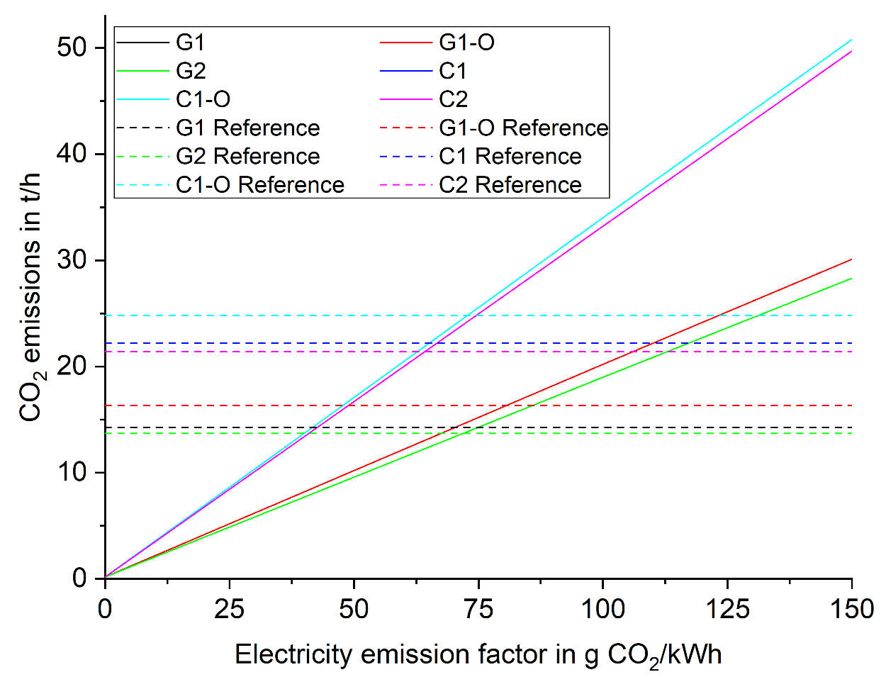

Figure 1. Hourly emissions in comparison to a fossil production plant

# Heat integration

Figure 2 to Figure 7 shows the composite curve for the six scenarios.

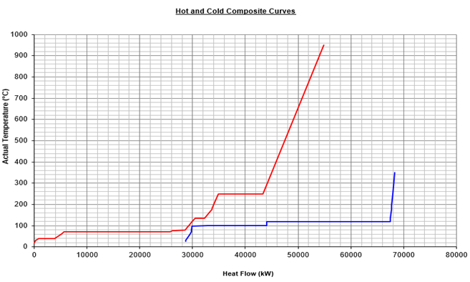

Figure 2. Composite curves for scenario “G1”

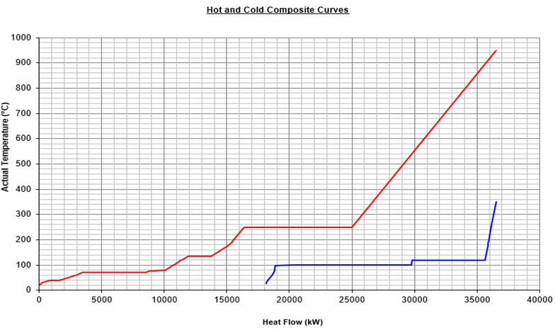

Figure 3. Composite curves for scenario “G1-O”

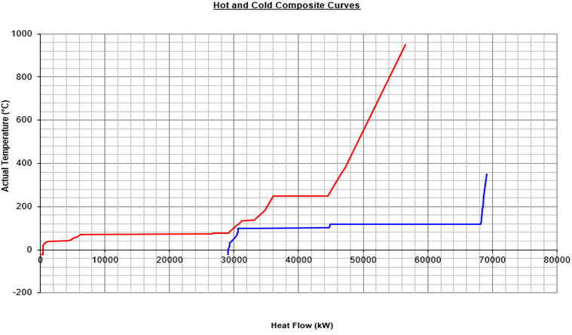

Figure 4. Composite curves for scenario “G2”

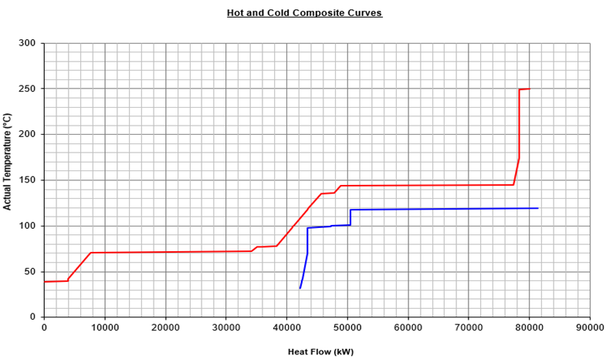

Figure 5. Composite curves for scenario “C1”

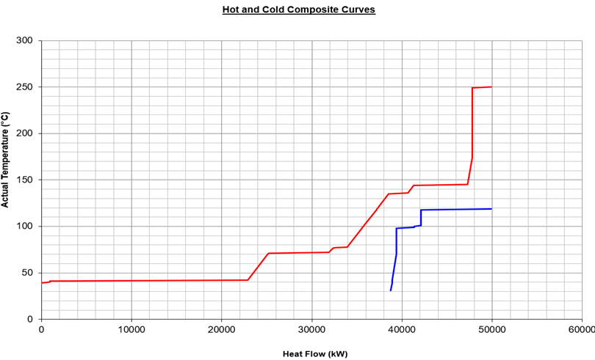

Figure 6. Composite curves for scenario “C1-O”

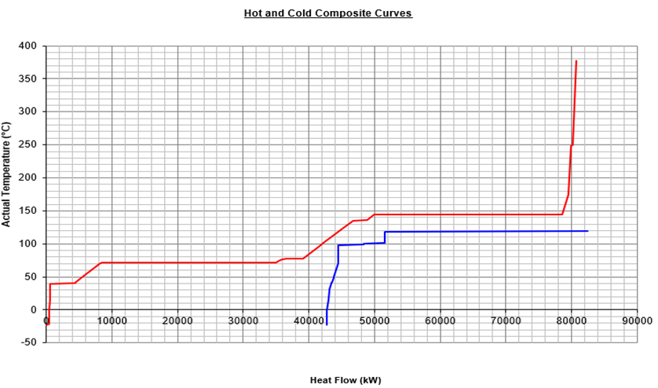

Figure 7. Composite curves for scenario “C2”

# Conversion of acetic acid to ethylene

The complete conversion of acetic acid to ethylene proceeds via the hydrogenation of acetic acid to ethanol and the following dehydration of ethanol. The hydrogenation of acetic acid requires 0.069 t H2/t acetic acid and generates 0.763 t ethanol/t acetic acid (Melin et al., 2022). This gives the ethanol production amount shown in Table 16. The available H2 from the process is also shown in the table. In scenarios “C1” and “C2”, a small H2 shortage is identified. With the data from the ethanol to ethylene model, the mass balance for the process is simplified and shown in the table. An economic assessment is not performed. If external H2 via water electrolysis is needed, the economics of the process might worsen.

Table 17. Mass balance for acetic acid hydrogenation (in t/h except for specific ethylene yield is in t ethylene/t biomass input)

|  |  |  |  |  |  |  |
| --- | --- | --- | --- | --- | --- | --- |
|  | G1 | G1-O | G2 | C1 | C1-O | C2 |
| **Acetic acid hydrogenation** | | | | | | |
| Acetic acid input | 3.1 | 0.8 | 3.1 | 4.1 | 1.0 | 4.1 |
| Ethanol output | 2.4 | 0.6 | 2.4 | 3.2 | 0.8 | 3.2 |
| H2 input | 0.2 | 0.1 | 0.2 | 0.3 | 0.1 | 0.3 |
| H2 available | 1.2 | 1.1 | 1.2 | 0.3 | 0.1 | 0.3 |
| Water output | 1.0 | 0.2 | 1.0 | 1.3 | 0.3 | 1.3 |
| **Ethanol to ethylene** | | | | | | |
| Ethanol input | 2.4 | 0.6 | 2.4 | 3.2 | 0.8 | 3.2 |
| Ethylene output | 1.4 | 0.3 | 1.4 | 1.8 | 0.5 | 1.8 |
| Water output | 1.0 | 0.2 | 1.0 | 1.3 | 0.3 | 1.3 |
| **Total ethylene production** | | | | | | |
| Ethylene output | 5.7 | 6.5 | 7.1 | 7.6 | 8.6 | 9.1 |
| Specific ethylene yield with AA hydrogenation | 0.31 | 0.35 | 0.38 | 0.41 | 0.46 | 0.50 |
| Specific ethylene yield without AA hydrogenation | 0.23 | 0.33 | 0.30 | 0.31 | 0.44 | 0.40 |

REFERENCES

Ahn, H., Luberti, M., Liu, Z., and Brandani, S. (2013). Process configuration studies of the amine capture process for coal-fired power plants. *International Journal of Greenhouse Gas Control* 16, 29–40. doi: 10.1016/j.ijggc.2013.03.002

Alerte, T., Edwards, J. P., Gabardo, C. M., O’Brien, C. P., Gaona, A., Wicks, J., et al. (2021). Downstream of the CO 2 Electrolyzer: Assessing the Energy Intensity of Product Separation. *ACS Energy Lett.* 6, 4405–4412. doi: 10.1021/acsenergylett.1c02263

Amghizar, I., Vandewalle, L. A., van Geem, K. M., and Marin, G. B. (2017). New Trends in Olefin Production. *Engineering* 3, 171–178. doi: 10.1016/J.ENG.2017.02.006

Andrade Coutinho, P. L. de, Morita, A. T., Cassinelli, L. F., Morschbacker, A., and Werneck Do Carmo, R. (2013). “Braskem's Ethanol to Polyethylene Process Development,” in *Catalytic Process Development for Renewable Materials*, eds. P. Imhof, and J. C. van der Waal (Wiley), 149–165.

Arvidsson, M., and Lundin, B. (2011). *Process integration study of a biorefinery producing ethylene from lignocellulosic feedstock for a chemical cluster*.

Bachman, J. E., Reed, D. A., Kapelewski, M. T., Chachra, G., Jonnavittula, D., Radaelli, G., et al. (2018). Enabling alternative ethylene production through its selective adsorption in the metal–organic framework Mn 2 (m -dobdc). *Energy Environ. Sci.* 11, 2423–2431. doi: 10.1039/C8EE01332B

Barecka, M. H., Ager, J. W., and Lapkin, A. A. (2021). Economically viable CO 2 electroreduction embedded within ethylene oxide manufacturing. *Energy Environ. Sci.* 14, 1530–1543. doi: 10.1039/D0EE03310C

BASF, Linde, and SABIC (2022). *BASF, SABIC and Linde start construction of the world’s first demonstration plant for large-scale electrically heated steam cracker furnaces*. Accessed October 06, 2022, https://www.basf.com/global/en/media/news-releases/2022/09/p-22-326.html

Beiron, J., Normann, F., and Johnsson, F. (2022). A techno-economic assessment of CO2 capture in biomass and waste-fired combined heat and power plants – A Swedish case study. *International Journal of Greenhouse Gas Control* 118, 103684. doi: 10.1016/j.ijggc.2022.103684

Blass, S. D., Hermann, R. J., Persson, N. E., Bhan, A., and Schmidt, L. D. (2014). Conversion of glycerol to light olefins and gasoline precursors. *Applied Catalysis A: General* 475, 10–15. doi: 10.1016/j.apcata.2014.01.013

Bui, M., Adjiman, C. S., Bardow, A., Anthony, E. J., Boston, A., Brown, S., et al. (2018). Carbon capture and storage (CCS): the way forward. *Energy Environ. Sci.* 11, 1062–1176. doi: 10.1039/C7EE02342A

Bushuev, V. A. (2012). *Bladed reactor for the pyrolysis of hydrocarbons*. EP2412430A1.

Butera, G., Jensen, S. H., Ahrenfeldt, J., and Clausen, L. R. (2021). Techno-economic analysis of methanol production units coupling solid oxide cells and thermochemical biomass conversion via the TwoStage gasifier. *Fuel Processing Technology* 215, 106718. doi: 10.1016/j.fuproc.2020.106718

Chen, Y.-H., Hsieh, W., Chang, H., and Ho, C.-D. (2022). Design and economic analysis of industrial-scale methanol-to-olefins plants. *Journal of the Taiwan Institute of Chemical Engineers* 130, 103893. doi: 10.1016/j.jtice.2021.05.040

Chernyak, S. A., Corda, M., Dath, J.-P., Ordomsky, V. V., and Khodakov, A. Y. (2022). Light olefin synthesis from a diversity of renewable and fossil feedstocks: state-of the-art and outlook. *Chem Soc Rev* 51, 7994–8044. doi: 10.1039/D1CS01036K

Coolbrook (2022). *Coolbrook*. Accessed October 06, 2022, https://coolbrook.com/

Dinh, C.-T., Li, Y. C., and Sargent, E. H. (2019). Boosting the Single-Pass Conversion for Renewable Chemical Electrosynthesis. *Joule* 3, 13–15. doi: 10.1016/j.joule.2018.10.021

Eckert, C., Xu, W., Xiong, W., Lynch, S., Ungerer, J., Tao, L., et al. (2014). Ethylene-forming enzyme and bioethylene production. *Biotechnol Biofuels* 7, 33. doi: 10.1186/1754-6834-7-33

EcoCatalytic (2022). *Innovative technologies for the fuels of the future*. Accessed October 19, 2022, https://bio2electric.com/

Eryazici, I., Ramesh, N., and Villa, C. (2021). Electrification of the chemical industry—materials innovations for a lower carbon future. *MRS Bulletin* 46, 1197–1204. doi: 10.1557/s43577-021-00243-9

European Bioplastics (2022). *Bioplastics market data*. Accessed October 20, 2022, https://www.european-bioplastics.org/market/

Fan, D., Dai, D.-J., and Wu, H.-S. (2012). Ethylene Formation by Catalytic Dehydration of Ethanol with Industrial Considerations. *Materials (Basel)* 6, 101–115. doi: 10.3390/ma6010101

Fu, X., Zhang, J., and Kang, Y. (2021). Electrochemical reduction of CO 2 towards multi-carbon products via a two-step process. *React. Chem. Eng.* 6, 612–628. doi: 10.1039/D1RE00001B

Gao, Y., Neal, L., Ding, D., Wu, W., Baroi, C., Gaffney, A. M., et al. (2019). Recent Advances in Intensified Ethylene Production—A Review. *ACS Catal.* 9, 8592–8621. doi: 10.1021/acscatal.9b02922

Gayubo, A. G., Valle, B., Aguayo, A. T., Olazar, M., and Bilbao, J. (2010). Olefin Production by Catalytic Transformation of Crude Bio-Oil in a Two-Step Process. *Ind Eng Chem Res* 49, 123–131. doi: 10.1021/ie901204n

Gogate, M. R. (2019). Methanol-to-olefins process technology: current status and future prospects. *Petroleum Science and Technology* 37, 559–565. doi: 10.1080/10916466.2018.1555589

Greenblatt, J. B., Miller, D. J., Ager, J. W., Houle, F. A., and Sharp, I. D. (2018). The Technical and Energetic Challenges of Separating (Photo)Electrochemical Carbon Dioxide Reduction Products. *Joule* 2, 381–420. doi: 10.1016/j.joule.2018.01.014

Haldor Topsoe. *Tailored to your business - eCOs™*. Accessed September 20, 2021, https://www.topsoe.com/processes/carbon-monoxide

Hannula, I. (2015). Co-production of synthetic fuels and district heat from biomass residues, carbon dioxide and electricity: Performance and cost analysis. *Biomass and Bioenergy* 74, 26–46. doi: 10.1016/j.biombioe.2015.01.006

Haribal, V. P., Chen, Y., Neal, L., and Li, F. (2018). Intensification of Ethylene Production from Naphtha via a Redox Oxy-Cracking Scheme: Process Simulations and Analysis. *Engineering* 4, 714–721. doi: 10.1016/j.eng.2018.08.001

Hsu, C. S., and Robinson, P. R. (2017). *Springer Handbook of Petroleum Technology*. Cham: Springer International Publishing.

IEAGHG (2019). *Towards Zero Emissions CCS in Power Plants Using Higher Capture Rates or Biomass*. Accessed October 12, 2022, https://ieaghg.org/publications/technical-reports/reports-list/9-technical-reports/951-2019-02-towards-zero-emissions

Ioannou, I., D'Angelo, S. C., Martín, A. J., Pérez-Ramírez, J., and Guillén-Gosálbez, G. (2020). Hybridization of Fossil- and CO2 -Based Routes for Ethylene Production using Renewable Energy. *ChemSusChem* 13, 6370–6380.

IRENA (2013). *Production of Bio-ethylene - Technology Brief*, https://irena.org/-/media/Files/IRENA/Agency/Publication/2013/IRENA-ETSAP-Tech-Brief-I13-Production_of_Bio-ethylene.pdf

Jamil, F., Aslam, M., Al-Muhtaseb, A. H., Bokhari, A., Rafiq, S., Khan, Z., et al. (2022). Greener and sustainable production of bioethylene from bioethanol: current status, opportunities and perspectives. *Reviews in Chemical Engineering* 38, 185–207. doi: 10.1515/revce-2019-0026

Ji, Y., Guan, A., and Zheng, G. (2022). Copper-based catalysts for electrochemical carbon monoxide reduction. *Cell Reports Physical Science* 3, 101072. doi: 10.1016/j.xcrp.2022.101072

Jouny, M., Hutchings, G. S., and Jiao, F. (2019). Carbon monoxide electroreduction as an emerging platform for carbon utilization. *Nat Catal* 2, 1062–1070. doi: 10.1038/s41929-019-0388-2

Jouny, M., Luc, W., and Jiao, F. (2018a). General Techno-Economic Analysis of CO 2 Electrolysis Systems. *Ind Eng Chem Res* 57, 2165–2177. doi: 10.1021/acs.iecr.7b03514

Jouny, M., Luc, W., and Jiao, F. (2018b). High-rate electroreduction of carbon monoxide to multi-carbon products. *Nat Catal* 1, 748–755. doi: 10.1038/s41929-018-0133-2

Kearns, D., Liu, H., and Consoli, C. (2021). *TECHNOLOGY READINESS AND COSTS OF CCS*. Accessed October 12, 2022.

Khojasteh Salkuyeh, Y., and Adams, T. A. (2015). A novel polygeneration process to co-produce ethylene and electricity from shale gas with zero CO2 emissions via methane oxidative coupling. *Energy Conversion and Management* 92, 406–420. doi: 10.1016/j.enconman.2014.12.081

Kibria Nabil, S., McCoy, S., and Kibria, M. G. (2021). Comparative life cycle assessment of electrochemical upgrading of CO 2 to fuels and feedstocks. *Green Chem.* 23, 867–880. doi: 10.1039/D0GC02831B

Kolesnichenko, N. V., Ezhova, N. N., and Snatenkova, Y. M. (2020). Lower olefins from methane: recent advances. *Russ. Chem. Rev.* 89, 191–224. doi: 10.1070/RCR4900

Kolesnichenko, N. V., Goryainova, T. I., Biryukova, E. N., Yashina, O. V., and Khadzhiev, S. N. (2011). Synthesis of lower olefins from dimethyl ether in the presence of zeolite catalysts modified with rhodium compounds. *Pet. Chem.* 51, 55–60. doi: 10.1134/S0965544111010105

Kosaric, N., Duvnjak, Z., Farkas, A., Sahm, H., Bringer-Meyer, S., Goebel, O., et al. (2010). “Ethanol,” in *Ullmann's encyclopedia of industrial chemistry* (Weinheim, Wiley online library: Wiley-VCH), 1–72.

Kuckshinrichs, W., and Hake, J.-F. (2015). *Carbon Capture, Storage and Use*. Cham: Springer International Publishing.

Küngas, R. (2020). Review—Electrochemical CO 2 Reduction for CO Production: Comparison of Low- and High-Temperature Electrolysis Technologies. *J. Electrochem. Soc.* 167, 44508. doi: 10.1149/1945-7111/ab7099

Küngas, R., Blennow, P., Heiredal-Clausen, T., Holt, T., Rass-Hansen, J., Primdahl, S., et al. (2017). eCOs - A Commercial CO 2 Electrolysis System Developed by Haldor Topsoe. *ECS Trans.* 78, 2879–2884. doi: 10.1149/07801.2879ecst

Lako, P., Koyama, M., and Nakada, S. (2015). *Biomass for Heat and Power - Technology Brief*. Accessed October 05, 2022, https://www.irena.org/-/media/Files/IRENA/Agency/Publication/2015/IRENA-ETSAP_Tech_Brief_E05_Biomass-for-Heat-and-Power.pdf

Layritz, L. S., Dolganova, I., Finkbeiner, M., Luderer, G., Penteado, A. T., Ueckerdt, F., et al. (2021). The potential of direct steam cracker electrification and carbon capture & utilization via oxidative coupling of methane as decarbonization strategies for ethylene production. *Applied Energy* 296, 117049. doi: 10.1016/j.apenergy.2021.117049

Legrand, U., Apfel, U.-P., Boffito, D. C., and Tavares, J. R. (2020). The effect of flue gas contaminants on the CO2 electroreduction to formic acid. *Journal of CO2 Utilization* 42, 101315. doi: 10.1016/j.jcou.2020.101315

Li, F., Ding, S., Wang, Z., Li, Z., Li, L., Gao, C., et al. (2018). Production of Light Olefins from Catalytic Cracking Bio-oil Model Compounds over La 2 O 3 -Modified ZSM-5 Zeolite. *Energy Fuels* 32, 5910–5922. doi: 10.1021/acs.energyfuels.7b04150

Li, H., Zhang, S., Zhou, J., Wang, Z., Zhao, X., and Qiu, T. (2022). Toward carbon‐neutral ethylene production: assessment of the application potential of b io‐ethylene production pathways in China. *Biofuels Bioprod Bioref* 16, 1568–1582. doi: 10.1002/bbb.2406

Li, W., Feaster, J. T., Akhade, S. A., Davis, J. T., Wong, A. A., Beck, V. A., et al. (2021). Comparative Techno-Economic and Life Cycle Analysis of Water Oxidation and Hydrogen Oxidation at the Anode in a CO 2 Electrolysis to Ethylene System. *ACS Sustainable Chem. Eng.* 9, 14678–14689. doi: 10.1021/acssuschemeng.1c01846

Linde (2022). *Linde EDHOX ethylene technology*. Accessed October 06, 2022, https://www.linde-engineering.com/en/images/52222_LE_Petrochemicals_EDHOX_flyer_2021_DIN_A4_RZ_VIEW_tcm19-609833.pdf

Liu, K., Song, C., and Subramani, V. (2009). *Hydrogen and Syngas Production and Purification Technologies*. Hoboken, NJ, USA: John Wiley & Sons, Inc.

Liu, Y., Kamata, H., Ohara, H., Izumi, Y., Ong, D. S. W., Chang, J., et al. (2020). Low-Olefin Production Process Based on Fischer–Tropsch Synthesis: Process Synthesis, Optimization, and Techno-Economic Analysis. *Ind Eng Chem Res* 59, 8728–8739. doi: 10.1021/acs.iecr.0c00542

Luc, W., Ko, B. H., Kattel, S., Li, S., Su, D., Chen, J. G., et al. (2019). SO2-Induced Selectivity Change in CO2 Electroreduction. *J Am Chem Soc* 141, 9902–9909. doi: 10.1021/jacs.9b03215

Melin, K., Nieminen, H., Klüh, D., Laari, A., Koiranen, T., and Gaderer, M. (2022). Techno-Economic Evaluation of Novel Hybrid Biomass and Electricity-Based Ethanol Fuel Production. *Front. Energy Res.* 10. doi: 10.3389/fenrg.2022.796104

Mohsenzadeh, A., Zamani, A., and Taherzadeh, M. J. (2017). Bioethylene Production from Ethanol: A Review and Techno-economical Evaluation. *ChemBioEng Reviews* 4, 75–91. doi: 10.1002/cben.201600025

Morschbacker, A. (2009). Bio-Ethanol Based Ethylene. *Polymer Reviews* 49, 79–84. doi: 10.1080/15583720902834791

Moulijn, J. A. (2013). *Chemical process technology*. Chichester, West Sussex: John Wiley & Sons Inc.

Mynko, O., Amghizar, I., Brown, D. J., Chen, L., Marin, G. B., Alvarenga, R. F. de, et al. (2022). Reducing CO2 emissions of existing ethylene plants: Evaluation of different revamp strategies to reduce global CO2 emission by 100 million tonnes. *Journal of Cleaner Production* 362, 132127. doi: 10.1016/j.jclepro.2022.132127

Na, J., Seo, B., Kim, J., Lee, C. W., Lee, H., Hwang, Y. J., et al. (2019). General technoeconomic analysis for electrochemical coproduction coupling carbon dioxide reduction with organic oxidation. *Nat Commun* 10, 5193. doi: 10.1038/s41467-019-12744-y

Najari, S., Saeidi, S., Concepcion, P., Dionysiou, D. D., Bhargava, S. K., Lee, A. F., et al. (2021). Oxidative dehydrogenation of ethane: catalytic and mechanistic aspects and future trends. *Chem Soc Rev* 50, 4564–4605. doi: 10.1039/d0cs01518k

Ozden, A., Wang, Y., Li, F., Luo, M., Sisler, J., Thevenon, A., et al. (2021). Cascade CO2 electroreduction enables efficient carbonate-free production of ethylene. *Joule* 5, 706–719. doi: 10.1016/j.joule.2021.01.007

Pan, X., Jiao, F., Miao, D., and Bao, X. (2021). Oxide-Zeolite-Based Composite Catalyst Concept That Enables Syngas Chemistry beyond Fischer-Tropsch Synthesis. *Chem Rev* 121, 6588–6609. doi: 10.1021/acs.chemrev.0c01012

Pappijn, C. A. (2020). Challenges and Opportunities of Carbon Capture and Utilization: Electrochemical Conversion of CO2 to Ethylene.

Plastics Europe (2021). *Plastics -The facts 2021*. Accessed October 20, 2022, https://plasticseurope.org/wp-content/uploads/2021/12/Plastics-the-Facts-2021-web-final.pdf

Putta, K. R., Pandey, U., Gavrilovic, L., Rout, K. R., Rytter, E., Blekkan, E. A., et al. (2022). Optimal Renewable Energy Distribution Between Gasifier and Electrolyzer for Syngas Generation in a Power and Biomass-to-Liquid Fuel Process. *Front. Energy Res.* 9. doi: 10.3389/fenrg.2021.758149

Pyl, S. P., Dijkmans, T., Antonykutty, J. M., Reyniers, M.-F., Harlin, A., van Geem, K. M., et al. (2012). Wood-derived olefins by steam cracking of hydrodeoxygenated tall oils. *Bioresour Technol* 126, 48–55. doi: 10.1016/j.biortech.2012.09.037

Pyl, S. P., Schietekat, C. M., Reyniers, M.-F., Abhari, R., Marin, G. B., and van Geem, K. M. (2011). Biomass to olefins: Cracking of renewable naphtha. *Chemical Engineering Journal* 176-177, 178–187. doi: 10.1016/j.cej.2011.04.062

Qiao, J., Liu, Y., Hong, F., and Zhang, J. (2014). A review of catalysts for the electroreduction of carbon dioxide to produce low-carbon fuels. *Chem Soc Rev* 43, 631–675. doi: 10.1039/c3cs60323g

Rakshit, P. K., Pathak, S., Voolapalli, R. K., and Upadhyayula, S. (2020). Thermodynamic Analysis, Kinetics Modeling, and Reactor Model Development for Acetic Acid Hydrogenation Reaction over Bimetallic Pt–Sn Catalyst. *Energy Fuels* 34, 3640–3648. doi: 10.1021/acs.energyfuels.9b04070

Ramdin, M., Mot, B. de, Morrison, A. R. T., Breugelmans, T., van den Broeke, L. J. P., Trusler, J. P. M., et al. (2021). Electroreduction of CO2/CO to C2 Products: Process Modeling, Downstream Separation, System Integration, and Economic Analysis. *Ind Eng Chem Res* 60, 17862–17880. doi: 10.1021/acs.iecr.1c03592

REN, T., Patel, M., and BLOK, K. (2006). Olefins from conventional and heavy feedstocks: Energy use in steam cracking and alternative processes. *Energy* 31, 425–451. doi: 10.1016/j.energy.2005.04.001

Ripatti, D. S., Veltman, T. R., and Kanan, M. W. (2019). Carbon Monoxide Gas Diffusion Electrolysis that Produces Concentrated C2 Products with High Single-Pass Conversion. *Joule* 3, 240–256. doi: 10.1016/j.joule.2018.10.007

Roh, K., Bardow, A., Bongartz, D., Burre, J., Chung, W., Deutz, S., et al. (2020). Early-stage evaluation of emerging CO 2 utilization technologies at low technology readiness levels. *Green Chem.* 22, 3842–3859. doi: 10.1039/c9gc04440j

Romero Cuellar, N. S., Scherer, C., Kaçkar, B., Eisenreich, W., Huber, C., Wiesner-Fleischer, K., et al. (2020). Two-step electrochemical reduction of CO2 towards multi-carbon products at high current densities. *Journal of CO2 Utilization* 36, 263–275. doi: 10.1016/j.jcou.2019.10.016

Saito, H., and Sekine, Y. (2020). Catalytic conversion of ethane to valuable products through non-oxidative dehydrogenation and dehydroaromatization. *RSC Adv* 10, 21427–21453. doi: 10.1039/d0ra03365k

Schneider, V., and Frölich, P. K. (1931). Mechanism of Formation of Aromatics from Lower Paraffins. *Industrial and Engineering Chemistry* 23, 1405–1410.

Shin, H., Hansen, K. U., and Jiao, F. (2021). Techno-economic assessment of low-temperature carbon dioxide electrolysis. *Nat Sustain* 4, 911–919. doi: 10.1038/s41893-021-00739-x

Siemens AG (2018). *Siemens Steam Turbine SST-300*. Accessed October 12, 2022, https://assets.siemens-energy.com/siemens/assets/api/uuid:07137baa-e796-4876-b99b-8a056835cb3e/sst-300-interactivepraes.pdf

Simell, P., Hannula, I., Tuomi, S., Nieminen, M., Kurkela, E., Hiltunen, I., et al. (2014). Clean syngas from biomass—process development and concept assessment. *Biomass Conv. Bioref.* 4, 357–370. doi: 10.1007/s13399-014-0121-y

Sisler, J., Khan, S., Ip, A. H., Schreiber, M. W., Jaffer, S. A., Bobicki, E. R., et al. (2021). Ethylene Electrosynthesis: A Comparative Techno-economic Analysis of Alkaline vs Membrane Electrode Assembly vs CO 2 –CO–C 2 H 4 Tandems. *ACS Energy Lett.* 6, 997–1002. doi: 10.1021/acsenergylett.0c02633

Spallina, V., Velarde, I. C., Jimenez, J. A. M., Godini, H. R., Gallucci, F., and van Sint Annaland, M. (2017). Techno-economic assessment of different routes for olefins production through the oxidative coupling of methane (OCM): Advances in benchmark technologies. *Energy Conversion and Management* 154, 244–261. doi: 10.1016/j.enconman.2017.10.061

Spliethoff, H. (2010). *Power Generation from Solid Fuels*. Berlin, Heidelberg: Springer Berlin Heidelberg.

St. Teuner, C., Neumann, P., and Linde, F. von (2001). CO through CO2 Reforming - The Calcor Standard and Calcor Economy Processes. *OIL Gas European Magazine*, 44–46.

Statista (2022). *Annual production of plastics worldwide from 1950 to 2020*. Accessed October 20, 2022, https://www.statista.com/statistics/282732/global-production-of-plastics-since-1950/

Sturman, M., and Oelgemöller, M. (2021). Process Parameters in the Electrochemical Reduction of Carbon Dioxide to Ethylene. *ChemBioEng Reviews* 8, 149–188. doi: 10.1002/cben.202100004

SYPOX (2022). *SYPOX*. Accessed October 06, 2022, https://www.sypox.eu/

Tran, N.-H., Duong, H. P., Rousse, G., Zanna, S., Schreiber, M. W., and Fontecave, M. (2022). Selective Ethylene Production from CO2 and CO Reduction via Engineering Membrane Electrode Assembly with Porous Dendritic Copper Oxide. *ACS Appl Mater Interfaces* 14, 31933–31941. doi: 10.1021/acsami.2c06068

van Zandvoort, I., van der Waal, J. K., Ras, E.-J., Graaf, R. de, and Krishna, R. (2019). Highlighting non-idealities in C2H4/CO2 mixture adsorption in 5A zeolite. *Separation and Purification Technology* 227, 115730. doi: 10.1016/j.seppur.2019.115730

Vega, F., Baena-Moreno, F. M., Gallego Fernández, L. M., Portillo, E., Navarrete, B., and Zhang, Z. (2020). Current status of CO2 chemical absorption research applied to CCS: Towards full deployment at industrial scale. *Applied Energy* 260, 114313. doi: 10.1016/j.apenergy.2019.114313

Voldsund, M., Gardarsdottir, S., Lena, E. de, Pérez-Calvo, J.-F., Jamali, A., Berstad, D., et al. (2019). Comparison of Technologies for CO2 Capture from Cement Production—Part 1: Technical Evaluation. *Energies* 12, 559. doi: 10.3390/en12030559

Wilson, J., Gering, S., Pinard, J., Lucas, R., and Briggs, B. R. (2018). Bio-production of gaseous alkenes: ethylene, isoprene, isobutene. *Biotechnol Biofuels* 11, 234. doi: 10.1186/s13068-018-1230-9

Wu, Y., Meng, D., Yao, D., Liu, X., Xu, Y., Zhu, Z., et al. (2020). Mechanism Analysis, Economic Optimization, and Environmental Assessment of Hybrid Extractive Distillation–Pervaporation Processes for Dehydration of n -Propanol. *ACS Sustainable Chem. Eng.* 8, 4561–4571. doi: 10.1021/acssuschemeng.0c00263

Xia, R., Lv, J.-J., Ma, X., and Jiao, F. (2021). Enhanced multi-carbon selectivity via CO electroreduction approach. *Journal of Catalysis* 398, 185–191. doi: 10.1016/j.jcat.2021.03.034

Xia, R., Overa, S., and Jiao, F. (2022). Emerging Electrochemical Processes to Decarbonize the Chemical Industry. *JACS Au* 2, 1054–1070. doi: 10.1021/jacsau.2c00138

Yu, B.-Y., and Chien, I.-L. (2016). Design and Optimization of the Methanol-to-Olefin Process. Part I: Steady-State Design and Optimization. *Chem. Eng. Technol.* 39, 2293–2303. doi: 10.1002/ceat.201500654

Yue, P., Fu, Q., Li, J., Zhu, X., and Liao, Q. (2022). Comparative life cycle and economic assessments of various value-added chemicals' production via electrochemical CO 2 reduction. *Green Chem.* 24, 2927–2936. doi: 10.1039/d1gc04270j

Zakaria, Z. Y., Amin, N. A. S., and Linnekoski, J. (2013). A perspective on catalytic conversion of glycerol to olefins. *Biomass and Bioenergy* 55, 370–385. doi: 10.1016/j.biombioe.2013.02.014

Zámostný, P., Bělohlav, Z., and Šmidrkal, J. (2012). Production of olefins via steam cracking of vegetable oils. *Resources, Conservation and Recycling* 59, 47–51. doi: 10.1016/j.resconrec.2011.03.007

Zhai, Y., Chiachiarelli, L., and Sridhar, N. (2009). Effect of Gaseous Impurities on the Electrochemical Reduction of CO 2 on Copper Electrodes. *ECS Trans.* 19, 1–13. doi: 10.1149/1.3220175

Zhang, H., Li, J., Cheng, M.-J., and Lu, Q. (2019). CO Electroreduction: Current Development and Understanding of Cu-Based Catalysts. *ACS Catal.* 9, 49–65. doi: 10.1021/acscatal.8b03780

Zhang, M., and Yu, Y. (2013). Dehydration of Ethanol to Ethylene. *Ind Eng Chem Res* 52, 9505–9514. doi: 10.1021/ie401157c

Zhao, Z., Jiang, J., and Wang, F. (2021). An economic analysis of twenty light olefin production pathways. *Journal of Energy Chemistry* 56, 193–202. doi: 10.1016/j.jechem.2020.04.021

Zimmermann, H., and Walzl, R. (2010). “Ethylene,” in *Ullmann's encyclopedia of industrial chemistry* (Weinheim, Wiley online library: Wiley-VCH).