Supplementary Material

The role of periodontitis in the link between alpha-tocopherol intake and cognitive performance: a mediation analysis in older adults

Heming Zhang1, 2†, Li Sun1†, Lin Zhang3, Jiangjing Li1, Yongfei Liu1, Zhiyang Chen1,2, Shuang Wang1, Changjun Gao1*, Xude Sun1*

**\* Correspondence:** Xude Sun: sunxudes@163.com, Changjun Gao: gaocj74@163.com

# Supplementary Figures

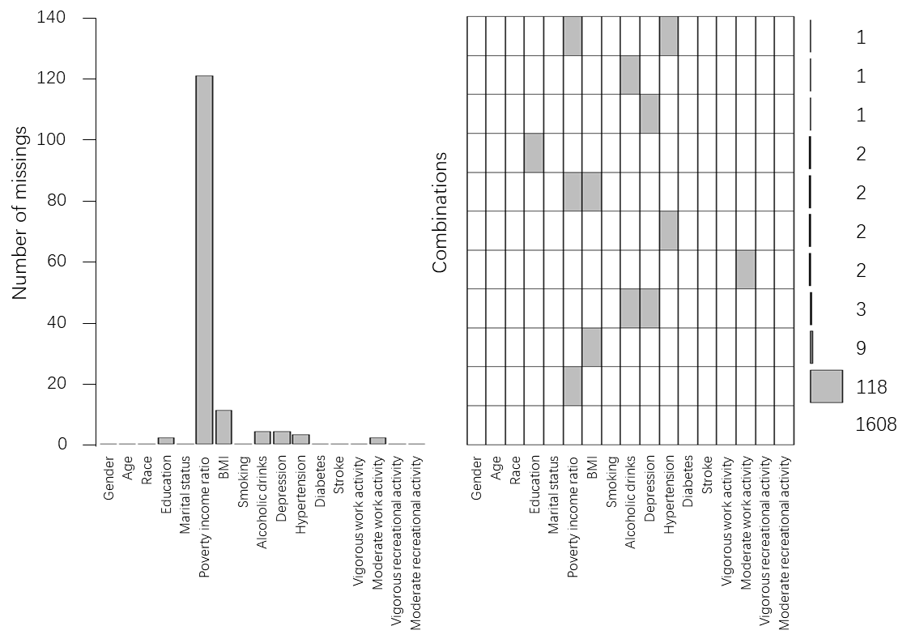

**Supplementary Figure S1.** Missing data of included participants.