Supplementary material
Data sheet 2
Annex 2
Molecular biology data of the right ventricle in heat maps by time groups
- 72hs right ventricle

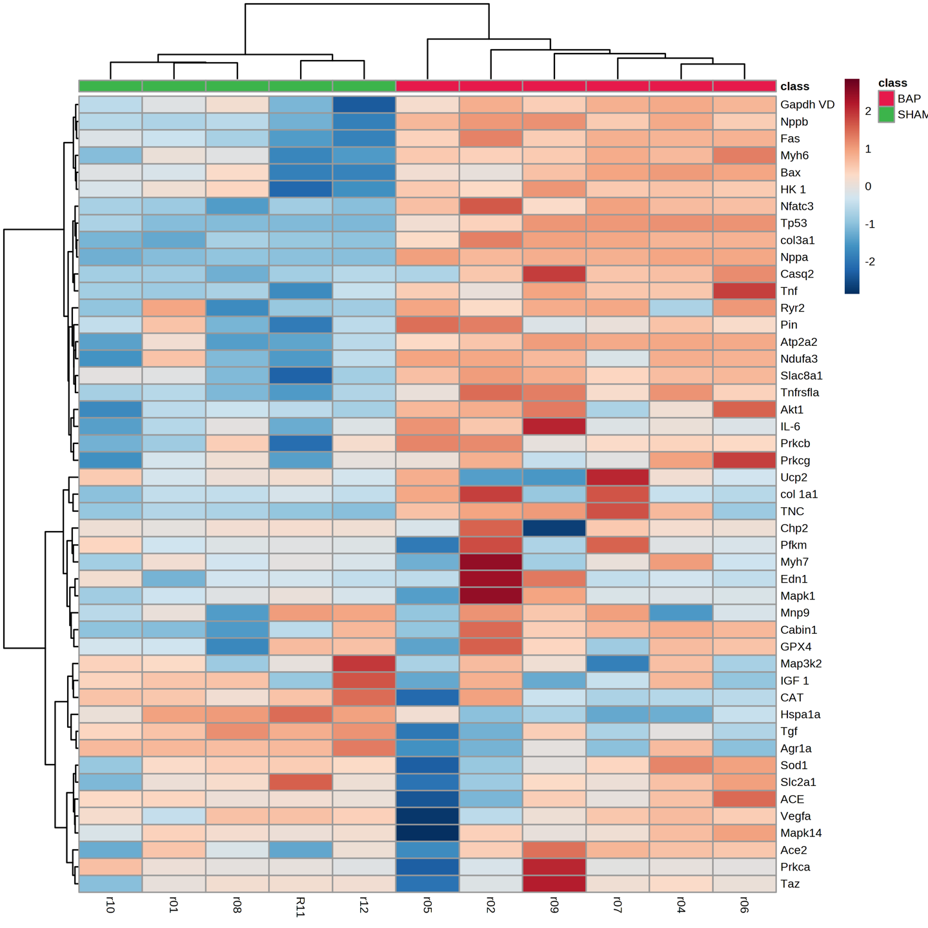

- 2 weeks- right ventricle

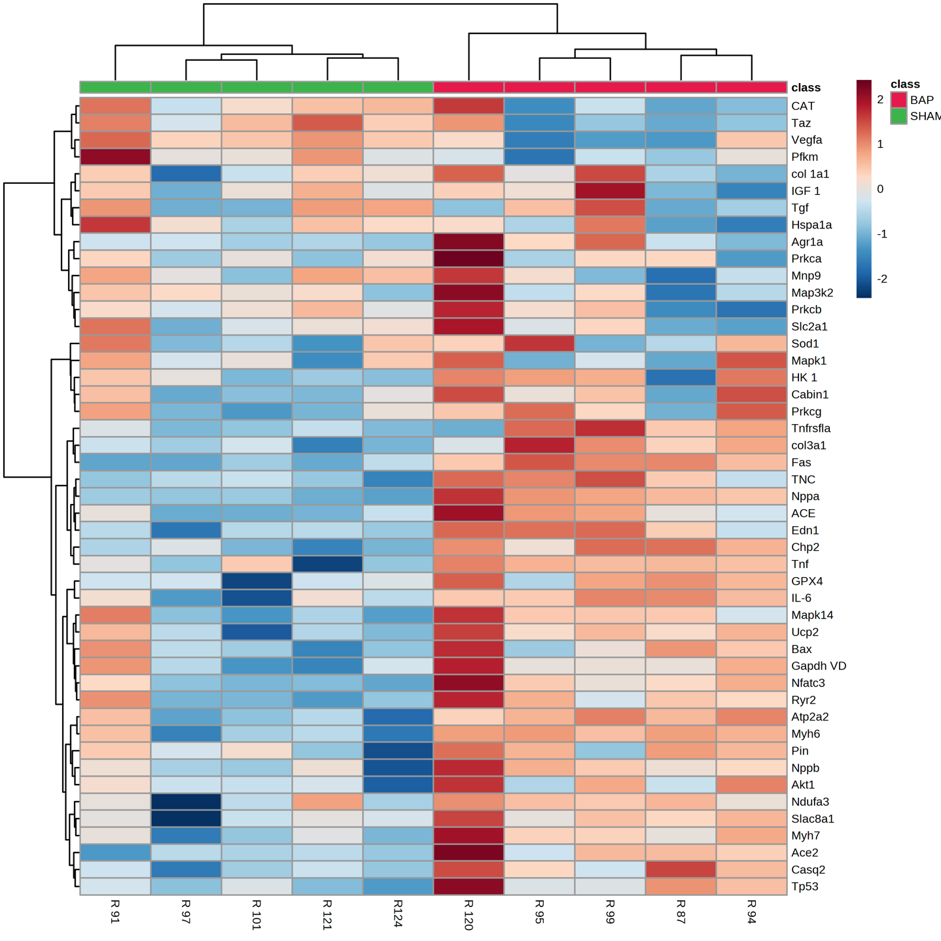

- 4 weeks- right ventricle
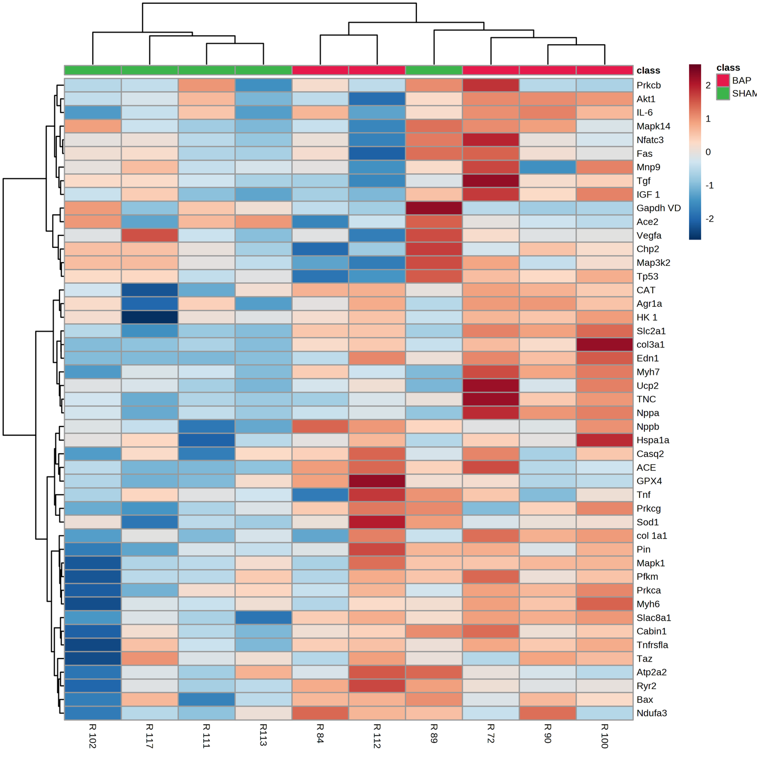

- 6 weeks- right ventricle

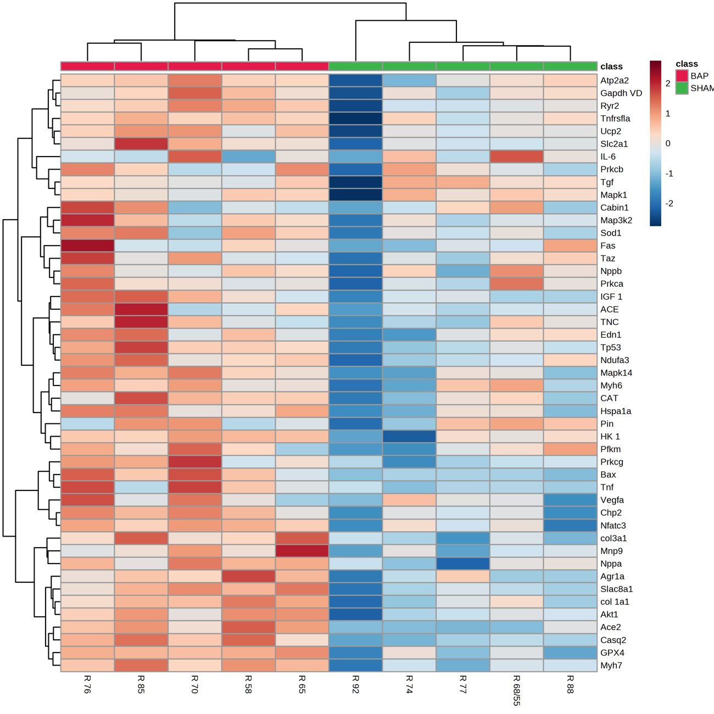

- 8 weeks- right ventricle
