Figure S1: Summary flowchart describing the creation of the full Discovery and Replication datasets (blue), as well as the unrelated Discovery and Replication datasets (green)_used for the mediation analyses, based on the QC in Tables S1 and S2.
A
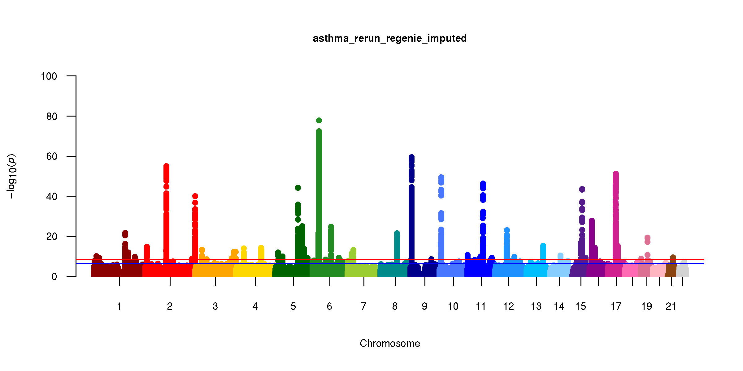
A

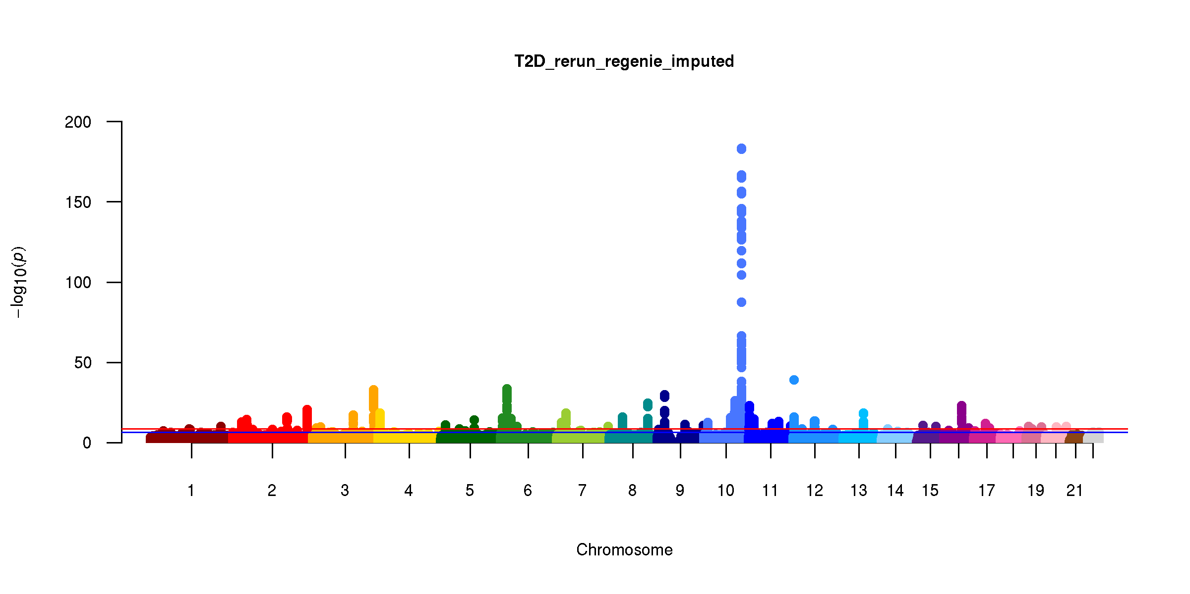
A

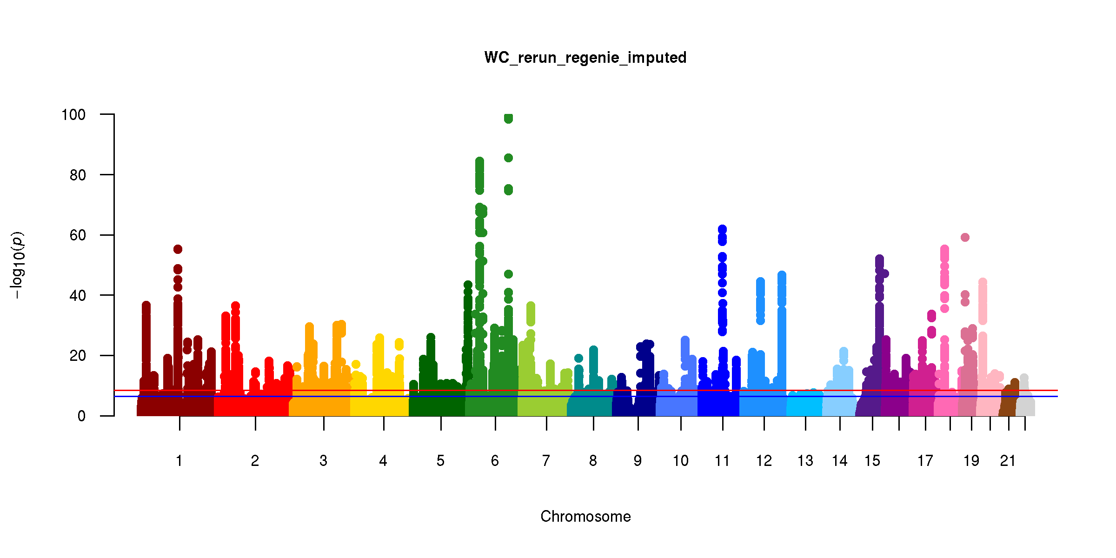
A

D.
A

E.

F.

G.

Figure S2: Manhattan plots for asthma (A), type 2 diabetes (B), waist circumference adjusted for BMI (C), waist circumference not adjusted for BMI (D), BMI (E), height (F) and weight (G) for the discovery sample. Genome-wide significant threshold (p=5.0x10⁻⁸) is indicated by the red line and genome-wide suggestive threshold (5.0x10⁻⁶) is indicated by the blue line.

Figure S3: Diagram of the associations between SNP 7:28178625 and the major phenotypes examined. The association with WCadjBMI is due to the adjustment for BMI which is a collider due to the strong association with height, one aspect of BMI, shown in purple. Both weight and WC (unadjusted) did not show association with this SNP.

Table S1: Discovery quality control

 | # variants | # variants removed in this step | # subject | # subjects removed in this step
Step 1: Initial variant QC
Genotyped variants | 805,426
Autosomal variants | 784,256 | 21,170
Covered by both arrays | 733,322 | 50,934
Batch level qc | 687,004 | 46,318
SNPs only (indels removed) | 674,489 | 12,515
Step 2: Subject QC1
Genotypes available |  |  | 488,377
Phenotypes available |  |  | 488,282 | 95
Genetic and reported sex match |  |  | 487,910 | 372
Sex chromosomes non-XX XY |  |  | 487,440 | 470
Outliers in heterozygosity/missing rate |  |  | 486,477 | 963
"Caucasian" (f.22006) |  |  | 408,186 | 78,291
Individual call rate > 99% |  |  | 366,752 | 41,434
Unrelated |  |  | 307,259 | 59,493
Step 3: Final variant QC2
call rate > 99% | 639,862 | 34,627
HWE p<5x10-8 | 610,019 | 29.843
MAF > 1% | 529,024 | 80,995
Total | 529,024 |  | 366,752
1Subject QC was performed using the 674,489 variants
2Unrelated subjects were used for final variant QC and then the set of variants were selected for the full set of subjects

Table S2: Replication quality control

 | # variants | # variants removed in this step | # subjects | # subjects removed in this step
Step 1: Initial variant QC
Genotyped variants | 805,426
Autosomal variants | 784,256 | 21,170
Covered by both arrays | 733,322 | 50,934
Batch level qc | 687,004 | 46,318
SNPs only (indels removed) | 674,489 | 12,515
Step 2: Subject QC¹
Mahalanobis defined non-British white |  |  | 49,352
Genetic and reported sex match |  |  | 49,307 | 45
Sex chromosomes non-XX XY |  |  | 49,265 | 42
Outliers in heterozygosity/missing rate |  |  | 49,133 | 132
Individual call rate > 99% |  |  | 44,173 | 4,960
Unrelated² |  |  | 39,133 | 5,040
Step 3: Final variant QC2
call rate > 99% | 639,847 | 34,642
HWE p<5x10-8 | 631,089 | 8758
MAF > 1% | 550,028 | 81,061
Total | 550,028 |  | 44,173
¹Subject QC was performed using the 674,489 variants
²Unrelated subjects were used for final variant QC and then the set of variants were selected for the full set of subjects

