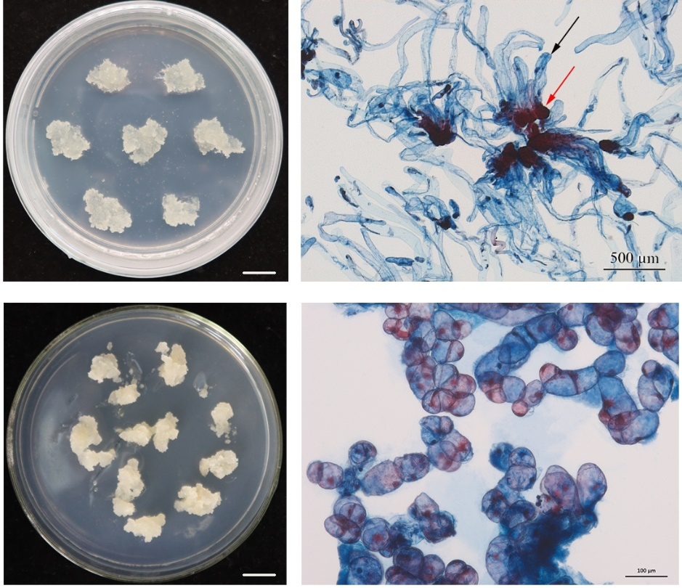

EXTRA FIGURE 1 | Maintenance and proliferation of callus with different embryogenic responses, embryo-genic, and non-embryogenic responses in P. massoniana. (A) Embryogenic callus with a white, translucent appearance. Scale bar = 1.0 cm. (B) Embryogenic callus double stained with acetocarmine and Evans blue, red arrows indicate cluster of embryonic head cells, black arrows indicate suspensor cells. Scale bar = 0.05 cm. (C) Non-embryogenic callus with a yellow, compact and friable appearance. Scale bar = 1.0 cm. (D) Non-embryogenic callus double stained with acetocarmine and Evans blue. Scale bar = 0.01 cm.

