***Supplementary Material***

# Supplementary Methods

## 1.1 TLS field methods

At Pepperwood, nine scan positions were used on a 10 x 10-m grid for a total of 18 scans per 20 x 20-m plot in an “S'' pattern. To replicate this pattern for the circular plots at LDSF and Saddle Mountain, the TLS was positioned at the edge of the plot and moved in the same “S” pattern, however the even numbered scan positions were extended outward slightly to account for the curve of the circular plot. The RIEGL VZ-400i is capable of auto-registration which does not require reflective tie points; however, in some cases cylindrical reflectors were placed in densely forested plots to assist with manual registration in case of auto-registration failure. At LDSF and Saddle Mountain, reflectors were placed at the plot edge in each cardinal direction and the center of the plot to visually assist in locating the plot boundaries. The TLS was not operated during windy weather conditions, as wind causes a ghosting effect in the 3D point cloud.

# Allometric equations

The CARB FIA protocol species-specific wood densities and specific gravities were used in Equation 1. Specifically, for *Q. agrifolia* and *Q. garryana*, the CARB FIA protocol uses volume equations developed by Pillsbury and Kirkley (1984) which includes the stem, branches, and bark, yet excludes foliage estimates in the total volume. The volume estimate was then multiplied by CARB species-specific wood density to obtain AGB estimates. In contrast, all conifer CARB volume equations only calculate the volume of the stem (trunk) without the volume of the branches or bark. To calculate AGB for conifers, three independent species-specific biomass equations for the stem (as discussed above), branches, and bark equation were summed to estimate total AGB of each tree.

The Jenkins et al. (2003) and the Chojnacky et al. (2014) protocols produce AGB estimates directly, without an intermediate volume estimate. Jenkins et al. (2003) used published data to categorize North America tree species into 10 generalized AGB estimation equations based on taxonomic categories, while Chojnacky et al. (2014) expanded to a total of 35 taxonomic category equations. *Q. agrifolia*, *Q. garryana*, and *S. sempervirens* are not included in Jenkins et al. (2003) reference data. All other species of interest were included in the reference data, and the same specific gravities and wood densities (Miles and Smith, 2009) as FIA were used. Both Jenkins et al. (2003) and Chojnacky et al. (2014) include foliage in their AGB estimates. *Q. agrifolia* and *Q. garryana* AGB were estimated using the “Mixed hardwood” taxa category, and *S. sempervirens* was estimated using the Cedar/larch taxa equation as recommended in Jenkins et al. (2003). Some genera with largely varying wood specific gravities were divided into two different taxa groups. Supplementary Materials Table 1 shows each species within the equation taxa group for Jenkins et al. 2003 and Chojnacky et al. 2014.

Additionally, Sillett et al. (2019) developed local species-specific allometric equations for *S. sempervirens* in Mendocino County, California (north of our study area), and was the only non-FIA species-specific equation used. While Disney et al. (2020) also developed TLS-based equations for *S. sempervirens*, these equations are based on a much larger size range of trees than our study site so our comparison focused on only Sillett et al. (2019). We attempted to compare other local species-specific allometric equations for *S. sempervirens* and *P. ponderosa* by Ritchie et al. (2013), but all required additional data inputs that were unavailable. To our knowledge, the only species-specific biomass equations that exist for *Q. agrifolia* or *Q. garryana* are Pillsbury and Kirkley (1984), which are used in the FIA protocol. No known local species-specific equations exist for *A. concolor*.

## 2.1 Tree segmentation

First, individual trees were segmented in Lidar360 with the “Point Cloud Segmentations from Seed Point” tool based on the seed point .csv input file, created from manual DBH fitting in Lidar360. In closed canopy forests, automatic tree segmentation is not usually accurate enough for AGB estimation because overlapping canopies from neighboring trees are either included, or branches from the focal tree are improperly excluded from the segmented point cloud, particularly at higher heights with fewer lidar returns. As such, the “Segmentation Tool” in CloudCompare (www.danielgm.net/cc), another point cloud editing software, was used to manually edit the automatically segmented tree and remove extraneous points.

After each tree was segmented and cleaned, TLSeparation (v1.3.2; tlseparation.github.io/documentation) in Python was used with the “generic tree” function to remove the foliage from the trees to produce only wood structure files. When there was not a lot of noise (i.e. scatter) produced by the leaves, the ‘generic_tree’ function sufficiently separated the foliage from wood within the point cloud. This was determined by viewing the pointcloud, after TLSeparator, to see if the cylindrical structure of the branches were interrupted by a clump of leaves. Occasionally, however, individual trees would error within the TLSeparator script, possibly due to scatter from the leaves in which case the ‘nopath’ function was used.

## 2.2 Calculating DBH and height using TLS data

To calculate DBH and height using TLS scans, the Lidar360 “TLS seed point editor” function was used to first manually to identify individual tree stem seed points within the plot. Seed points were then used to automatically specify a group of points based on a specified criterion (e.g. height of points above ground), and the seed was then “grown” from that point to surrounding points that matched the original seed’s point criteria. This allowed for semi-automated segmentation of individual trees from a respective seed point. The “Fit DBH” tool with the “fitting by circle” option was then used to calculate DBH for each tree of interest.

## 2.3 Using QSMs to calculate tree volume

Tree volume was estimated directly from the segmented and cleaned point cloud data using Quantitative Structure Models (QSM) (Raumonen et al. 2013, 2020, Calders et al. 2015b, Disney et al. 2018, Lau et al. 2018). First the “cubical_down_sampling” function was used to downsample each point cloud as trials without downsampling resulted in prohibitively long processing times, and also, occasionally produced errors within the QSMs, likely from noise.

A range of TreeQSM input parameters were tested to optimize QSM outputs. Initially, input parameters were chosen based on species, DBH, and height where QSM output (as a 3D mesh) was compared visually to the original segmented point cloud. Ultimately, the height optimization produced the most precise QSM (Raumonen, 2020). Thus, for this study, QSM input parameters were based on three height classes, 2-10 m, 10-25 m, and >25 m. The QSM output includes tree total volume as well as volumes of each compartment (i.e. stem branches and twigs). To calculate AGB for each tree, the QSM total volume was multiplied by the species’ wood specific density (Miles and Smith, 2009).

Regardless of optimization, some tree QSMs repeatedly failed. This was often due to poor point cloud quality in dense plots where foliage was close to, or in contact with the sensor, creating excessive noise within the point cloud. In addition, QSMs could not always correctly identify the trunk of the tree within the point cloud, generating varied and inaccurate results. All QSMs were visually compared to the segmented point cloud and any that did not produce visually similar structured models (i.e. large branches missing) were discarded and not used in subsequent analyses.

# Supplementary Tables

**Table 1.** The division of study species within taxa groups for Jenkins et al. (2003) and Chojnacky et al. (2014). FIA uses unique equations for each species and are not listed here.

|  |  |  |
| --- | --- | --- |
| **Equation Group by Author and Taxa** | | **Study Species** |
| Jenkins et al. (2003) | | |
|  | Hardwood/oak/hickory/beech | *Quercus agrifolia*, *Q. garryana* |
|  | Cedar/larch | *Sequoia sempervirens* |
|  | True fir/hemlock | *Abies concolor* |
|  | Pine | *Pinus ponderosa* |
| Chojnacky et al. (2014) | | |
|  | Fagaceae, evergreen | *Quercus agrifolia* |
|  | Fagaceae, deciduous | *Quercus garryana* |
|  | Cupressaceae 0.30-0.39 spg | *Sequoia sempervirens* |
|  | Abies ≥ 0.35 spg | *Abies concolor* |
|  | Pine <0.45 spg | *Pinus ponderosa* |

**Table 2.** Range of TLS-derived diameter at breast height (DBH, cm) and height (m) by species for successful QSMs (sample size shown for each species).

|  |  |  |  |
| --- | --- | --- | --- |
| **Species** | **QSM sample size (n)** | **DBH range (cm)** | **Height range (m)** |
| *Abies concolor* | 158 | 10.9-76.4 | 4.25-31.01 |
| *Pinus ponderosa* | 20 | 16.2-71.7 | 8.51-38.74 |
| *Sequoia sempervirens* | 24 | 17.5-71.6 | 7.75-36.43 |
| *Quercus agrifolia* | 28 | 11.5-50.5 | 3.16-19.24 |
| *Quercus garryana* | 52 | 12.4-47.9 | 4.57-19.95 |

**Table 3**. Statistical results for TLS QSM and FIA volume comparison (Figure 3 in main manuscript) including RMSE (kg), CV RMSE (%), Bias (kg), and Bias (%).

|  |  |  |  |  |  |  |
| --- | --- | --- | --- | --- | --- | --- |
| **Species** | **Sample Size (n)** | **R²** | **RMSE (kg)** | **CV RMSE (%)** | **Bias (kg)** | **Bias %** |
| All | 282 | -- | 362.48 | 42.85 | 192.13 | 15.27 |
| *Abies concolor* | 158 | 0.98 | 302.33 | 43.03 | 163.93 | 9.73 |
| *Pinus ponderosa* | 20 | 0.99 | 147.69 | 12.12 | 11.63 | -5.10 |
| *Sequoia sempervirens* | 24 | 0.96 | 506.71 | 38.85 | 264.33 | 28.74 |
| *Quercus agrifolia* | 28 | 0.84 | 612.39 | 55.32 | 424.38 | 36.23 |
| *Quercus garryana* | 52 | 0.81 | 325.58 | 41.45 | 188.86 | 22.43 |

**Table 4.** Statistical results for TLS AGB (kg) compared to AGB calculated using published allometries (kg) (Figure 4 in main manuscript) including RMSE (kg), CV RMSE (%), Bias (kg), and Bias (%).

|  |  |  |  |  |  |  |
| --- | --- | --- | --- | --- | --- | --- |
| **Species by Method** | | **Sample Size (n)** | **RMSE (kg)** | **CV RMSE (%)** | **Bias (kg)** | **Bias (%)** |
| FIA | | | | | | |
|  | All | 282 | 193.88 | 39.09 | 97.03 | 20 |
|  | *Abies concolor* | 158 | 129.14 | 31.78 | 59.41 | 12 |
|  | *Pinus ponderosa* | 20 | 185.06 | 25.35 | 88.10 | 25 |
|  | *Sequoia sempervirens* | 24 | 242.79 | 34.85 | 124.80 | 39 |
|  | *Quercus agrifolia* | 28 | 359.89 | 55.21 | 249.21 | 36 |
|  | *Quercus garryana* | 52 | 207.51 | 41.36 | 120.00 | 22 |
| Jenkins et al. 2003 | | | | | | |
|  | All | 282 | 179.06 | 36.10 | 11.93 | 1 |
|  | *Abies concolor* | 158 | 158.56 | 39.02 | -18.64 | -2 |
|  | *Pinus ponderosa* | 20 | 194.05 | 26.58 | 44.97 | 6 |
|  | *Sequoia sempervirens* | 24 | 200.88 | 28.84 | 93.85 | 15 |
|  | *Quercus agrifolia* | 28 | 238.96 | 36.66 | 33.57 | -4 |
|  | *Quercus garryana* | 52 | 183.39 | 36.55 | 42.66 | 4 |
| Chojnacky et al. 2014 | | | | | | |
|  | All | 282 | 200.09 | 40.34 | 37.21 | 11 |
|  | *Abies concolor* | 158 | 180.18 | 44.34 | -3.60 | 9 |
|  | *Pinus ponderosa* | 20 | 187.04 | 25.62 | 23.49 | 5 |
|  | *Sequoia sempervirens* | 24 | 236.07 | 33.89 | 155.61 | 29 |
|  | *Quercus agrifolia* | 28 | 287.32 | 44.08 | 136.94 | 14 |
|  | *Quercus garryana* | 52 | 186.66 | 37.20 | 58.15 | 7 |
| Sillett et al. 2019 | | | | | | |
|  | *Sequoia sempervirens* | 24 | 220.25 | 31.62 | 16.53 | 11 |

**Table 5**. Statistical results for new species-specific TLS DBH-based AGB estimates (kg) (AGB Equation 1) compared to AGB estimated using FIA, Jenkins et al. (2003), and Chojnacky et al. (2014) and Sillett et al. (2019) equations for all trees using TLS DBH (Figure 5 in main manuscript) including RMSE (kg), CV RMSE (%), Bias (kg), and Bias (%).

|  |  |  |  |  |  |
| --- | --- | --- | --- | --- | --- |
| **Species by Method** | | **RMSE (kg)** | **CV RMSE (%)** | **Bias (kg)** | **Bias (%)** |
| FIA | | | | | |
|  | All | 120.41 | 25.00 | 82.72 | 23 |
|  | *Abies concolor* | 84.20 | 20.61 | 61.56 | 17 |
|  | *Pinus ponderosa* | 177.43 | 24.87 | 71.62 | 27 |
|  | *Sequoia sempervirens* | 159.51 | 23.24 | 114.42 | 41 |
|  | *Quercus agrifolia* | 206.03 | 35.29 | 181.10 | 38 |
|  | *Quercus garryana* | 101.86 | 21.89 | 83.67 | 25 |
| Jenkins et al. 2003 | | | | | |
|  | All | 69.13 | 14.35 | -2.38 | 5 |
|  | *Abies concolor* | 64.30 | 15.74 | -16.49 | 3 |
|  | *Pinus ponderosa* | 33.99 | 4.76 | 28.49 | 9 |
|  | *Sequoia sempervirens* | 87.39 | 12.74 | 83.46 | 23 |
|  | *Quercus agrifolia* | 97.94 | 16.78 | -34.55 | 0 |
|  | *Quercus garryana* | 64.97 | 13.96 | 6.34 | 7 |
| Chojnacky et al. 2014 | | | | | |
|  | All | 92.00 | 19.10 | 22.90 | 15 |
|  | *Abies concolor* | 92.04 | 22.53 | -1.45 | 14 |
|  | *Pinus ponderosa* | 45.22 | 6.34 | 7.01 | 7 |
|  | *Sequoia sempervirens* | 155.09 | 22.60 | 145.22 | 35 |
|  | *Quercus agrifolia* | 90.20 | 15.45 | 68.82 | 17 |
|  | *Quercus garryana* | 62.44 | 13.42 | 21.82 | 10 |
| Sillett et al. 2019 | | | | | |
|  | *Sequoia sempervirens* | 119.50 | 17.41 | 6.15 | 16 |

**Table 6.** Statistical results for new species-specific TLS DBH^2 * height-based AGB estimates (kg) (AGB Equation 2) compared to AGB estimated using FIA, Jenkins et al. (2003), and Chojnacky et al. (2014) and Sillett et al. (2019) equations with TLS DBH and TLS height (Figure 6 in main manuscript), including RMSE (kg), CV RMSE (%), Bias (kg), and Bias (%).

|  |  |  |  |  |  |
| --- | --- | --- | --- | --- | --- |
| **Species by Method** | | **RMSE (kg)** | **CV RMSE (%)** | **Bias (kg)** | **Bias (%)** |
| FIA | | | | | |
|  | All | 124.31 | 25.25 | 93.32 | 32 |
|  | *Abies concolor* | 62.90 | 15.48 | 59.42 | 30 |
|  | *Pinus ponderosa* | 92.88 | 12.72 | 88.10 | 30 |
|  | *Sequoia sempervirens* | 160.12 | 22.98 | 124.82 | 44 |
|  | *Quercus agrifolia* | 276.39 | 44.32 | 221.03 | 40 |
|  | *Quercus garryana* | 124.49 | 25.06 | 115.05 | 31 |
| Jenkins et al. 2003 | | | | | |
|  | All | 127.40 | 25.88 | 8.23 | 13 |
|  | *Abies concolor* | 124.47 | 30.63 | -18.64 | 14 |
|  | *Pinus ponderosa* | 145.32 | 19.91 | 44.97 | 11 |
|  | *Sequoia sempervirens* | 118.74 | 17.04 | 93.87 | 28 |
|  | *Quercus agrifolia* | 165.40 | 26.52 | 5.39 | -1 |
|  | *Quercus garryana* | 107.65 | 21.67 | 37.72 | 12 |
| Chojnacky et al. 2014 | | | | | |
|  | All | 150.88 | 30.65 | 33.51 | 21 |
|  | *Abies concolor* | 148.20 | 36.47 | -3.59 | 23 |
|  | *Pinus ponderosa* | 137.54 | 18.84 | 23.49 | 9 |
|  | *Sequoia sempervirens* | 168.61 | 24.20 | 155.63 | 38 |
|  | *Quercus agrifolia* | 210.60 | 33.77 | 108.76 | 16 |
|  | *Quercus garryana* | 111.52 | 22.45 | 53.20 | 15 |
| Sillett et al. 2019 | | | | | |
|  | *Sequoia sempervirens* | 134.08 | 19.25 | 16.55 | 22 |

**Table 7.** Statistical results for TLS AGB (kg) compared to TLS allometric equation derived AGB (kg) using AGB Equation 1 (DBH only) and AGB Equation 2 (DBH and Height) (Figure 7 in main manuscript), including R², RMSE (kg), CV RMSE (%), Bias (kg), and Bias (%).

|  |  |  |  |  |  |  |
| --- | --- | --- | --- | --- | --- | --- |
| **Species by Equation Variable** | | **R²** | **RMSE (kg)** | **CV RMSE (%)** | **Bias (kg)** | **Bias (%)** |
| DBH | | | | | | |
|  | All | -- | 162.86 | 32.84 | 14.31 | -5 |
|  | *Abies concolor* | 0.95 | 119.28 | 29.35 | -2.15 | -5 |
|  | *Pinus ponderosa* | 0.93 | 196.95 | 26.98 | 16.48 | -3 |
|  | *Sequoia sempervirens* | 0.92 | 179.22 | 25.73 | 10.38 | -10 |
|  | *Quercus agrifolia* | 0.77 | 270.06 | 41.43 | 68.11 | -5 |
|  | *Quercus garryana* | 0.80 | 177.76 | 35.43 | 36.32 | -4 |
| DBH²H | | | | | | |
|  | All | -- | 150.95 | 30.43 | 3.70 | -29 |
|  | *Abies concolor* | 0.95 | 115.21 | 28.35 | 0.00 | -38 |
|  | *Pinus ponderosa* | 0.96 | 154.50 | 21.16 | 0.00 | -13 |
|  | *Sequoia sempervirens* | 0.92 | 183.13 | 26.29 | -0.02 | -30 |
|  | *Quercus agrifolia* | 0.81 | 232.18 | 35.62 | 28.18 | -9 |
|  | *Quercus garryana* | 0.80 | 171.93 | 34.27 | 4.94 | -16 |

**Table 8.** Relative differences between approaches used to calculate AGB where column headers represent the Figures which contain each comparison. Differences are calculated for each species and across all species. With the SESE comparison only Sillett et al. (2019) is used.

|  |  |  |  |  |
| --- | --- | --- | --- | --- |
| **Species** | **Figure 3** | **Figure 4** | **Figure 5** | **Figure 6** |
|  | *QSM vs. FIA volume* | *QSM AGB vs. published equations* | *TLS Equation 1 vs. published equations* | *TLS Equation 2 vs. published equations* |
| ABCO | 20.2% | 6.4% | 11.3% | 22.4% |
| PIPO | 1.6% | 12.0% | 20.8% | 25.4% |
| QUEAGR | 86.3% | 15.3% | 21.2% | 11.9% |
| QUEGAR | 51.3% | 11.2% | 15.1% | 16.1% |
| SESE | 45.6% | 23.5% | 15.9% | 19.4% |
| ALL | 33.3% | 10.0% | 14.4% | 20.2% |

# Supplementary Figures

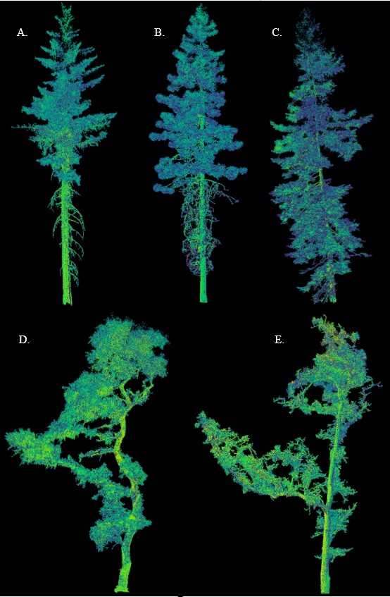

**Figure 1**: Point clouds of individual trees scanned via terrestrial laser scanning (TLS) from the study species: A) ABCO, B) PIPO, C) SESE, D) QUEAGR, and E) QUEGAR.

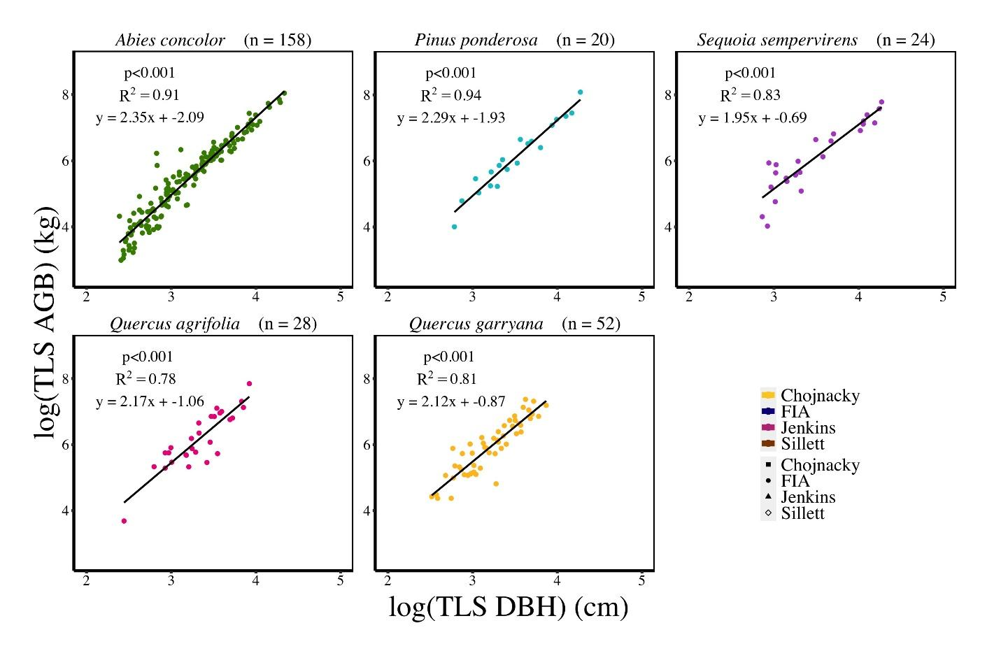

**Figure 2**. New species-specific allometric equations developed via linear regression of the log transformed TLS DBH (cm) compared to the log transformed TLS QSM AGB (kg) for each species (AGB Equation 1 in main manuscript).

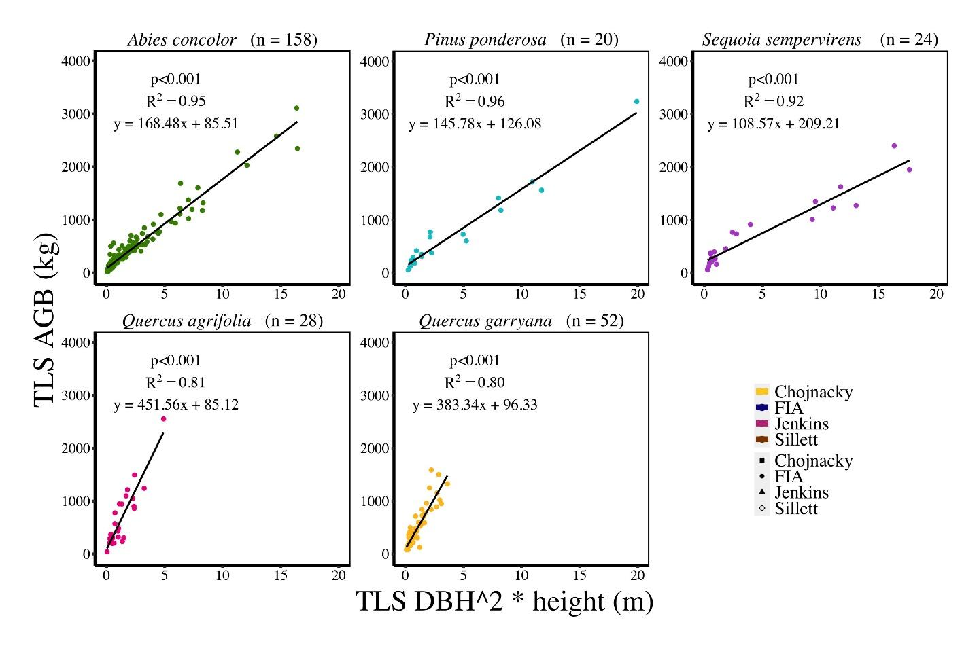

**Figure 3**. New species-specific allometric equations developed via linear regression of TLS DBH^2 * height (m) compared to the TLS QSM AGB (kg) for each species (AGB Equation 2 in main manuscript).

# Allometric equations details from CARB FIA Protocols, Sillett et al. (2019), Jenkins et al. (2003), Chojnacky et al. (2014) and Pillsbury & Kirkley (1984)

This is a combination of the equations that were used to calculate aboveground biomass (AGB) for *Abies concolor, Pinus ponderosa, Sequoia sempervirens*, *Quercus agrifolia* and *Quercus garryana*. The select equations for each species from each paper are displayed here to simplify information.

This section contains the following:

* CARB Protocols pages 16-18
* Jenkins et al. (2003) page 19
* Chojnacky et al. (2014) page 20
* Sillett et al. (2019) page 21
* Pillsbury & Kirkley (1984) page 22

**Table 9.** CARB/FIA Protocol tree codes with selected species, specific gravity, wood density, volume equation code, biomass equation code, and the chosen equation source for each species.

|  |  |  |  |  |  |  |  |  |
| --- | --- | --- | --- | --- | --- | --- | --- | --- |
| **CARB/ FIA species code** | **Equation source** | **Scientific name** | **Common name** | **FIA Specific gravity** | **FIA Wood density** | **FIA CA Volume equation code** | **FIA CA Biomass live branch equation code** | **FIA CA Biomass bark equation code** |
| 15 | Jenkins et al. (2003), Chojnacky et al. (2014) | *Abies concolor* | white fir | 0.37 | 23.09 | 23 | 1 | 1 |
| 122 | Jenkins et al. (2003), Chojnacky et al. (2014) | *Pinus ponderosa* | ponderosa pine | 0.38 | 23.71 | 5 | 7 | 9 |
| 211 | Jenkins et al. (2003), Chojnacky et al. (2014), Sillett et al. (2019) | *Sequoia sempervirens* | Redwood | 0.36 | 22.46 | 24 | 10 | 17, 13 (DBH is >39.37in, & <39.37in, respectively) |
| 801 | Jenkins et al. (2003), Chojnacky et al. (2014), Pillsbury and Kirkley (1984) (for reference) | *Quercus agrifolia* | California live oak | 0.59 | 36.82 | 43 | -- | -- |
| 815 | Jenkins et al. (2003), Chojnacky et al. (2014), Pillsbury and Kirkley (1984) (for reference) | *Quercus garryana* | Oregon white oak | 0.64 | 39.94 | 41 | -- | -- |

## 5.1 FIA/CARB Regional Biomass Equations to Estimate Bole, Bark, and Branches

### 5.1.1 Biomass of the Tree Stem

Tree stem biomass, regardless of whether it is merchantable bole or total stem, is calculated from cubic volume estimates and the wood density factor (in table above) as follows:

**Cubic volume** = green cubic volume in cubic feet (ft3)

**Wood density** = (Specific gravity of a tree species) * (62.4 lbs/ft3)

**Weight of water** = 62.4 pounds/cubic foot

**Biomass of the tree stem (in tons) = (cubic foot volume * wood density) / 2000**

### 5.1.2 Biomass of Bark

All equations produce Biomass of Bark in kilograms. To convert to tons, multiply by 0.0011023.

Note that *Log* in the equations is Natural Log.

All of the following equation variables are defined as:

Log = Natural Log

DBH = Diameter at Breast Height

HT = Height of Tree in Meters

BB = Biomass of Bark, weight in kilograms, of the bark on the tree bole

#### 5.1.2.1 Equation 1: FIA, Abies concolor

$$BB=\frac{\exp\left(2.1069+2.7271*\log\left(DBH\right)\right)}{1000}$$

#### 5.1.2.2 Equation 9: FIA, Pinus ponderosa

$$BB=exp⁡(-3.6263+1.24077*\log\left(DBH\right)+0.8567*\log\left(HT\right))$$

#### 5.1.2.3 Equation 13: FIA, Sequoia sempervirens of DBH <39.37in

$$BB=0.336+0.00058*{DBH}^{2}*HT$$

#### 5.1.2.4 Equation 17: FIA, Sequoia sempervirens of DBH is >39.37in

$$BB=\frac{\exp\left(7.189689+1.5837*\log\left(DBH\right)\right)}{1000}$$

### 5.1.3 Biomass of Live Branches

All equations produce Biomass of Live Branches in kilograms. To convert to tons multiply by 0.0011023.

Note that *Log* in the equations is Natural Log.

All of the following equation variables are defined as:

Log = Natural Log

DBH = Diameter at Breast Height

HT = Height of Tree in Meters

BLB = Biomass of Live Branches, weight in kilograms, of the wood and bark of the live branches in the crown

$π=3.141593$

#### 5.1.3.1 Equation 1: FIA, Abies concolor

$$BLB=13.0+12.4*{\left(\frac{DBH}{100}\right)}^{2}*HT$$

#### 5.1.3.2 Equation 7: FIA, Pinus ponderosa

$$BLB=exp⁡(-4.1068+1.5177*\log\left(DBH\right)+1.0424*\log\left(HT\right))$$

#### 5.1.3.3 Equation 10: FIA, Sequoia sempervirens of DBH <39.37in

$$BLB=0.199+0.00381*{DBH}^{2}*HT$$

## 5.2 Jenkins et al. (2003) equations

**Table 10.** Jenkins et al. (2003) group equations. Biomass equation: $bm=Exp(β_{1}+β_{2} \ln{(DBH)}$, where bm=total aboveground biomass (kg dry weight), DBH=diameter at breast height (cm), Exp=exponential function, and ln=log base e(2.718282).

|  |  |  |  |  |  |
| --- | --- | --- | --- | --- | --- |
| **Group** | **Taxa** | **Species** |  |  | **R2** |
| Softwood | True Fir/hemlock | *Abies concolor* | -2.5384 | 2.4814 | 0.992 |
| Softwood | Pine | *Pinus ponderosa* | -2.5356 | 2.4349 | 0.987 |
| Softwood | Cedar/larch | *Sequoia sempervirens* | -2.0336 | 2.2592 | 0.981 |
| Hardwood | Hard maple/oak/hickory beech | *Quercus agrifolia* and *Quercus garryana* | -2.0127 | 2.4342 | 0.998 |

## 5.3 Chojnacky et al. (2014) equations

**Table 11.** Chojnacky et al. (2014) group equations. Where (with biomass in kg and diameter in cm) the biomass equation is: $\ln\left(biomass\right)=β_{1}+β_{2} ln\left(diameter\right).$

|  |  |  |  |  |  |
| --- | --- | --- | --- | --- | --- |
| **Group** | **Taxa** | **Species** |  |  | **R2** |
| Conifer | Abies ≥ 0.35 spg | *Abies concolor* | -3.1774 | 2.6426 | 0.75 |
| Conifer | Pinus < 0.45 spg | *Pinus ponderosa* | -2.6177 | 2.4638 | 0.83 |
| Conifer | Cupressaceae 0.30–0.39 spg | *Sequoia sempervirens* | -2.7765 | 2.4195 | 0.76 |
| Hardwood | Fabaceae, deciduous | *Quercus agrifolia* | -2.0705 | 2.4410 | 0.84 |
| Hardwood | Fabaceae, evergreen | *Quercus garryana* | -2.2198 | 2.4410 | 0.84 |

|  |  |  |  |  |  |  |  |  |  |  |  |  |  |  |
| --- | --- | --- | --- | --- | --- | --- | --- | --- | --- | --- | --- | --- | --- | --- |
| **Dependent Variable** | **V1** | **V2** | **V3** | ***a*** | ***b*** | ***c*** | ***d*** | ***e*** | ***N*** | ***R2*** | **RMSE** | **Mean** | **TCV** | **Form of equation** |
| Biomass (g) | DTB (cm) | Height (m) |  | 7.585E-02 | 2.401E+00 | 3.468E-03 | 3.301E+00 |  | 44 | 0.978 | 1.072E+03 | 8.452E+03 | 12% | $$a{V1}^{b}+c{V2}^{d}$$ |
| Carbon (kg) | DTB (cm) | Height (m) |  | 3.992E-02 | 2.391E+00 | 1.775E-03 | 3.298E+00 |  | 44 | 0.978 | 5.046+02 | 4.236E+03 | 12% | $$a{V1}^{b}+c{V2}^{d}$$ |
| Bark mass (kg) | DTB (cm) | Height (m) |  | 1.011E-02 | 2.457E+00 | 4.605E-04 | 3.353E+00 |  | 44 | 0.894 | 3.975E+02 | 1.472E+03 | 27% | $$a{V1}^{b}+c{V2}^{d}$$ |
| Wood mass (kg) | DTB (cm) | Height (m) |  | 7.015E-02 | 2.368E+00 | 3.038E-03 | 3.290E+00 |  | 44 | 0.980 | 8.456E+02 | 6.756E+03 | 13% | $$a{V1}^{b}+c{V2}^{d}$$ |
| Dead mass (kg) | CV (m3) |  |  | 5.197E-03 | 1.281E+00 |  |  |  | 44 | 0.724 | 5.452E+01 | 7.340E+01 | 74% | $$a{V1}^{b}$$ |
| Total Volume (m3) | DTB (cm) | Height (m) |  | 2.752E-04 | 2.372E+00 | 1.173E-05 | 3.306E+00 |  | 44 | 0.981 | 3.276E+00 | 2.721E+01 | 12% | $$a{V1}^{b}+c{V2}^{d}$$ |
| Bark Volume (m3) | DTB (cm) | Height (m) |  | 4.530E-05 | 2.428E+00 | 1.811E-06 | 3.378E+00 |  | 44 | 0.890 | 1.621E+00 | 5.902E+00 | 27% | $$a{V1}^{b}+c{V2}^{d}$$ |
| Sapwood Volume (m3) | DTB (cm) | Height (m) | CV (m3) | 2.313E-04 | 2.097E+00 | 1.269E-05 | 2.964E+00 | 6.121E-04 | 44 | 0.962 | 1.128E+00 | 7.406E+00 | 15% | $$a{V1}^{b}+c{V2}^{d}+eV3$$ |
| Heartwood Volume (m3) | DTB (cm) | Height (m) |  | 8.672E-05 | 2.470E+00 | 3.463E-06 | 3.440E+00 |  | 44 | 0.974 | 2.094E+00 | 1.372E+01 | 15% | $$a{V1}^{b}+c{V2}^{d}$$ |
| Dead Volume (m3) | CV (m3) |  |  | 1.269E-05 | 1.281E+00 |  |  |  | 44 | 0.724 | 1.335E-01 | 1.797E-01 | 74% | $$a{V1}^{b}$$ |
| Bark Area (m2) | CV (m3) | DTB (cm) |  | 8.815E-01 | 8.659E-01 | 1.428E-02 | 2.144E+00 |  | 44 | 0.933 | 1.702E+02 | 8.511E+02 | 20% | $$a{V1}^{b}+c{V2}^{d}$$ |
| Cambium (m2) | CV (m3) | DTB (cm) |  | 2.600E-01 | 9.260E-01 | 2.431E-03 | 2.372E+00 |  | 44 | 0.935 | 8.786E+01 | 4.111E+02 | 21% | $$a{V1}^{b}+c{V2}^{d}$$ |
| Heartwood Area (m2) | DTB (cm) | Height (m) |  | 1.201E-02 | 1.836E+00 | 8.340E-04 | 2.559E+00 |  | 44 | 0.976 | 1.002E+01 | 8.985E+01 | 11% | $$a{V1}^{b}+c{V2}^{d}$$ |
| Leaf Mass (kg) | CV (m3) | DTB (cm) |  | 4.039E-02 | 1.054E+00 | 1.476E-04 | 2.750E+00 |  | 44 | 0893 | 5.098E+01 | 1.696E+02 | 31% | $$a{V1}^{b}+c{V2}^{d}$$ |
| Leaf Area (m2) | CV (m3) | DTB (cm) |  | 3.122E-01 | 1.026E+00 | 1.752E-03 | 2.580E+00 |  | 44 | 0.901 | 2.725E+01 | 9.692E+02 | 28% | $$a{V1}^{b}+c{V2}^{d}$$ |
| Leaves (millions) | CV (m3) | DTB (cm) |  | 3.794E-02 | 9.779E-01 | 2.451E-04 | 2.548E+00 |  | 44 | 0.886 | 2.799E+01 | 9.266E+01 | 30% | $$a{V1}^{b}+c{V2}^{d}$$ |

## 5.4 Sillett et al. (2019) *Sequoia sempervirens* specific equations

**Table 12**. Sillett et al. (2019) Table 3. Allometric equations to estimate aboveground quantities of *S. sempervirens* in second-growth forests using ground-based measurements. Predictors (V1, V2, V3) are listed from left to right in descending order of importance (DTB=trunk diameter at top of buttress, Height=tree height, CV=crown volume) followed by regression coefficients (a-e), sample size (N), goodness of fit (R2), root mean square error (RMSE), 44 tree average dependent variable (Mean), tree-level coefficient of variation (TCV) computed as RMSE:Mean ratio, and form of equation. Blank cells indicate unnecessary values, as fewer coefficients were needed in these equations.

## 5.5 Pillsbury and Kirkley (1984) oak equations

Pillsbury and Kirkley (1984) equations are included for reference. These are used as the base of all oak equations including FIA.

**Table 13.** Pillsbury and Kirkley (1984), Table 2. Equations for estimating diameter inside bark based on measured diameter outside bark for California hardwoods. Where SE = standard error of estimate (cm), DIB = diameter inside bark (cm), DOB = diameter outside bark (cm).

|  |  |  |  |  |
| --- | --- | --- | --- | --- |
| **Species** | **Equation** | **N** | **R2** | **SE** |
| *Quercus agrifolia* | | | | |
|  | DIB= -1.92379 + 0.93475(DOB) | 60 | 0.992 | 1.47 |
| *Quercus garryana* | | | | |
|  | DIB= -0.78034 + 0.95956(DOB) | 60 | 0.995 | 1.19 |

**Table 14.** Pillsbury and Kirkley, 1984, Table 4. Metric equations for total, wood, and saw-log volumes for California hardwoods.

|  |  |  |  |  |
| --- | --- | --- | --- | --- |
| **Species** | **Equation** | **N** | **R2** | **SE** |
| *Quercus agrifolia* | | | | |
|  | TVOL = 0.0000446992(DBH2.31958)(HT0.62528) | 60 | 0.968 | 1.25 |
| WVOL = 0.0000135114(DBH2.53284)(HT0.60764) | 59 | 0.971 | 1.25 |
| *SVOL = 0.0000060095(DBH2.24437)(HT0.81358)(IV0.43381) | 68 | 0.884 | 1.37 |
| *Quercus garryana* | | | | |
|  | TVOL = 0.0000674342(DBH2.14321)(HT0.74220) | 60 | 0.961 | 1.26 |
| WVOL = 0.0000236325(DBH2.25575)(HT0.87108) | 60 | 0.958 | 1.30 |
| SVOL = 0.0000097284(DBH2.10651)(HT0.91215)(IV0.32652) | 32 | 0.838 | 1.41 |

Where: SE = Standard error of estimate (cm)

TVOL = total tree volume (m3)

WVOL = wood volume (m3)

SVOL = saw-log volume (m3)

DBH = diameter at breast height (cm)

HT = total tree height (m)

IV = an indicator variable (1 = non-merchantable first segment; 10 = merchantable first segment)

* = Combined equation for sawlog volumes for canyon live oak, interior live oak, and coast live oak.

# References cited

Calders, K., Newnham, G.J., Armston, J.D., Disney, M.I., Schaaf, C.B., Paynter, I., (2015b). Terrestrial LIDAR for forest monitoring. A sourcebook of methods and procedures for monitoring and reporting anthropogenic greenhouse gas emissions and removals associated with deforestation, gains and losses of carbon stocks in forests remaining forests, and forestation. GOFC-GOLD Land Cover Project Office, Wageningen University, The Netherlands. (Gofc-gold ed.).

Chojnacky, D. C., Heath, L. S., & Jenkins, J. C. (2014). Updated generalized biomass equations for North American tree species. *Forestry*, *87*(1), 129–151.<https://doi.org/10.1093/forestry/cpt053>

Disney, M. I., Vicari, M. B., Burt, A., Calders, K., Lewis, S. L., Raumonen, P., & Wilkes, P. (2018). Weighing trees with lasers: Advances, challenges and opportunities. *Interface Focus*, *8*(2).<https://doi.org/10.1098/rsfs.2017.0048>

Disney, M., Burt, A., Wilkes, P., Armston, J., & Duncanson, L. (2020). New 3D measurements of large redwood trees for biomass and structure. *Scientific Reports*, *10*(1).<https://doi.org/10.1038/s41598-020-73733-6>

Jenkins, J. C., Chojnacky, D. C., Heath, L. S., Birdsey, R. A. (2003). National scale biomass estimators for United States tree species. *Forest Science*. (49), 12-35.

Lau, A., Calders, K., Bartholomeus, H., Martius, C., Raumonen, P., Herold, M., Vicari, M., Sukhdeo, H., Singh, J., & Goodman, R. C. (2019). Tree biomass equations from terrestrial LiDAR: A case study in Guyana. *Forests*, *10*(6).<https://doi.org/10.3390/f10060527>

Miles, P. D., & Smith, W. B. (2009). Specific Gravity and Other Properties of Wood and Bark for 156 Tree Species Found in North America.<http://www.nrs.fs.fed.us/>

Pillsbury, N. H., & Kirkley, M. L. (1984). Equations for total, wood, and saw-log volume for thirteen California hardwoods*.*(PNW-RN-414; p. PNW-RN-414). *U.S. Department of Agriculture, Forest Service, Pacific Northwest Forest and Range Experiment Station*. <https://doi.org/10.2737/PNW-RN-414>

Raumonen, P. (updated 2020). TreeQSM Quantitative Structure Models of Single Trees from Laser Scanner Data Instructions for MATLAB-software TreeQSM, version 2.4.0.

Raumonen, P., Kaasalainen, M., Markku, Å., Kaasalainen, S., Kaartinen, H., Vastaranta, M., Holopainen, M., Disney, M., & Lewis, P. (2013). Fast automatic precision tree models from terrestrial laser scanner data. *Remote Sensing*, *5*(2), 491–520.<https://doi.org/10.3390/rs5020491>

Ritchie, M., Zhang, J., & Hamilton, T. (2013). Aboveground Tree Biomass for Pinus ponderosa in Northeastern California. *Forests*, *4*(1), 179–196. <https://doi.org/10.3390/f4010179>

Sillett, S. C., Pelt, R. V., Carroll, A. L., Campbell-Spickler, J., Coonen, E. J., & Iberle, B. (2019). Allometric equations for Sequoia sempervirens in forests of different ages. *Forest Ecology* *and Management*, *433*, 349–363.<https://doi.org/10.1016/j.foreco.2018.11.016>