**Landslide susceptibility evaluation based on active deformation and Graph Convolutional Network algorithm**

*Xianmin Wang1,2,3,4*, Aiheng Du1, Fengchang Hu1, Zhiwei Liu1, Xinlong Zhang1, Lizhe Wang2,3, Haixiang Guo4*

*1Hubei Subsurface Multi-scale Imaging Key Laboratory, School of Geophysics and Geomatics, China University of Geosciences, Wuhan, 430074, China*

*2State Key Laboratory of Biogeology and Environmental Geology, China University of Geosciences, Wuhan, 430074, China*

*3Key Laboratory of Geological and Evaluation of Ministry of Education, China University of Geosciences, Wuhan, 430074, China*

*4Laboratory of Natural Disaster Risk Prevension and Emergency Management, School of Economics and Management, China University of Geosciences, Wuhan, 430074, China*

[*xianminwang@163.com*](mailto:xianminwang@163.com)

**Online Resource 1: Connections of spatial and temporal baselines**

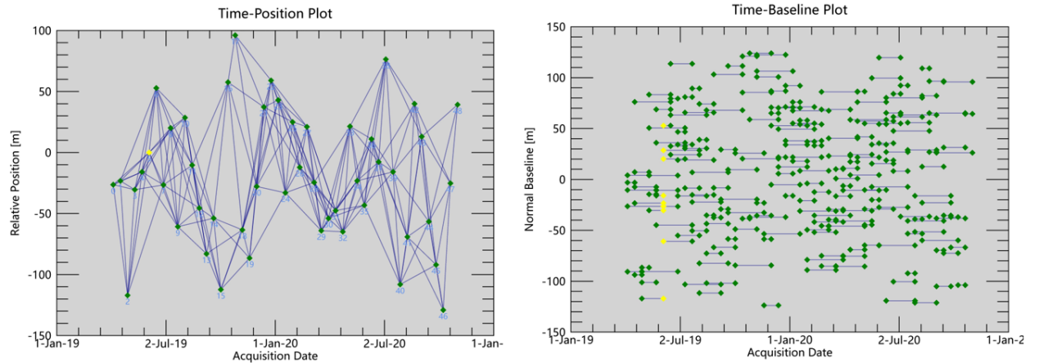

Figure S1 Connection plots of spatial and temporal baselines for SAR images.

**Online Resource 2: Collinearity inspection of the initial indices of landslide susceptibility evaluation**

Table S1 Collinearity inspection of various landslide susceptibility evaluation indices. The abbreviations include: TWI=Topographic wetness index; and NDVI=Normalized difference vegetation index.

| No. | Influencing factor | VIF | TOL |
| --- | --- | --- | --- |
| 1 | Elevation | 1.679 | 0.595 |
| 2 | Slope angle | 3.876 | 0.258 |
| 3 | Slope aspect | 1.016 | 0.984 |
| 4 | Plan curvature | 1.215 | 0.823 |
| 5 | Profile curvature | 1.228 | 0.815 |
| 6 | Surface roughness | 3.598 | 0.278 |
| 7 | TWI | 1.347 | 0.742 |
| 8 | NDVI | 1.380 | 0.725 |
| 9 | Distance to river | 1.245 | 0.804 |
| 10 | Distance to fold | 1.101 | 0.908 |
| 11 | Stratum | 1.258 | 0.795 |
| 12 | Land use | 1.359 | 0.736 |
| 13 | Cumulative rainfall | 1.237 | 0.809 |
| 14 | Distance to road | 1.134 | 0.882 |