**Supplementary Material**

**Effects of altered streamflow on macroinvertebrate taxonomic richness and composition in the Goulburn River, Australia**

Sudeep Banad a,b, Yongping Wei b, C. T. Dhanya c, Ron Johnstone b

*a The UQ-IITD Academy of Research (UQIDAR), Indian Institute of Technology, Delhi, India*

*b School of Earth and Environmental Sciences, University of Queensland, St Lucia, QLD 4072, Australia*

*c Department of Civil Engineering, Indian Institute of Technology, Delhi, India*

S1. Satellite images used for river channel extraction.

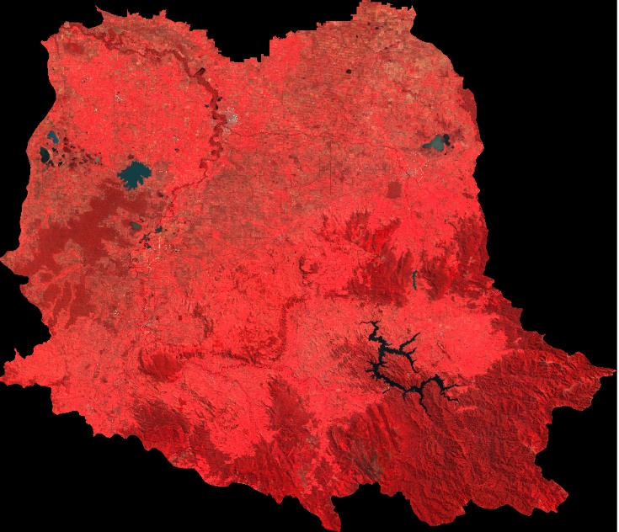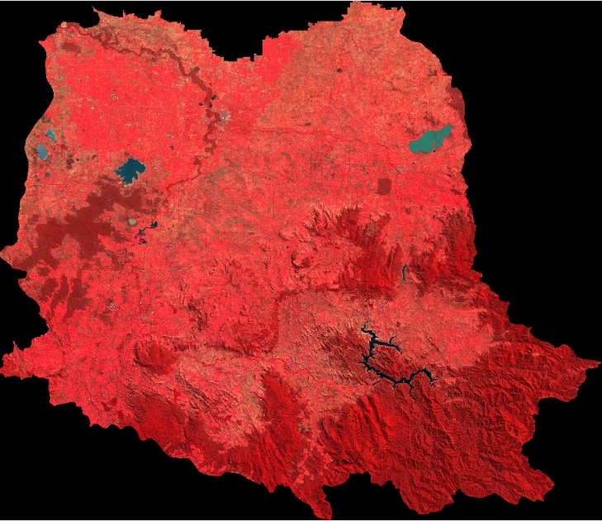

FCC 2011

FCC 2001

Figure S1. False colour composite of Goulburn basin using Landsat 7 images

S2. Flow-based indices which represent the five most critical components of the flow regime, which regulate the ecological processes in river ecosystems

Table S1. Flow indices used.

|  |  |
| --- | --- |
| **Variable** | **Description** |
| QMEAN | Mean average discharge |
| Q50 | Median discharge |
| QCVANN | Coefficient of variation of discharges |
| QDFRANGE | Range of discharges |
| QMR | Mean annual runoff. QMEAN ÷ catchment area |
| QJAN | Mean January discharge |
| QFEB | Mean February discharge |
| QMAR | Mean March discharge |
| QAPR | Mean April discharge |
| QMAY | Mean May discharge |
| QJUN | Mean June discharge |
| QJUL | Mean July discharge |
| QAUG | Mean August discharge |
| QSEP | Mean September discharge |
| QOCT | Mean October discharge |
| QNOV | Mean November discharge |
| QDEC | Mean December discharge |
| Q1 | Discharge exceeded 1% of the time |
| Q5 | Discharge exceeded 5% of the time |
| Q10 | Discharge exceeded 10% of the time |
| Q20 | Discharge exceeded 20% of the time |
| Q25 | Discharge exceeded 25% of the time |
| Q75 | Discharge exceeded 75% of the time |
| Q80 | Discharge exceeded 80% of the time |
| Q90 | Discharge exceeded 90% of the time |
| Q95 | Discharge exceeded 95% of the time |
| Q99 | Discharge exceeded 99% of the time |
| Q10Q90 | Ratio of 10th and 90th discharge percentile. Q10 ÷ Q90 |
| Q20Q80 | Ratio of 20th and 80th discharge percentile. Q20 ÷ Q80 |
| Q25Q75 | Ratio of 25th and 75th discharge percentile. Q25 ÷ Q75 |
| Q1Q50 | Ratio of 1st and 50th discharge percentile. Q1 ÷ Q50 |
| Q5Q50 | Ratio of 5th and 50th discharge percentile. Q5 ÷ Q50 |
| Q10Q50 | Ratio of 10th and 50th discharge percentile. Q10 ÷ Q50 |
| Q20Q50 | Ratio of 20th and 50th discharge percentile. Q20 ÷ Q50 |
| Q25Q50 | Ratio of 25th and 50th discharge percentile. Q25 ÷ Q50 |
| Q75Q50 | Ratio of 75th and 50th discharge percentile. Q75 ÷ Q50 |
| Q80Q50 | Ratio of 80th and 50th discharge percentile. Q80 ÷ Q50 |
| Q90Q50 | Ratio of 90th and 50th discharge percentile. Q90 ÷ Q50 |
| Q95Q50 | Ratio of 95th and 50th discharge percentile. Q95 ÷ Q50 |
| Q99Q50 | Ratio of 99th and 50th discharge percentile. Q99 ÷ Q50 |
| QS100 | Range discharge variability. QDFRANGE ÷ Q50 |
| QS50 | Interquartile discharge variability. (Q75‐Q25) ÷ Q50 |
| QS80 | 90th and 10th percentiles discharge variability (Q90‐ Q10) ÷ Q50 |
| QSK1 | Discharge skewness one. QMEAN ÷ Q50 |
| QSK2 | Discharge skewness two. (QMEAN‐Q50) ÷ Q50 |
| QSMED | Specific median discharge. Q50 ÷ Catchment area |
| QSTDEV | Standard deviation of discharges |
| QMAX | Maximum discharge |
| QSMAX | Specific maximum discharge QMAX ÷ Catchment area |
| QAMAX | Annual maximum discharge. QMAX ÷ Q50 |
| QJANMAX | Maximum January discharge |
| QFEBMAX | Maximum February discharge |
| QMARMAX | Maximum March discharge |
| QAPRMAX | Maximum April discharge |
| QMAYMAX | Maximum May discharge |
| QJUNMAX | Maximum June discharge |
| QJULMAX | Maximum July discharge |
| QAUGMAX | Maximum August discharge |
| QSEPMAX | Maximum September discharge |
| QOCTMAX | Maximum October discharge |
| QNOVMAX | Maximum November discharge |
| QDECMAX | Maximum December discharge |
| QCVANNMAX | Coefficient of variation of monthly maximum discharge |
| QDFMEDMAX | Median maximum monthly discharge ÷ Q50 |
| HQ | High discharge volume. Mean maximum monthly discharge ÷ Q50 |
| QMAX90 | Maximum discharge for the previous 90 days |
| QMAX180 | Maximum discharge for the previous 180 days |
| QMAX270 | Maximum discharge for the previous 270 days |
| QMIN | Minimum discharge |
| QJANMIN | Minimum January discharge |
| QFEBMIN | Minimum February discharge |
| QMARMIN | Minimum March discharge |
| QAPRMIN | Minimum April discharge |
| QMAYMIN | Minimum May discharge |
| QJUNMIN | Minimum June discharge |
| QJULMIN | Minimum July discharge |
| QAUGMIN | Minimum August discharge |
| QSEPMIN | Minimum September discharge |
| QOCTMIN | Minimum October discharge |
| QNOVMIN | Minimum November discharge |
| QDECMIN | Minimum December discharge |
| QCVANNMIN | Coefficient of variation of monthly minimum discharge |
| QSMIN | Specific minimum discharge. QMIN ÷ catchment area |
|  |  |
| Frequency. |  |
| QFRE1 | Number of flow events greater than Q50 |
| QFRE3 | Number of flow events greater than 3 x Q50 |
| QHPC | High pulse count. Number of flow events greater than Q25 |
| QLPC | Low pulse count. Number of flow events less than Q75 |
|  |  |
| Duration |  |
| QDAYMAX35 | Average 35‐day (7 week) maximum discharge |
| QDAYMAX91 | Average 91‐day (13 week) maximum discharge |
| QDAY35MAX50 | QDAYMAX35 ÷ Q50 |
| QDAY91MAX50 | QDAYMAX91 ÷ Q50 |
| Q5MEAN | Monthly high flow duration index. Q5 ÷ QMEAN |
| QDAYMIN35 | Average 35‐day (7‐week) minimum discharge |
| QDAYMIN91 | Average 91‐day (13‐week) minimum discharge |
| QDAY35MIN50 | QDAYMIN35 ÷ Q50 |
| QDAY91MIN50 | QDAYMIN91 ÷ Q50 |
| Q95QMEAN | Monthly low flow duration index. Q95 ÷ QMEAN |
| QZEROWEEK | Number of weeks possessing zero flow |
| QZEROMON | Number of months possessing zero flow |
|  |  |
| Timing |  |
| QMAXJW | Julian week occurrence of the maximum discharge |
| QMEMAXJW | Mean average of the seven Julian weeks possessing the highest discharges |
| QSTDMAXJW | Standard deviation of the seven Julian weeks possessing the highest discharges |
| QCV7JWMAX | Coefficient of variation of the seven Julian weeks possessing the highest discharges |
| QMINJW | Julian week occurrence of the maximum discharge |
| QMEMINJW | Mean average of the seven Julian weeks possessing the lowest discharges |
| QSTDMINJW | Standard deviation of the seven Julian weeks possessing the lowest discharges |
| QCV7JWMIN | Coefficient of variation of the seven Julian weeks possessing the lowest discharges |

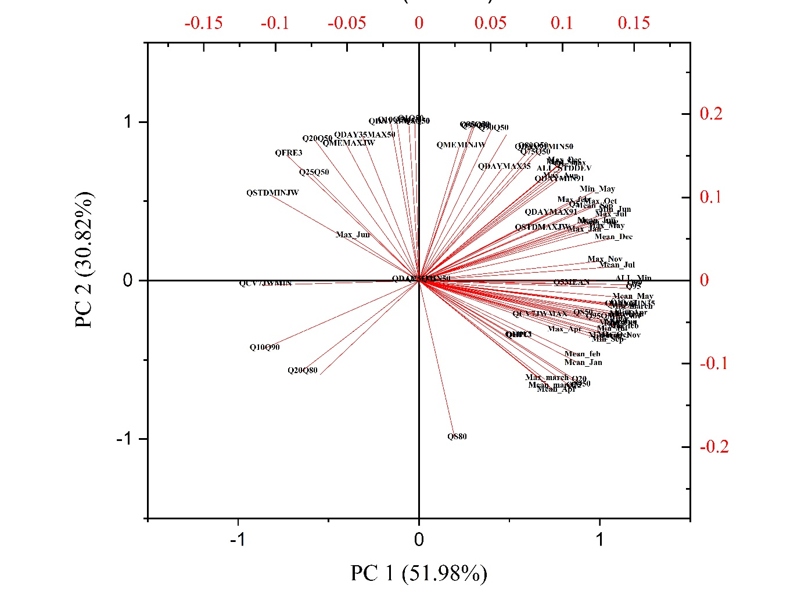

Figure S2 . PCA (axis 1 and 2) plot

S3. Partial dependency plots

These plots show the non-linear shape of the estimated relationship between the predictor variables and the response variable, when all other predictors are held at their average value

Figure S3. Partial dependency plots for species richness

Figure S4. Partial dependency plots for species abundance

Figure S5. Partial dependency plots for species diversity

Figure S6. Partial dependency plots for EPT index