Supplementary Material

A intelligent modelling framework to optimize the spatial layout of ocean buoy stations

Miaomiao Song1,2,3, Shixuan Liu1,2,3*, Shizhe Chen1,2,3*, Xiao Fu1,2,3, Shanshan Zheng1,2,3, Wei Hu1, Saiyu Gao1, Kaiyu Cheng1

1Institute of Oceanographic Instrumentation, Qilu University of Technology (Shandong Academy of Sciences), China,

2School of Ocean Technology Sciences, Qilu University of Technology (Shandong Academy of Sciences), China

3National Marine Monitoring Equipment Engineering Technology Research Center, China

**\*Correspondence:**Shixuan Liu

[lsx@sdioi.com](mailto:lsx@sdioi.com)

Shizhe Chen

chensz@qlu.edu.cn

# Supplementary Figures and Tables

## Supplementary Figures



**Figure 1. The Spatial Neighborhood Model(SNM) of ocean buoy stations**

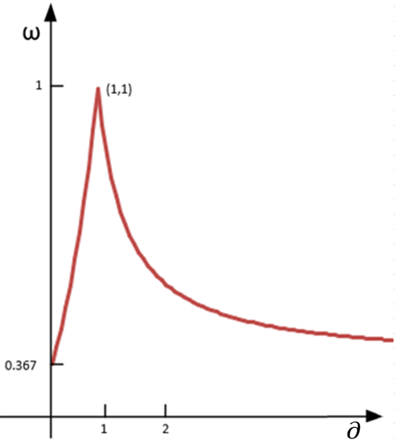

**Figure 2. Variation curve of the inertia weight factor ($ω$) according to the change rate of the objective values($∂$)**



**Figure 3. Study area and feasible solution space (red triangles are the existing buoy stations and the red polygon area is the feasible solution space)**

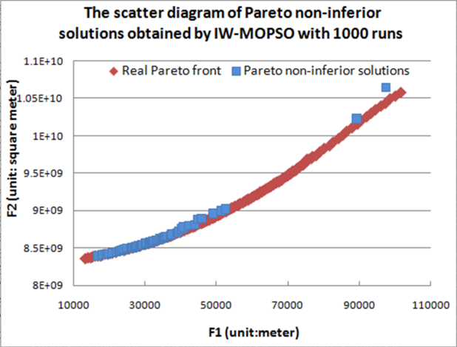 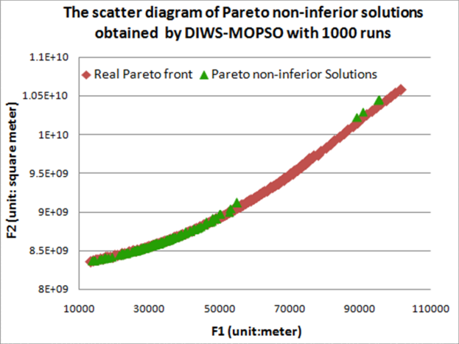

(a)Pareto non-inferior solutions of IW-MOPSO (b) Pareto non-inferior solutions of DIWS-MOPSO

**Figure 4. The scatter diagrams of Pareto non-inferior solutions obtained by IW-MOPSO and DIWS-MOPSO with 1000 runs for single buoy station location selection**

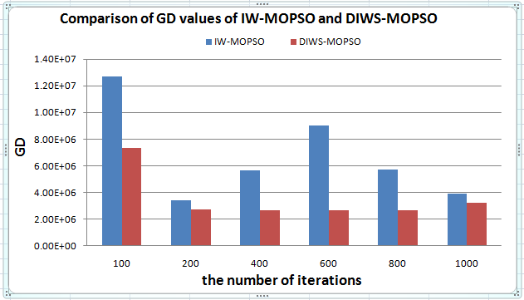

**Figure 5. Convergence comparison of IW-MOPSO and DIWS-MOPSO algorithms by GD values**

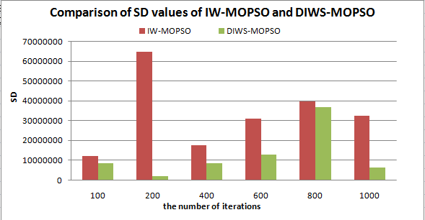

**Figure 6. SD values comparison of IW-MOPSO and DIWS-MOPSO**

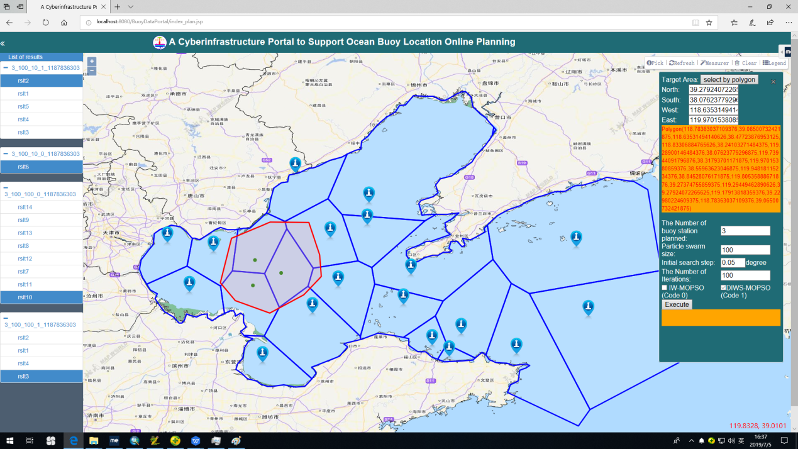

**Figure 7. Screenshot of a cyberinfrastructure portal aggregating the SNM, the ocean buoy location model and the algorithms of IW-MOPSO and DIWS-MOPSO to support ocean buoy layout planning**

1.2 Supplementary Tables

**Table 1. Comparison of selection results of multi-buoy stations location**

|  |  |  |  |  |
| --- | --- | --- | --- | --- |
| Number of buoy stations | IW-MOPSO | | DIWS-MOPSO | |
| a fine pattern | T1 | a fine pattern | T1 |
| 2 |  | 10 |  | 10 |
| 3 |  | 20 |  | 20 |
| 4 |  | 60 |  | 20 |
| 5 |  | 80 |  | 60 |
| 6 |  | 600 |  | 200 |

Note: 1. T is the number of iterations required for a fine pattern.

1. T is the number of iterations required for a fine pattern.