**Supplemental materials:**

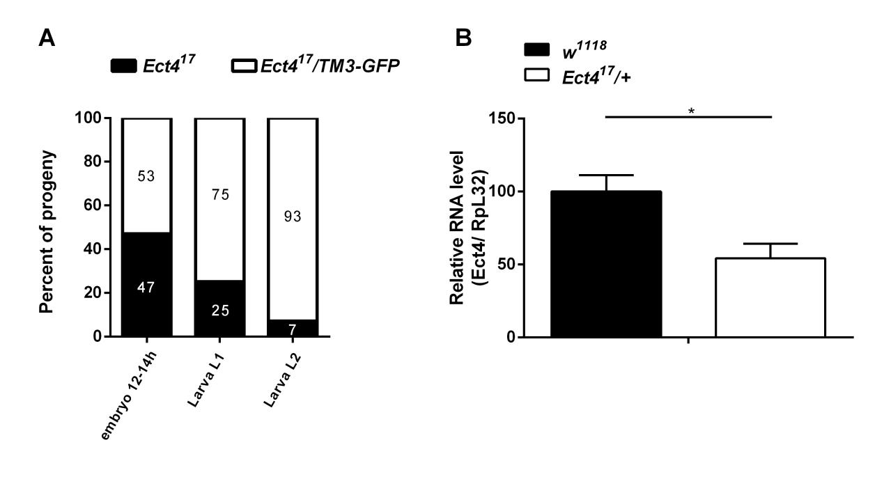

**Figure S1**. *Ect4* is required for viability during developments. (A) The ratio between *Ect4* mutant homozygous and heterozygous progeny was followed throughout development at 25℃ (n=205). (B) Expression levels of *Ect4* on 3 to 5-d-old *Ect4* heterozygous mutant (*Ect417/+*) or wild-type flies (*w1118*). Data represent the means ± standard errors of 3 independent pools of 10 male flies. *t* test : \**P*< 0.05.

Figure S2

**Figure S2**. Knockdown of *Ect4,* specifically in the fat body, altered resistance upon DCV infection. (A) Survival of flies containing knockdown of *Ect4,* specifically in the fat body by the *ppl-Gal4* driver and genetic control flies upon DCV infection. (B) Quantitative RT-PCR analysis of the accumulation of viral RNA at 48 and 72 h post-infection in flies containing knockdown of *Ect4,* specifically in the fat body and genetic control flies. (C) Quantitative RT-PCR analysis of the accumulation of viral RNA at 48 h in control flies or flies overexpressing an *Ect4* transgene in *Ect4* mutant background. *Ect4* is expressed under the control of *hs-Gal4*. *UAS-Ect4/+*; *Ect417/hs-Gal4* flies express *Ect4* after heat-shock (HS) treatment. Data represent the means ± standard errors of 3 independent pools of 15 male flies (A) or 10 male flies (B, C) for each genotype. Log-rank test (A) and *t-*test (B, C): \**P*< 0.05, \*\**P*< 0.01, \*\*\**P*< 0.001, ns, not significant.

C:\Users\ledodo\Desktop\revise\S3-tif.tifS3-tif

**Figure S3**. Knockdown of *Ect4* in flies suppressed *TotA* and *TotM* induction by DCV infection. (A) Quantitative RT-PCR analysis of the RNA level of *Ect4* to confirm RNAi efficiency. (B, C) Expression levels of *TotA* and *TotM* at 48 and 72 h in control flies or *Ect4* RNAi flies under the control of the Gal4-Gal80ts system upon DCV infection. (D, E) Expression levels of *TotA* and *TotM* at 48 and 72 h post-infection in flies containing knockdown of *Ect4,* specifically in the fat body and genetic control flies. Data represent the means ± standard errors of 3 independent pools of 10 male flies. The *t-*test: \**P*< 0.05, \*\**P*< 0.01.