Supplementary materials

Diversity and assembly of root-associated microbiomes of rubber trees

Lan Guoyu^{1,2*}, Wei Yaqing^{1,3+} , Li Yuwu⁴⁺, Wu Zhixiang^{1,2}
1. Rubber Research Institute, Chinese Academy of Tropical Agricultural Sciences, Haikou, Hainan 571101, P.R. China
2. Hainan Danzhou Tropical Agro-ecosystem National Observation and Research Station, Danzhou, Hainan 571737, P.R. China
3. College of Ecology and Environment, Hainan University, Haikou, Hainan 570228, P.R. China 4. 4. College of Landscape Architecture and Forestry,Qingdao Agricultural University, No. 700, Changcheng Road, Chengyang District, Qingdao, Shandong Province 266109, P.R. China

*Corresponding author: Lan Guoyu and Li Yuwu
Tel: +86-898-23301800
Fax: +86-898-23300315
E-mail: langyrri@163.com & liyuwu@qau.edu.cn

Supplementary materials

Figure S1 Sampling sites (18 sampling sites in total) of root-associated microbiome for rubber tree root in south China. We selected three plots in each site, and sampled in both dry season and rainy season, thus we got a total of 144 samples for each compartment.
Figure S2 Sampling design of soil (A) and rubber tree root (B). Blue solid circle is the location for soil sampling, red solid circle is the location for rubber tree root and rhizosphere soil, while the larger soil brown circle is the trunk of the rubber tree.
Figure S3 The bar plot showing significant difference in bacterial and fungal community compositions at phylum level among different compartments of rubber tree root. * p < 0.05, ** p < 0.01, *** p < 0.001
Figure S4 Beta-diversity of root-associated bacterial and fungal communities of different compartments of rubber tree root. A: PCoA ordinations based on the Bray-Curtis similarity of bacterial and fungal community beta-diversity of four compartments of root for rubber trees. Each solid circle represents an individual sample. B: Boxplots illustrate the distance to the centroid for compartments in the PCoA.
Figure S5 The bar plot showing the abundance and percentage of core bacterial and fungal community composition at phylum level across different compartments of rubber tree root. Core bacterial OTUs: present in all samples of each compartment; and with a relative abundance >0.01%. Core fungal OTUs, present in at least 60 % samples of each compartment and with a relative abundance ≥ 0.01%.
Figure S6 The bar plot showing significant difference in core bacterial and fungal community composition in each phylum arcorss different compartments of rubber tree root. Core bacterial OTUs: present in all samples of each compartment; and with a relative abundance >0.01%. Core fungal OTUs, present in at least 60 % samples of each compartment and with a relative abundance ≥ 0.01%.* p < 0.05, ** p < 0.01, *** p < 0.001.
Figure S7 The enrichment and depletion patterns of the root-associated bacterial and fungal microbiomes in each phylum in each compartment compared with soil. The y-axis represents the fold-change (FC) in abundance compared with soil, and the x-axis represents the logarithm (base10) of abundance for each phylum. Numbers on the right of the panel indicate enriched or depleted OTUs. Blue solid circles indicate endosphere, dark green solid circles indicate rhizoplane, while light blue solid circles indicate rhizosphere.
Figure S8: The bar plot showing the relative abundance fungal groups as inferred by FUNguild for different compartments of rubber tree root.
Figure S9 Network of root-associated core bacterial and fungal communities of different compartments of rubber tree root. Green solid circles represent bacteria, red solid circles represent fungi; green solid lines represent positive correlations; red solid lines represent negative correlations.
Figure S10 Number of shared and unique edges of soil bacterial and fungal networks in different compartments. The number where the two circles cross is number of shared edges.
Figure S11: Network degree of core bacterial and fungal communities for different compartments of rubber tree root.
Figure S12 Heat maps displaying pearson correlation coefficients between the environmental variables and relative abundance of bacterial phylum of different compartments of rubber tree root. SOM: soil organic matter; TN: total nitrogen; TP: total phosphorus; TK: total potassium; WC: water content; pH: soil pH. * p < 0.05, ** p < 0.01, *** p < 0.001
Figure S13 Heat maps displaying pearson correlation coefficients between the environmental variables and relative abundance of fungal phylum of different compartments of rubber tree root. SOM: soil organic matter; TN: total nitrogen; TP: total phosphorus; TK: total potassium; WC: water content; pH: soil pH. * p < 0.05, ** p < 0.01, *** p < 0.001

Table S1 Information on sampling sites of root-associated microbiome for rubber tree root in south of China.
Table S2 Analysis of similarities (ANOSIM) of the bacterial and fungal community composition among the four compartments based on Bray-Curtis distance metric
Table S3 The core enriched and depleted bacterial and fungal OTUs of in each compartment compared with soil.
Table S4 The potential sources of rubber tree root associated bacterial and fungal communities of different compartments estimated by FEAST.
Table S5 The bacterial and fungal community network edges and modularity of different compartments of rubber tree root
Table S6 The core bacterial and fungal community network edges and modularity of different compartments of rubber tree root

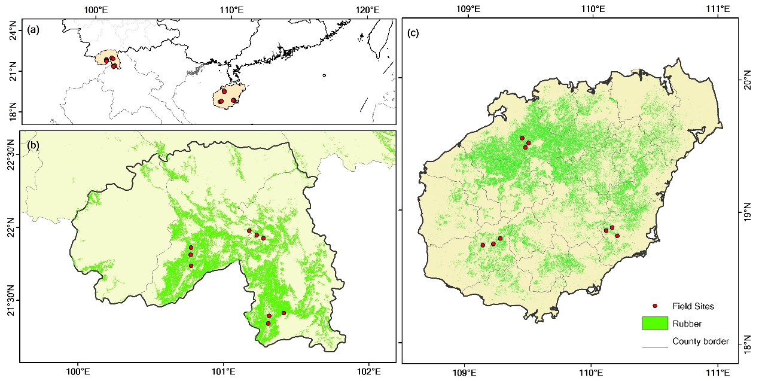
Figure S1 Sampling sites (18 sampling sites in total) of root-associated microbiome for rubber tree root in south China. We selected three plots in each site, and sampled in both dry season and rainy season, thus we got a total of 144 samples for each compartment.

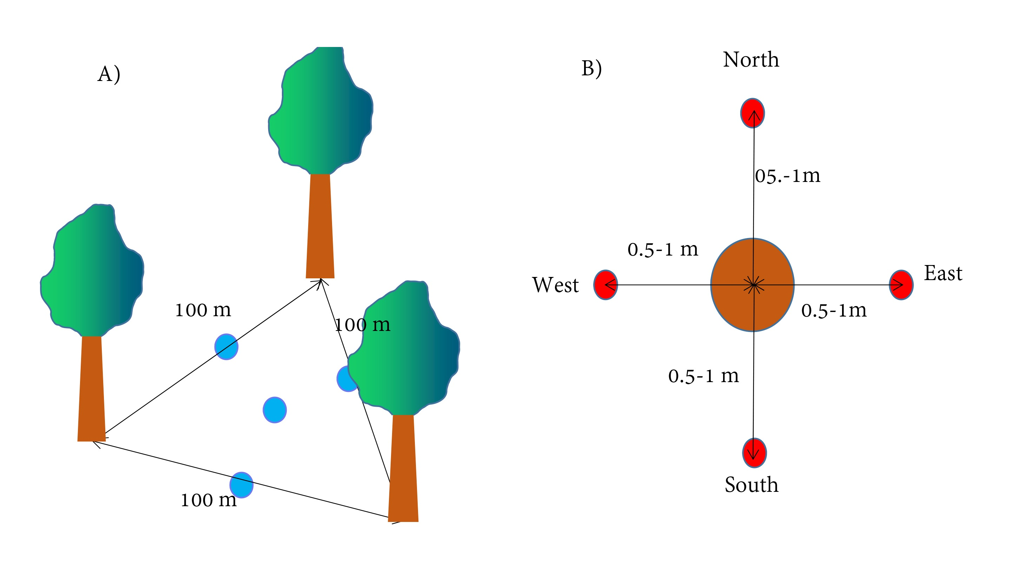
Figure S2 Sampling design of soil (A) and rubber tree root (B). Blue solid circle is the location for soil sampling, red solid circle is the location for rubber tree root and rhizosphere soil, while the larger soil brown circle is the trunk of the rubber tree.

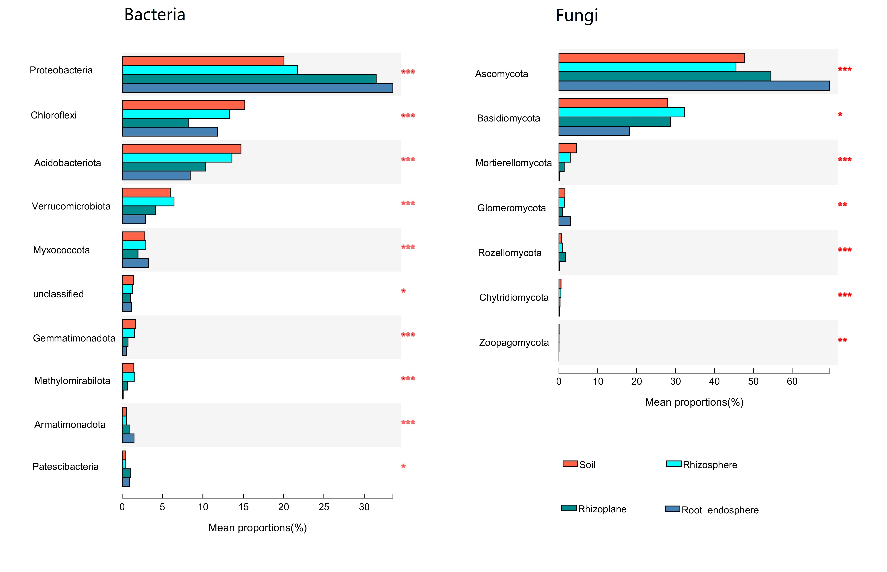
Figure S3 The bar plot showing significant difference in bacterial and fungal community compositions at phylum level among different compartments of rubber tree root. * p < 0.05, ** p < 0.01, *** p < 0.001

Figure S4 Beta-diversity of root-associated bacterial and fungal communities of different compartments of rubber tree root. A: PCoA ordinations based on the Bray-Curtis similarity of bacterial and fungal community beta-diversity of four compartments of root for rubber trees. Each solid circle represents an individual sample. B: Boxplots illustrate the distance to the centroid for compartments in the PCoA. * p < 0.05, ** p < 0.01, *** p < 0.001.

Figure S5 The bar plot showing the abundance and percentage of core bacterial and fungal community composition at phylum level across different compartments of rubber tree root. Core bacterial OTUs: present in all samples of each compartment; and with a relative abundance >0.01%. Core fungal OTUs, present in at least 60 % samples of each compartment and with a relative abundance ≥ 0.01%.

Figure S6 The bar plot showing significant difference in core bacterial and fungal community composition in each phylum among different compartments of rubber tree root. * p < 0.05, ** p < 0.01, *** p < 0.001. Core bacterial OTUs: present in all samples of each compartment; and with a relative abundance >0.01%. Core fungal OTUs, present in at least 60 % samples of each compartment and with a relative abundance ≥ 0.01%.

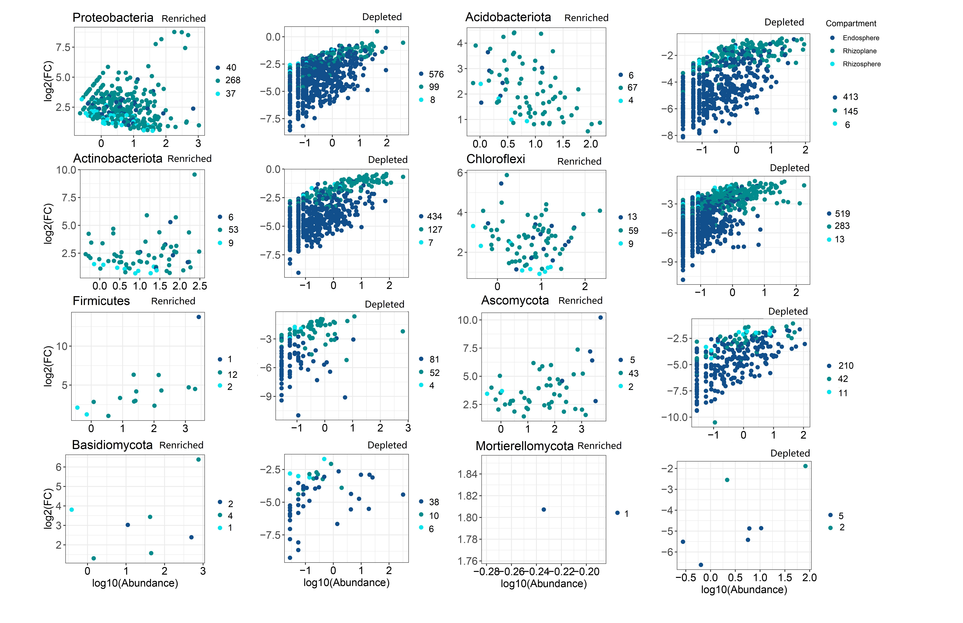 Figure S7 The enrichment and depletion patterns of the root-associated bacterial and fungal microbiomes in each phylum in each compartment compared with soil. The y-axis represents the fold-change (FC) in abundance compared with soil, and the x-axis represents the logarithm (base10) of abundance for each phylum. Numbers on the right of the panel indicate enriched or depleted OTUs. Blue solid circles indicate endosphere, dark green solid circles indicate rhizoplane, while light blue solid circles indicate rhizosphere.

Figure S8: The barplot showing the relative abundance fungal groups as inferred by FUNguild for different compartments of rubber tree root.

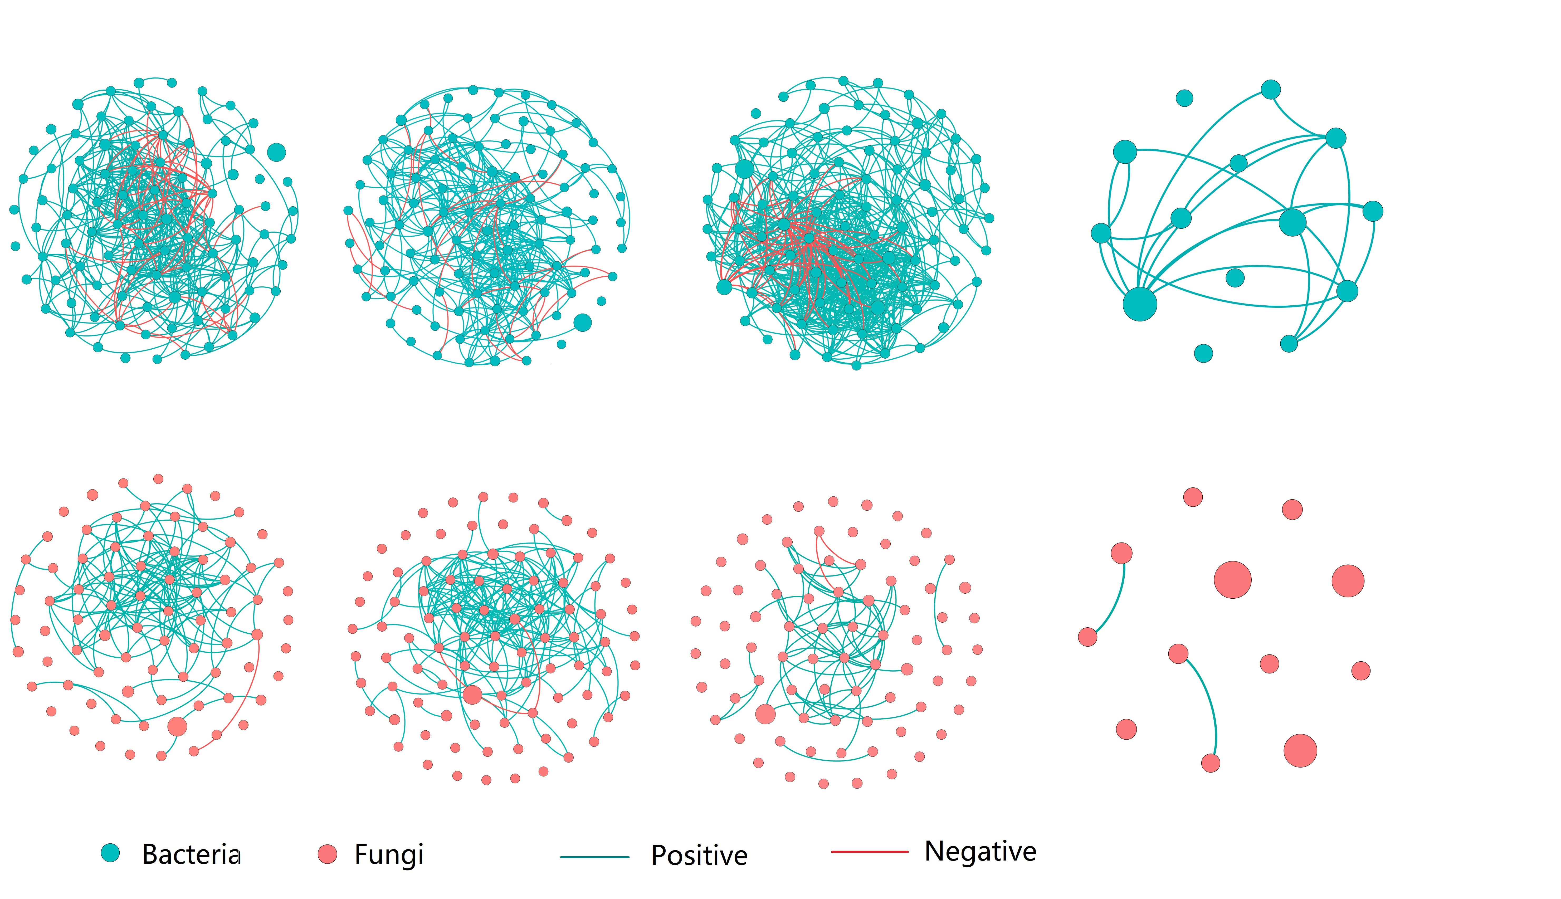
Figure S9 Network of root-associated core bacterial and fungal communities of different compartments of rubber tree root. Green solid circles represent bacteria, red solid circles represent fungi; green solid lines represent positive correlations; red solid lines represent negative correlations.

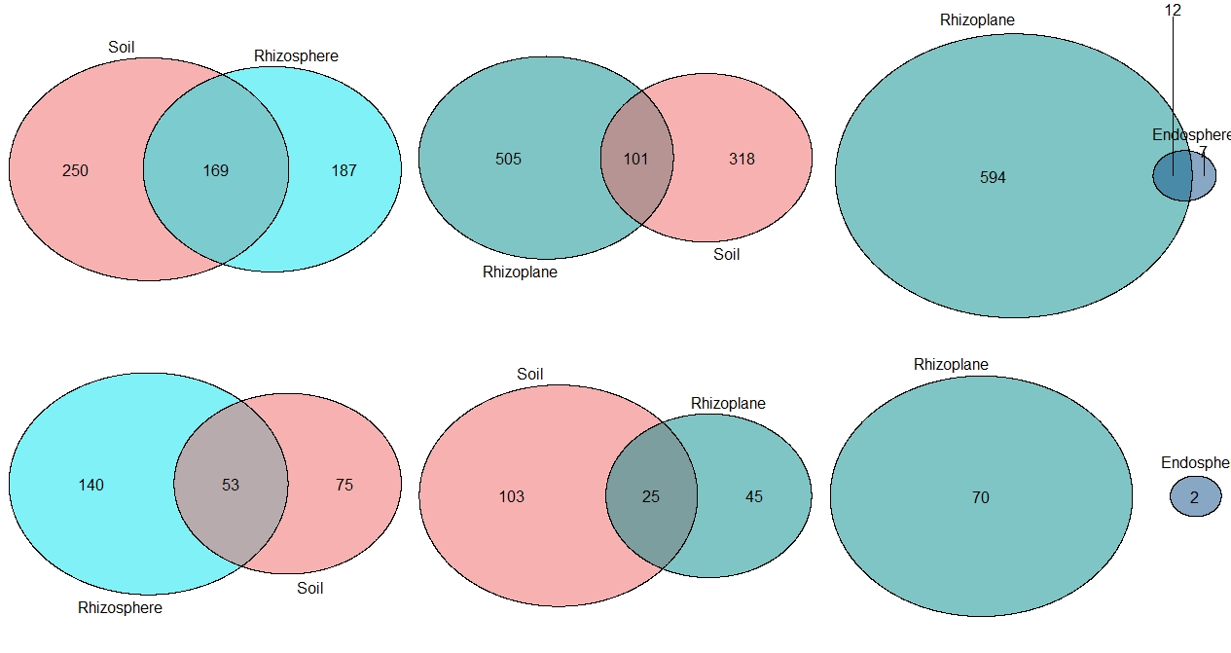
Figure S10 Number of shared and unique edges of soil bacterial and fungal networks in different compartments. The number where the two circles cross is number of shared edges.

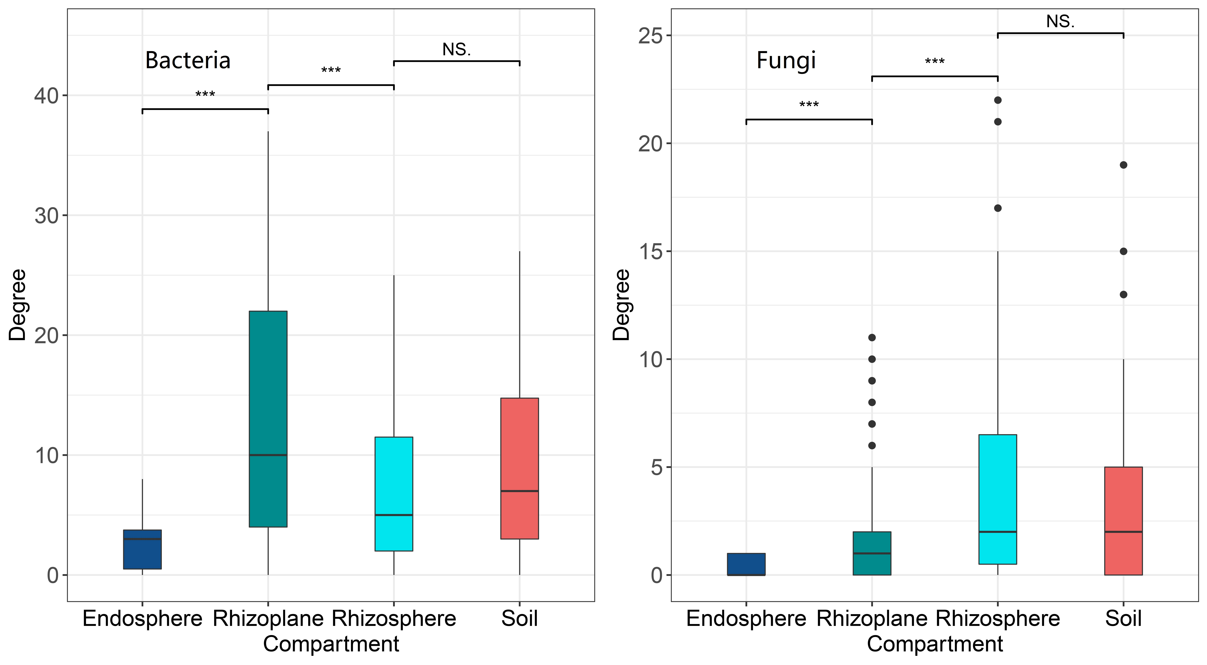
Figure S11: Network degree of core bacterial and fungal communities for different compartments of rubber tree root. * p < 0.05, ** p < 0.01, *** p < 0.001

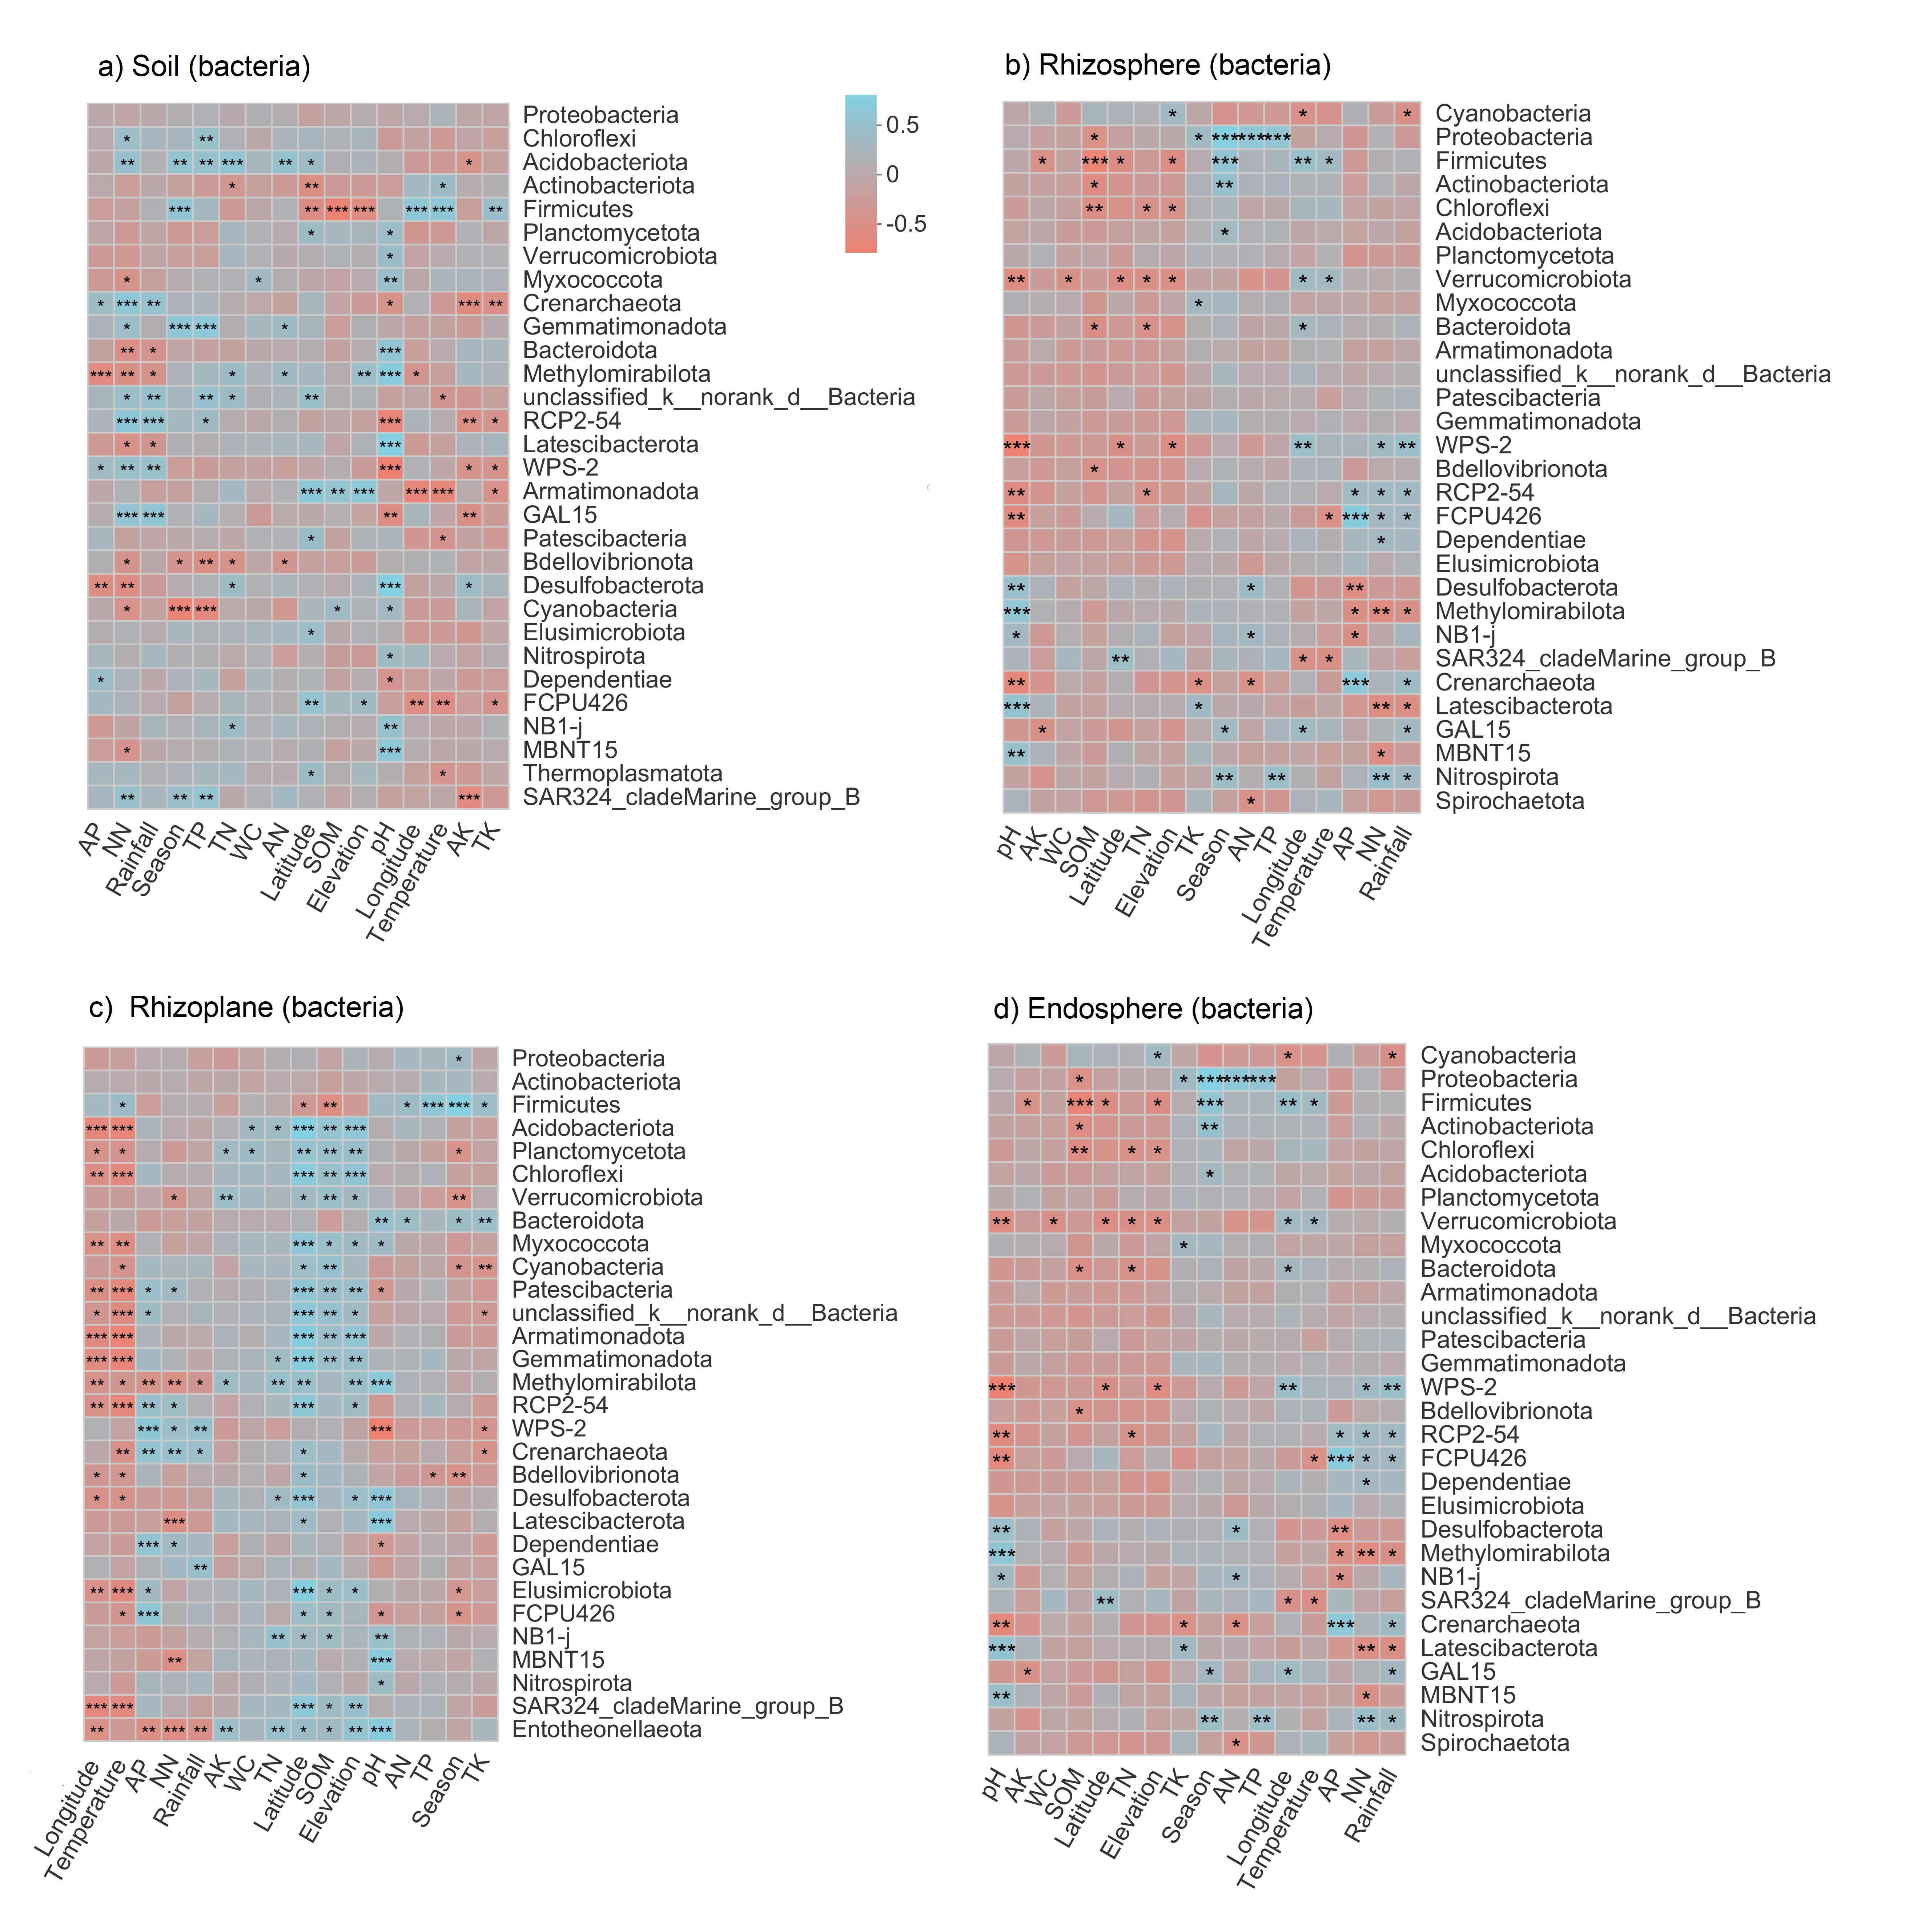
Figure S12 Heat maps displaying pearson correlation coefficients between the environmental variables and relative abundance of bacterial phylum of different compartments of rubber tree root. SOM: soil organic matter; TN: total nitrogen; TP: total phosphorus; TK: total potassium; WC: water content; pH: soil pH. * p < 0.05, ** p < 0.01, *** p < 0.001

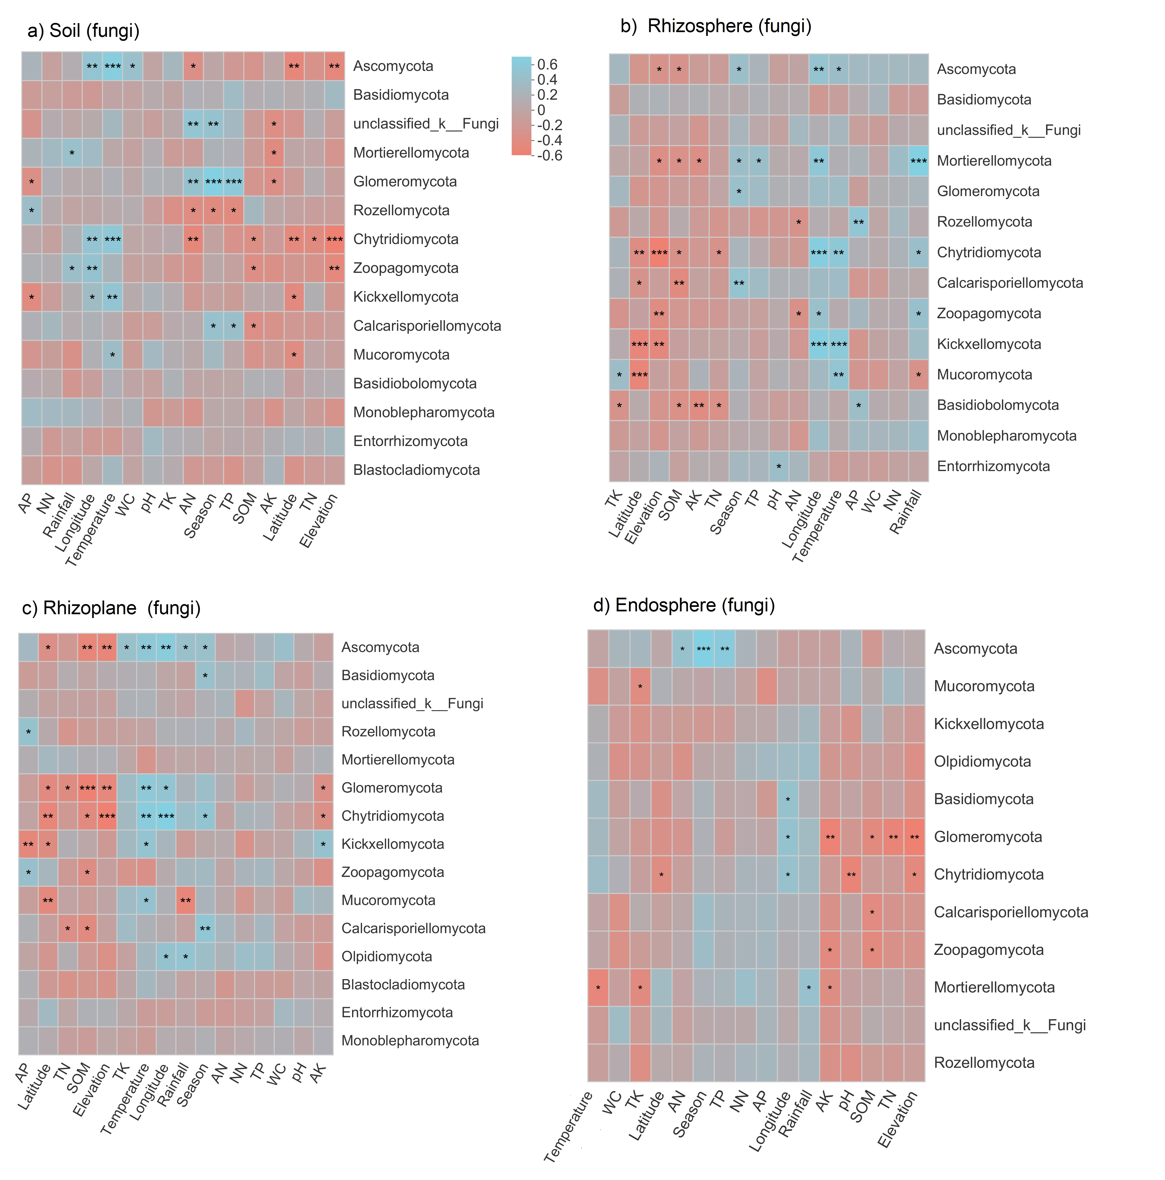
Figure S13 Heat maps displaying pearson correlation coefficients between the environmental variables and relative abundance of fungal phylum of different compartments of rubber tree root. SOM: soil organic matter; TN: total nitrogen; TP: total phosphorus; TK: total potassium; WC: water content; pH: soil pH. * p < 0.05, ** p < 0.01, *** p < 0.001

Table S1 Information on sampling sites of root-associated microbiome for rubber tree root in south of China
Plot | Site | Longitude | Latitude | Rainfall  （mm） | Temperature  （℃） | Elevation（m）
1 | Danzhou | 109° 29'27.4" | 19° 31'09" | 1856.02 | 23.67 | 134
2 | Danzhou | 109° 26'25" | 19° 33'19.6" | 1856.02 | 23.67 | 110
3 | Danzhou | 109° 28'1.8" | 19° 29'5.1" | 1856.02 | 23.67 | 159
4 | Wanning | 110° 12'7.9" | 18° 49'19.3" | 1858.83 | 24.73 | 162
5 | Wanning | 110° 9'36.2" | 18° 53'3.0" | 1858.83 | 24.73 | 166
6 | Wanning | 110° 6'47.5" | 18° 51'38.6" | 1858.83 | 24.73 | 160
7 | Ledong | 109°8'9.6" | 18° 44'35.2" | 1189.12 | 25.29 | 165
8 | Ledong | 109° 13'9" | 18°45'16.6" | 1189.12 | 25.29 | 174
9 | Ledong | 109° 16'27.1" | 18° 47'44.6" | 1189.12 | 25.29 | 173
10 | Jinghong | 100° 46'44.6" | 21° 51'40.8" | 1513.75 | 21.58 | 651
11 | Jinghong | 100° 46'31.4" | 21° 48'45.3" | 1513.75 | 21.58 | 630
12 | Jinghong | 100° 46'44.8" | 21°44'12.6" | 1513.75 | 21.58 | 635
13 | Menglun | 101° 13'46.8" | 21°56'52.9" | 1513.75 | 21.58 | 618
14 | Menglun | 101° 10'42.1" | 21°58'39.7" | 1513.75 | 21.58 | 1069
15 | Menglun | 101°16'28.5" | 21°55'34.2" | 1513.75 | 21.58 | 549
16 | Mengpeng | 101°24'58.1" | 21°24'39.9" | 1513.75 | 21.58 | 619
17 | Mengpeng | 101°18'56" | 21°23'33.2" | 1513.75 | 21.58 | 600
18 | Mengpeng | 101°18'30.6" | 21°20'26.8" | 1513.75 | 21.58 | 615

Table S2 Analysis of similarities (ANOSIM) of the bacterial and fungal community composition among the four compartments based on Bray-Curtis distance metric

Group | Bacteria |  | Fungi
 | R-statistics | P-value | R-statistics | P-value
Soil-rhizosphere | 0.0081 | 0.792 | 0.0226 | 0.987
Soil-rhizoplane | 0.2549 | 0.001 | 0.1105 | 0.001
Soil-endosphere | 0.9996 | 0.001 | 0.5855 | 0.001
Rhizosphere-rhizoplane | 0.2267 | 0.001 | 0.0755 | 0.002
Rhizospere-endosphere | 0.9993 | 0.001 | 0.5150 | 0.001
Rhizoplane-endosphere | 0.9852 | 0.001 | 0.3096 | 0.001

Table S3 The core enriched and depleted bacterial and fungal OTUs of in each compartment compared with soil.
ID | Abundance | FC | p-value | Class | Phylum | Compartment | Enrich/Depleted | Taxon
OTU15880 | 20 | 0.03 | 0 | Alphaproteobacteria | Proteobacteria | Endosphere | Depleted | Bacteria
OTU15005 | 93 | 0.12 | 0 | Alphaproteobacteria | Proteobacteria | Endosphere | Depleted | Bacteria
OTU10109 | 24 | 0.12 | 0 | Actinobacteria | Actinobacteriota | Endosphere | Depleted | Bacteria
OTU15123 | 71 | 0.14 | 0 | Actinobacteria | Actinobacteriota | Endosphere | Depleted | Bacteria
OTU17119 | 91 | 0.5 | 0.0035 | Alphaproteobacteria | Proteobacteria | Endosphere | Depleted | Bacteria
OTU12092 | 46 | 0.58 | 0.0411 | Acidobacteriae | Acidobacteriota | Endosphere | Depleted | Bacteria
OTU15285 | 129 | 0.13 | 0.0002 | AD3 | Chloroflexi | Rhizoplane | Depleted | Bacteria
OTU15078 | 56 | 0.14 | 0.0009 | AD3 | Chloroflexi | Rhizoplane | Depleted | Bacteria
OTU11222 | 638 | 0.22 | 0.003 | Bacilli | Firmicutes | Rhizoplane | Depleted | Bacteria
OTU25337 | 85 | 0.34 | 0 | Acidobacteriae | Acidobacteriota | Rhizoplane | Depleted | Bacteria
OTU10109 | 79 | 0.41 | 0.0001 | Actinobacteria | Actinobacteriota | Rhizoplane | Depleted | Bacteria
OTU14878 | 114 | 0.44 | 0.0003 | Actinobacteria | Actinobacteriota | Rhizoplane | Depleted | Bacteria
OTU8703 | 91 | 0.45 | 0.0001 | Acidobacteriae | Acidobacteriota | Rhizoplane | Depleted | Bacteria
OTU8927 | 89 | 0.45 | 0.0229 | Verrucomicrobiae | Verrucomicrobiota | Rhizoplane | Depleted | Bacteria
OTU12917 | 177 | 0.47 | 0.0058 | TK10 | Chloroflexi | Rhizoplane | Depleted | Bacteria
OTU24572 | 57 | 0.6 | 0.0066 | Thermoleophilia | Actinobacteriota | Rhizoplane | Depleted | Bacteria
OTU22408 | 64 | 0.61 | 0.0329 | Actinobacteria | Actinobacteriota | Rhizoplane | Depleted | Bacteria
OTU15123 | 310 | 0.63 | 0.0395 | Actinobacteria | Actinobacteriota | Rhizoplane | Depleted | Bacteria
OTU25910 | 75 | 0.65 | 0.0393 | Thermoleophilia | Actinobacteriota | Rhizoplane | Depleted | Bacteria
OTU23596 | 62 | 0.66 | 0.0043 | Thermoleophilia | Actinobacteriota | Rhizoplane | Depleted | Bacteria
OTU12107 | 111 | 0.67 | 0.0442 | Verrucomicrobiae | Verrucomicrobiota | Rhizoplane | Depleted | Bacteria
OTU15880 | 396 | 0.69 | 0.0451 | Alphaproteobacteria | Proteobacteria | Rhizoplane | Depleted | Bacteria
OTU16555 | 78 | 0.75 | 0.0451 | Thermoleophilia | Actinobacteriota | Rhizoplane | Depleted | Bacteria
OTU19352 | 88 | 1.45 | 0.0308 | Acidobacteriae | Acidobacteriota | Rhizoplane | Enriched | Bacteria
OTU14337 | 104 | 1.77 | 0.0166 | Acidobacteriae | Acidobacteriota | Rhizoplane | Enriched | Bacteria
OTU11019 | 197 | 1.81 | 0.0105 | Alphaproteobacteria | Proteobacteria | Rhizoplane | Enriched | Bacteria
OTU12092 | 146 | 1.83 | 0.0065 | Acidobacteriae | Acidobacteriota | Rhizoplane | Enriched | Bacteria
OTU22472 | 115 | 1.89 | 0.006 | Gammaproteobacteria | Proteobacteria | Rhizoplane | Enriched | Bacteria
OTU25900 | 139 | 1.9 | 0.0002 | Planctomycetes | Planctomycetota | Rhizoplane | Enriched | Bacteria
OTU11184 | 122 | 1.96 | 0 | Actinobacteria | Actinobacteriota | Rhizoplane | Enriched | Bacteria
OTU11097 | 1046 | 2 | 0 | Alphaproteobacteria | Proteobacteria | Rhizoplane | Enriched | Bacteria
OTU17119 | 426 | 2.33 | 0.0002 | Alphaproteobacteria | Proteobacteria | Rhizoplane | Enriched | Bacteria
OTU7574 | 185 | 2.34 | 0.0006 | Actinobacteria | Actinobacteriota | Rhizoplane | Enriched | Bacteria
OTU6741 | 439 | 2.47 | 0 | Gammaproteobacteria | Proteobacteria | Rhizoplane | Enriched | Bacteria
OTU9031 | 2027 | 22.81 | 0.0011 | Bacilli | Firmicutes | Rhizoplane | Enriched | Bacteria
OTU19166 | 321 | 0.05 | 0 | Tremellomycetes | Basidiomycota | Endosphere | Depleted | Fungi
OTU21161 | 56 | 0.1 | 0.001 | Sordariomycetes | Ascomycota | Endosphere | Depleted | Fungi
OTU14075 | 110 | 0.12 | 0.0001 | Sordariomycetes | Ascomycota | Endosphere | Depleted | Fungi
OTU10729 | 33 | 0.29 | 0.0233 | Dothideomycetes | Ascomycota | Endosphere | Depleted | Fungi
OTU541 | 496 | 5.26 | 0.025 | Tremellomycetes | Basidiomycota | Endosphere | Enriched | Fungi
OTU11507 | 3306 | 7 | 0.03 | Dothideomycetes | Ascomycota | Endosphere | Enriched | Fungi
OTU11930 | 2459 | 84.88 | 0.0376 | Sordariomycetes | Ascomycota | Endosphere | Enriched | Fungi
OTU19112 | 27 | 0.39 | 0.0165 | Sordariomycetes | Ascomycota | Rhizoplane | Depleted | Fungi
OTU10753 | 44 | 0.47 | 0.0251 | Sordariomycetes | Ascomycota | Rhizoplane | Depleted | Fungi
OTU11507 | 1408 | 2.98 | 0.0047 | Dothideomycetes | Ascomycota | Rhizoplane | Enriched | Fungi
OTU11578 | 220 | 3.64 | 0.0269 | Dothideomycetes | Ascomycota | Rhizoplane | Enriched | Fungi
OTU11761 | 152 | 9.95 | 0.0003 | Sordariomycetes | Ascomycota | Rhizoplane | Enriched | Fungi
OTU11536 | 505 | 36.11 | 0.0002 | Sordariomycetes | Ascomycota | Rhizoplane | Enriched | Fungi
OTU11930 | 1098 | 37.91 | 0.0068 | Sordariomycetes | Ascomycota | Rhizoplane | Enriched | Fungi

Table S4 The potential sources of rubber tree root associated bacterial and fungal communities of different compartments estimated by FEAST.
Taxon | Sink | Source1 | Source2 | Source3 | Source4
Bacteria | Soil | Rhizosphere  (50.05%) | Rhizoplane  (17.68%) | Endosphere  (4.35%) | Unknown  (27.92)
 | Rhizosphere | Soil  (48.03%) | Rhizoplane  (21.64%) | Endosphere  (5.84%) | Unknown  (24.49%)
 | Rhizoplane | Rhizosphere  (25.58%) | Endosphere  (18.69%) | Soil  （20.64%） | Unknown  （35.09%）
 | Endosphere | Rhizoplane  （36.28%） | Rhizosphere  （19.22%） | Soil  （7.32%） | Unknown  （37.18%）
Fungi | Soil | Rhizosphere  (70.60%) | Rhizoplane  (18.00%) | Endosphere  (1.50%) | Unknown  (9.90%)
 | Rhizosphere | Soil  (56.73%) | Rhizoplane  (35.50%) | Endosphere  (0.83%) | Unknown  (6.94%)
 | Rhizoplane | Rhizosphere  (50.60%) | Endosphere  (20.00%) | Soil  （20.60%） | Unknown  （8.80%）
 | Endosphere | Rhizoplane  （88.87%） | Rhizosphere  （2.50%） | Soil  （1.90%） | Unknown  （6.73%）

Table S5 The bacterial and fungal community network edges and modularity of different compartments of rubber tree root.
Taxon | Compartments | Total edges | Positive | Negative | Ratio (Negative/Positive) | Modularity
Bacteria | Soil | 10594 | 7267 | 3327 | 45.78 | 0.261
 | Rhizosphere | 8609 | 5809 | 2800 | 48.20 | 0.344
 | Rhizoplane | 10092 | 9017 | 1097 | 12.17 | 0.430
 | Endosphere | 4727 | 4727 | 0 | 0 | 0.427
 | Soil | 1508 | 1468 | 40 | 2.72% | 0.725
Fungi | Rhizosphere | 1775 | 1660 | 115 | 6.93% | 0.615
 | Rhizoplane | 1248 | 1186 | 62 | 5.23% | 0.695
 | Endosphere | 1193 | 1192 | 1 | 0.08% | 0.792

Table S6 The core bacterial and fungal community network edges and modularity of different compartments of rubber tree root.
Taxon | Compartments | Number of nodes | Total edges | Positive | Negative | Ratio (Negative/Positive) | Modularity
Bacteria | Soil | 94 | 419 | 365 | 54 | 14.79 | 0.362
 | Rhizosphere | 99 | 356 | 330 | 26 | 7.88 | 0.465
 | Rhizoplane | 90 | 606 | 547 | 59 | 10.79 | 0.303
 | Endosphere | 14 | 19 | 19 | 0 | 0 | 0.216
 | Soil | 79 | 128 | 127 | 1 | 0.79 | 0.433
Fungi | Rhizosphere | 91 | 193 | 191 | 2 | 1.04 | 0.329
 | Rhizoplane | 77 | 71 | 69 | 2 | 2.90 | 0.473
 | Endosphere | 12 | 2 | 2 | 0 | 0 | 0.500

