Supplementary Material

Assessing the Efficacy of Probiotics in Augmenting Bovine Reproductive Health: An Integrated In Vitro, In Silico, and In Vivo Study
Purva Gohil¹, Bhavya Nanavati¹, Kajal Patel¹, Vishal Suthar^{2*}, Madhvi Joshi^{1*}, Deepak B Patil², Chaitanya G Joshi¹
*Correspondence:
- Dr. Madhvi Joshi,
Scientist-D and Joint Director,
Gujarat Biotechnology Research Centre (GBRC), Gandhinagar,
Department of Science and Technology, Government of Gujarat, India.
Phone: +91- 99784 41233
Email: madhvimicrobio@gmail.com
ORCID: orcid.org/0000-0003-4102-7114
- Dr. Vishal Suthar,
Directorate of Research,
Kamdhenu University,
Sector 10 A, Gandhinagar, Gujarat, India 382010
Phone: +91-98244 91049
Email: vsuthar28@gmail.com
ORCID: orcid.org/0000-0002-2136-4060

Supplementary Figures

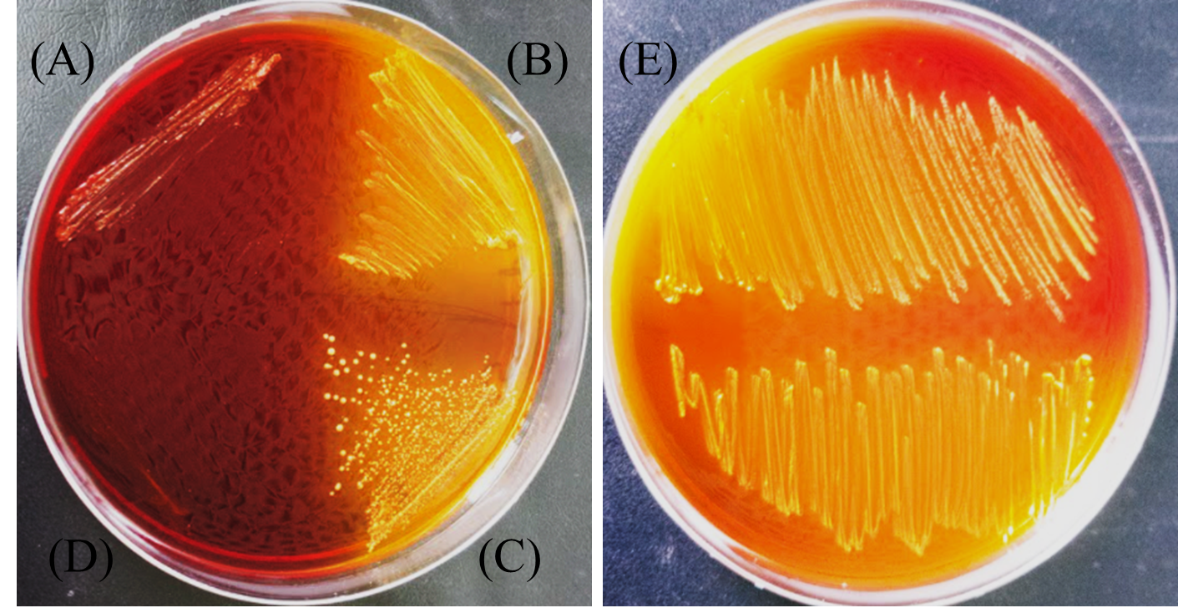

Supplementary Figure 1. Acid production capacity of probiotic isolates showing yellow coloration surrounding cell growth on the MRS agar plate supplemented with (0.017% W/V) bromocresol purple (A) Acid production capacity of negative control - S. aureus. (B) Acid production capacity of Sample A. (C) Acid production capacity of Sample B. (D) Acid production capacity of negative control - E. coli. (E) Acid production capacity of positive control - Lactobacillus rhamnosus.

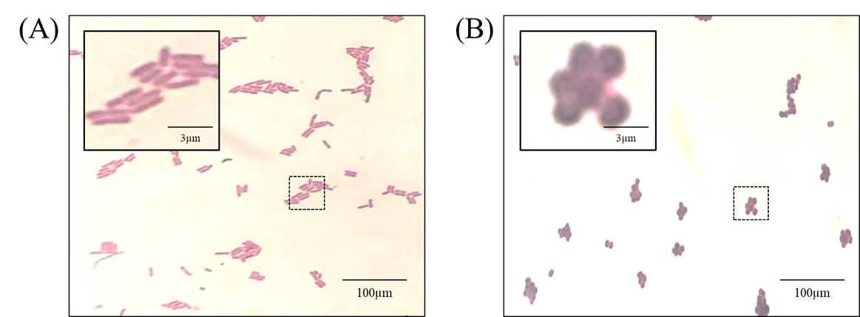

Supplementary Figure 2. Gram’s staining of Sample A and B under light microscope with magnification of 100x, using oil immersion lens. (A) Sample A – Gram positive rods and (B) Sample B – Gram positive cocci.

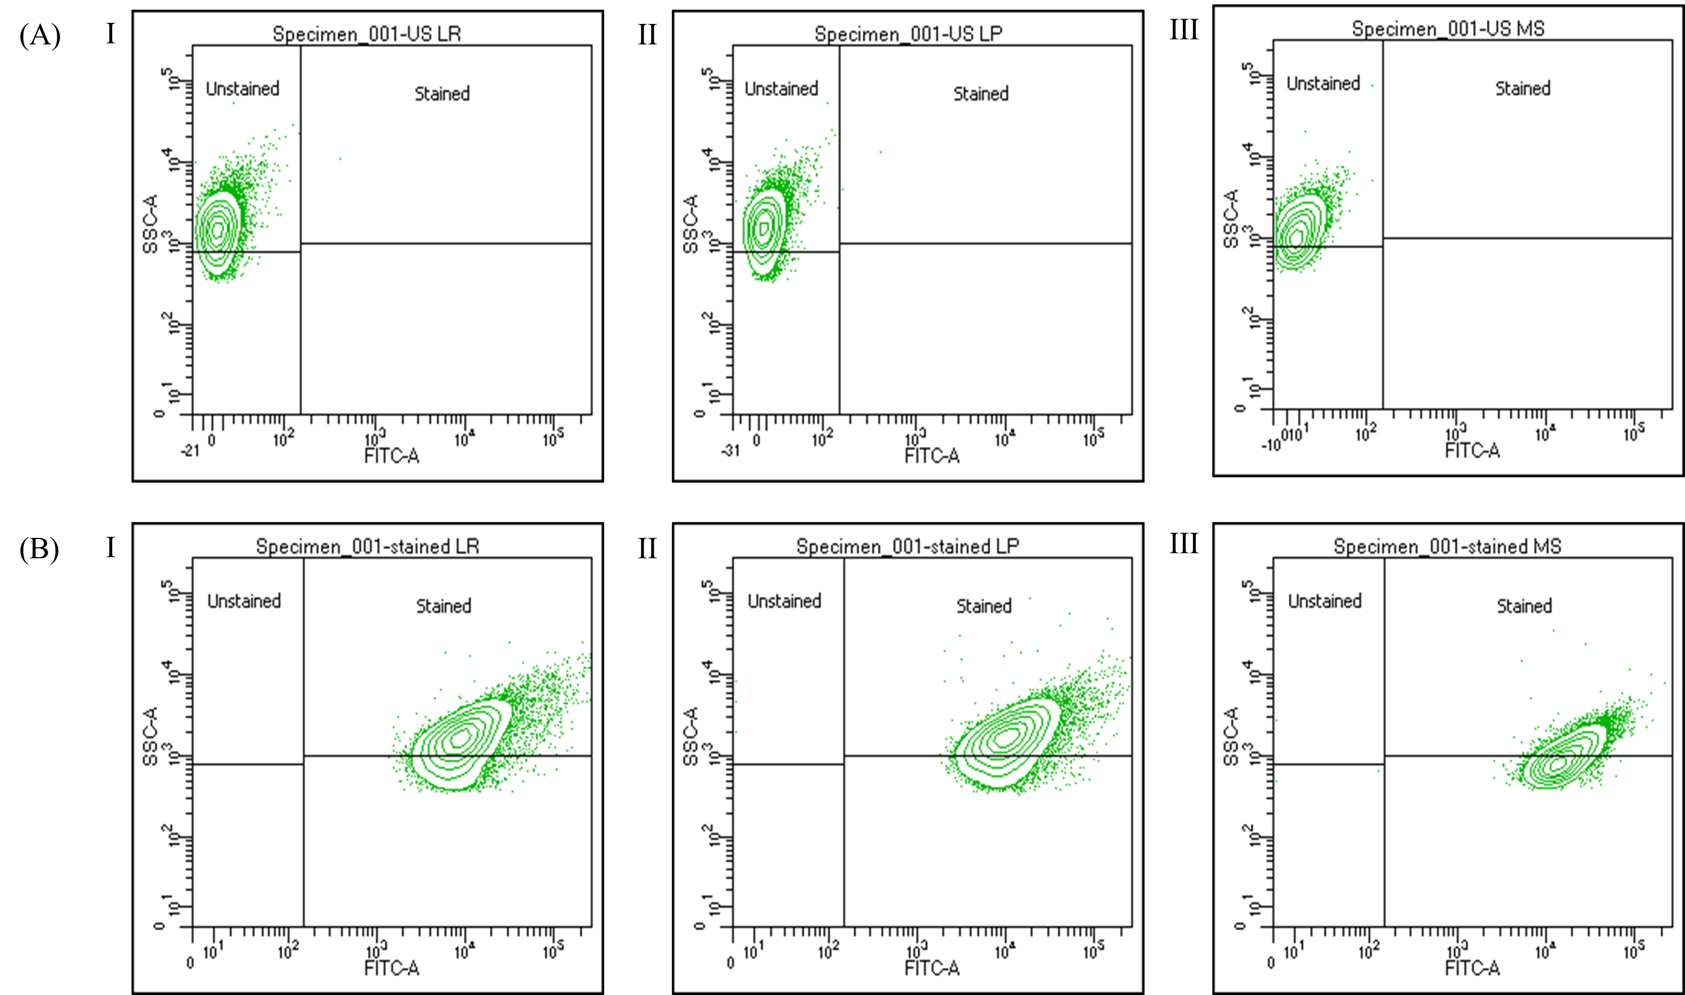
Supplementary Figure 3. Cell Adhesion Assay:
Labelling of the probiotic bacterial cells with CFDA-SE and analyzing (A) Unstained cells as well as (B) Stained cells
- is showing Lactobacillus rhamnosus cells
- is showing Lactiplantibacillus plantarum cells, while
- is showing Pediococcus pentosaceus cells
The efficiency of the CFDA-SE labelling was analyzed by measuring the fluorescence of the bacteria using FITC channel.

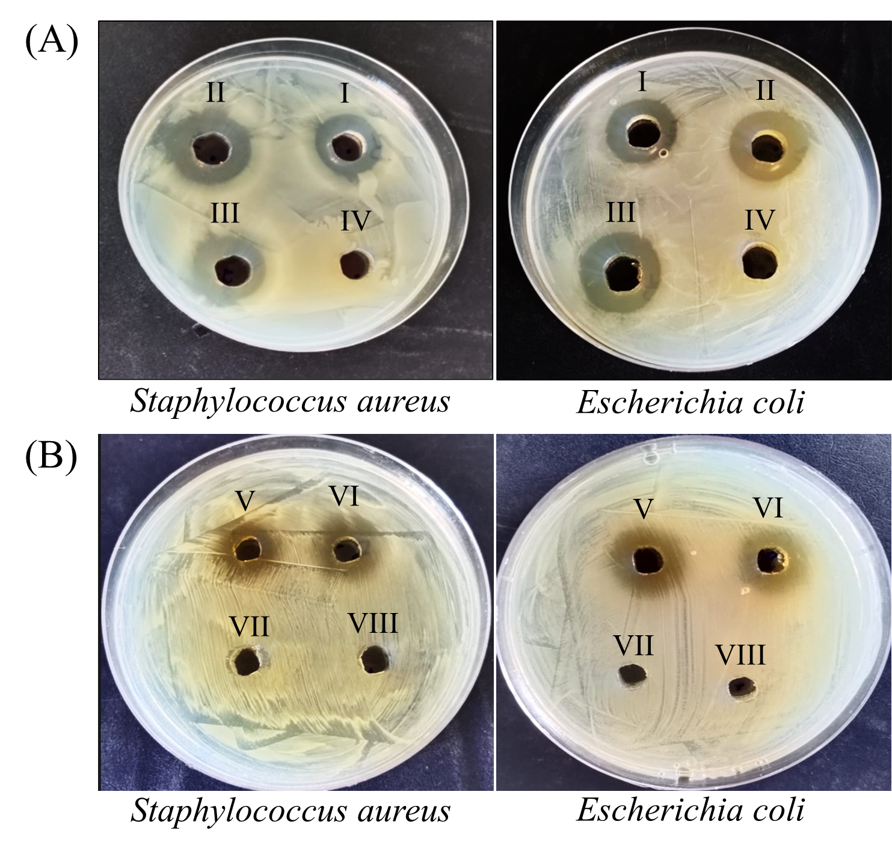
Figure 4. In vitro anti-microbial activity of sample A and sample B against pathogenic Escherichia coli and Staphylococcus aureus. (A) Concentrated CFS (65°C, 1.5 hours) from sample A and B produces a clear zone against pathogenic Escherichia coli and Staphylococcus aureus. Where (I) CFS of sample B; (II) CFS of sample A; (III) CFS of Positive control - Lactobacillus rhamnosus; (IV) Negative control – MRS broth. (B) 80% ammonium sulphate precipitation of sample A and B showing inhibitory effect against the pathogenic E. coli and S. aureus, while no zone was observed in CFS neutralized at pH7. Where (V) partially purified bacteriocin of sample B; (VI) partially purified bacteriocin of sample A; (VII) CFS of sample B at pH7; (VIII) CFS of sample A at pH7.

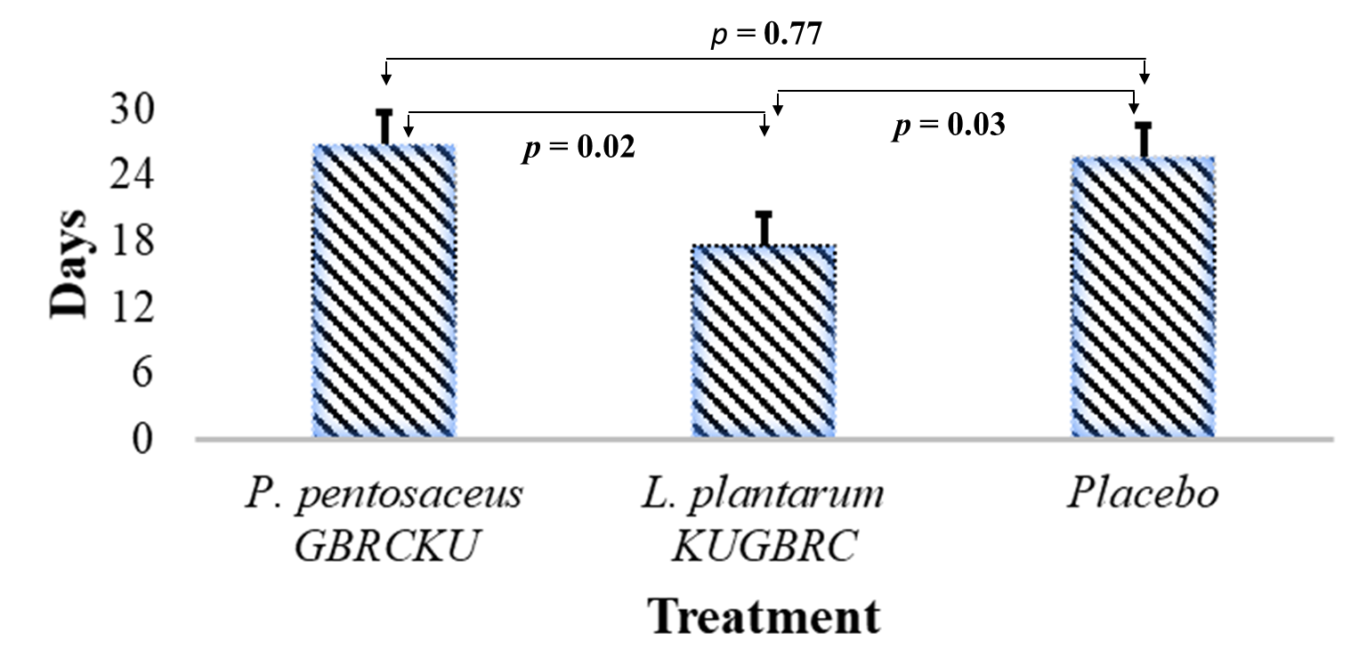

Figure 5: In vivo Assay: Effect of P. pentosaceus GBRCKU (n= 23), L. plantarum GBRCKU (n =40) and placebo (n =29) treatment on duration between administration of probiotics to induction of estrus in buffaloes. Line with p value shows the significance level in the graph.

- Supplementary Tables
Supplementary Table 1. A description of each differentially abundant enzyme between Sample A and Sample B
CAZy families | Enzyme family | Enzyme name | Putative enzymatic activities | L. plantarum KUGBRC | P. pentosaceus GBRCKU
AA4 | Auxiliary Activity | vanillyl-alcohol oxidase | 1.1.3.38 | 1 | 0
AA10 | Auxiliary Activity | lytic xylan monooxygenase / xylan oxidase (glycosidic bond-cleaving) | 1.14.99.- | 0 | 0
CE20 | Carbohydrate Esterase | xyloglucan acetylesterase (XAC1771) | 3.1.1.6 | 0 | 1
CE2 | Carbohydrate Esterase | acetyl xylan esterase | 3.1.1.72 | 1 | 1
CE4 | Carbohydrate Esterase | peptidoglycan GlcNAc deacetylase | 3.5.1.- | 1 | 0
CE1 | Carbohydrate Esterase | acetyl xylan esterase | 3.1.1.72 | 2 | 0
CE9 | Carbohydrate Estrase | N-acetylglucosamine 6-phosphate deacetylase | 3.5.1.25 | 1 | 2
GH13_29 | Glycoside Hydrolase | α-amylase | - | 1 | 1
GH2 | Glycoside Hydrolase | β-galactosidase | 3.2.1.23 | 1 | 1
GH43_26 | Glycoside Hydrolase | β-xylosidase | 3.2.1.- | 0 | 2
GH170 | Glycoside Hydrolase | 6-phospho-N-acetylmuramidase | 3.2.1.- | 2 | 1
GH125 | Glycoside Hydrolase | exo-α-1,6-mannosidase | 3.2.1.163 | 0 | 0
GH20 | Glycoside Hydrolase | family 20 glycosylhydrolase | 3.2.1.- | 0 | 0
GH85_CB | Glycoside Hydrolase | endo-β-N-acetylglucosaminidase | 3.2.1.96 | 0 | 0
GH42 | Glycoside Hydrolase | β-galactosidase | 3.2.1.23 | 1 | 0
CBM34_GH1 | Glycoside Hydrolase | alpha-glycosidase | - | 1 | 0
GH13_39 | Glycoside Hydrolase | α-amylase | 3.2.1.1 | 1 | 0
GH78 | Glycoside Hydrolase | α-L-rhamnosidase | 3.2.1.40 | 2 | 2
GH38 | Glycoside Hydrolase | α-mannosidase | 3.2.1.24 | 1 | 0
GH25 | Glycoside Hydrolase | lysozyme | 3.2.1.17 | 6 | 2
GH13_31 | Glycoside Hydrolase | α-amylase | - | 4 | 0
GH126 | Glycoside Hydrolase | α-amylase | 3.2.1.- | 0 | 1
GH73 | Glycoside Hydrolase | lysozyme | 3.2.1.17 | 2 | 2
GH13 | Glycoside Hydrolase | maltogenic α-amylase |  | 1 | 0
GH65 | Glycoside Hydrolase | α,α-trehalase | 3.2.1.28 | 4 | 1
GH92 | Glycoside Hydrolase Family | alpha-mannosidase | 3.2.1.- | 0 | 0
GT8 | Glycosyl transferase | peptidase | - | 0 | 2
GT51 | GlycosylTransferase | murein polymerase | 2.4.1.129 | 2 | 2
GT35 | GlycosylTransferase | glycogen or starch phosphorylase | 2.4.1.1 | 1 | 0
GT5 | GlycosylTransferase | UDP-Glc: glycogen glucosyltransferase | 2.4.1.- | 1 | 0
GT26 | GlycosylTransferase | UDP-ManNAcA: β-N-acetyl mannosaminuronyltransferase | 2.4.1.- | 1 | 1
GT28 | GlycosylTransferase | beta-N-acetylglucosaminyltransferase | 2.4.1.- | 1 | 1
GT113 | GlycosylTransferase | Glucosyltransferase | 2.4.1.- | 0 | 1

Supplementary Table 2. Unique genes from pangenome analysis for the strains P. pentosaceus GBRCKU and L. plantarum KUGBRC
Pfam_ACC | Pfam_ID | No. of gene count
P. pentosaceus GBRCKU
PF04371.18 | Porphyromonas-type peptidyl-arginine deiminase | 2
PF03577.18 | Peptidase family C69 | 1
PF01189.20 | 16S rRNA methyltransferase RsmB/F | 1
PF10651.12 | BppU N-terminal domain | 1
PF01380.25 | SIS domain | 2
PF00216.24 | Bacterial DNA-binding protein | 1
PF07852.14 | Protein of unknown function (DUF1642) | 1
PF06114.16 | IrrE N-terminal-like domain | 1
PF07944.15 | Beta-L-arabinofuranosidase, GH127 | 1
PF00440.26 | Bacterial regulatory proteins, tetR family | 1
PF01047.25 | MarR family | 1
PF03613.17 | PTS system mannose/fructose/sorbose family IID component | 1
PF13377.9 | Periplasmic binding protein-like domain | 1
PF03610.19 | PTS system fructose IIA component | 1
PF04326.17 | Putative DNA-binding domain | 1
PF03448.20 | MgtE intracellular N domain | 1
PF13527.10 | Acetyltransferase (GNAT) domain | 1
PF00480.23 | ROK family | 1
PF01370.24 | NAD dependent epimerase/dehydratase family | 1
PF13175.9 | AAA ATPase domain | 1
PF01263.23 | Aldose 1-epimerase | 1
PF05105.15 | Bacteriophage holin family | 1
PF02378.21 | Phosphotransferase system, EIIC | 1
PF12833.10 | Helix-turn-helix domain | 2
PF13333.9 | Integrase core domain | 1
PF00990.24 | Diguanylate cyclase, GGDEF domain | 1
PF01418.20 | Helix-turn-helix domain, rpiR family | 1
PF00185.27 | Aspartate/ornithine carbamoyltransferase, Asp/Orn binding domain | 1
PF13347.9 | MFS/sugar transport protein | 2
PF08282.15 | haloacid dehalogenase-like hydrolase | 1
PF00563.23 | EAL domain | 1
PF00753.30 | Metallo-beta-lactamase superfamily | 1
PF00759.22 | Glycosyl hydrolase family 9 | 1
PF18449.4 | Delta endotoxin | 1
PF13518.9 | Helix-turn-helix domain | 1
PF01261.27 | Xylose isomerase-like TIM barrel | 1
PF13520.9 | Amino acid permease | 1
PF00165.26 | Bacterial regulatory helix-turn-helix proteins, AraC family | 1
PF03830.18 | PTS system sorbose subfamily IIB component | 1
PF06964.15 | Alpha-L-arabinofuranosidase C-terminal domain | 1
PF18423.4 | Zinc binding domain | 1
PF01757.25 | Acyltransferase family | 1
PF20469.1 | Overcoming lysogenization defect protein-like, TOPRIM domain | 1
PF01145.28 | SPFH domain / Band 7 family | 1
PF03609.17 | PTS system sorbose-specific iic component | 1
PF00702.29 | haloacid dehalogenase-like hydrolase | 1
PF14471.9 | Domain of unknown function (DUF4428) | 1
PF00696.31 | Amino acid kinase family | 1
PF01381.25 | Helix-turn-helix | 1
PF13361.9 | UvrD-like helicase C-terminal domain | 1
L. plantarum KUGBRC
PF13460.9 | NAD(P)H-binding | 1
PF00005.30 | ABC transporter | 1
PF07724.17 | AAA domain (Cdc48 subfamily) | 1
PF13443.9 | Cro/C1-type HTH DNA-binding domain | 1
PF13354.9 | Beta-lactamase enzyme family | 1
PF10396.12 | GTP-binding protein TrmE N-terminus | 1
PF03235.17 | Protein of unknown function DUF262 | 1
PF02384.19 | N-6 DNA Methylase | 1
PF07693.17 | KAP family P-loop domain | 1
PF01381.25 | Helix-turn-helix | 1
PF13337.9 | Lon-like protease BrxL-like, ATPase domain | 1
PF08747.14 | BREX protein BrxB | 1
PF10097.12 | Predicted membrane protein (DUF2335) | 1
PF08665.15 | PglZ domain | 1
PF02096.23 | 60Kd inner membrane protein | 1
PF08849.14 | BrxA | 1
PF00589.25 | Phage integrase family | 1

Supplementary Table 3. AMR gene found from the L. plantarum KUGBRC (Sample A) and P. pentosaceus GBRCKU (Sample B)
 | Protein ID, KEGG ID
Drug class | Sample A | Sample B
aminoglycoside | M4S29_RS14400 | MCL3858033.1, MCL3858741.1
aminoglycoside | M4S29_RS14401 | MCL3858033.1, MCL3858741.2
aminoglycoside | M4S29_RS14402 | MCL3858033.1, MCL3858741.3
aminoglycoside | M4S29_RS14403 | MCL3858033.1, MCL3858741.4
aminoglycoside | M4S29_RS14404 | MCL3858033.1, MCL3858741.5
aminoglycoside | M4S29_RS14405 | MCL3858033.1, MCL3858741.6
beta-lactam | 0 | 0
beta-lactam | 0 | 0
beta-lactam | 0 | 0
beta-lactam | M00700, K18907, K18104 | 0
beta-lactam | 0 | 0
beta-lactam | 0 | 0
beta-lactam | M00700, K18907, K18104 | 0
beta-lactamase | 0 | 0
cephalosporin | M00700, K18907, K18104 | 0
cephalosporin | M00700, K18907, K18104 | 0
cephalosporin | 0 | 0
cephalosporin | M00700, K18907, K18104 | 0
fluoroquinolone | K18104 | WP_002833736.1, WP_002833389.1
fluoroquinolone | K18104 | WP_002833736.1, WP_002833389.2
fluoroquinolone | K18104 | WP_002833736.1, WP_002833389.3
fluoroquinolone | K18104 | WP_002833736.1, WP_002833389.4
fluoroquinolone | K18104 | WP_002833736.1, WP_002833389.5
glycopeptide | K07260, K08641 | WP_002833736.1, WP_002833389.6
lincomycin | K18104 (imrA) | 0
macrolide | K18231 | 0
nitrofuran | 0 | 0
protein synthesis | 0 | 0
tetracycline | K18220 | 0
Tetracycline | K18220 | 0

Supplementary Table 4. Number of different strains of Lactiplantibacillus plantarum and Pediococcus pentosaceus retrieved from NCBI to study comparative genome analysis
Name of probiotics | Strain name | Size (mb) | Accession | Source
Lactiplantibacillus plantarum | DF | 36,97,306 | GCA_001953595.1 | Drosophila melanogaster
Lactiplantibacillus plantarum | ATCC 202195 | 33,53,701 | GCA_018351295.1 | Healthy infant faeces
Lactiplantibacillus plantarum | Heal19 | 33,66,732 | GCA_013367715.1 | vaginal origin to healthy human females
Lactiplantibacillus plantarum | Y44 | 33,06,722 | GCA_007833595.1 | Fish intense
Lactiplantibacillus plantarum | CACC 558 | 33,48,896 | GCA_010092485.1 | Canine faeces
Lactiplantibacillus plantarum | FBL-3a | 32,32,240 | GCA_003999275.1 | Beef cattle faeces
Lactiplantibacillus plantarum | LQ80 | 34,47,624 | GCA_003097595.1 | Pig feed from feed plant
Lactiplantibacillus plantarum | LZ206 | 32,63,715 | GCA_001659745.1 | Bos taurus  raw cow milk
Lactiplantibacillus plantarum | DR7 | 32,30,619 | GCA_003586485.1 | Bos taurus milk
Lactiplantibacillus plantarum | plantarum | 31,64,369 | GCA_003076435.1 | weaned piglets
Lactiplantibacillus plantarum | LZ227 | 34,25,292 | GCA_001660025.1 | Bos taurus  raw cow milk
Lactiplantibacillus plantarum | LB1-2 | 35,41,869 | GCA_002906875.1 | Apis mellifera
Lactiplantibacillus plantarum | AG30 | 34,42,875 | GCA_000687495.1 | Sheep rumen
Lactiplantibacillus plantarum | Lp1610 | 32,98,660 | GCA_001540925.1 | Teat canal bovine
Lactiplantibacillus plantarum | MHO2.5 | 3,34,80,971 | GCA_001888495.1 | Shrimp intestine
Lactiplantibacillus plantarum | A3 | 33,93,963 | GCA_001888525.1 | Marine fish intestine
Lactiplantibacillus plantarum | JDARSH | 32,01,523 | GCA_003023825.1 | Milk sample
Lactiplantibacillus plantarum | EML1 | 31,80,629 | GCA_008016845.1 | Wild boar faeces
Lactiplantibacillus plantarum | SNU.Lp177 | 32,04,772 | GCA_001273585.1 | Porcine faeces
Lactiplantibacillus plantarum | IMAU80873 | 32,95,567 | GCA_009766165.1 | Acid yak milk
Lactiplantibacillus plantarum | IMAU20970 | 32,95,567 | GCA_009766165.1 | Acid Camel milk
Lactiplantibacillus plantarum | NRCC1 | 29,95,133 | GCA_001649985.1 | Camelus dromedarius
Lactiplantibacillus plantarum | ZN-3 | 32,85,934 | GCA_013377705.1 | Chicken gut
Lactiplantibacillus plantarum | HFC8 | 34,05,709 | GCA_001302645.1 | Human Gut
Pediococcus pentosaceus | MGBC116430 | 18,94,480 | GCA_910579815.1 | Mouse caecum
Pediococcus pentosaceus | ET34 | 19,53,235 | GCA_019008315.1 | Salmon
Pediococcus pentosaceus | SPARC2 | 17,36,516 | GCA_019793535.1 | Animal fecal
Pediococcus pentosaceus | B4 | 18,35,556 | GCA_011009615.1 | Meles meles fecal sample
Pediococcus pentosaceus | SMM914 | 19,24,818 | GCA_016652195.1 | Sus
Pediococcus pentosaceus | TUCO-3 | 19,38,078 | GCA_013385165.1 | Felis catus milk
Pediococcus pentosaceus | SL001 | 19,19,175 | GCA_007923185.1 | Soil

