Supporting Information for

**Summer extreme consecutive dry days over Northeast China in the changing climate: Observed features and projected future changes based on CESM-LE**

Yankun Suna, Yufan Wanga, b, Mengqi Zhangb*, Zixuan Zengb, c

*a College of Resources and Environment, Northeast Agricultural University, Harbin, 150030, China*

*b Nansen-Zhu International Research Center,* *Institute of Atmospheric Physics, Chinese Academy of Sciences, Beijing, 100029, China*

*c College of Earth and Planetary Sciences, University of Chinese Academy of Sciences, Beijing, 100049, China*

**\*Corresponding author:** Mengqi Zhang, Institute of Atmospheric Physics, Chinese Academy of Sciences, P.O. Box 9804, Beijing 100029, China

1. **mail:** [zhangmengqi@mail.iap.ac.cn](mailto:zhangmengqi@mail.iap.ac.cn)

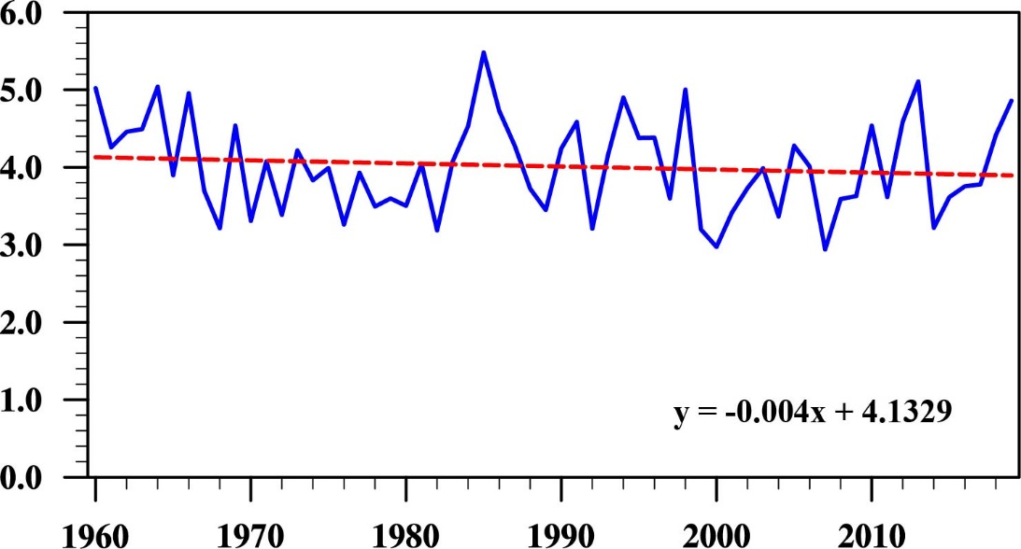

**Figure S1** The time series of summer precipitation averaged over Northeast China (blue line; unit: mm/day) and its linear trend (red line) during 1960−2019. The linear trend does not pass the 90% confidence level.

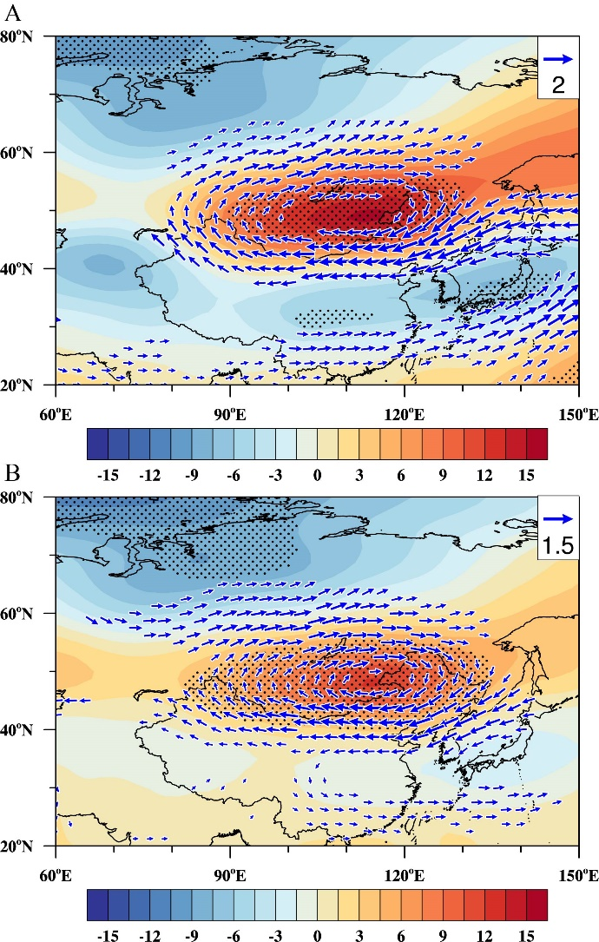

**Figure S2** Regressions of summer anomalous **(A)** 200 hPa and **(B)** 500 hPa geopotential height (shading; unit: gpm) and horizontal wind (vector; unit: m s−1) against the normalized CDDA index during 1960−2019. Stippled regions and vectors indicate that the anomalies are significant at the 95% confidence level.

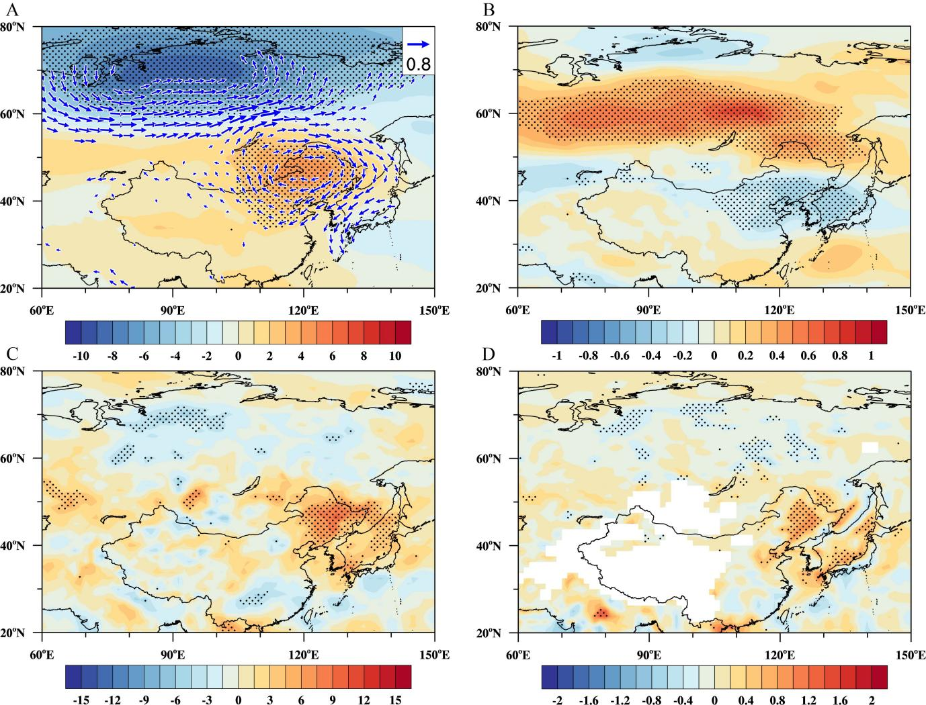

**Figure S3** Regressions of summer anomalous **(A)** 850 hPa geopotential height (shading; unit: gpm) and horizontal wind (vector; unit: m s−1), **(B)** 850 hPa zonal wind (unit: m s−1), **(C)** 500 hPa vertical velocity (unit: 10−3 Pa s−1), and **(D)** moisture divergence vertically integrated from the surface to 850 hPa (unit: 10−5 kg m−2 s−1) against the normalized CDDA index during 1960−2019. Stippled regions and vectors indicate that the anomalies are significant at the 95% confidence level. The results are calculated using the detrended data.

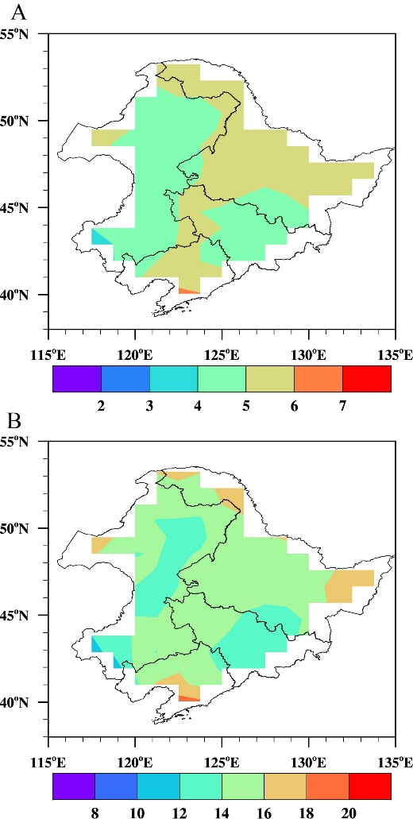

**Figure S4** **(A)** The spatial distribution of the threshold (unit: day) of the summer extreme CDDs over NEC in the CESM-LE MME during 1960−2019. **(B)** The climatology of accumulated days of the summer extreme CDDs (CDDA; unit: day) over NEC in the CESM-LE MME during 1960−2019.

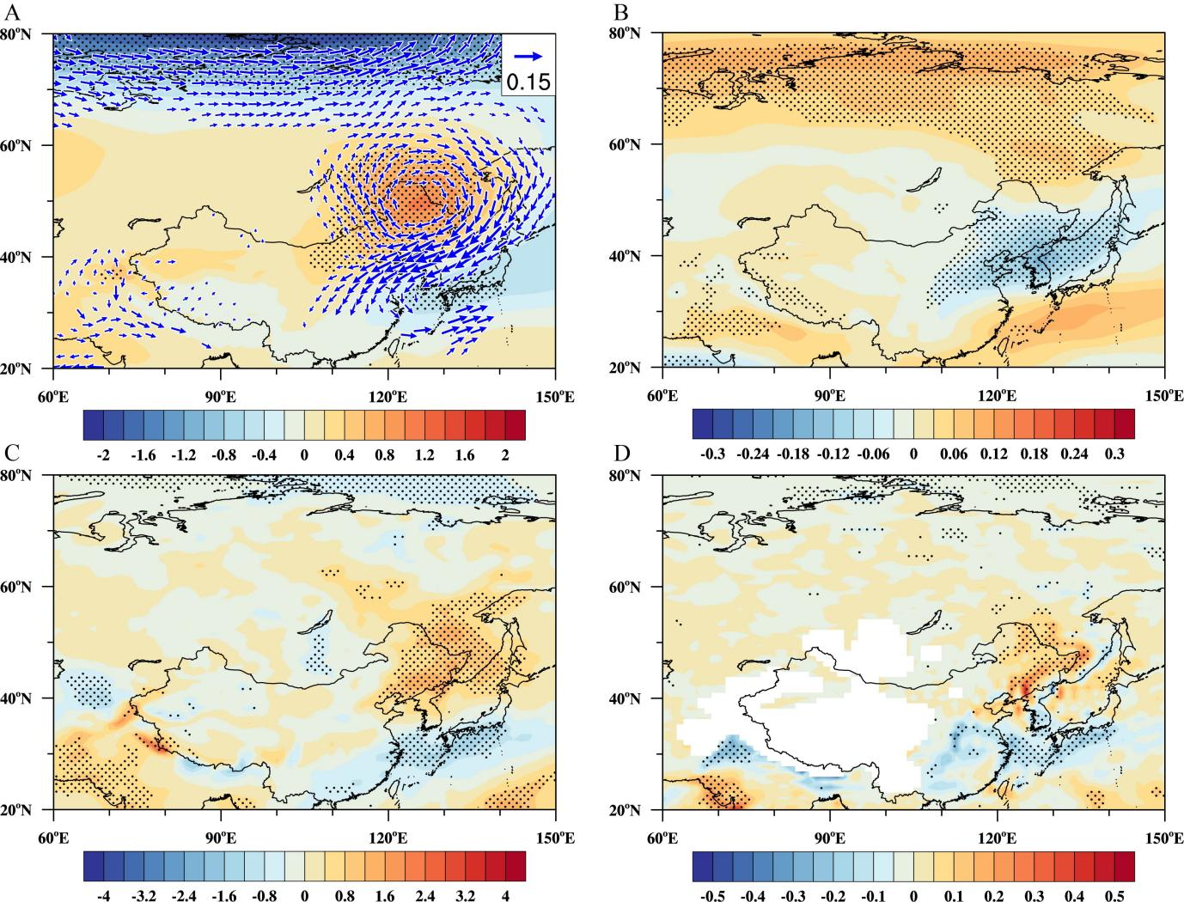

**Figure S5** Regressions of summer anomalous **(A)** 850 hPa geopotential height (shading; unit: m) and horizontal wind (vector; unit: m s−1), **(B)** 850 hPa zonal wind (unit: m s−1), **(C)** 500 hPa vertical velocity (unit: 10−3 Pa s−1), and **(D)** moisture divergence vertically integrated from the surface to 850 hPa (unit: 10−5 kg m−2 s−1), against the normalized CDDA index in the CESM-LE MME during 1960−2019. Stippled regions and vectors indicate that the anomalies are significant at the 95% confidence level. The results are calculated using the detrended data.