Supplementary Material
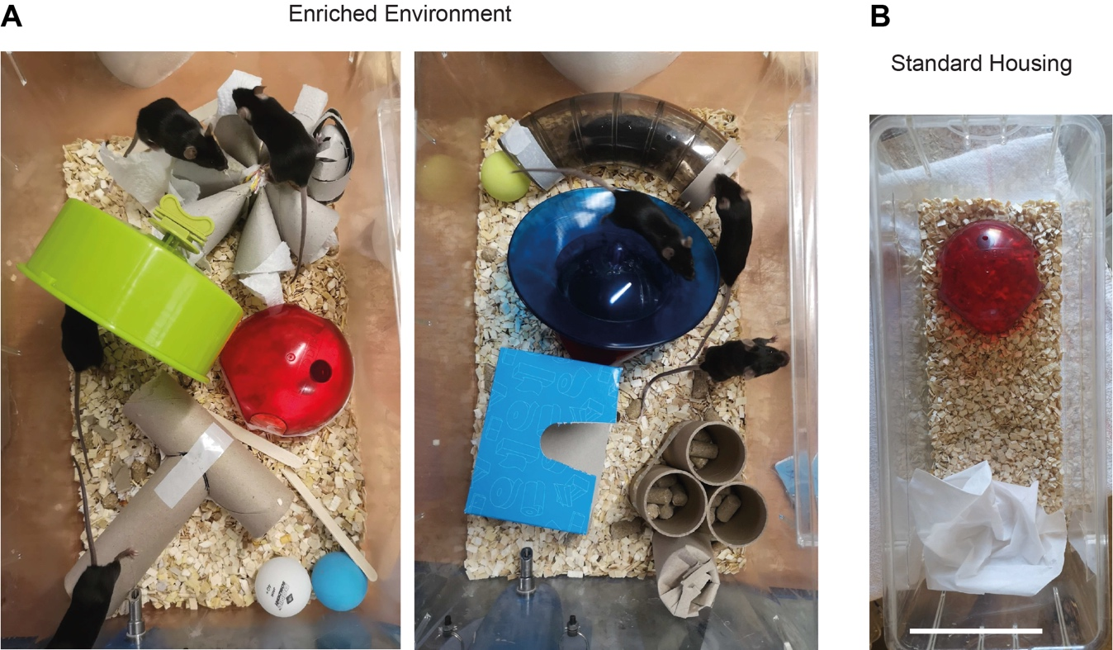
Figure S1
Examples of EN cages. Diverse materials and toys were used in numerous setup combinations in order to stimulate exploratory behavior and learning in mice from EN groups. Right: the equipment of a standard housing cage. Scale bar 10 cm.

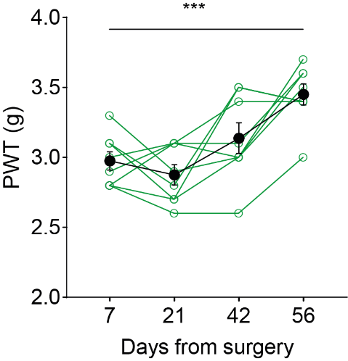
Figure S2
Significant increase in postsurgical PWT of neuropathic animals housed in enriched environment. Data taken from Fig. 3B. One-way ANOVA, F (3, 21) = 13.06, p < 0.0001, day 7 x day 56: p = 0.0005, n = 8.

Figure S3
Unaltered electrophysiological properties. (A) Resting membrane potential. Two-way ANOVA, surgery effect (SNI vs sham) F(1,119) = 3.4409, p = 0.067; housing effect (SH vs ExEE) F(1,119) = 0.8821, p = 0.349. (B) Membrane decay time. Two-way ANOVA, surgery effect (SNI vs sham) F(1,119) = 1.0898, p = 0.2987; housing effect (SH vs ExEE) F(1,119) = 3.34, p = 0.0698. (C) First action potential (AP) amplitude measured from voltage threshold. Two-way ANOVA, surgery effect (SNI vs sham) F(1,119) = 1.555, p = 0.2149; housing effect (SH vs ExEE) F(1,119) = 0.6363, p =0.427. (D) Action potential firing threshold, obtained from dV/dt >= 5mV/ms. Two-way ANOVA, surgery effect (SNI vs sham) F(1,119) = 2.647, p = 0.1064; housing effect (SH vs ExEE) F(1,119) = 2.4706, p = 0.1187. (E) First AP width. Two-way ANOVA, surgery effect (SNI vs sham) F(1,119) = 0.1621, p = 0.6879; housing effect (SH vs ExEE) F(1,119) = 3.35, p = 0.0697. (F) AP depolarization velocity. Two-way ANOVA, surgery effect (SNI vs sham) F(1,119) = 19.079, p = 0.0003; housing effect (SH vs ExEE) F(1,119) = 0.5029, p = 0.4796. (G) AP repolarization velocity. Two-way ANOVA, surgery effect (SNI vs sham) F(1,119) = 0.2301, p = 0.6324; housing effect (SH vs ExEE) F(1,119) = 0.4708, p = 0.4940.

