Supplementary Materials

ABHD12 siRNA1:
sense (5’-3’): GCCACCCUAUCAUUCUGUATT
antisense (5’-3’): UACAGAAUGAUAGGGUGGCTT

ABHD12 siRNA2:
sense (5’-3’): GGAAUCUCCAUUCACUAAUTT
antisense (5’-3’): AUUAGUGAAUGGAGAUUCCTT

USP41 siRNA1:
sense (5’-3’): GCUGGGAGCAUGAGUUUAUTT
antisense (5’-3’): AUAAACUCAUGCUCCCAGCTT

USP41 siRNA2:
sense (5’-3’): GGUGCAGAAUUGAUAUUAUTT
antisense (5’-3’): AUAAUAUCAAUUCUGCACCTT

Supplementary Figure S1. Consensus clustering of TCGA cohort based on 22 degradome-related genes (DRGs). (A-C) Consensus clustering. (D) Expression pattern of the 22 DRGs between BRCA subtype 1 and BRCA subtype 2. (E) Survival difference between BRCA subtype 1 and BRCA subtype 2.

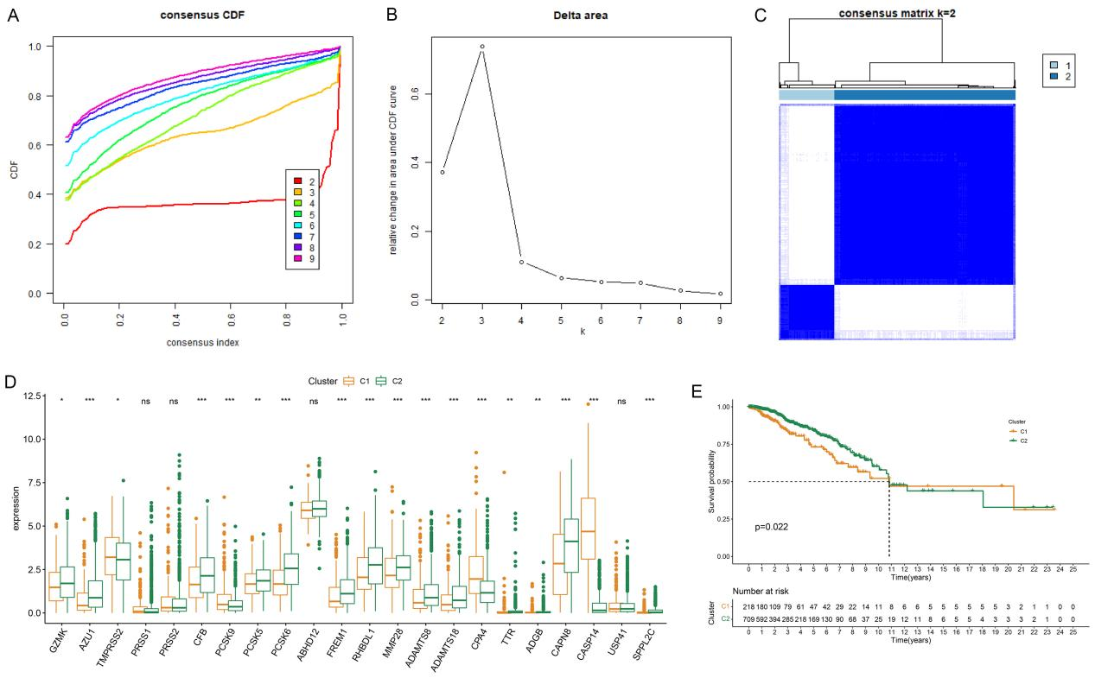

Supplementary Figure S2. Principal component analysis. (A) Principal component analysis between low-risk group and high-risk group in TCGA cohort. (B) Principal component analysis between low-risk group and high-risk group in GSE96058.

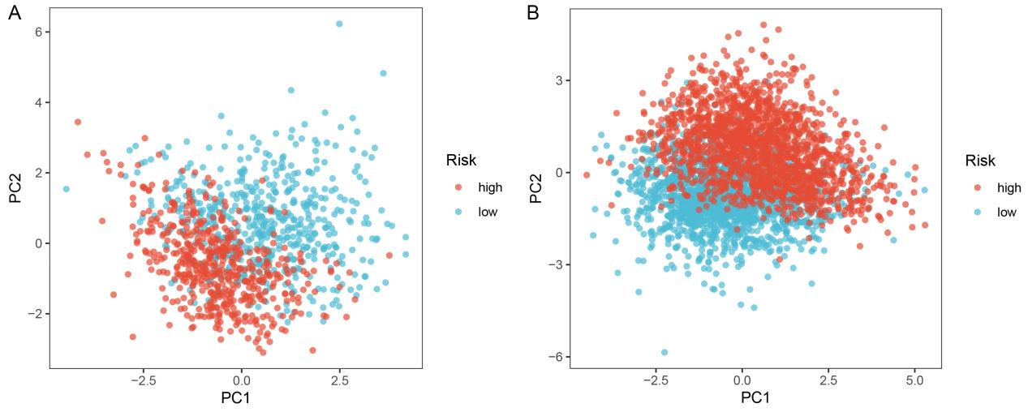

Supplementary Figure S3. ROC curves showing the predictive capability of risk score and other clinicopathological characteristics. (A) The predictive capability of risk score in TCGA cohort. (B) The predictive capability of risk score in GSE96058.
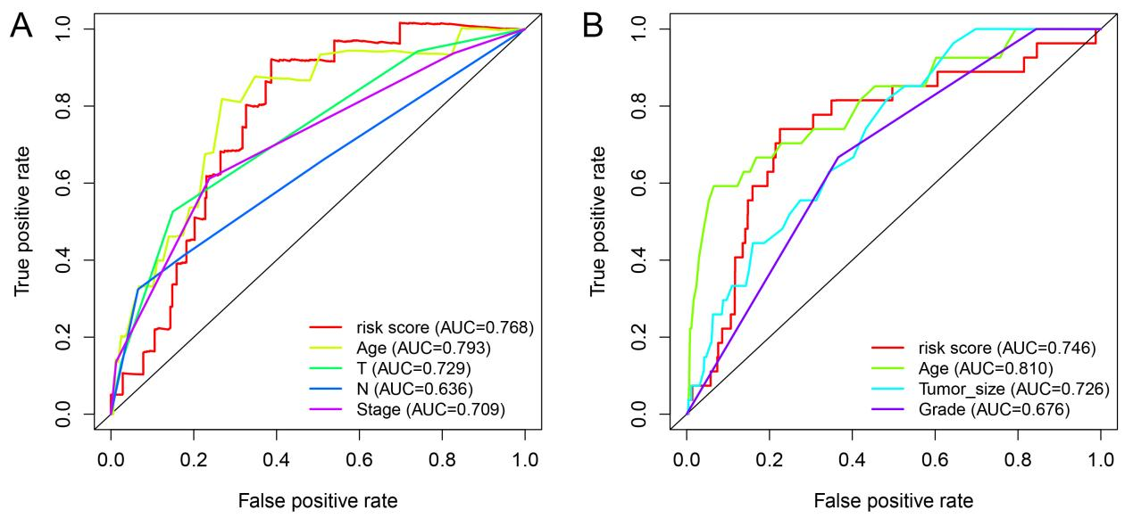

Supplementary Figure S4. Subgroup analysis of the degradome signature. (A) Age: ≤ 65 & > 65. (B) Anatomic location of primary tumor: Right & Left. (C) T stage: T₁₋₂ & T₃₋₄. (D) Lymph node status: Positive & Negative. (E) Person neoplasm cancer status: Tumor free & With tumor. (F) Clinical stage: Early breast cancer & Advanced breast cancer. (G) Histology: Infiltrating ductal carcinoma & Infiltrating lobular carcinoma. (H) PAM50: Luminal & Basal (TNBC). (I) Menopause: Post & Pre.
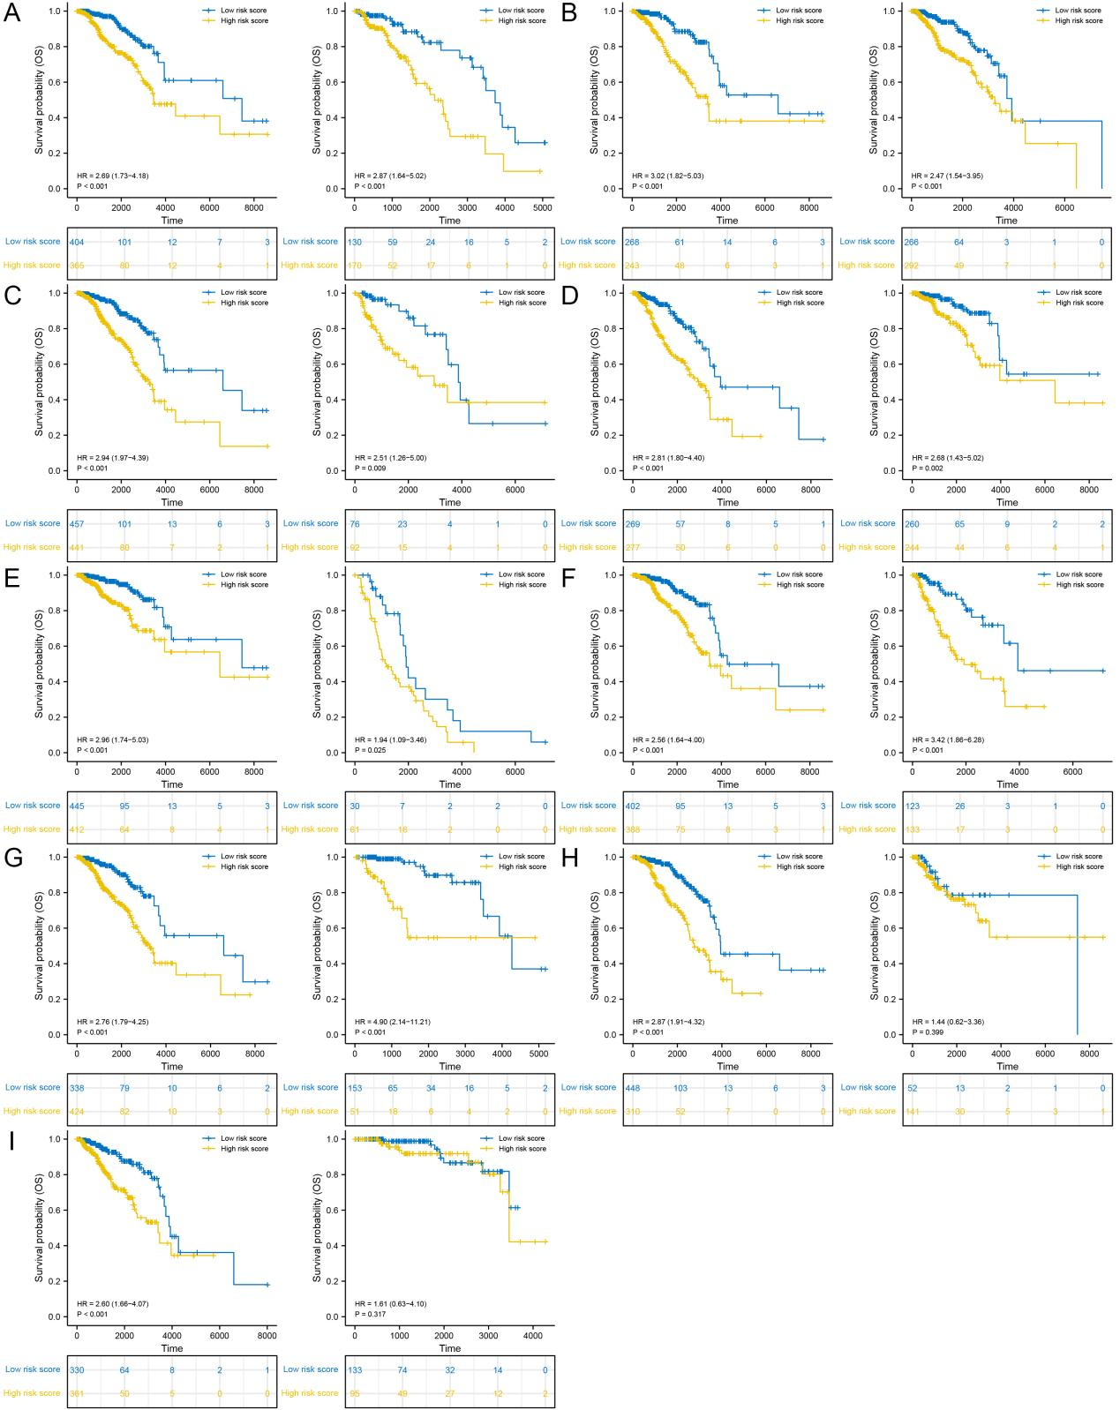

Supplementary Figure S5. Univariate and multivariate Cox regression analyses of the four validation cohorts. (A-B) TCGA ER-positive cohort. (C-D) TCGA HER2-positive cohort. (E-F) TCGA Pathological stage III. (G-H) GSE96058.

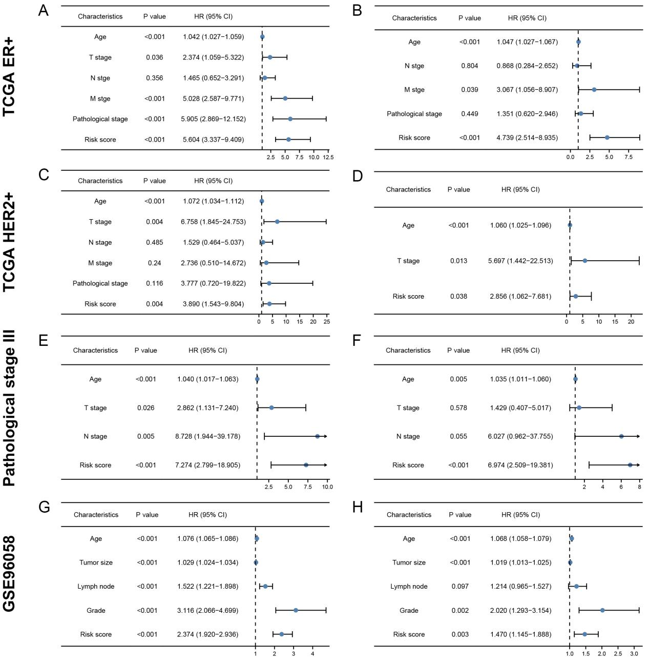

Supplementary Figure S6. Drug sensitivity analysis with IC50. (A) Docetaxel. (B) Epirubicin. (C) Afuresertib. (D) Buparlisib. (E) Ipatasertib. (F) Dactolisib. (G) Ibrutinib. (H) Lapatinib. (I) Sapitinib.

