Supplementary Material

Age-dependent resistance of a perennial herb, *Aristolochia contorta* against specialist and generalist leaf-chewing herbivores

Se Jong Jeong, Bo Eun Nam, Hyeon Jin Jeong, Jae Yeon Jang, Youngsung Joo, Jae Geun Kim*

**\* Correspondence:** jaegkim@snu.ac.kr

## Supplementary Figures

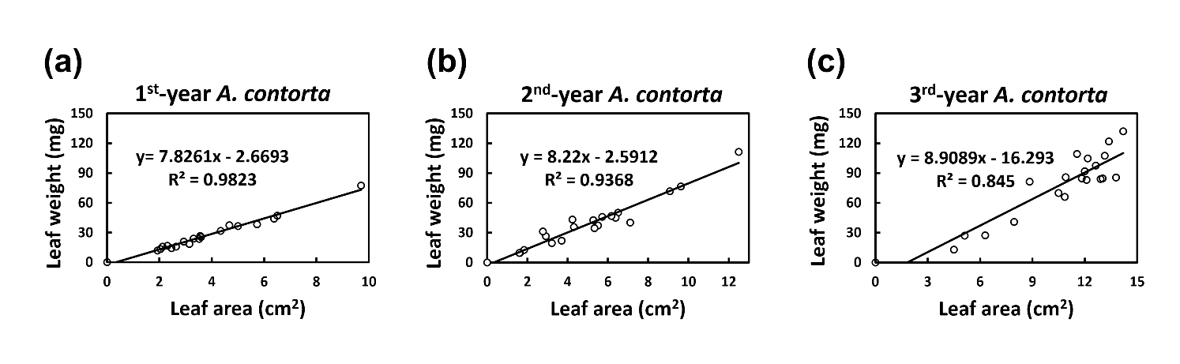

**Figure S1.** Formulae on the leaf weight from leaf area of *A*. *contorta* for each age group. **(a)** 1st-year *A. contorta* leaves, **(b)** 2nd-year *A. contorta* leaves, **(c)** 3rd-year *A. contorta* leaves, where *x* was the leaf area (cm2), *y* was the leaf weight (mg). Constants were estimated from subsampled *A. contorta* leaves according to plant age (*n* = 20, respectively).

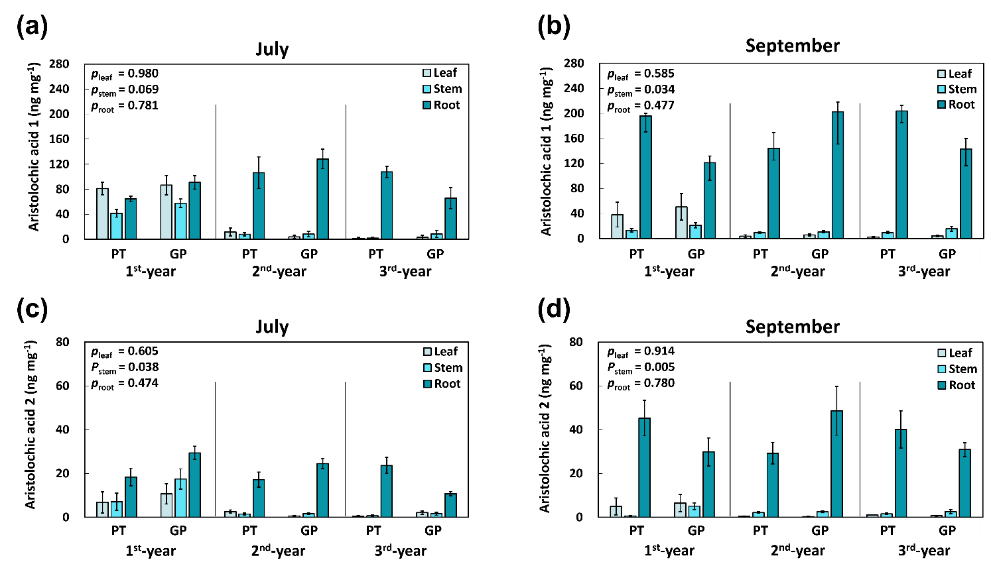

**Figure S2.** Aristolochic acids concentrations in each of the plant leaves and roots were different with plant age, not by source populations. *p* values refer the significance of the origin population (*df* = 1) from one-way ANOVA. **(a, b)** Aristolochic acid 1, **(c, d)** Aristolochic acid 2. PT, Pyeongtaek (*n* = 5 for July; *n* = 5 for September, in case of 1st-year roots (September), *n* = 4); GP, Gapyeong (*n* = 5 for July; *n* = 5 for September).

## 

**Figure S3.** The total C and N (wt%) of each organ of the plants. **(a)** leaf total C , **(b)** stem total C, **(c)** root total C, **(d)** leaf total N, **(e)** stem total N, **(f)** root total N. The vertical bars show the standard error for each group (*n* = 7, respectively). Different letters represent statistically different sub-groups by Duncan's post-hoc test (*p* < 0.05).

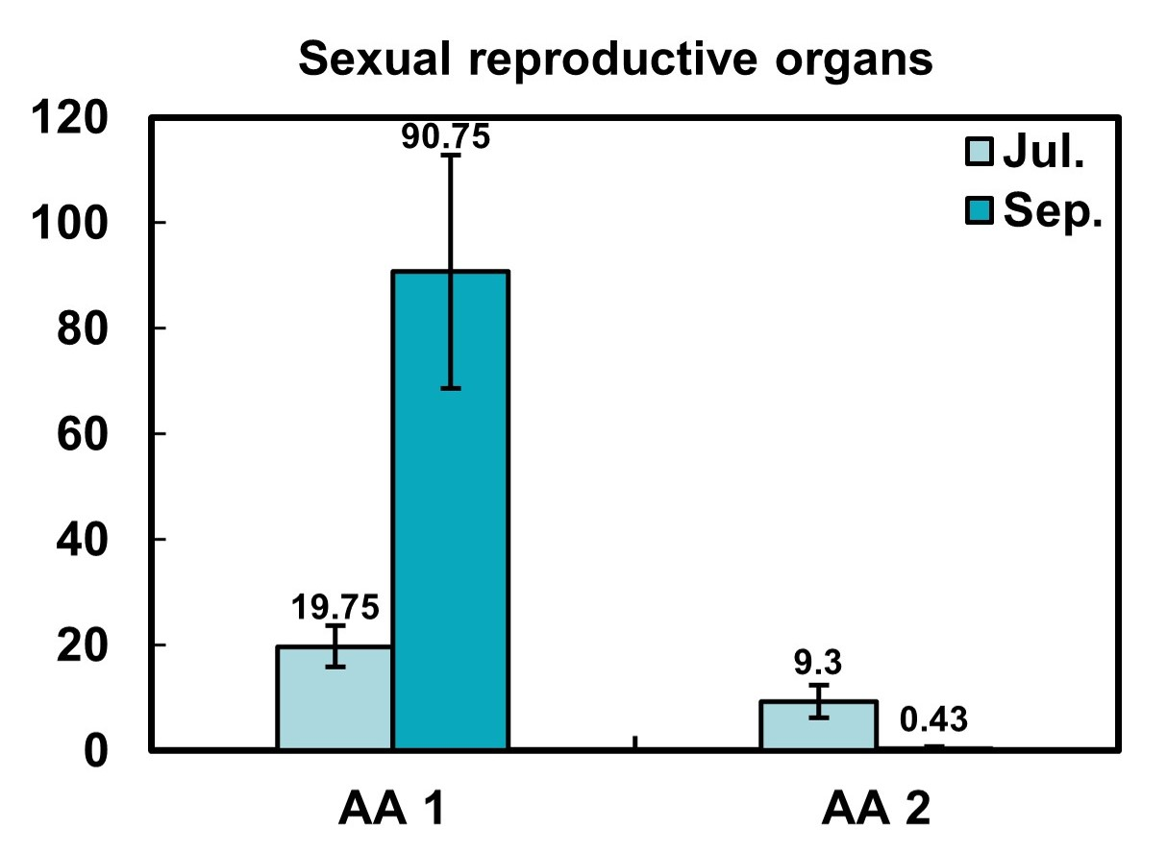

## Figure S4. The aristolochic acid 1(AA 1) and aristolochic acid 2(AA 2) contents in Sexual reproductive organs of 3rd-year *A.contorta*. This content of the sexual reproductive organs was lower than that of the root. The vertical bars show the standard error for each group (*n* = 8 in Jun, *n* = 5 in Sep).