Regulation of strawberry fruit flavonoids by multiple MYB-bHLH-WD40 ternary complexes
Maolan Yue ^{1†}, Leiyu Jiang ^{1†}, Nating Zhang ¹, Lianxi Zhang ¹, Yongqiang Liu¹, Yuanxiu Lin^{1,2}, Yunting Zhang^{1,2}, Ya Luo¹, Yong Zhang¹, Yan Wang^{1,2}, Mengyao Li¹, Xiaorong Wang^{1,2}, Qing Chen¹*, Haoru Tang^{1,2}*
¹Country College of Horticulture, Sichuan Agricultural University, Chengdu, China
² Institute of Pomology & Olericulture, Sichuan Agricultural University, Chengdu, China
* Correspondence:
Qing Chen, supnovel@sicau.edu.cn
Haoru Tang, htang@sicau.edu.cn

Supplementary Figures list
Figure S1 The phenotype of transient overexpression MYBs in ‘Benihoppe’ fruits.
Figure S2 Analysis of Cy3G and Pg3G by HPLC method.
Figure S3 Relative expression levels of genes in their own overexpressed samples.
Figure S4 R3-FaMYB5 and R2R3-FaMYB5 dimerized in different cell regions.
Figure S5 Relative expression levels of FaLWD1 and FaLWD1-like in FaMYB5 OE.
Figure S6 FaLWD1 and FaLWD1-like dimerized in different cell regions.
Figure S7 The phenotype of transient overexpression FaMYB1, FaEGL3 and FaLWD1-like in ‘Benihoppe’ fruits.

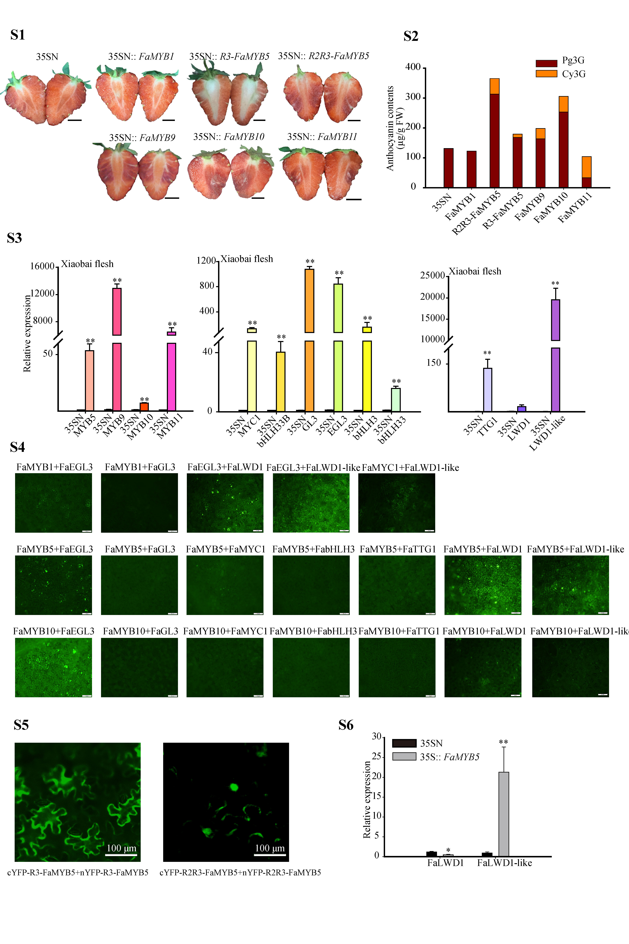
Figure S1 The phenotype of transient overexpression MYBs in ‘Benihoppe’ fruits.

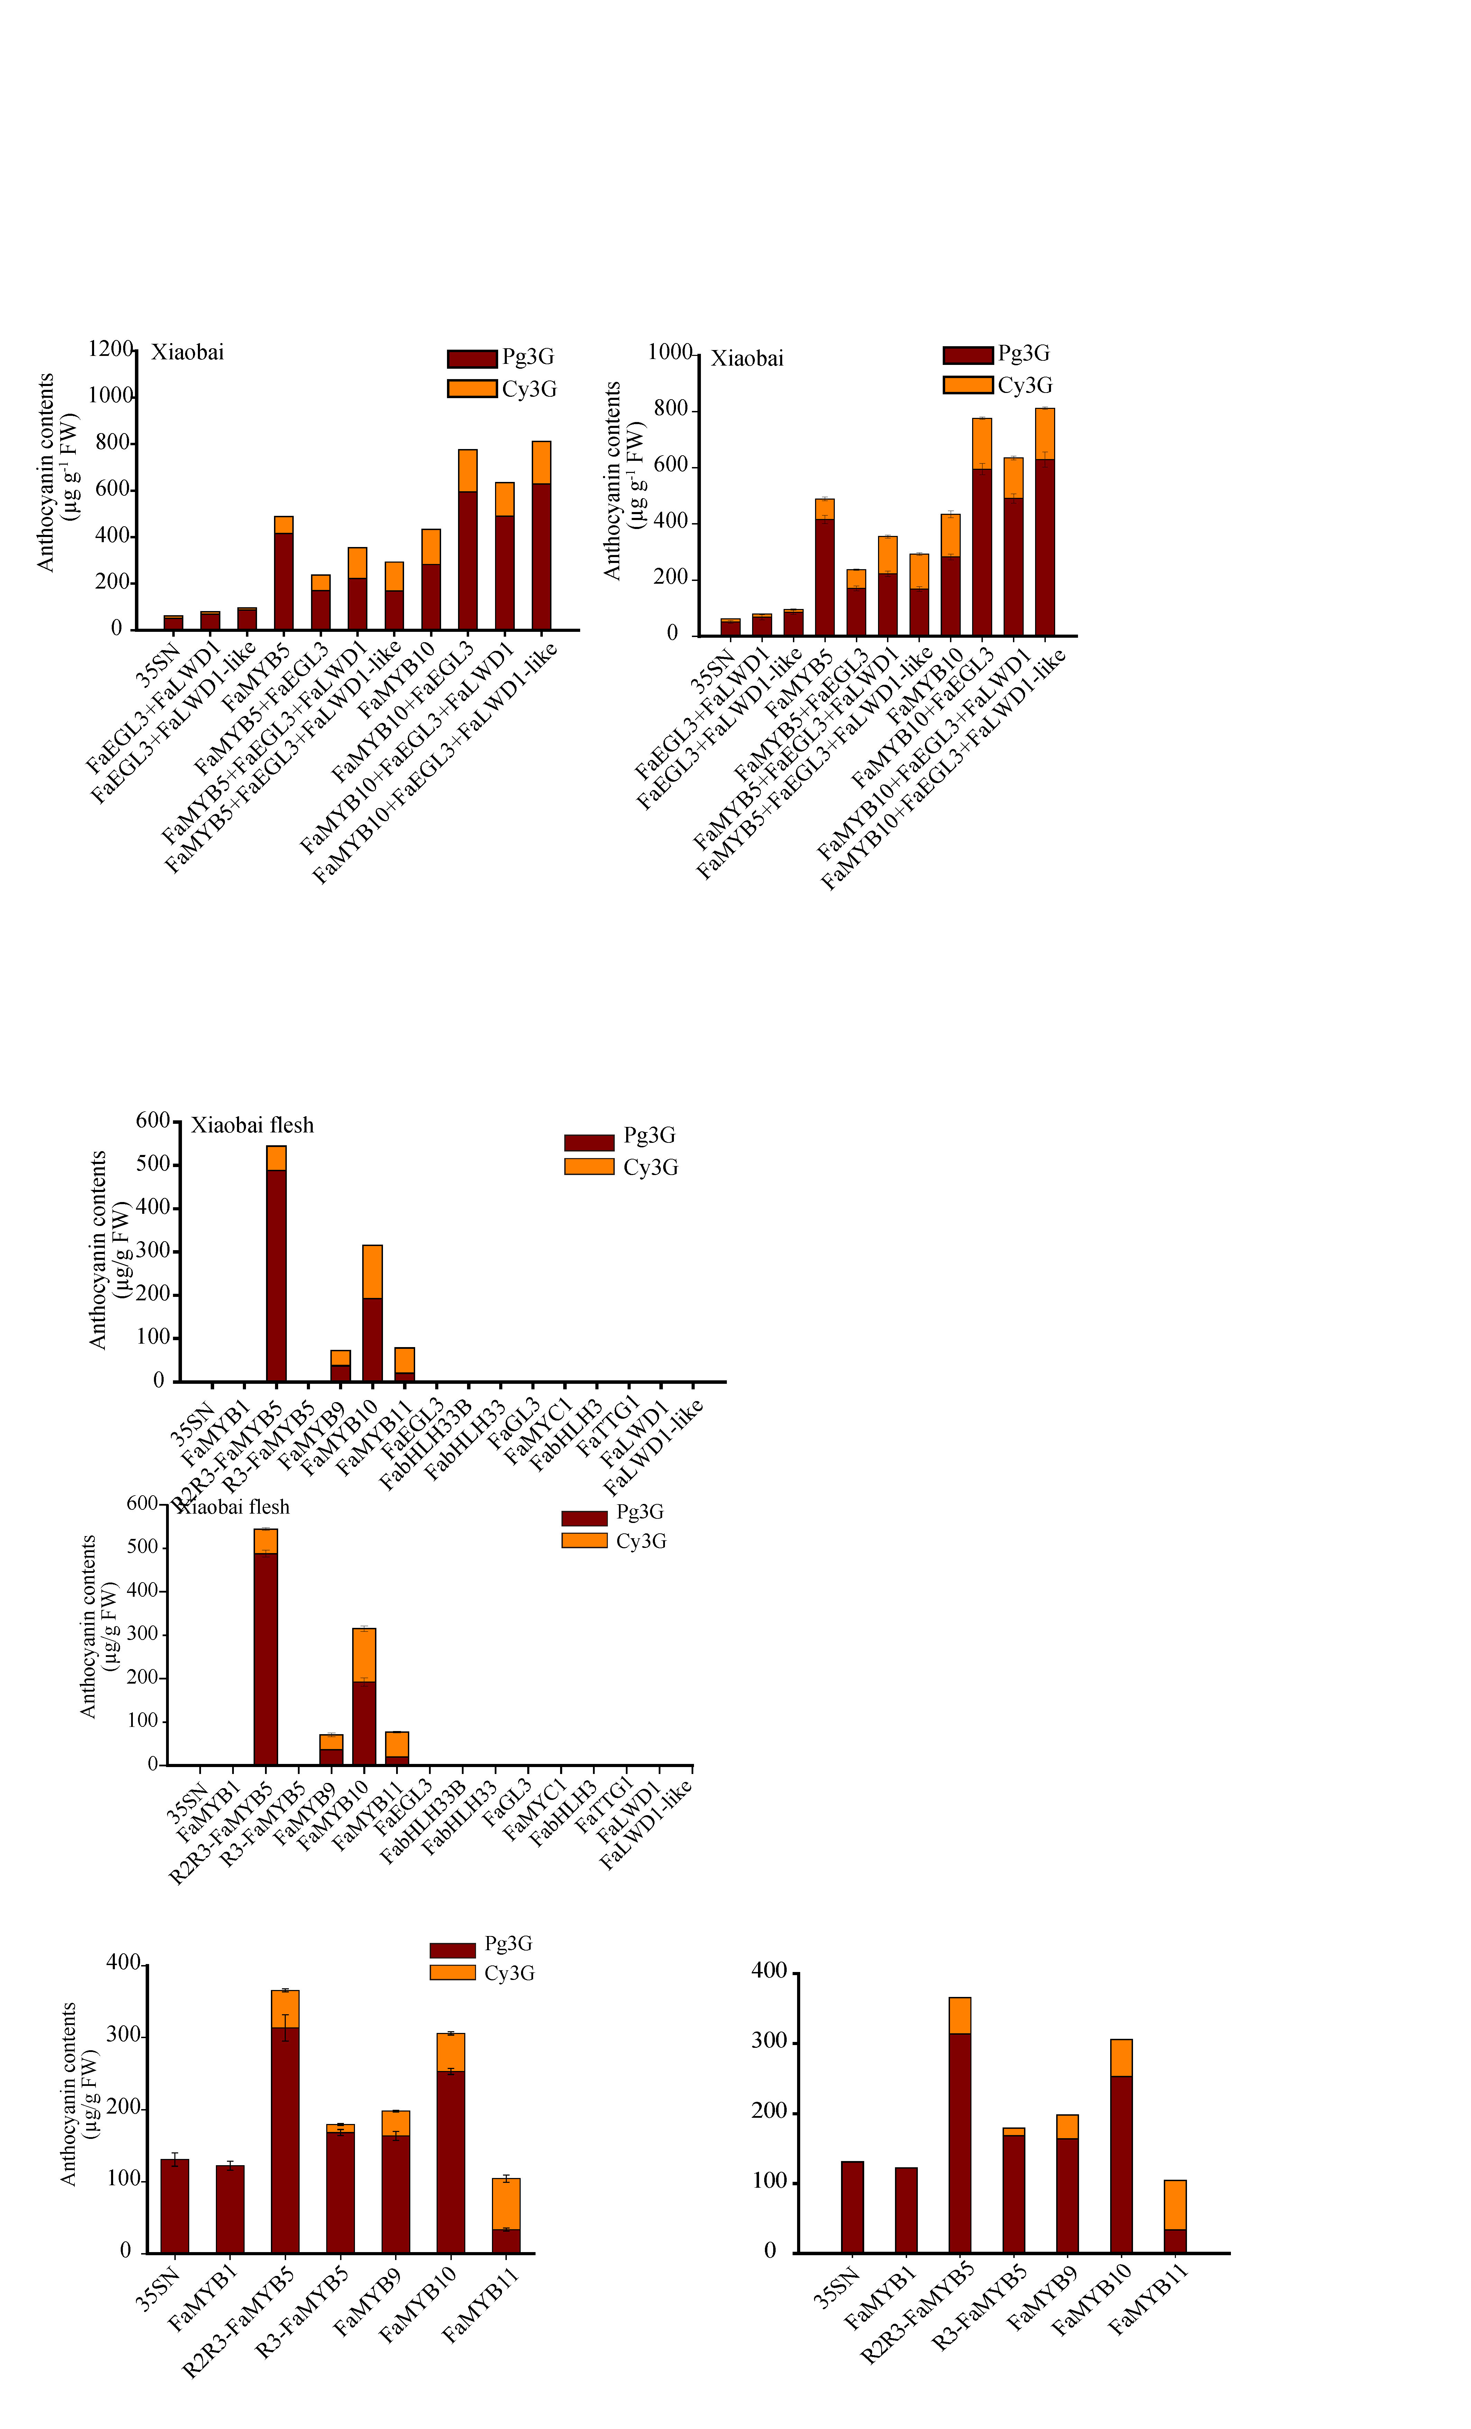
Figure S2 Analysis of Cy3G and Pg3G by HPLC method.

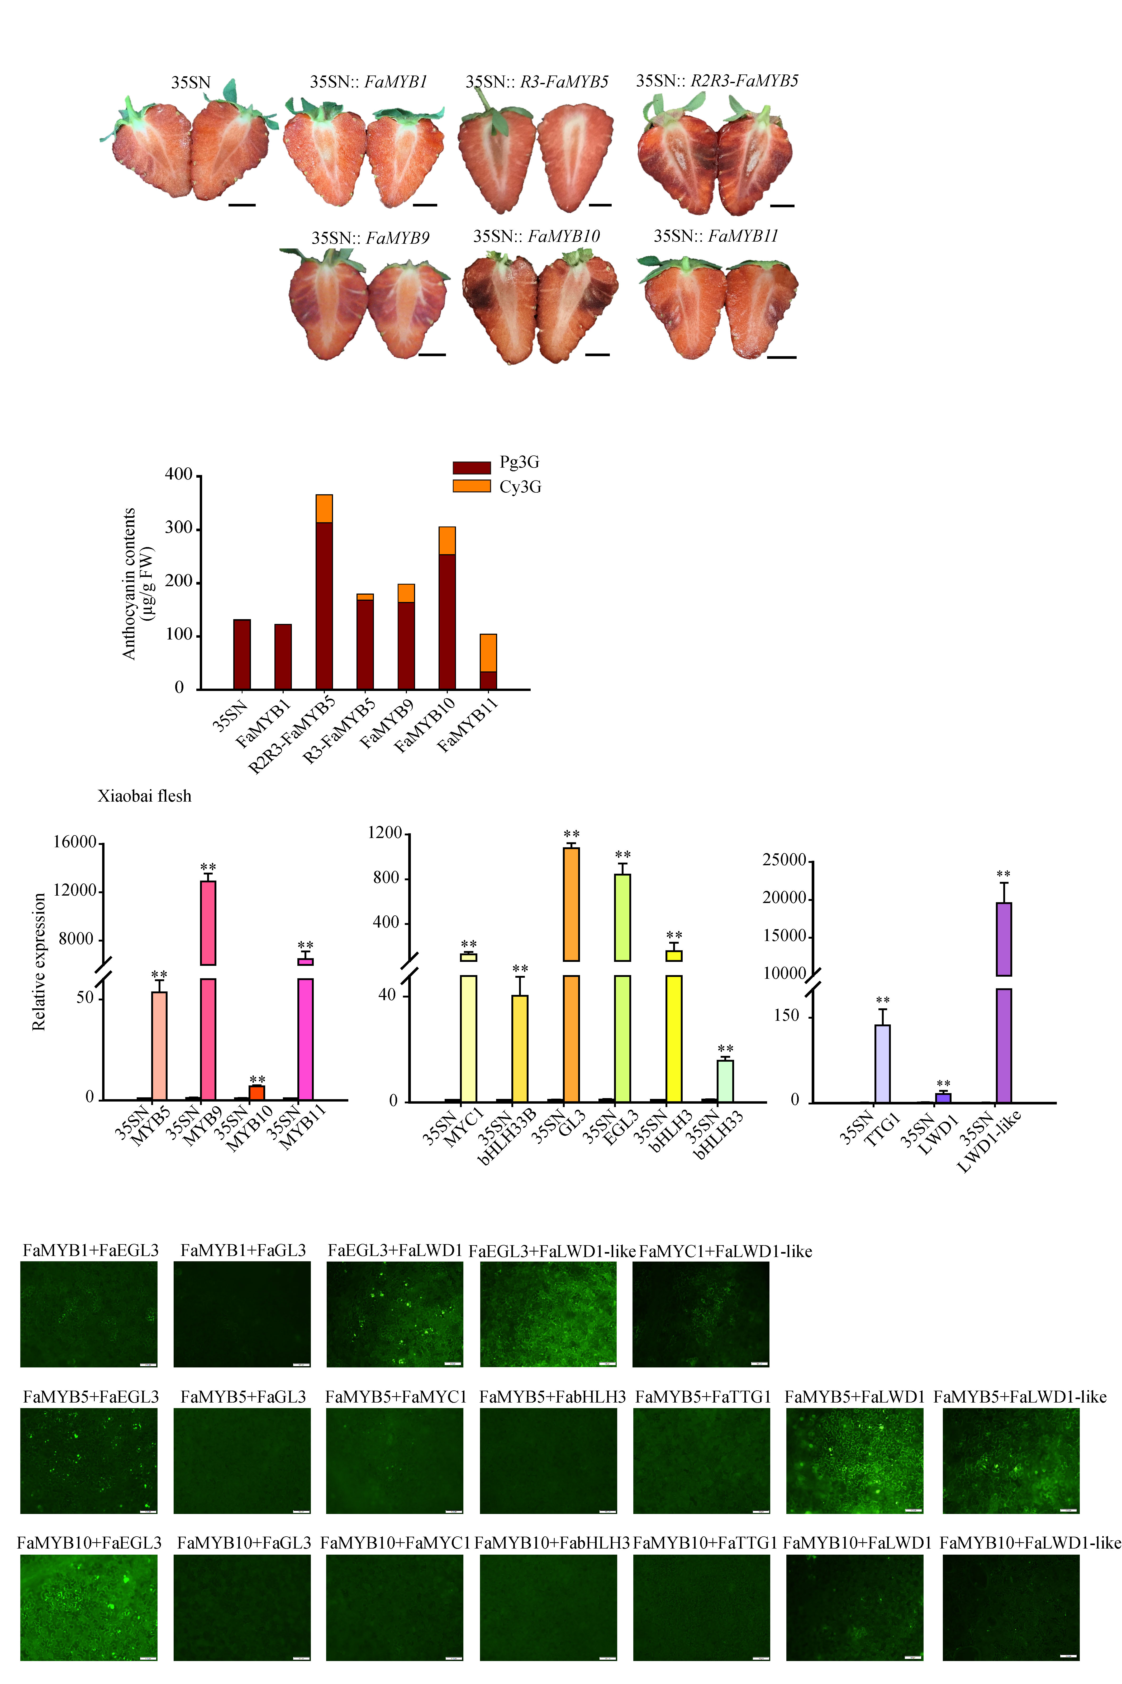
Figure S3 Relative expression levels of genes in their own overexpressed samples.

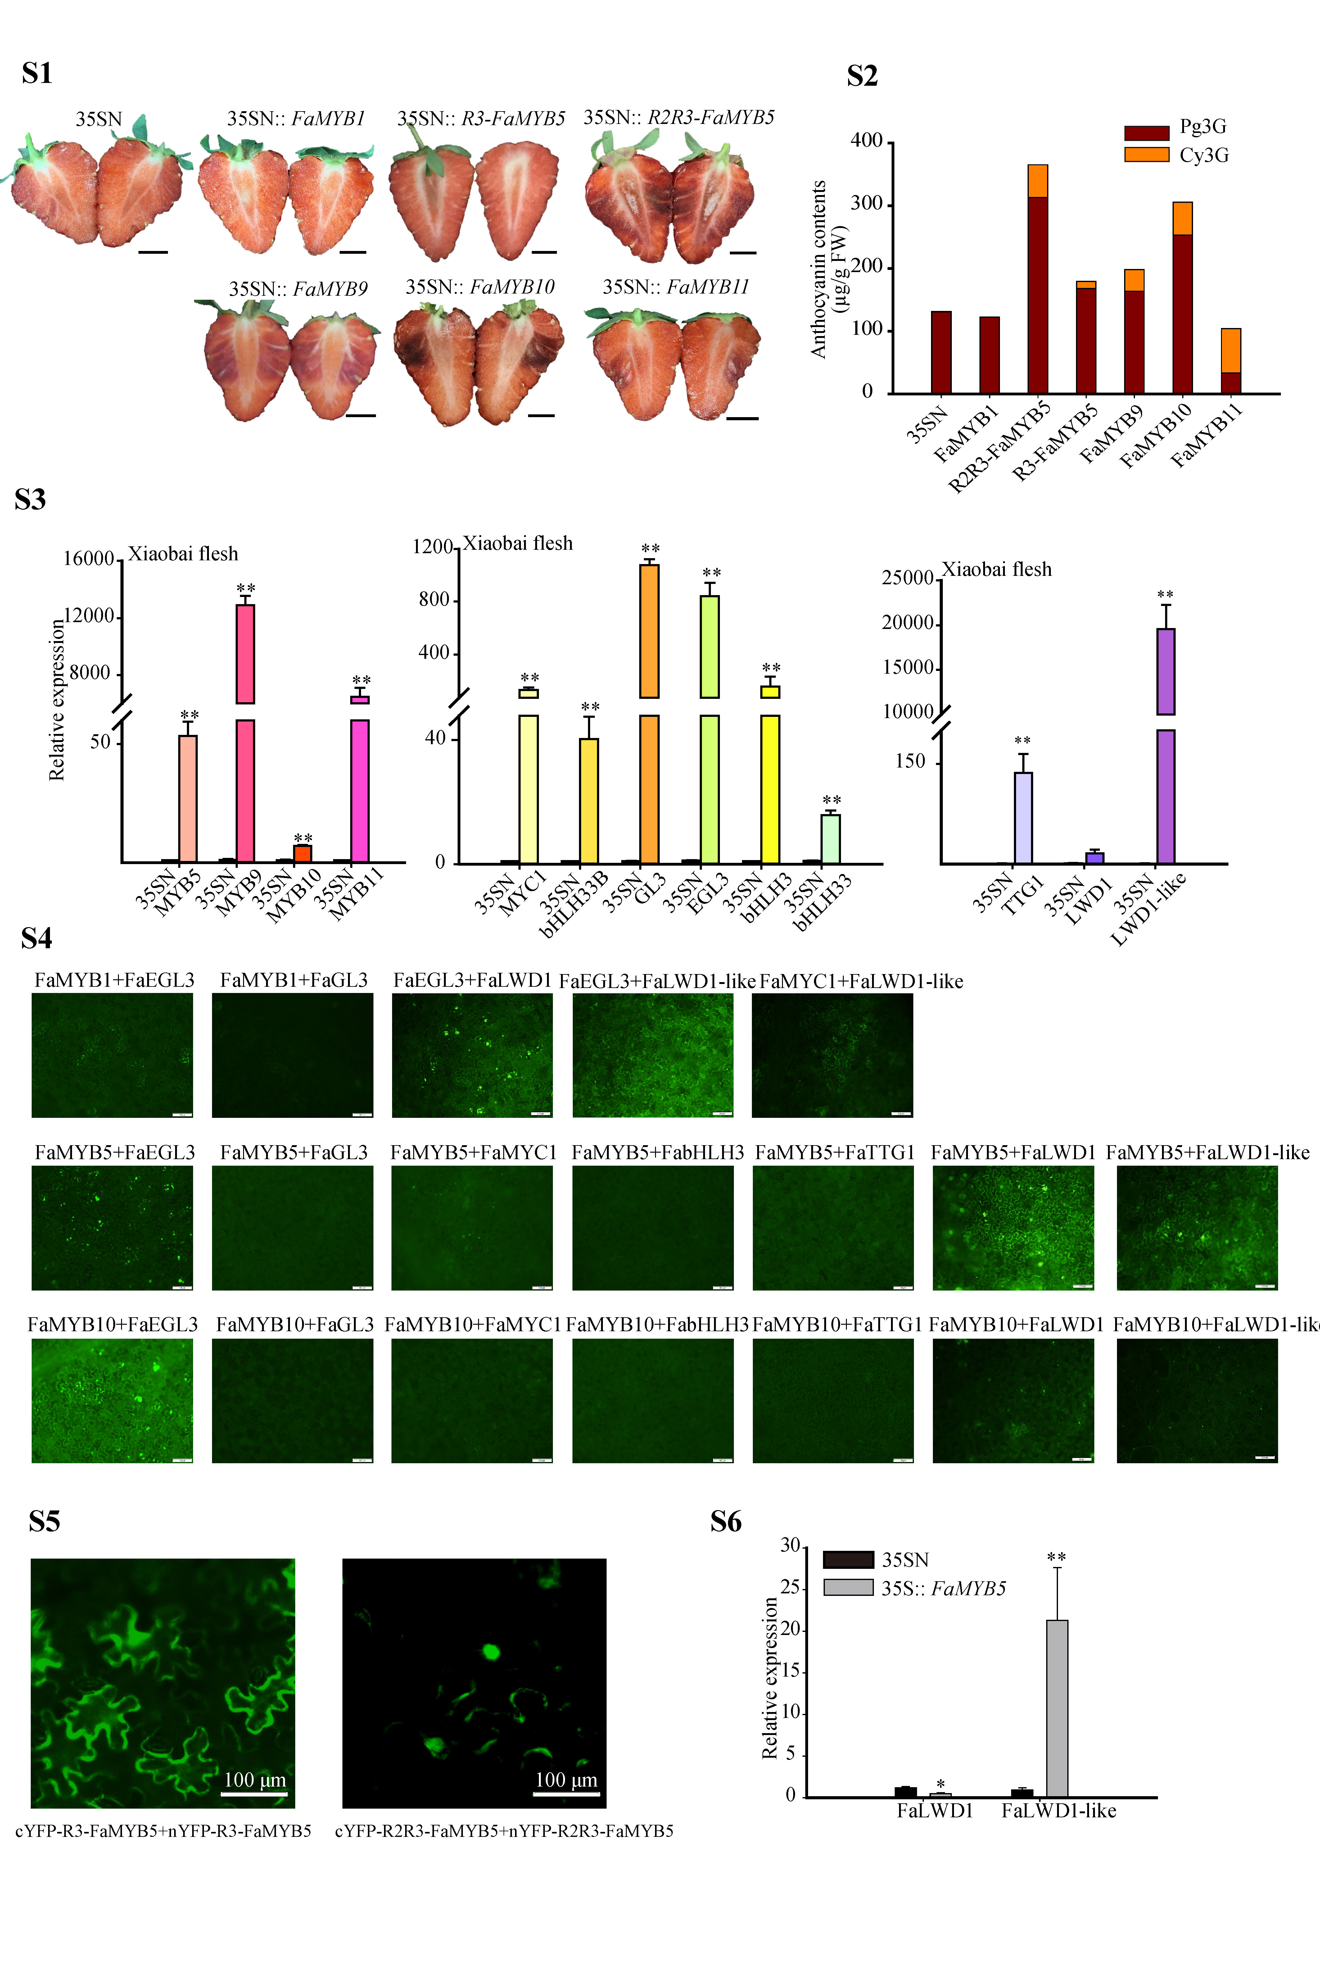
Figure S4 R3-FaMYB5 and R2R3-FaMYB5 dimerized in different cell regions.

Figure S5 Relative expression levels of FaLWD1 and FaLWD1-like in FaMYB5 OE.

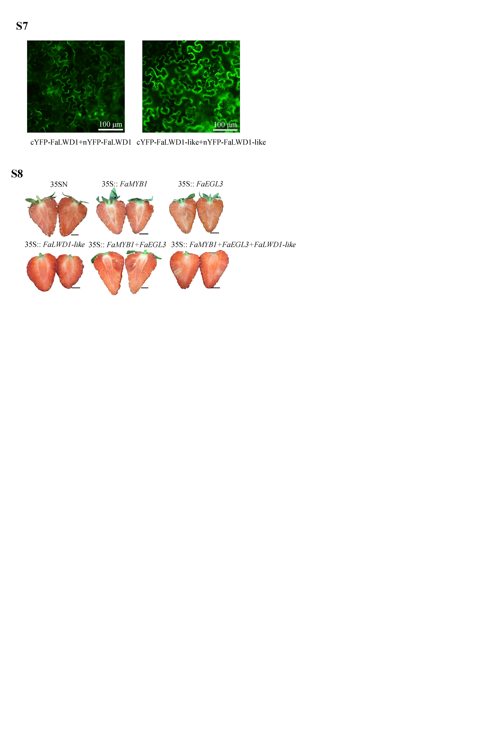
Figure S6 FaLWD1 and FaLWD1-like dimerized in different cell regions.

Figure S7 The phenotype of transient overexpression FaMYB1, FaEGL3 and FaLWD1-like in ‘Benihoppe’ fruits.

