Supp Table 1. Clinical characteristics of patients with different mRs
Variable | level | Overall | Lower mRs | Higher mRs | p-value
n |  | 488 | 374 | 114
Gender | M | 362 (74.18%) | 275 (73.53%) | 87 (76.32%) | 0.636
 | F | 126 (25.82%) | 99 (26.47%) | 27 (23.68%)
Age (years) |  | 60.00 (52.00-67.00) | 60.00 (52.00-67.00) | 60.00 (53.25-67.00) | 0.447
First Onset | With | 15 ( 3.07%) | 13 ( 3.48%) | 2 ( 1.75%) | 0.534
 | Without | 473 (96.93%) | 361 (96.52%) | 112 (98.25%)
HBP | With | 176 (36.07%) | 140 (37.43%) | 36 (31.58%) | 0.304
 | Without | 312 (63.93%) | 234 (62.57%) | 78 (68.42%)
SysP (kPa) |  | 20.80 (18.67-22.53) | 20.60 (18.67-22.50) | 21.33 (19.50-22.67) | 0.034
DiaP (kPa) |  | 12.00 (10.67-13.33) | 12.00 (10.67-13.33) | 12.00 (10.97-13.33) | 0.117
DM | With | 407 (83.40%) | 308 (82.35%) | 99 (86.84%) | 0.325
 | Without | 81 (16.60%) | 66 (17.65%) | 15 (13.16%)
DM_value(mmol/L) |  | 5.30 (4.70-6.30) | 5.20 (4.60-6.10) | 5.50 (4.93-7.07) | 0.002
HTG | With | 286 (58.61%) | 219 (58.56%) | 67 (58.77%) | 1
 | Without | 202 (41.39%) | 155 (41.44%) | 47 (41.23%)
TG (mmol/L) |  | 1.50 (1.02-2.10) | 1.54 (1.02-2.12) | 1.40 (1.00-1.85) | 0.118
TC (mmol/L) |  | 4.43 (3.78-5.08) | 4.34 (3.67-4.99) | 4.72 (4.06-5.29) | 0.001
LDL (mmol/L) |  | 2.70 (1.73-3.30) | 2.60 (1.66-3.30) | 2.90 (2.22-3.48) | 0.007
TOAST | 1 | 14 ( 2.87%) | 10 ( 2.67%) | 4 ( 3.51%) | 0.463
 | 2 | 40 ( 8.20%) | 33 ( 8.82%) | 7 ( 6.14%)
 | 3 | 430 (88.11%) | 329 (87.97%) | 101 (88.60%)
 | 4 | 4 ( 0.82%) | 2 ( 0.53%) | 2 ( 1.75%)
OCSP | 1 | 353 (72.34%) | 264 (70.59%) | 89 (78.07%) | <0.001
 | 2 | 104 (21.31%) | 91 (24.33%) | 13 (11.40%)
 | 3 | 17 ( 3.48%) | 15 ( 4.01%) | 2 ( 1.75%)
 | 4 | 14 ( 2.87%) | 4 ( 1.07%) | 10 ( 8.77%)
Onset_Time (hour) |  | 2.00 (1.05-3.25) | 2.00 (1.01-3.20) | 1.96 (1.10-3.29) | 0.975
DNT (hour) |  | 1.33 (1.00-1.83) | 1.33 (1.02-1.80) | 1.41 (1.00-2.00) | 0.305
OTT (hour) |  | 3.50 (2.57-5.02) | 3.58 (2.57-5.00) | 3.50 (2.57-5.38) | 0.988
NIHSS_Baseline |  | 7.00 (5.00-10.00) | 6.00 (5.00-9.00) | 9.00 (6.25-13.75) | <0.001
NIHSS_Day7 |  | 2.00 (1.00-5.00) | 2.00 (1.00-3.00) | 8.00 (6.00-10.00) | <0.001

Supp Table 2. Clinical features in different mRs groups in External Data I
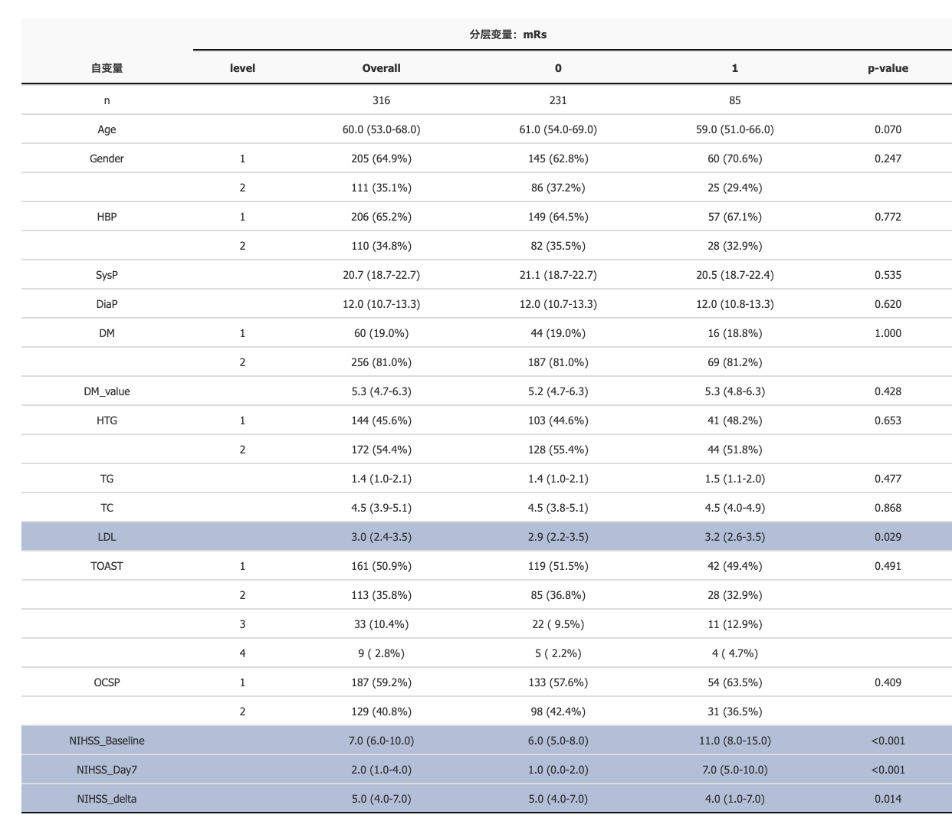

mRs 0 group： mRs (0-1); mRs 1 group: mRs (2-6)

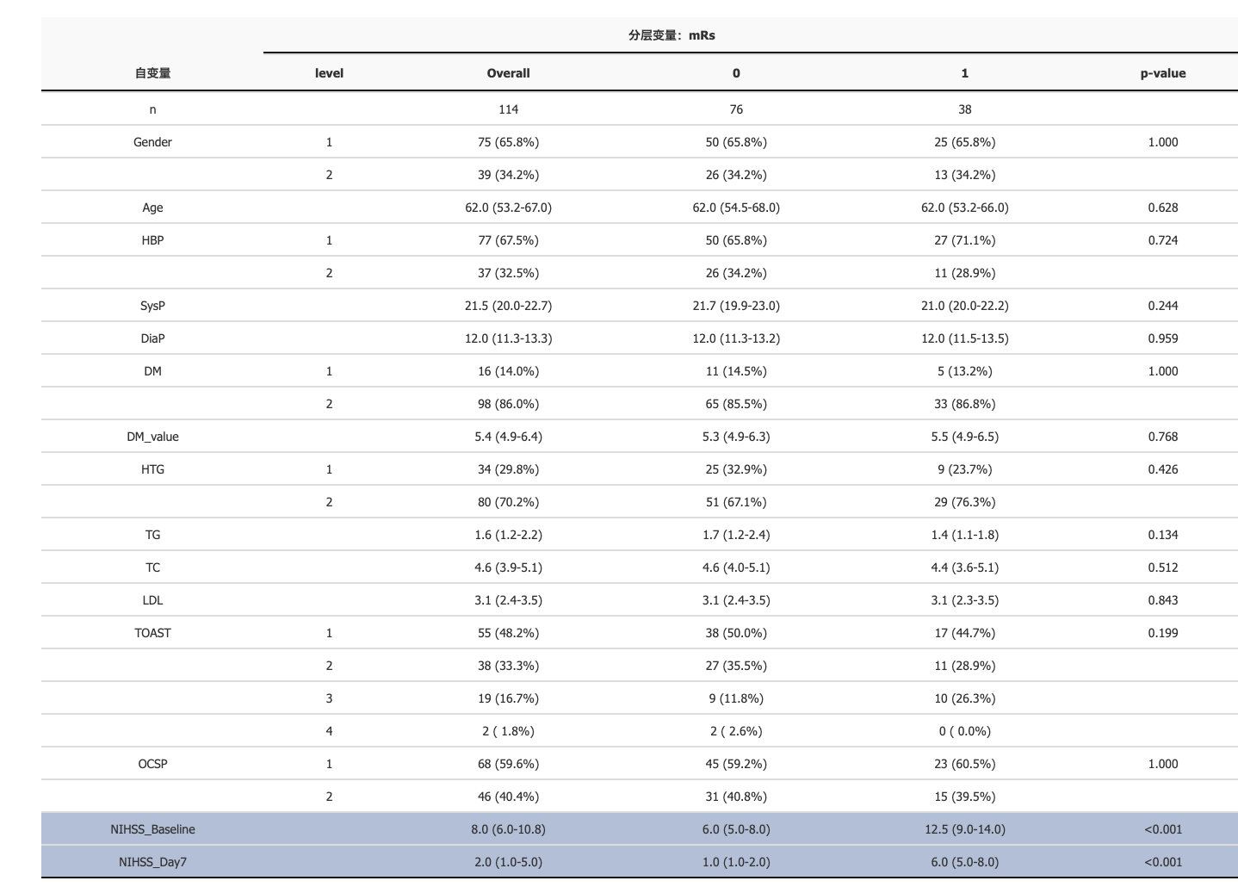
Supp Table 3. Clinical features in different mRs groups in External Data II

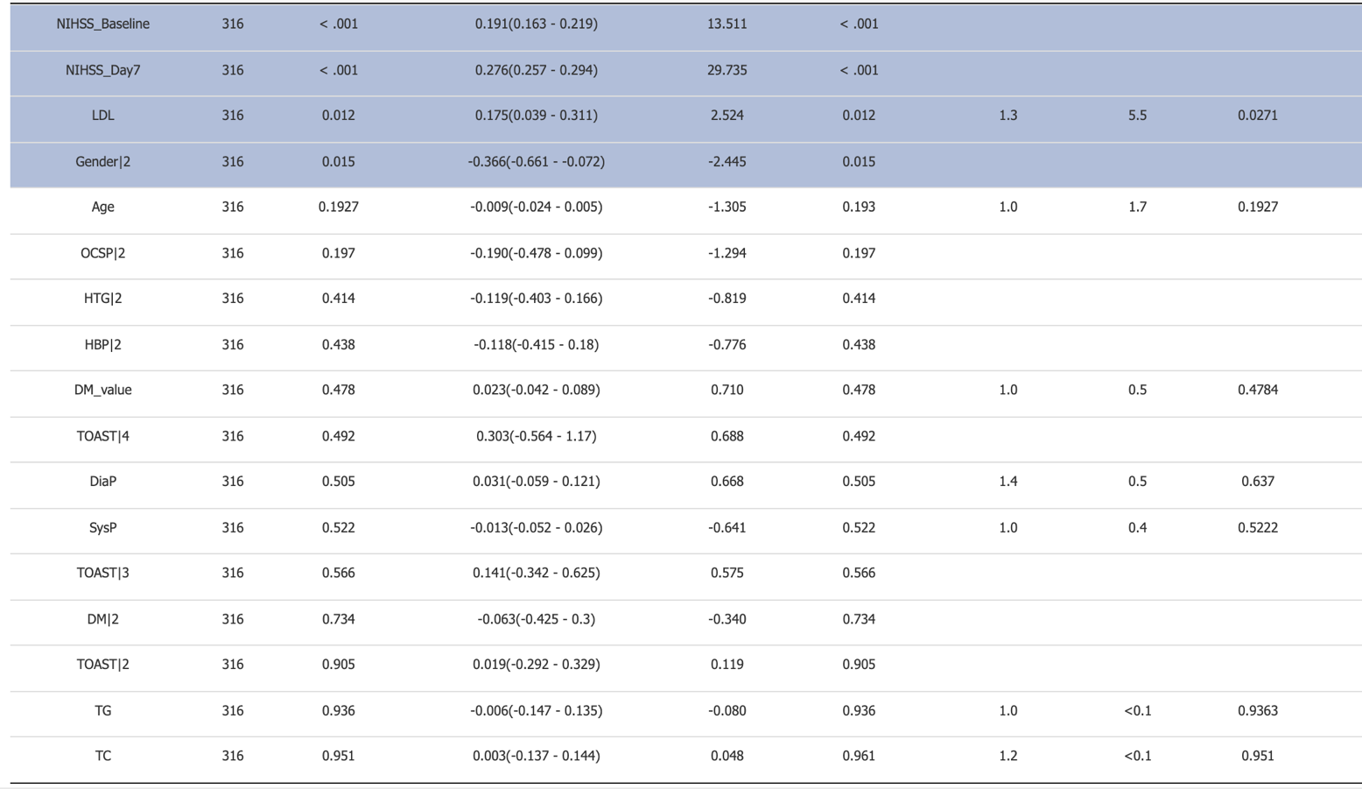
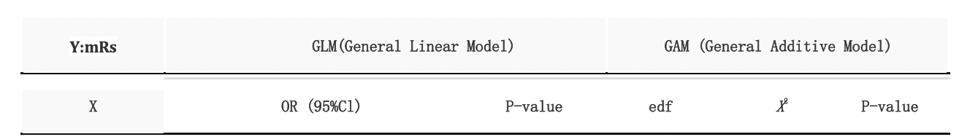
Supp Table 4. Single-factor analysis in GLM and GAM in External Data I

Supp Table 5. Univariable Logistic analysis in External Data I

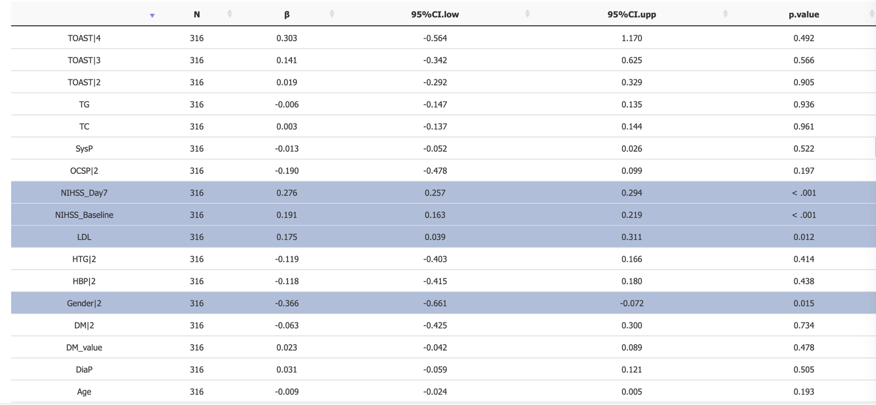

Supp Table 6. Multivariable Logistic analysis in External Data I
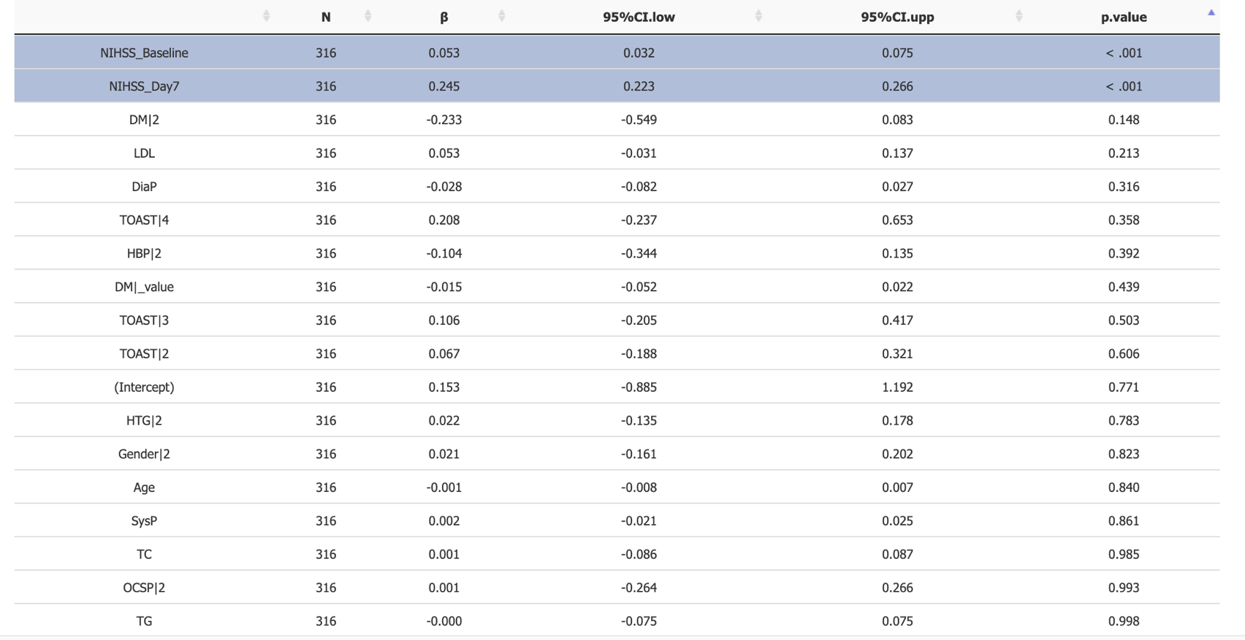

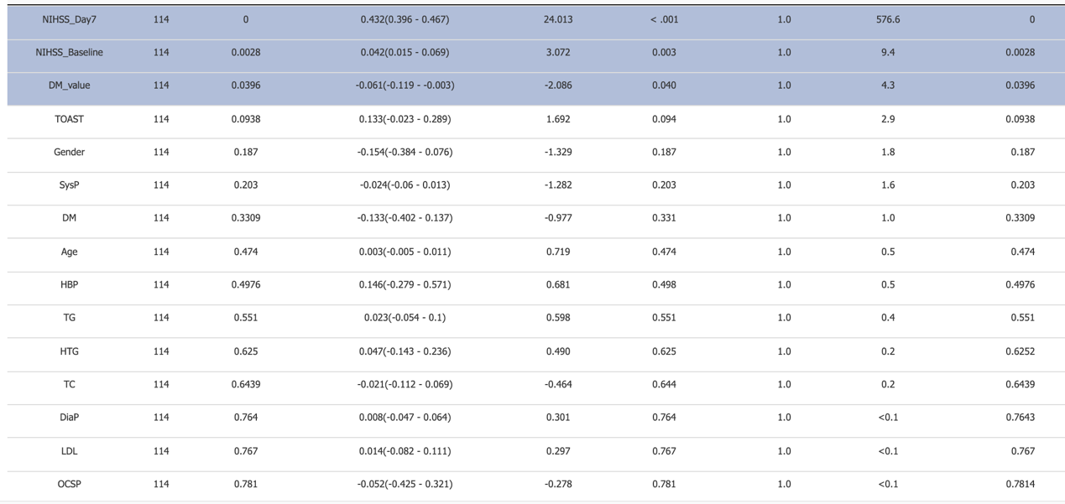
Supp Table 7 Single-factor analysis in GLM and GAM in External Data II

Supp Table 8 Univariable Logistic analysis in External Data II
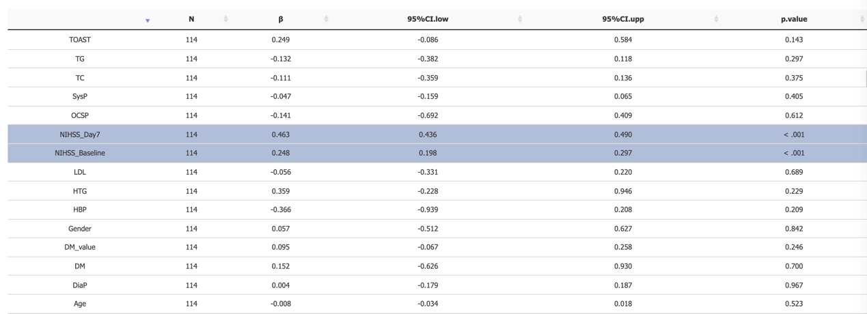

Supp Table 9 Multivariable Logistic analysis in External Data II
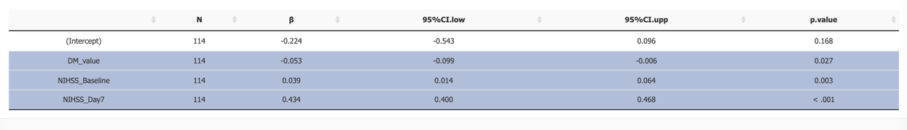

Supp Figure 1. Predictive ability of DecisionTreeClassifier Model. (A,B) AUC and an AP value of ROC curve for the decision tree classifier (C). The procedure for decision tree analysis shown by Graphviz.
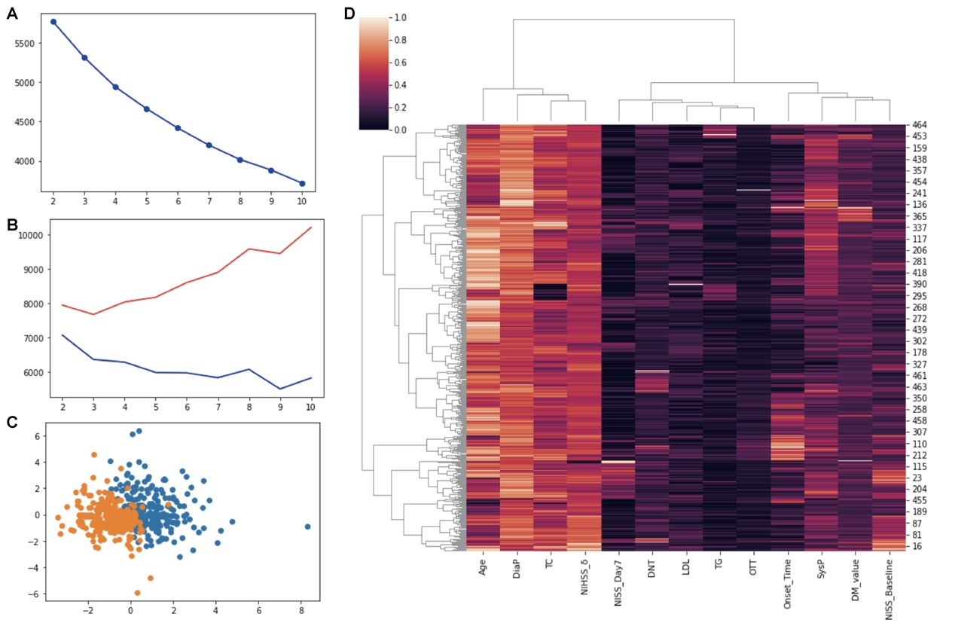
Supp Figure 2. The inertia and silhouette score with matplotlib for the K-means cluster map (A-C). The cluster map for clinical features drawn with seaborn. The different features were clustered with Agglomerative Clustering method (D).
Supp Figure 3. The multiple entry model illustrated by TensorBoard of deep neural network. A, Kernel training; B, epoch accuracy increased with training; C, epoch loss decreased with training.

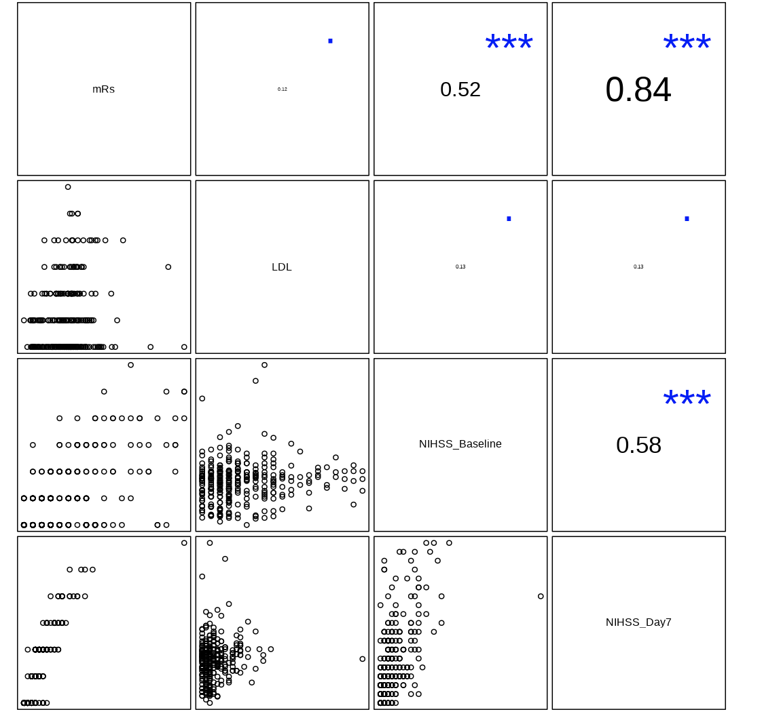
Supp Figure 4. The correlational map between mRs and risk factors based on single-factor ANOVA in External I. The mRs has a positive correlation with LDL, NIHSS_Day7 and NIHSS_Baseline.

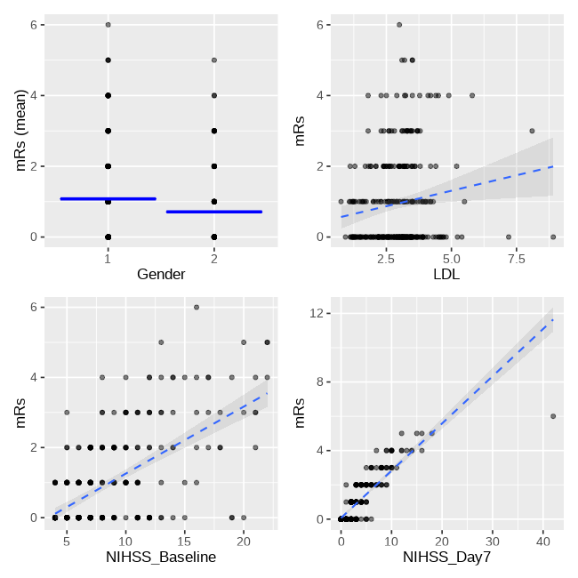
Supp Figure 5.The scatter plot between mRs and risk factors based on single-factor ANOVA in External I.
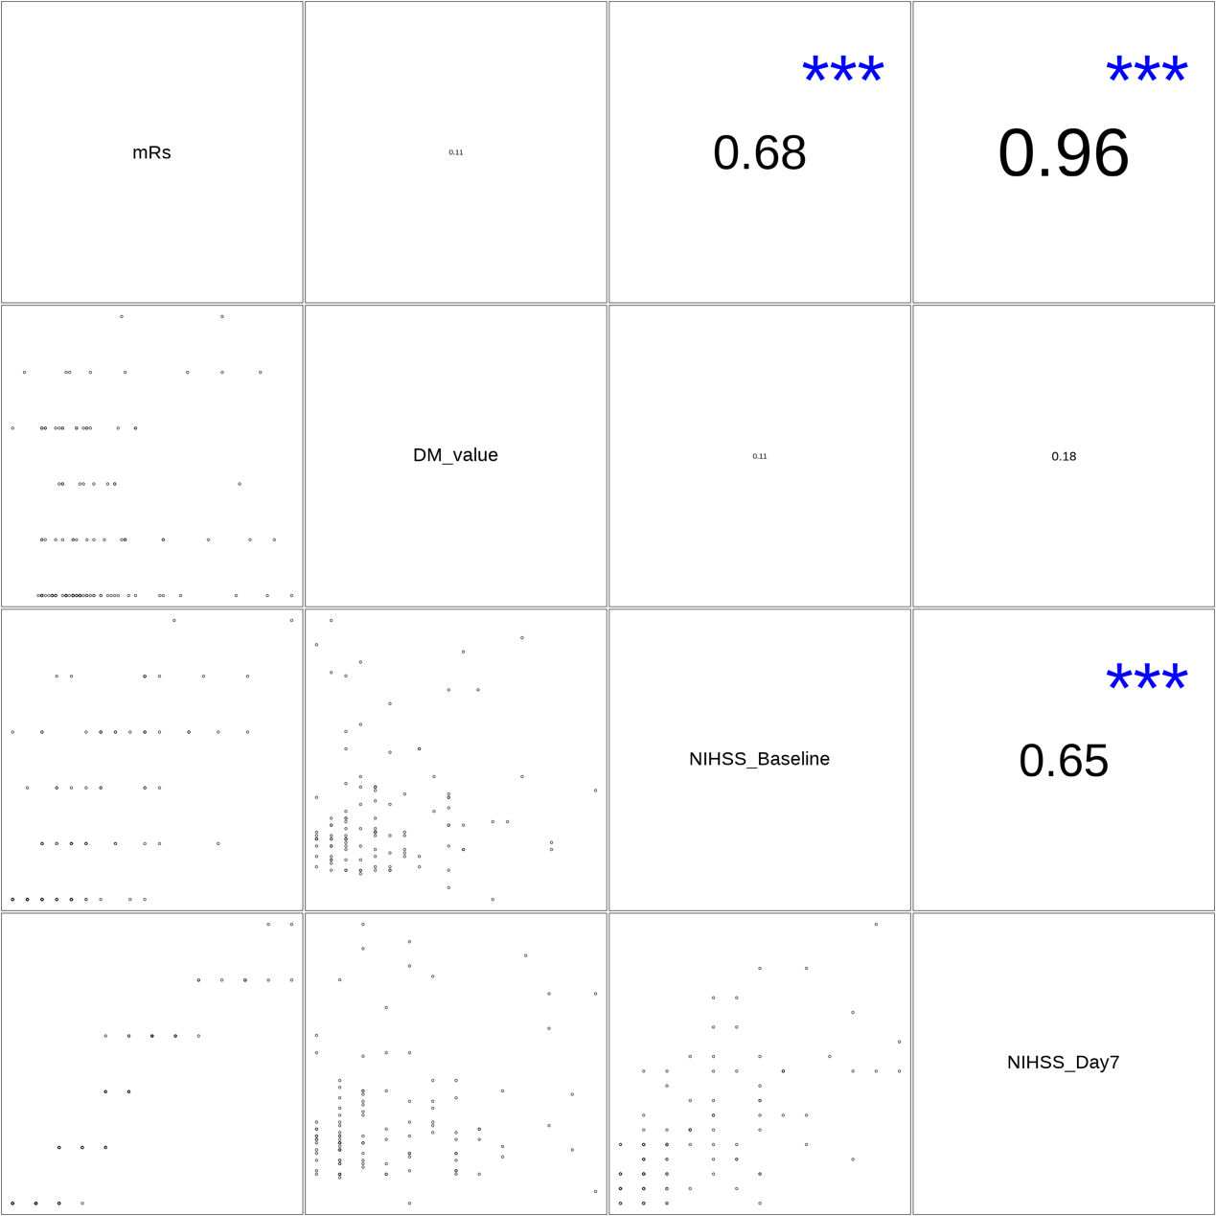
Supp Figure 6. The correlational map between mRs and risk factors based on single-factor ANOVA in External II. The mRs has a positive correlation with DM_value, NIHSS_Day7 and NIHSS_Baseline.

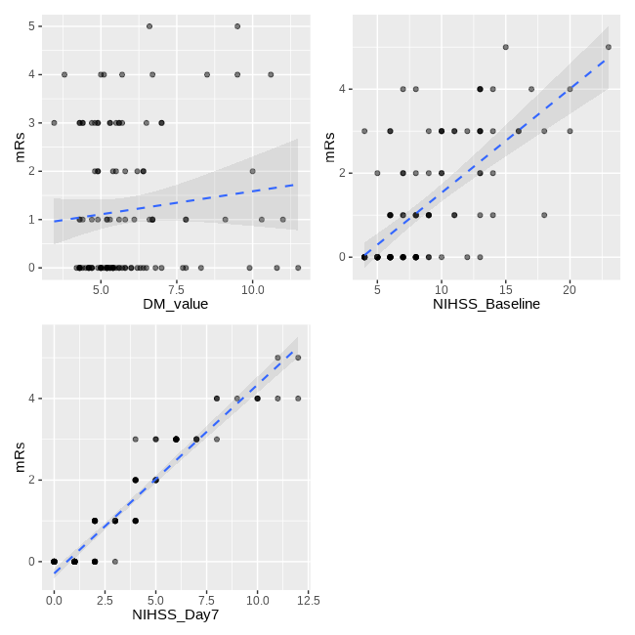
Supp Figure 7.The scatter plot between mRs and risk factors based on single-factor ANOVA in External II.

Supp Figure 8. Comparison of the NIHSS parameters for the Prediction of Outcomes. Solo ROC curve for baseline NIHSS, 3-day NIHSS and 7-day NIHSS to predict the MRS at three months post onset (A-C). The AUC value in three groups of combined baseline NIHSS, 3-day NIHSS and 7-day NIHSS, which indicated a strong prediction ability (D-F).

