Supplementary Material

Article Title
Torrego-Ellacuría M^{1,2}, Rubio-Herrera MA^{2,3}*, González López-Valcárcel B⁴, Fuentes-Ferrer ME^{5,6}, Martín V⁷, Poyato F⁷, Barber-Pérez P⁴, Santucci C^{4,8}, Nuñez A⁹, González-Pérez C^{1,10}, Luaces M¹
* Correspondence: Miguel Ángel Rubio-Herrera: marubioh@gmail.com

Table S1. Baseline characteristics at emergency admission by obesity degree
Baseline characteristics | Non-obesity | Obesity I | Obesity II | Obesity III
Age (years), mean±SD | 65.18±19.57 | 65.55±17.13 | 61.16±18.26 | 57.24±15.79
Age <70 years, n (%) | 1,203 (65.13) | 424 (23.01) | 147 (7.96) | 73 (3.95)
Age ≥70 years, n (%) | 1,063 (69.75) | 355 (23.29) | 85 (5.58) | 21 (1.38)
Sex
Male, n (%) | 1,901 (68.23) | 380 (23.76) | 102 (6.37) | 26 (1.6)
Female, n (%) | 1,175 (66.30) | 399 (22.52) | 130 (7.33) | 68 (3.84)
BMI (kg/m²), mean±SD | 25.45 ± 2.99 | 32.09 ± 1.42 | 36.99 ± 1.40 | 43.40 ± 3.14
Origin
Spanish, n (%) | 1,738 (69.18) | 554 (22.05) | 155 (6.17) | 65 (2.58)
Latin American, n (%) | 427 (60.82) | 184 (26.21) | 66 (9.40) | 25 (3.56)
Other origin, n (%) | 97 (63.39) | 41 (26.79) | 11 (7.19) | 4 (2.61)
Comorbidities
HT, n (%) | 1,109 (63.51) | 448 (25.66) | 134 (7.67) | 55 (3.15)
DM, n (%) | 455 (57.16) | 240 (30.15) | 66 (8.29) | 35 (4.39)
CVD, n (%) | 438 (67.48) | 163 (25.11) | 35 (5.39) | 13 (2.0)
BMI; body mass index; CI, confidence interval; CVD; cardiovascular disease; DM, diabetes mellitus; HT, hypertension; ICU, intensive care unit; SD, standard deviation.
This descriptive analysis was performed in the population of patients with an available BMI record (N =3371).

Table S2. Risk of hospitalization, ICU admission, invasive mechanical ventilation, and mortality based on the presence of obesity and obesity degree in the population < 70 years old
Population <70 years old  (N=1,871) | Obesity |  | Obesity I |  | Obesity II |  | Obesity III
Population <70 years old  (N=1,871) | OR (95% CI) | p value | OR (95% CI) | p value | OR (95% CI) | p value | OR (95% CI) | p value
Hospitalization | 1.88 (1.55-2.27) | <0.001 | 1.68 (1.5-2.10) | <0.001 | 1.70 (1.20-2.39) | 0.003 | 2.56 (1.57-4.17) | <0.001
ICU admission | 1.05 (0.71-1.55) | 0.795 | 0.96 (0.60-1.52) | 0.847 | 0.91 (0.45-1.85) | 0.792 | 2.70 (1.37-5.33) | 0.004
Invasive mechanical ventilation | 1.27 (0.85-1.89) | 0.253 | 1.13 (0.69-1.82) | 0.621 | 1.11 (0.54-2.29) | 0.765 | 3.32 (1.67-6.60) | 0.001
Mortality (30-day) | 0.76 (0.42-1.36) | 0.351 | 0.52 (0.24-1.15) | 0.105 | 0.76 (0.26-2.21) | 0.612 | 1.34 (0.45-3.96) | 0.601
Mortality (in-hospital) | 0.78 (0.46-1.30) | 0.335 | 0.61 (0.31-1.18) | 0.141 | 0.58 (0.20-1.67) | 0.312 | 1.31 (0.49-3.49) | 0.591
CI, confidence Interval; ICU, intensive care unit; OR; Odds ratio.
Reference category: non-obesity. Results adjusted for age, sex, and comorbidities (DM, HT, and CVD).
The logistic regression analysis for the variable “ICU admission”, "invasive mechanical ventilation” and “mortality” were calculated in the total number of patients requiring hospital admission (N=852).

Table S3. Risk of hospitalization, ICU admission, invasive mechanical ventilation and mortality based on the presence of comorbidities in the population < 70 years old
Population <70 years old  (N=1,871) | Non-obesity with obesity-related comorbidity |  | Obesity without obesity-related comorbidity |  | Obesity with obesity-related comorbidity
Population <70 years old  (N=1,871) | OR (95% CI) | p value | OR (95% CI) | p value | OR (95% CI) | p value
Hospitalization | 2.23 (1.74-2.87) | <0.001 | 1.61 (1.24-2.08) | <0.001 | 3.69 (2.83-4.82) | <0.001
ICU admission | 1.84 (1.09-3.10) | 0.021 | 1.26 (0.69-2.29) | 0.450 | 1.49 (0.88-2.51) | 0.135
Invasive mechanical ventilation | 1.66 (0.95-2.91) | 0.076 | 1.39 (0.74-2.59) | 0.305 | 1.74 (1.01-2.98) | 0.045
Mortality (30-day) | 2.99 (1.41-6.35) | 0.004 | 1.04 (0.38-2.86) | 0.943 | 1.56 (0.68-3.55) | 0.292
Mortality (in-hospital) | 1.97 (1.03-3.76) | 0.039 | 0.84 (0.36-1.97) | 0.682 | 1.24 (0.62-2.46) | 0.546
CI, confidence Interval; ICU, intensive care unit; OR; Odds ratio.
Reference categories: non-obesity without any obesity-related comorbidity. Results adjusted for age and sex. Obesity-related comorbidities have been previously defined in this text as diabetes mellitus, arterial hypertension, and cardiovascular disease.
The logistic regression analysis for the variables “ICU admission”, “IMV” and “mortality” were calculated in the total number of patients requiring hospital admission (N=852).

Table S4. Baseline characteristics and clinical outcomes according to presence/absence of obesity and comorbidities
 | Non-obesity |  | Obesity
 | Without obesity-related comorbidity | With obesity-related comorbidity | Without obesity-related comorbidity | With obesity-related comorbidity
Age (years), mean±SD | 51.50±17.27 | 75.79±13.83 | 50.60±14.63 | 70.34±14.67
Age < 70 years | 837 (44.7) | 366 (19.6) | 331 (17.7) | 337 (18.01)
Age ≥ 70 years | 153 (10.0) | 910 (59.7) | 46 (3.0) | 422 (27.7)
Sex
Male | 377 (23.3) | 714 (44.2) | 148 (9.2) | 377 (23.3)
Female | 613 (34.3) | 562 (31.5) | 229 (12.8) | 382 (21.4)
Origin
Spanish | 621 (24.5) | 1117 (44.1) | 177 (7.0) | 620 (24.5)
Latin American | 308 (43.4) | 119 (16.8) | 173 (24.4) | 109 (15.4)
Other origin | 59 (38.3) | 38 (24.7) | 27 (17.5) | 30 (19.48)
Emergency room stay but no admission | 611 (63.6) | 350 (36.5) | 192 (14.1) | 209 (15.4)
Inpatient hospitalization | 379 (29.0) | 926 (71.0) | 163 (8.6) | 509 (27.1)
ICU admission | 35 (38.9) | 55 (61.1) | 22 (14.4) | 41 (26.8)
N (%) unless otherwise stated. SD: standard deviation; ICU: Intensive Care Unit. Obesity-related comorbidities have been previously defined in this text as diabetes mellitus, arterial hypertension, and cardiovascular disease.

Table S5. Cost estimation of health resource use in overall sample with imputed records
Health resources | Overall population with imputed records  (n=5,301) |  |  | Population <70 years old with imputed records  (n=2,499)
 | Average cost  Non-obese (€) | Average cost  Obese (€) | Obesity excess cost (%) | Average cost  Non-obese (€) | Average cost  Obese (€) | Obesity excess cost (%)
Emergency department | 304.0 | 330.0 | 8.6 | 290.0 | 320.0 | 10.5
Hospitalization | 4,664.0 | 6,662.0 | 42.8 | 2,843.0 | 5,325.0 | 87.3
ICU hospitalization | 1,024.0 | 2,715.0 | 165.1 | 1,221.0 | 3,634.0 | 197.7
Medication | 30.0 | 66.0 | 120.0 | 35.0 | 94.0 | 169.2
Tracheostomy procedures + IMV >96 h | 359.0 | 987.0 | 174.9 | 426.0 | 1,365.0 | 220.7
Total | 6,381.0 | 10,761.0 | 68.6 | 4,814.0 | 10,739.0 | 123.1
Adjusted for selection bias by imputation of missing records for obesity based on probit models. ICU: Intensive Care Unit; IMV: invasive mechanical ventilation

Table S6. Missing value imputation probit models
Variable | Overall cohort (n=5,301) |  | Population <70 years old (n=2,499)
Variable | Average estimated coefficient | % of samples in which it is significant | Average estimated coefficient | % of samples in which it is significant
Age | 0.05 | 98% | 0.08 | 92%
Age (squared) | -0.00048 | 98% | -0.0008 | 79%
Male | -0.11 | 27% | -0.0222 | 3%
Latin American origin and other countries | 0.16 | 15% | 0.1048 | 6%
Spanish | -0.21 | 25% | -0.216 | 22%
DM | 0.52 | 99% | 0.7088 | 99%
CVD | -0.04 | 3% | -0.6898 | 7%
HT | 0.32 | 80% | 0.373 | 82%
R² | 0.0583 |  | 0.0711

Figure S1. Cumulative 30-day overall survival (obesity vs. non-obesity)
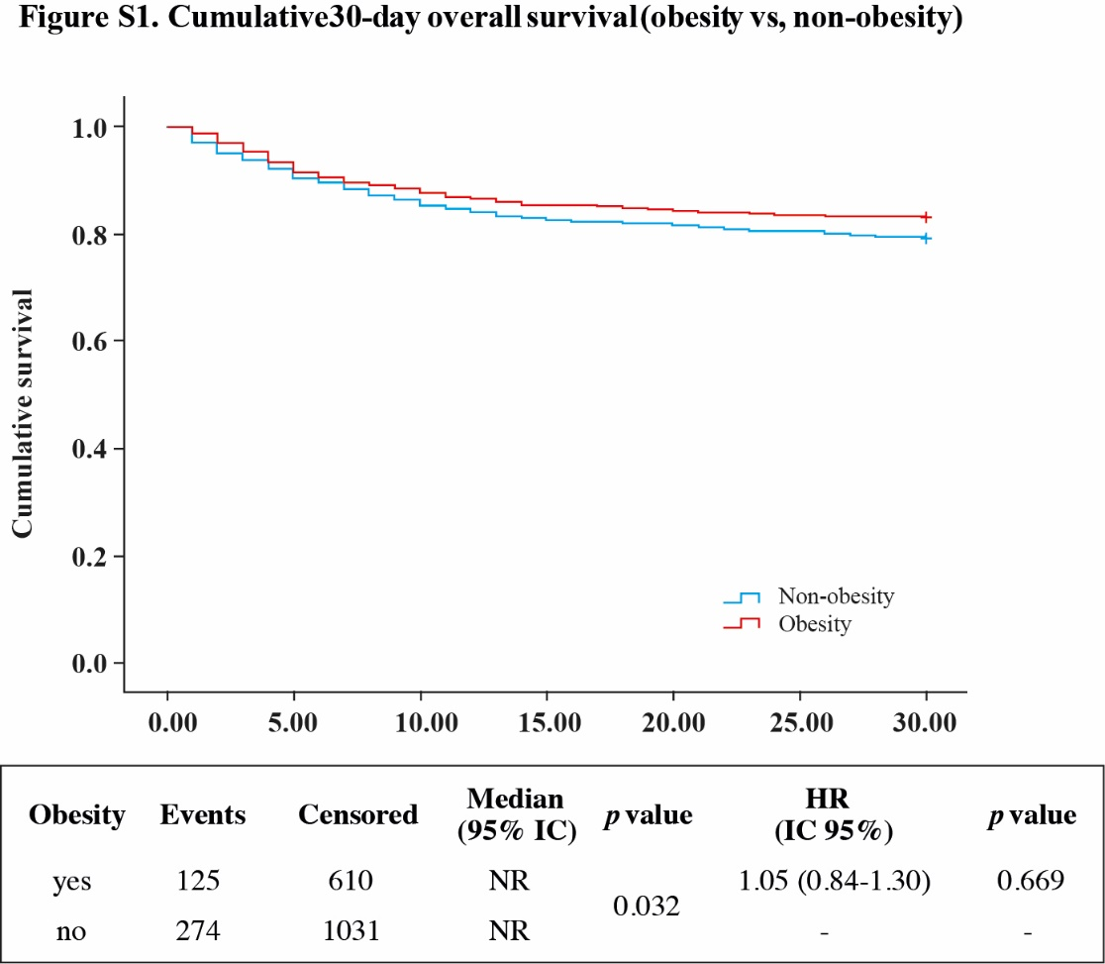

Figure S2. Cumulative 30-day overall survival (obesity vs. non-obesity) by obesity category
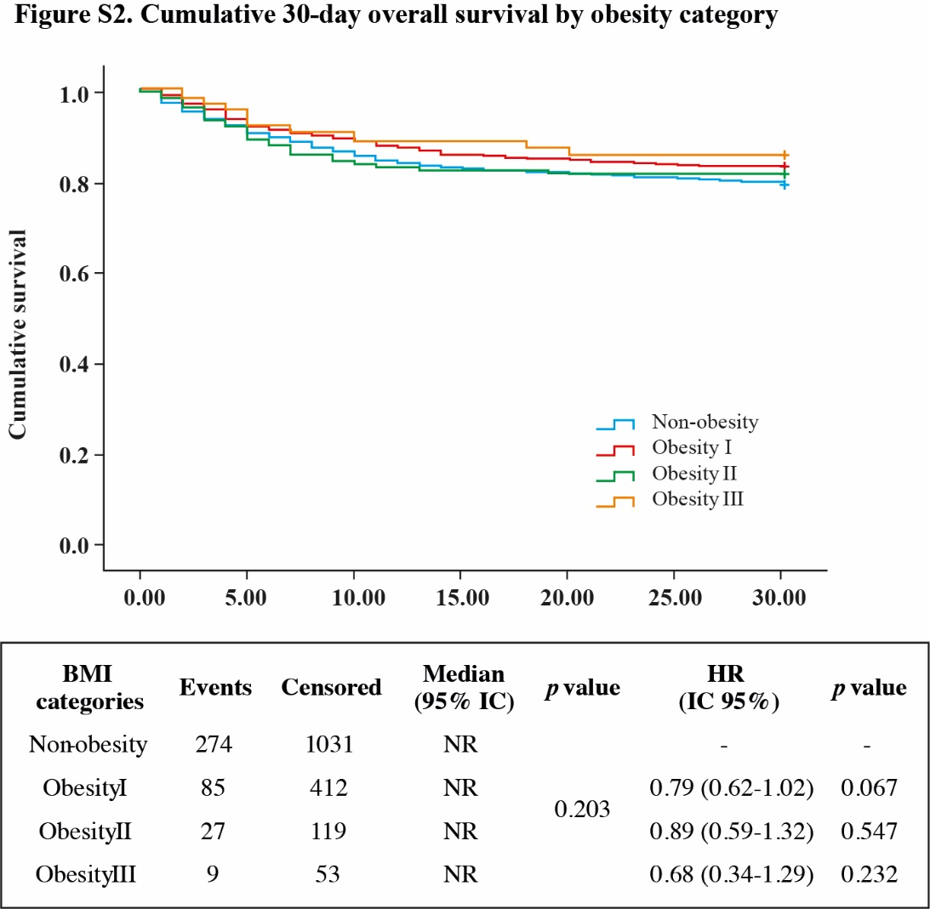

Figure S3. Cumulative 30-day overall survival (obesity vs. non-obesity) in patients < 70 years old

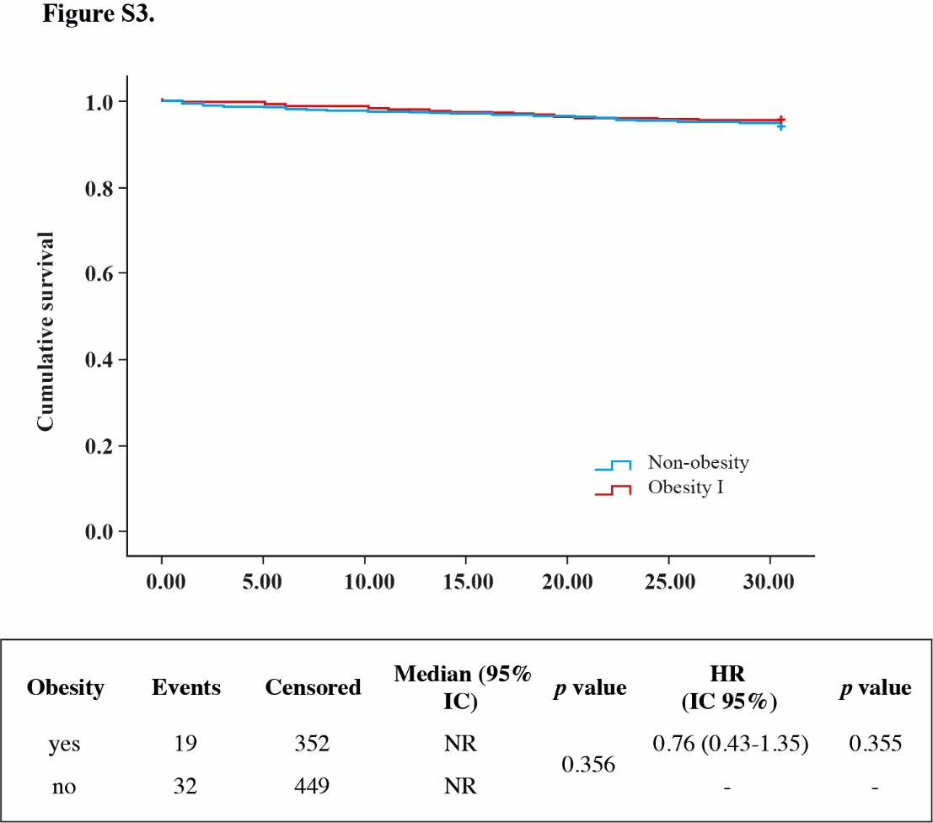
Figure S4. Cumulative 30-day overall survival by obesity category in patients < 70 years old
