Supporting Information

Structural polymorphism of the low-complexity C-terminal domain of TDP-43 amyloid aggregates revealed by solid-state NMR

Jayakrishna Shenoy K.P.1, Alons Lends1, Mélanie Berbon1, Muhammed Bilal1, Nadia El Mammeri1, Mathilde Bertoni1, Ahmad Saad1, Estelle Morvan2, Axelle Grélard1, Sophie Lecomte1, François-Xavier Theillet3, Alexander K. Buell4, Brice Kauffmann2, Birgit Habenstein1*, Antoine Loquet1*

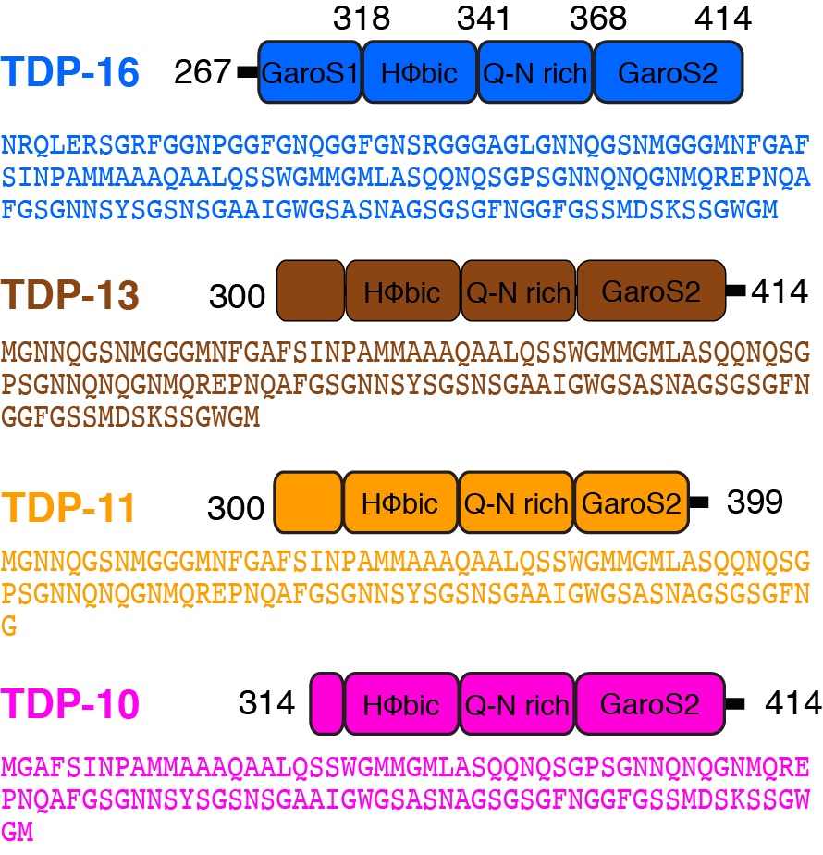

**Supplementary Figure 1:** Primary sequences of TDP constructs. The initial Methionine residues(black) in the sequences is from the construct and not from TDP-43.

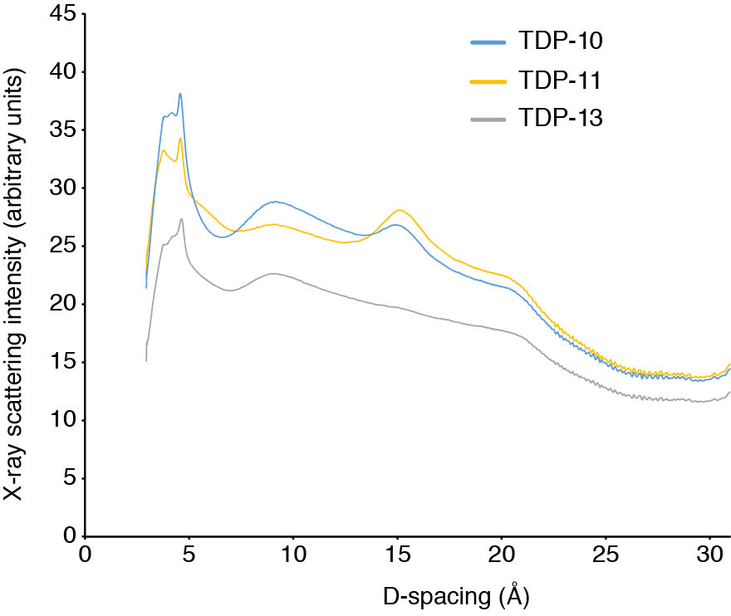

**Supplementary Figure 2:** Diffraction intensity plot of TDP-10, TDP-11 and TDP-13 amyloid fibrils.

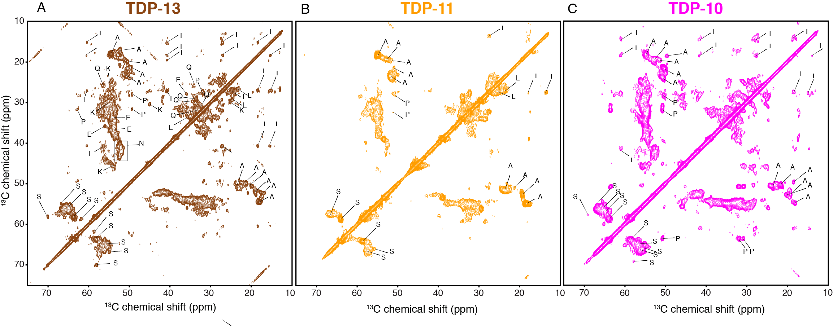

**Supplementary Figure 3: Characterization of rigid residues in TDP-43 CTF aggregates.** 13C-13C PDSD experiments of TDP-13 (in brown) (A), TDP-11(in orange) (B), and TDP-10 (in pink) (C) amyloid aggregates. The data were recorded at a 1H frequency of 800 MHz and 600MHz at 11 kHz MAS at 278 K, using a mixing time of 50 ms to reveal intra-residue correlations.