Supplementary Material

**Figure S1**

Plot of correlation between impervious surface, crop, woody surface, and herbaceous surface land cover in three scaled buffers around 66 urban grasslands (250 m, 500 m, and 1,000 m). Colored circles represent couples with correlations higher than 0.75.

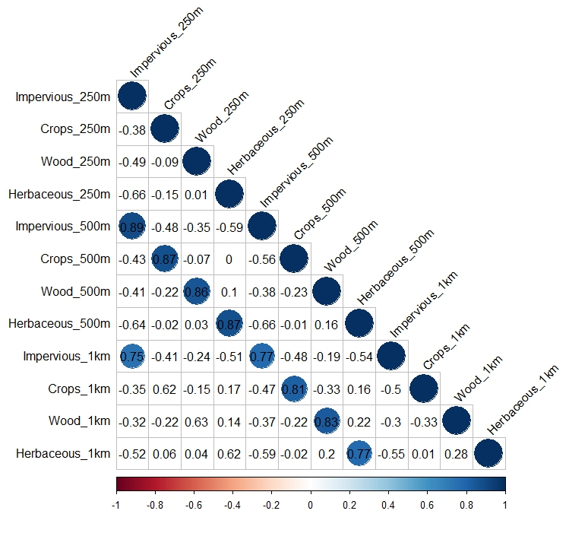

**Table S1**

Species codes, full names (nomenclature following Tison and de Foucault, 2014), and occurrences in 330 samples (for the species used in the CCA illustration, Figure 4).

|  |  |  |
| --- | --- | --- |
| **Names** | **Full names** | **Occurrence** |
| Hol.lan | *Holcus lanatus* L. | 280 |
| Vic.sat | *Vicia sativa* L. | 192 |
| Ran.acr | *Ranunculus acris* L. | 175 |
| Ant.odo | *Anthoxanthum odoratum* L. | 173 |
| Pla.lan | *Plantago lanceolata* L. | 150 |
| Con.arv | *Convolvulus arvensis* L. | 128 |
| Bro.hor | *Bromus hordeaceus* L. | 110 |
| Dau.car | *Daucus carota* L. | 107 |
| Poa.pra | *Poa pratensis* L. | 92 |
| Hyp.rad | *Hypochaeris radicata* L. | 79 |
| Vul.bro | *Vulpia bromoides* (L.) S.F.Gray | 69 |
| Cir.arv | *Cirsium arvense* (L.) Scop. | 68 |
| Leu.vul | *Leucanthemum vulgare* Lam. | 54 |
| Rum.cri | *Rumex crispus* L. | 46 |
| Her.sph | *Heracleum sphondylium* L. | 41 |
| Tri.fla | *Trisetum flavescens* (L.) P.Beauv. *subsp. flavescens* | 41 |
| Ste.gra | *Stellaria graminea* L. | 40 |
| Myo.dis | *Myosotis discolor* Pers. | 38 |
| Ran.rep | *Ranunculus repens* L. | 29 |
| Ave.bar | *Avena barbata* Pott ex Link *subsp. barbata* | 28 |

**Table S2**

Final mean models for the effect of mowing practices and land cover proportion within a 500-m radius on species richness, Shannon index; Ellenberg index for reaction, light, and nitrogen; and plant life-form species richness (for hemicryptophytes and geophytes). Significant results, i.e. estimates whose 95% confidence interval do not include zero, are in bold.

