**Supplementary materials**

Vuong & Geangu, *Frontiers in Cognition*

*Literature search.* We conducted a literature search on PUBMED, Scopus, Medline, Embase and PsycInfo up to October 12, 2022 for articles which investigated emotion processing of body expressions in infants and children. The following expression was used to search titles and abstracts:

[*body* OR *body expression(s)* OR *biological motion*] AND

[*discrimination* OR *perception* OR *identification* OR *recognition* OR *categorization* OR *understanding* OR *process*] AND

[*emotion(s)* OR *emotional*] AND

[*infant(s)* OR *child* OR *children*]

In addition, we used each database’s functionality (when available) to limit searches to (1) human studies, (2) English language, and (3) our targeted age group (i.e., infant, child and pre-school child). A total of 38 articles were included in the mini-review, 22 of which were included in our meta-analyses. Figure S1 illustrates the searching and screening process carried out by QV, in consultation with EG.

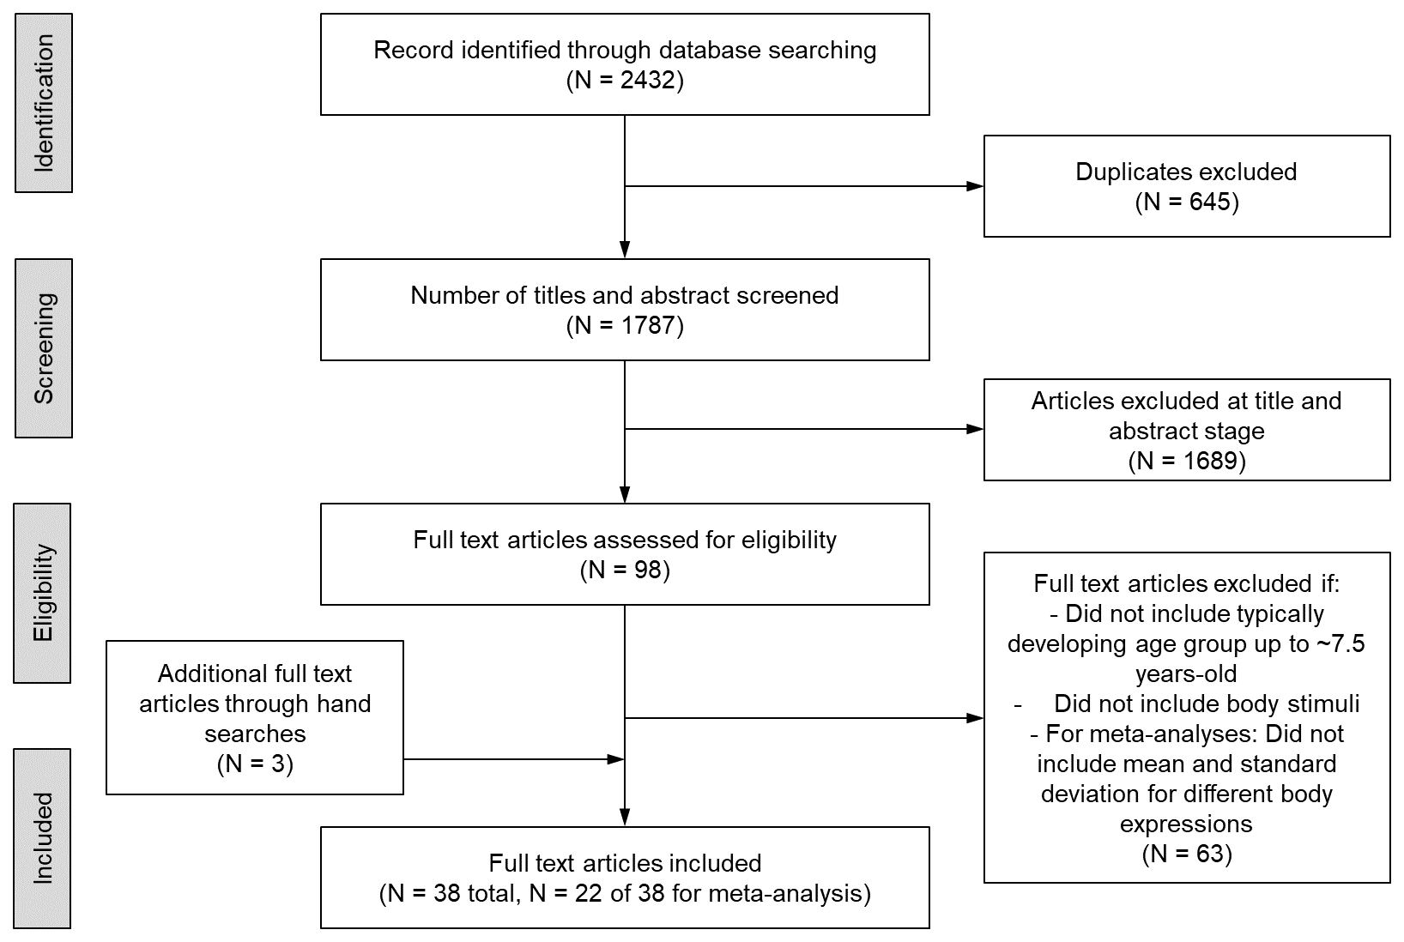

**Figure S1.** Flow chart illustrating the searching and screening process

*Meta-analysis*. We used 3 criteria for including an article in the meta-analysis: (1) was an experimental study; (2) included a typically developing age group within our age range (up to 7.5-years-old); included body stimuli in the study; and (3) provided sufficient information to extract effect sizes (sample size, mean and standard deviation for different body expressions). Twenty-two articles met these criteria. We used a plot digitizer (https://automeris.io/WebPlotDigitizer/index.html) to extract the mean and standard deviation needed from descriptive data plots for 7 articles (Krol 2015; Nicolina 2019; Ogren 2019; Ross 2021; Vieillard 2009; Witkower 2021; Yang 2022). The data and R scripts can be found at: https://osf.io/tyg6n/

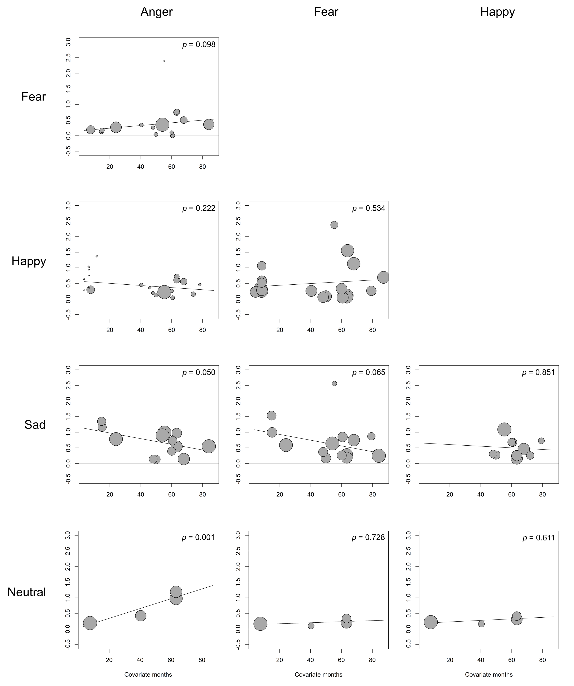

**Figure S2.** Scatterplots of the meta-regression for each emotion pair

Each scatterplot presents the correlation between effect size and mean age (in months). Each effect size is represented by a circle, with the circle diameter representing the weight of the individual data. The solid line represents the regression line (line of best fit). The *p*-value indicates whether months was a significant predictor of effect size or not. *Note.* There was no regression fit for *sad* vs *neutral* (2 effect sizes).