Supplementary Figures
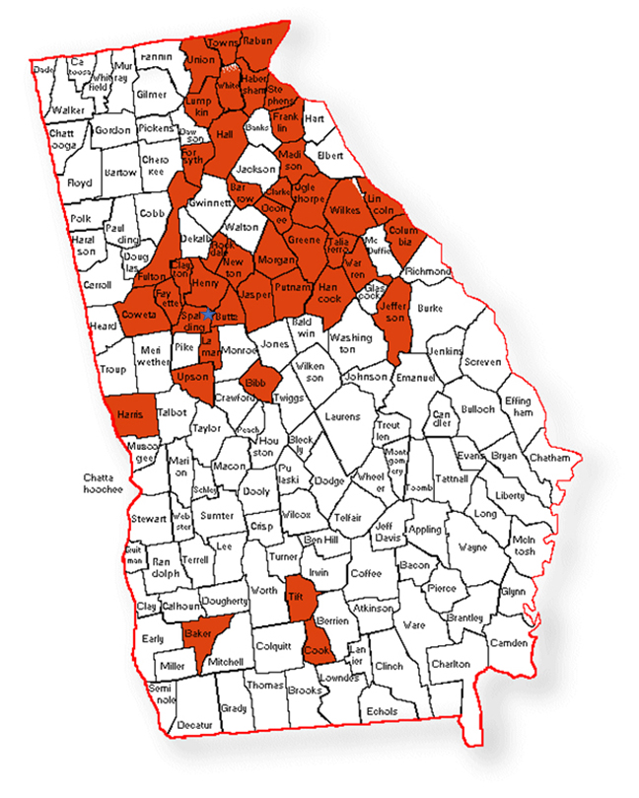
Figure S1: Map of Georgia showing Clarireedia spp. isolates collection counties marked in red color. Counties with asterisk consisted of double resistant isolates to both thiophanate-methyl and propiconazole.
Figure S2: In vitro growth of C. monteithiana in fungicide-amended potato dextrose agar (PDA) plate after four days of incubation; control with no fungicide (A), Reynoutria sachalinensis extr. (Regalia) (B), azoxystrobin (Heritage) (C), fluxapyroxad (Xzemplar) (D), penthiopyrad (Velista) (E), boscalid (Emerald) (F), propiconazole (Banner Maxx) (G), fludioxonil (Medallion) (H), Bacillus subtilis QST713 (Rhapsody) (I), and Bacillus amyloliquefaciens F727 (Stargus) (J).

Figure S3: In vitro growth of C. monteithiana in fungicide-amended potato dextrose agar (PDA) plate after four days of incubation; control with no fungicide (A), 100% Reynoutria sachalinensis extr. (B), 100% Bacillus subtilis QST713 (C), 100% propiconazole (D), 50% Bacillus subtilis QST713 + 50% Reynoutria sachalinensis extr. (E), 50% Reynoutria sachalinensis extr. + 50% propiconazole (F), 50% Bacillus subtilis QST713 + 50% propiconazole (G), 75% Reynoutria sachalinensis extr. + 25% propiconazole (H), 25% Reynoutria sachalinensis extr. + 75% propiconazole (I), 75% Bacillus subtilis QST713 + 25% propiconazole (J), and 25% Bacillus subtilis QST713 + 75% propiconazole (K)
Figure S4: Experimental plots of non-treated control (T1) (A), B. subtilis QST713 applied every 7 days (T2) (B), a tank mix of 75% B. subtilis QST713 + 25% propiconazole applied every 28 days (T5) (C), 75% B. subtilis QST713 + 25% propiconazole tank mix in rotation with 100% B. subtilis QST713 applied every 14 days (T6) (D), and 100% B. subtilis QST713 in rotation with 75% B. subtilis QST713 + 25% propiconazole tank mix applied every 14 days (T7) (E)
(photo taken at 42 days after the start of the experiment at the UGA Griffin campus, Griffin GA during the summer season, 2022)

