**8. Supplemental Figures**

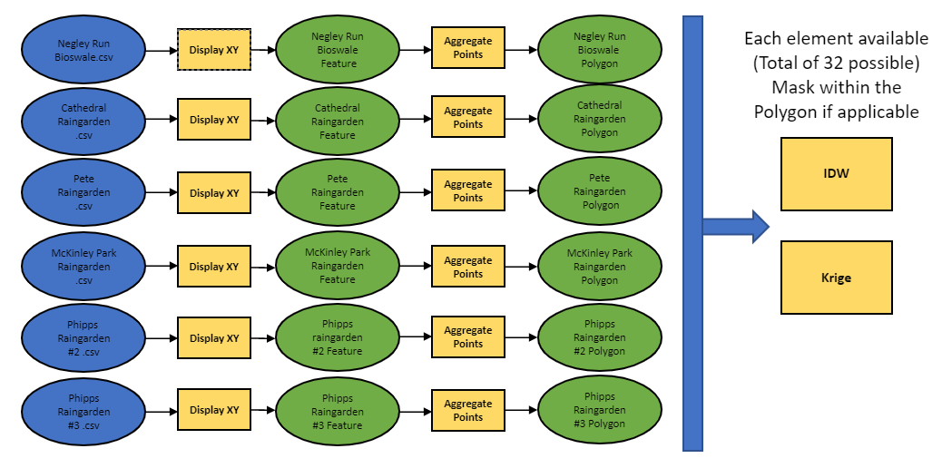

***Figure S1:*** *Represents the GIS workflow performed in ArcGIS Pro for each of the GI site datasets.*

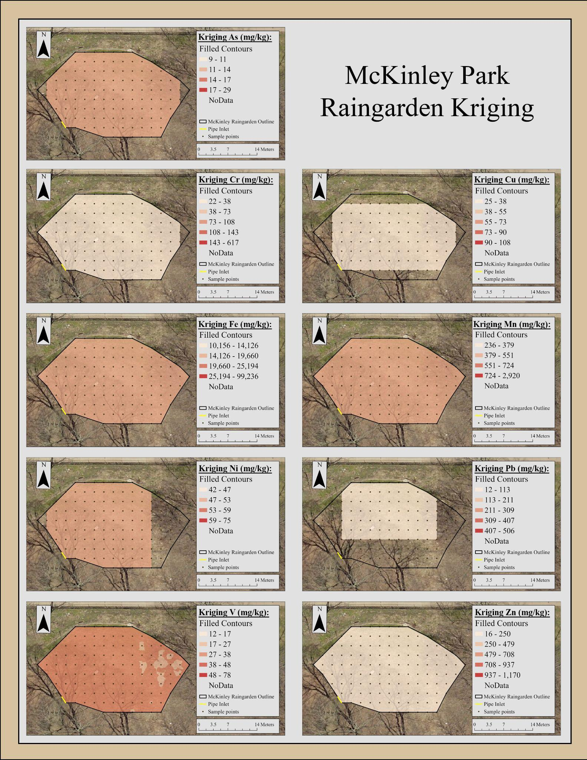

***Figure S2****:**A map of soil metal concentration patterns measured in the McKinley Park lower raingarden*

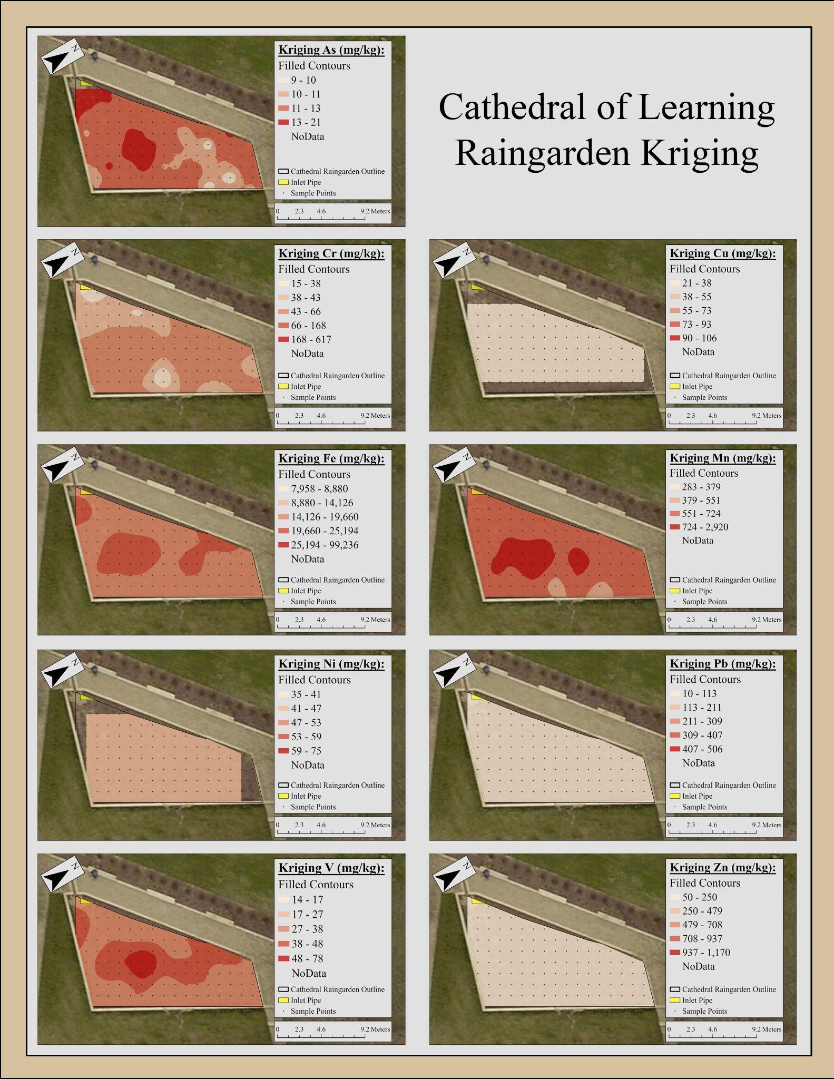

***Figure S3****: A map of soil metal concentration patterns measured in the Cathedral of Learning raingarden.*

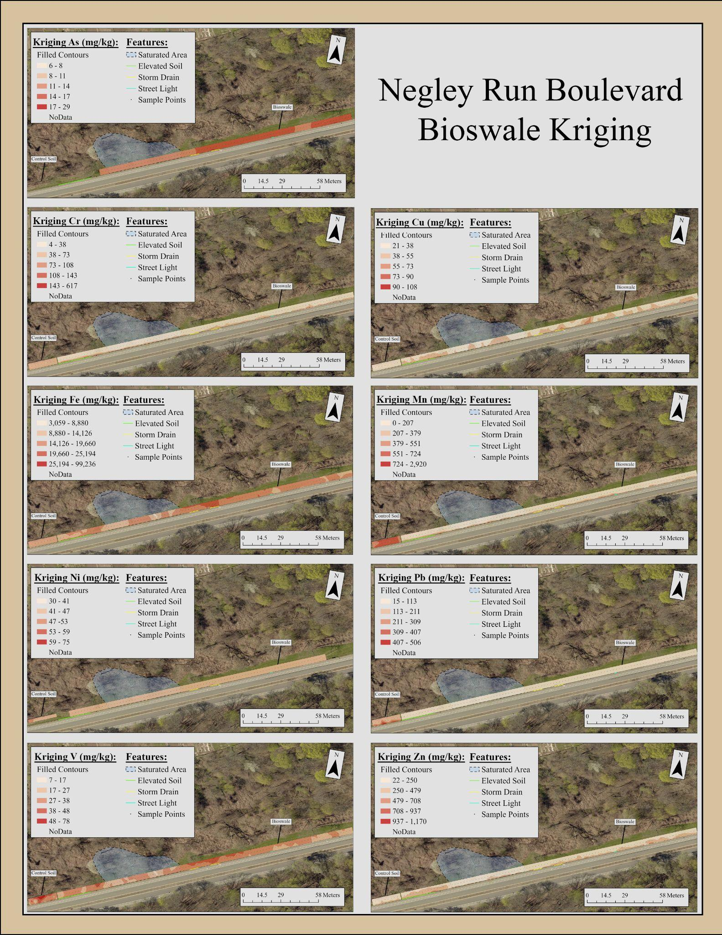

***Figure S4****: Maps of metal concentrations in the Negley Run Boulevard Legacy soil (left) and bioswale (right starting at the green line). Unknown hillside spring/pipe flow that saturates the swale soils is represented by the blue area with a black dashed line border. Runoff obstructions like elevated soil, storm drains, and streetlights both with concrete berms are represented by green, yellow, and cyan lines respectively.*

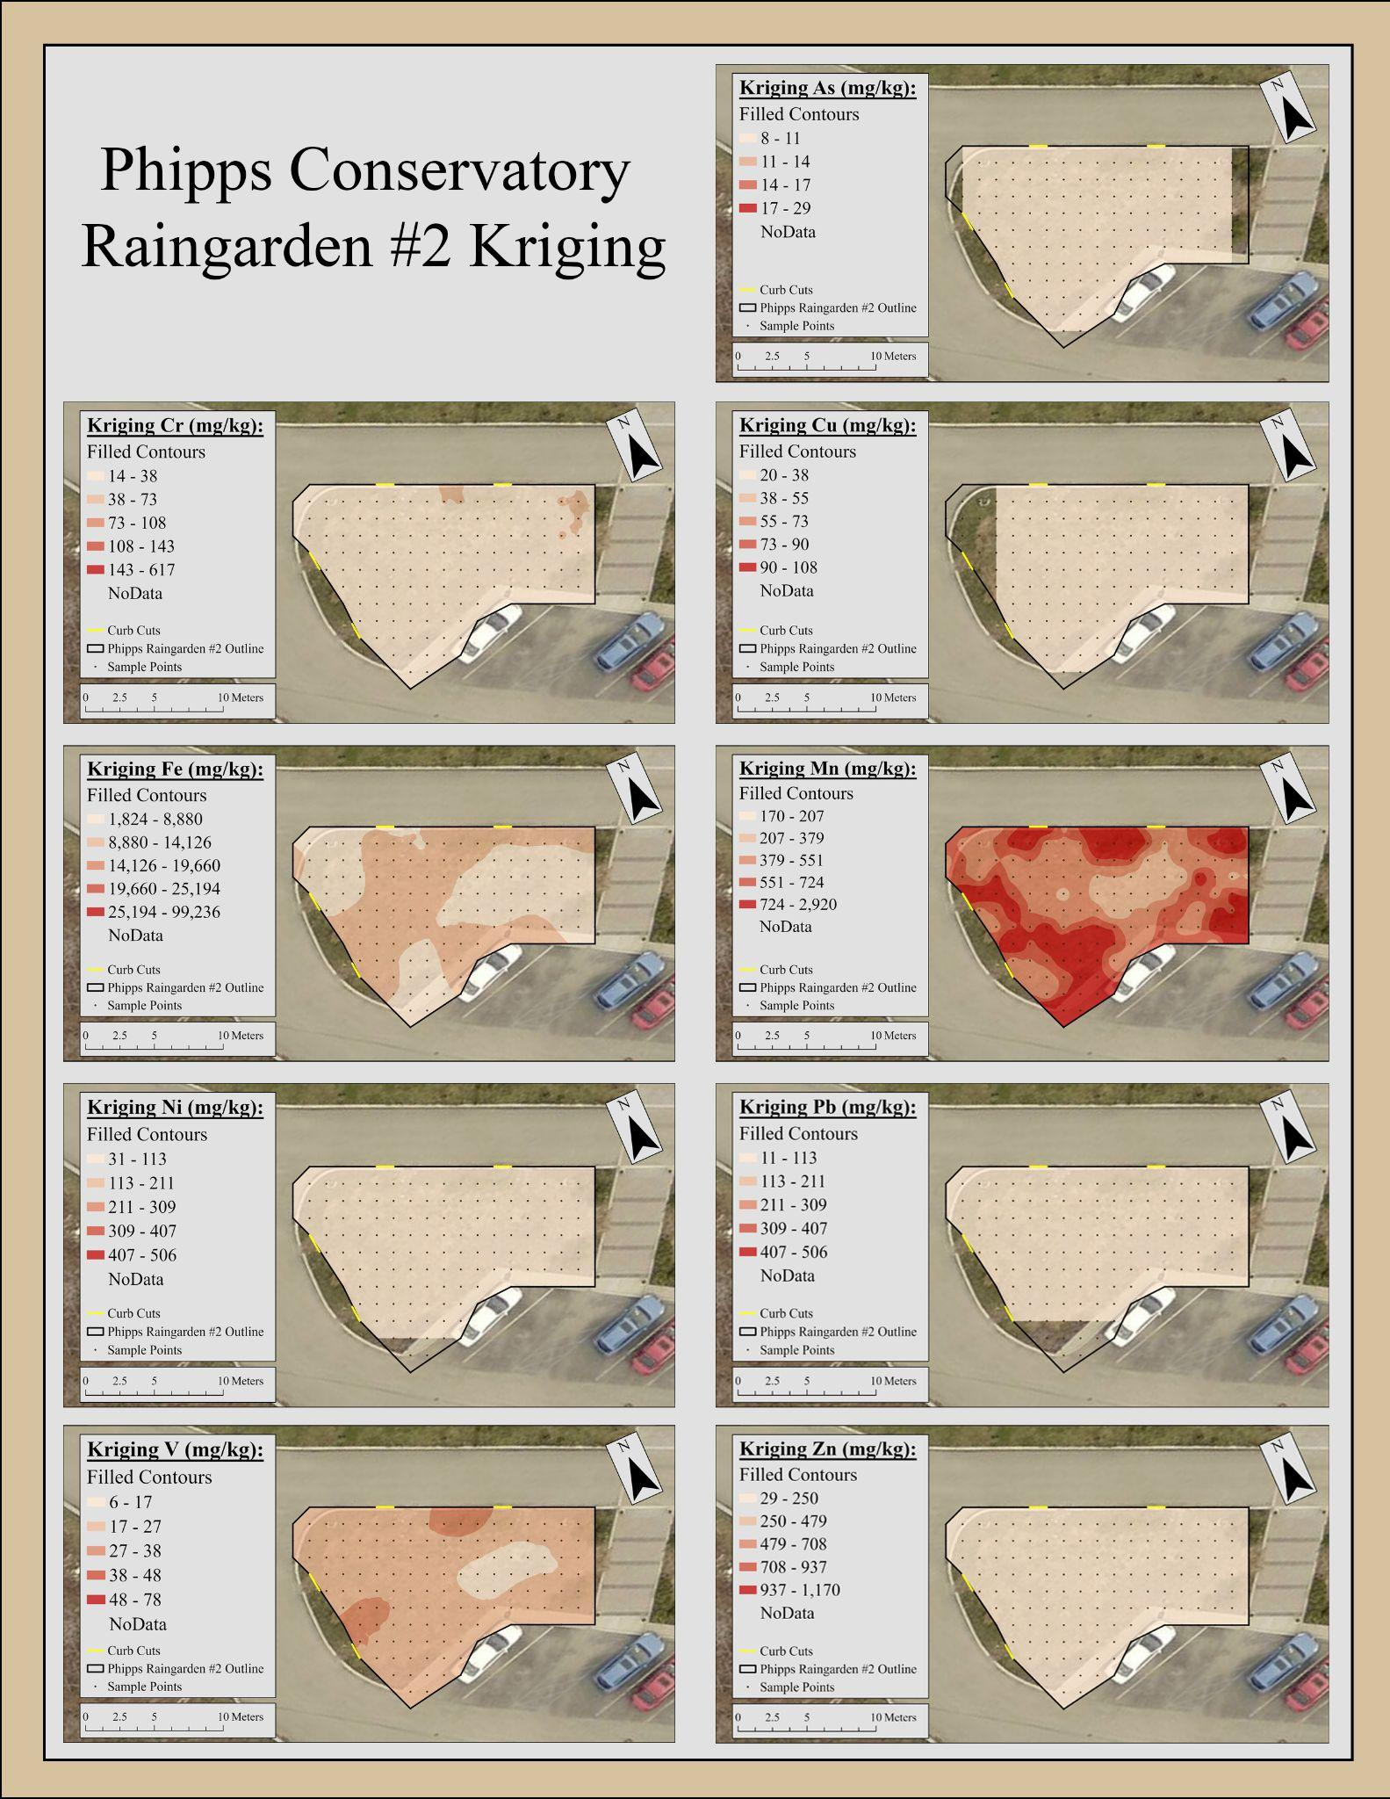

***Figure S5****: A map of soil metal concentration patterns measured in the Phipps Conservatory raingarden #2.*

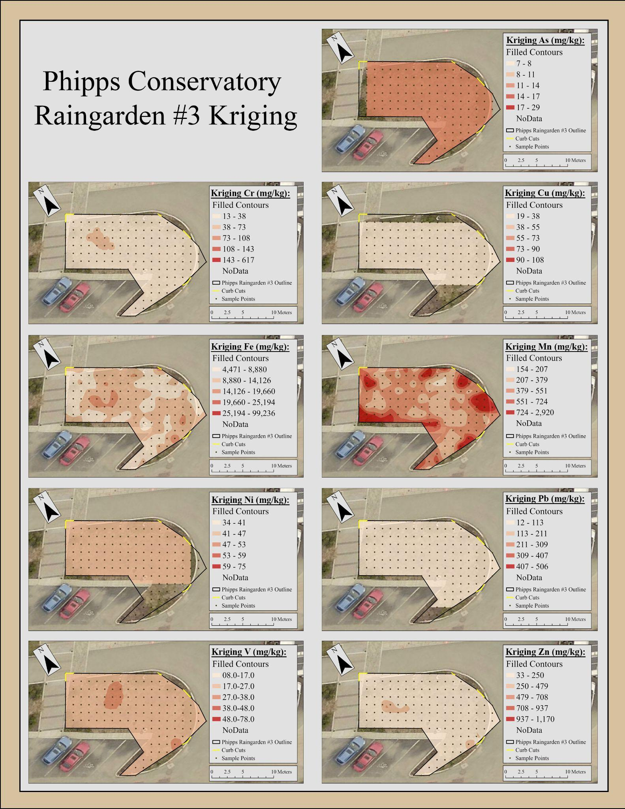

***Figure S6****: A map of soil metal concentration patterns measured in the Phipps Conservatory raingarden #3.*

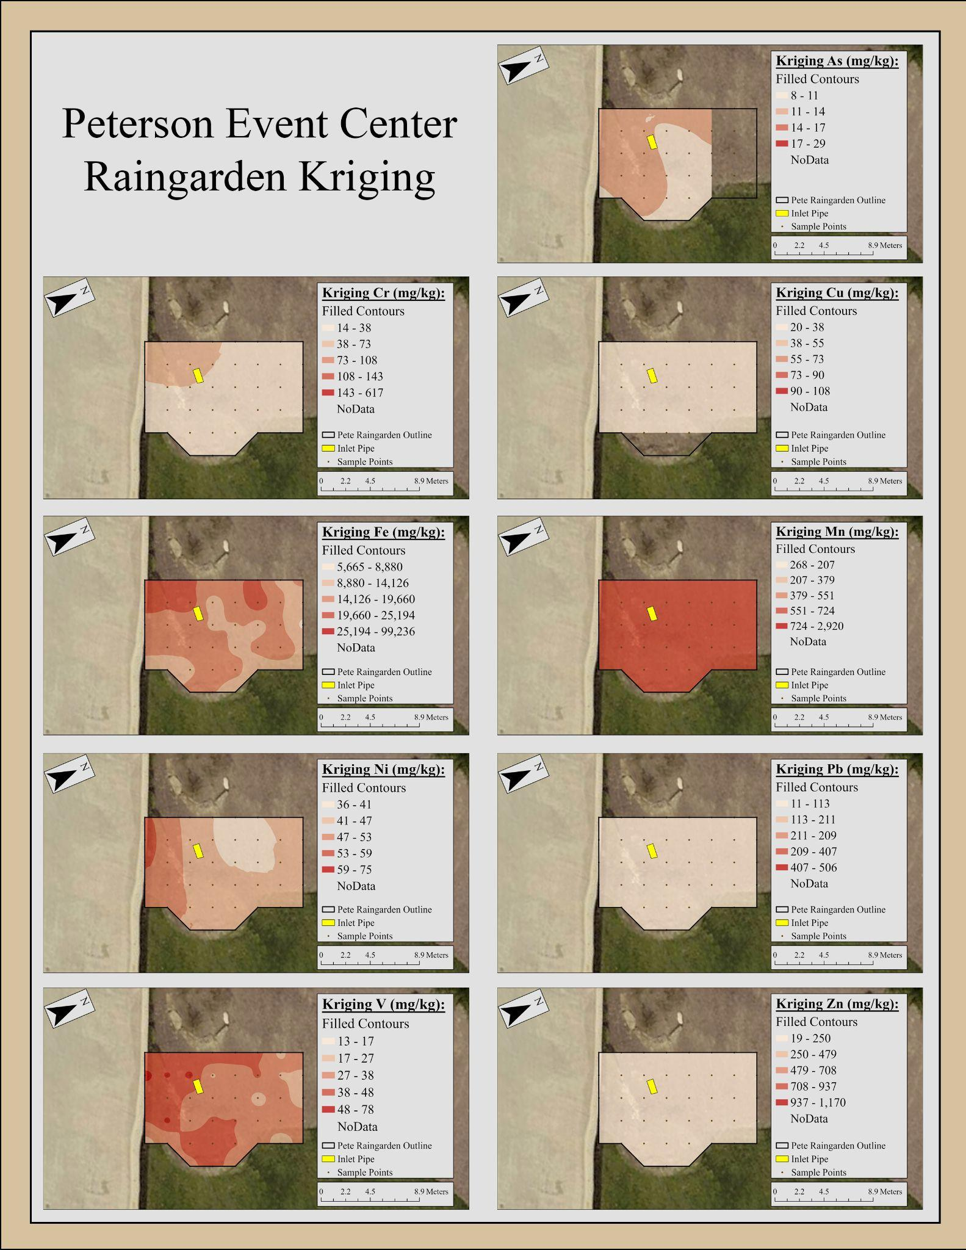

***Figure S7****: A map of soil metal concentration patterns measured in the Peterson Event Center raingarden.*

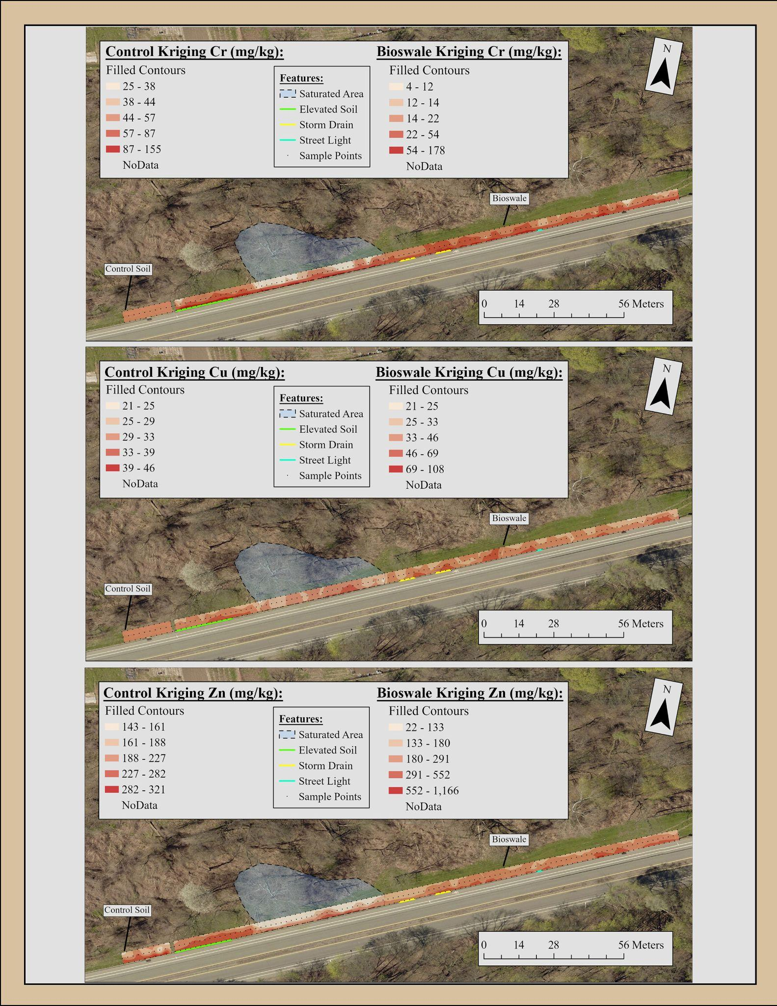

***Figure S8****: A map of Cr, Cu, and Zn soil metal concentration patterns measured in the Negley Run Blvd. bioswale. Note, the graduated color scale is optimized for comparison within the installation.*

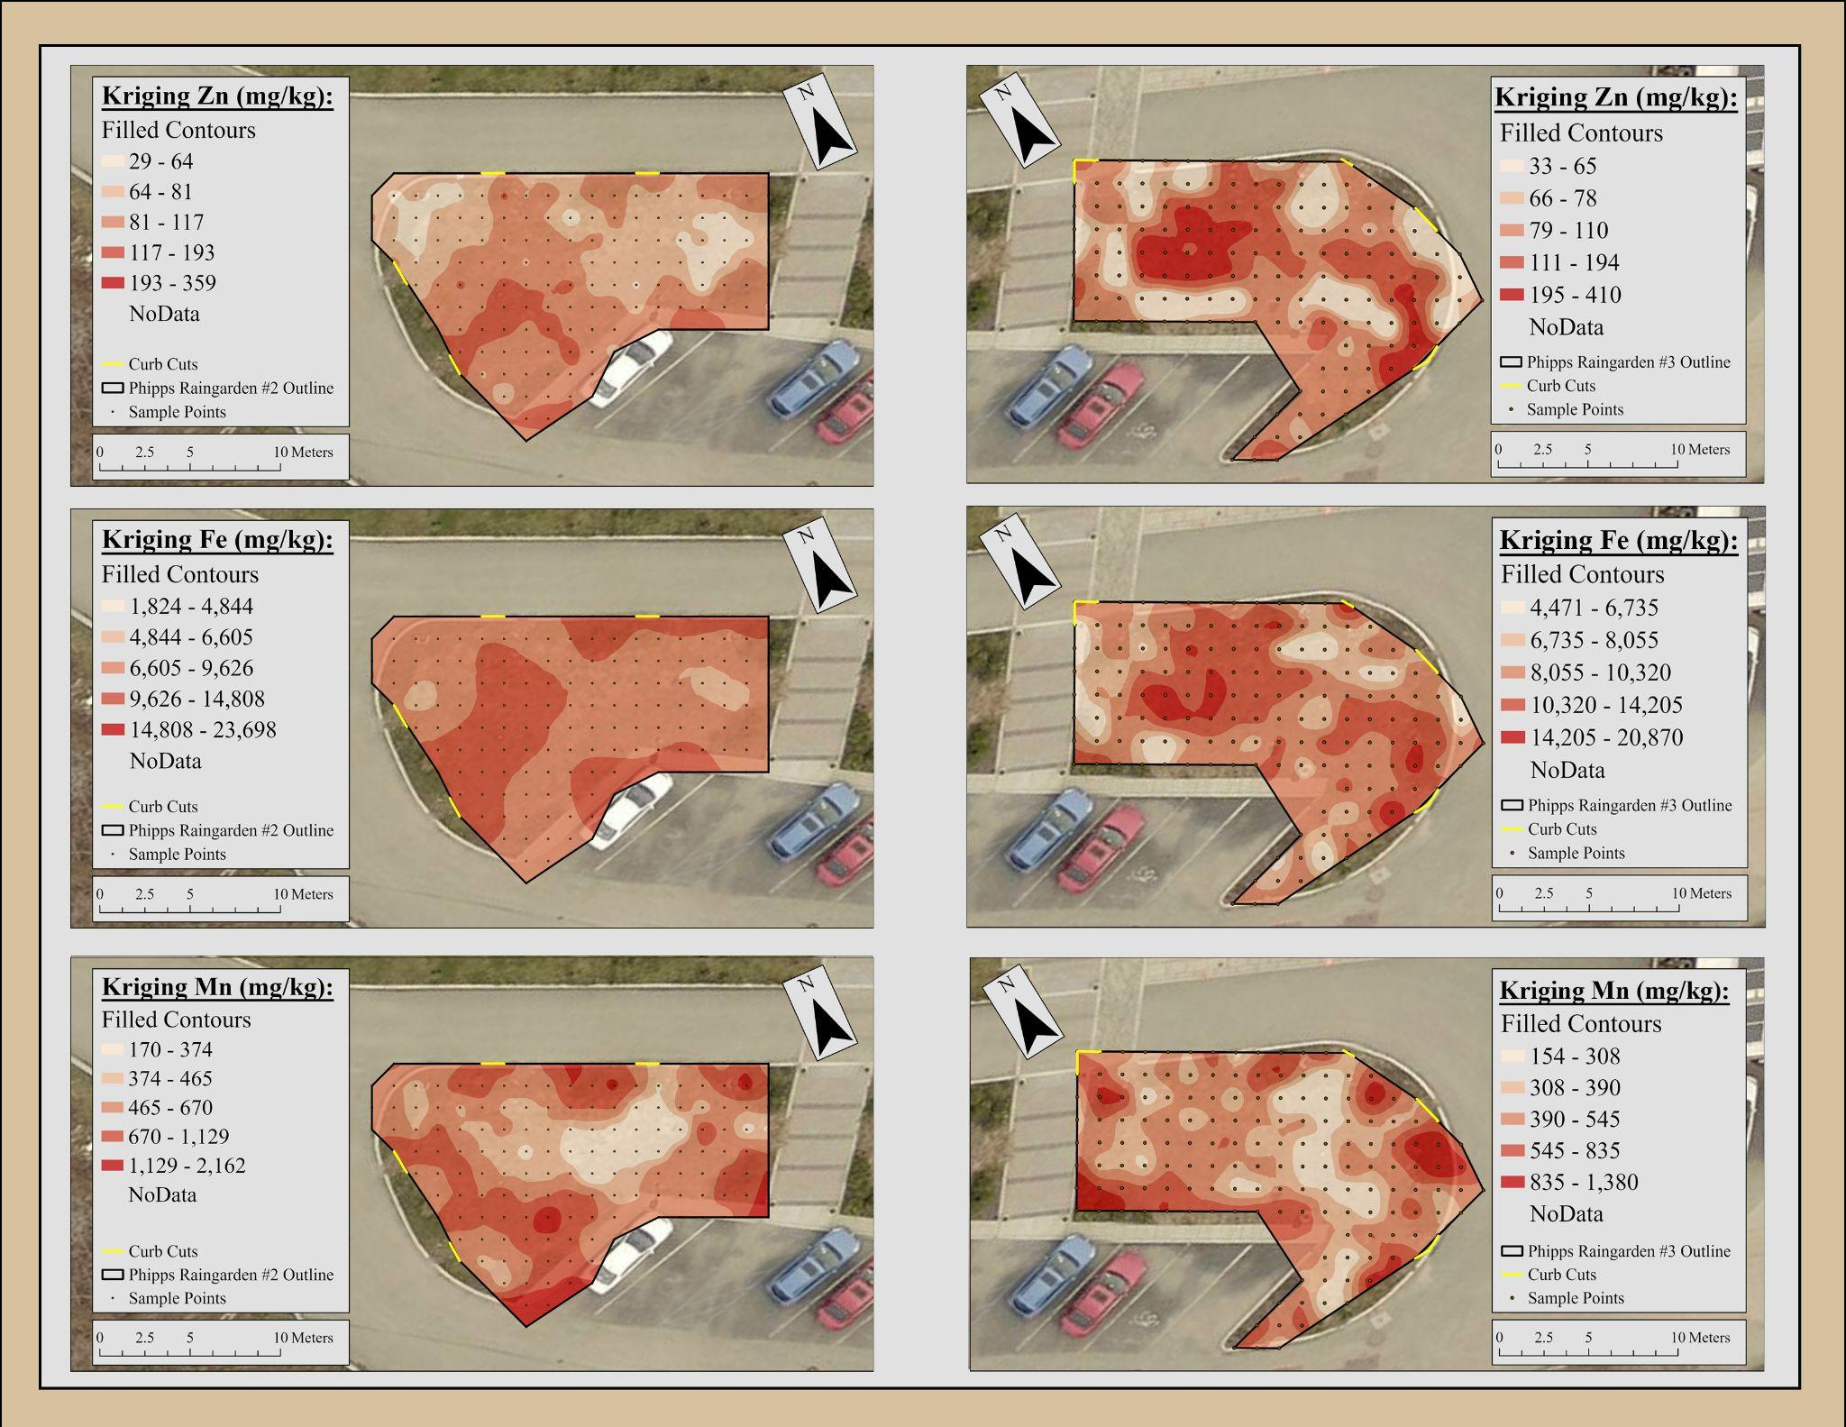

***Figure S9****: A map of Zn, Fe, and Mn sil metal concentration patterns measured in the Phipps Conservatory raingardens #2 (left) and #3 (right). Note, the graduated color scale is optimized for comparison within the installation.*