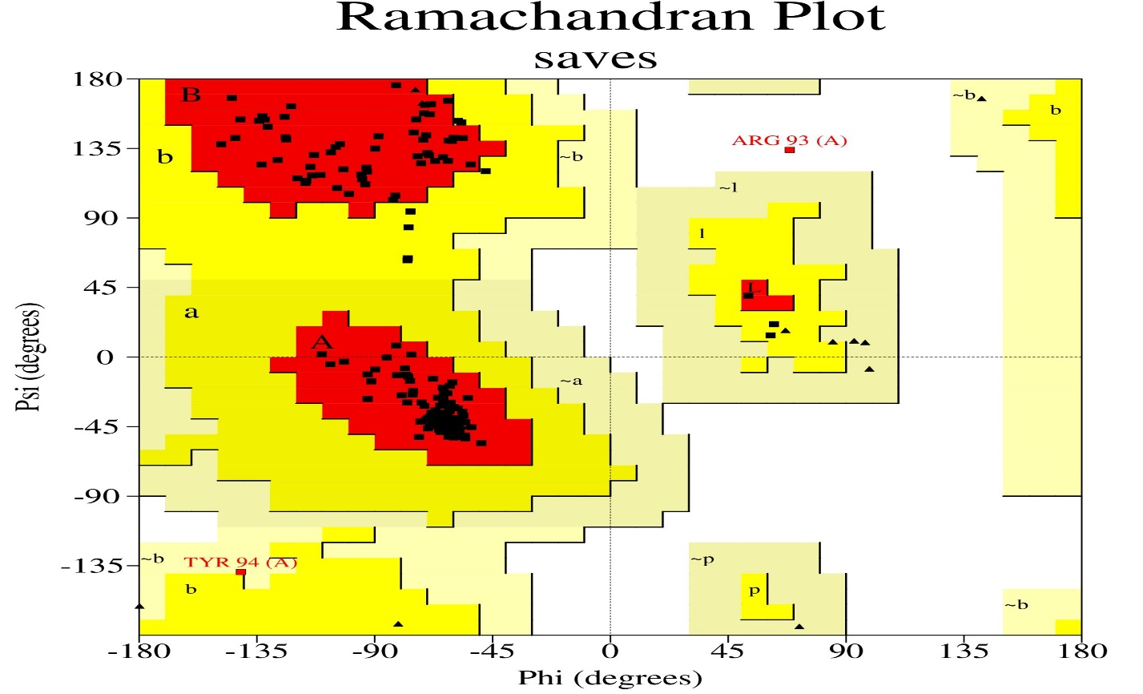

**Figure S1A.** Ramachandran plot of the developed model of thymidylate kinase.



**Figure S1B.** ERRAT plot of the developed model of thymidylate kinase.