Supplementary Material
Heme promotes sexual differentiation of Plasmodium falciparum in human erythrocytes
Bethany Flage, Matthew R. Dent, Jesus Tejero, and Solomon Fiifi Ofori-Acquah*
* Correspondence: Solomon Fiifi Ofori-Acquah, sfo2@pitt.edu

Supplementary Figures and Tables

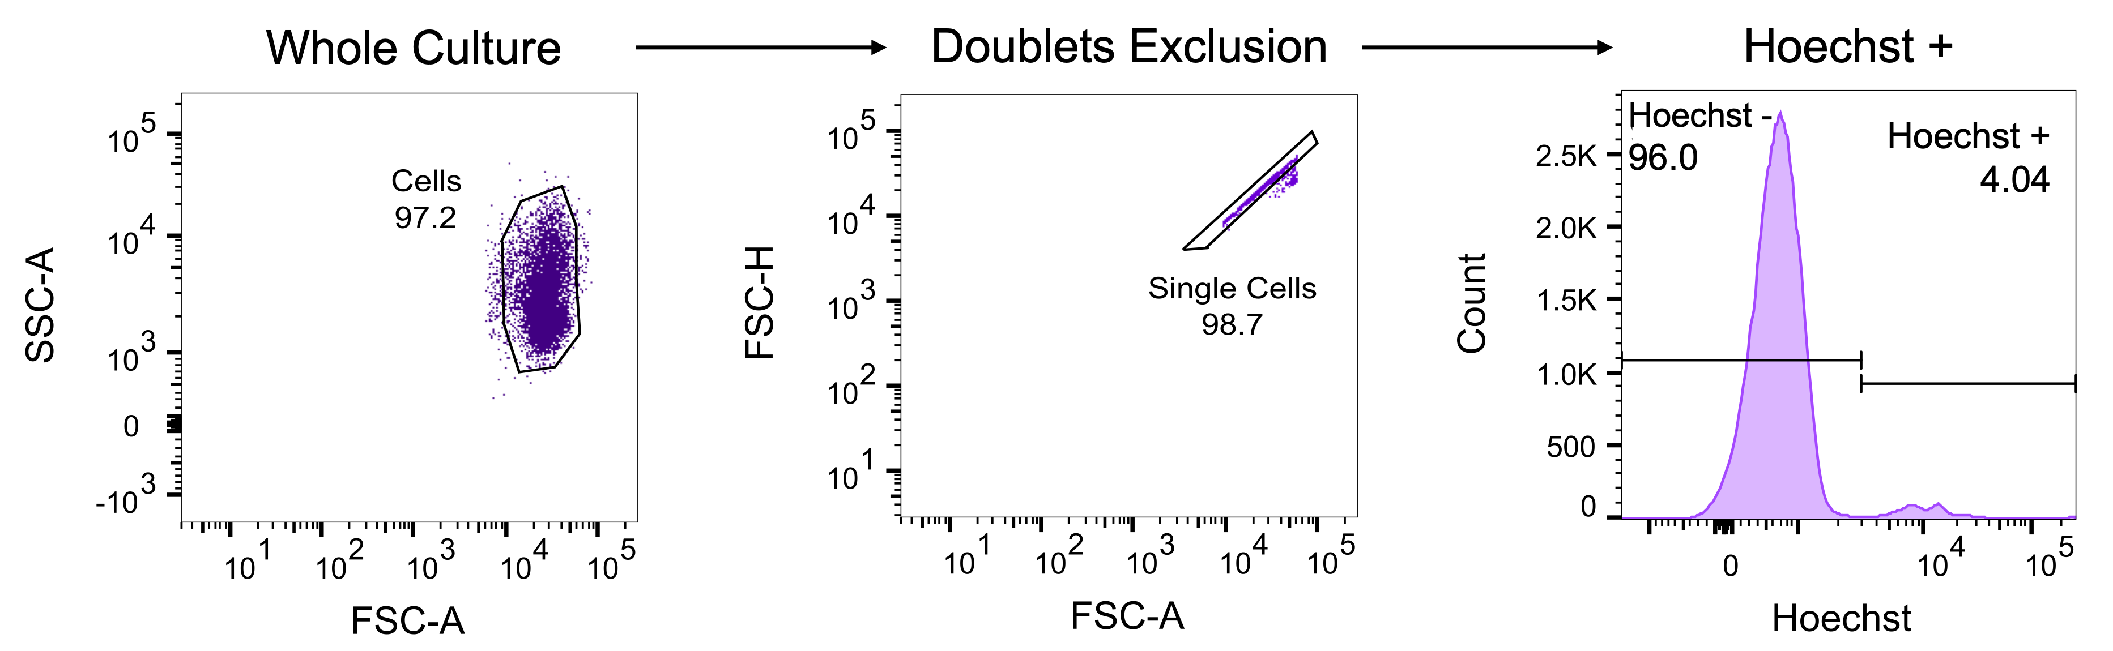

Supplementary Figure 1. Flow cytometry gating strategy for measuring parasitemia. The main erythrocyte population (containing both parasitized and non-parasitized cells) was selected based on fsc versus ssc (left panel), followed by doublets exclusion based on fsc-h versus fsc-a (middle panel). Hoechst positivity was then determined using a histogram in which positive populations can be clearly distinguished from negative populations. Hoechst positivity indicates parasite presence within a cell, as mature erythrocytes do not contain nuclei. Therefore, the representative plot indicates a parasitemia of 4.04%.

Supplementary Figure 2. Parasite development during CQ exposure. (A) Parasitemia measured by flow cytometry at 0, 24, 40, 44, and 48hrs. Little change in total parasitemia is observed through 40hrs of CQ treatment. (B) Representative images of cultures at 0, 30, and 40hrs of CQ treatment. Images captured using Olympus Provis microscope (100x) and obtained from blood smears stained with Giemsa. No morphological changes apparent through 30nM treatment.

Supplementary Table 1. qRT-PCR and ChIP Primers
qRT-PCR
Gene ID |  | Sequence (5'-3')
PF3D7_1218600 | tRNA synthetase Fw | AGCTAAAGAGATGCATGTTGGTCATT
 | tRNA synthetase Rv | GAGTACCCCAATCACCTACATGA
PF3D7_0935400 | gdv1 Fw | TAGGCGTCGAAATAGTGCTAGTAGAAA
 | gdv1 Rv | GTCCTCACAACCAGCATCATTAGTA
PF3D7_1222600 | ap2g Fw | TGGTGGTAATAAGAACAACAGAGGT
 | ap2g Rv | CCATCATAATCTTCTTCTTCGTCG
PF3D7_1335000 | msrp1 Fw | TACCAGGTGCCTTATCAAGTG
 | msrp1 Rv | CTTGGTTGTGATTCGGTTGATG
PF3D7_0936600 | gexp5 Fw | GTGGTTGTTTGAGAAGTGGTGA
 | gexp5 Rv | ACAGAATCCGTTTGAGATGATGA
PF3D7_0113600 | surfin 1.2 Fw | TTTTTCCCTCGATCTCCGCG
 | surfin 1.2 Rv | GGGTTTGGCCGTACTCTACT
PF3D7_1301800 | surfin 13.1 Fw | ACCCGAAGTGACAACATCTCC
 | surfin 13.1 Rv | TCTCCACGAGTTCCAAGTTTT
PF3D7_1115700 | fal2 Fw | GCTTGTAGGTTTT GGTATGAAAGAA
 | fal2 Rv | AGATAGGTCCCTTTTTAAAATACTATTGAC
PF3D7_1446800 | hdp Fw | AACCAACGACCCAGAAAGTATAA
 | hdp Rv | TCCATGTTGTTACCTGTAGGATG
ChIP qPCR Primers
Gene ID | Name | Sequence (5'-3')
PF2D7_1246200 | actin-1 Fw | agcagcaggaatccacaca
 | actin-1 Rv | tgatggtgcaagggttgtaa
PF3D7_1222600 | ap2g- Fw | tggtggtaataagaacaacagaggt
 | ap2g- Rv | ccatcataatcttcttcttcgtcg
PF3D7_0412400 | pfemp1- Fw | accgccccatctagtgatag
 | pfemp1- Rv | cacttggtgatgtggtgtca



