Supplementary material

SUPPLEMENTARY Table 1 Classification of drugs prescribed for Parkinson’s disease.
SUPPLEMENTARY Table 2 Comorbidities included in this analysis.
SUPPLEMENTARY Table 3 Prevalence of Parkinson’s disease by age group: All patients.
SUPPLEMENTARY Table 4 Concomitant drug prescribing by ATC main category: All patients.
Supplementary Table 5 Prescription of anti-PD drug by comorbidities: All patients.
SUPPLEMENTARY Table 6 Demographics and clinical characteristics of patients who newly initiated PD treatment and who stayed on levodopa monotherapy during the observation period or switched to adjunct therapy.
SUPPLEMENTARY Table 7 Factors associated with duration of levodopa monotherapy in patients who newly initiated PD treatment (N = 2,575).
SUPPLEMENTARY Table 8 Factors associated with a prescription for non-ergot DA monotherapy in patients who newly initiated PD treatment (N = 3,467).
SUPPLEMENTARY Table 9 Factors associated with duration of non-ergot DA monotherapy in patients who newly initiated PD treatment (N = 267).
SUPPLEMENTARY TABLE 10 Demographics and clinical characteristics of elderly patients ≥75 years who newly initiated PD treatment and who stayed on levodopa monotherapy during the observation period or switched to levodopa and non-ergot DA adjunct therapy.
SUPPLEMENTARY Table 11 Demographics and clinical characteristics of patients who increased levodopa dose from <300 mg to ≥300 mg during the observation period.

SUPPLEMENTARY FIGURE 1 Flow diagram.
SUPPLEMENTARY FIGURE 2 Maximum levodopa doses prescribed by age group during the observation period (All patients and those who newly initiated PD treatment).
SUPPLEMENTARY FIGURE 3 Longitudinal analysis of the type and combinations of anti-PD drugs prescribed during the observation period: Patients Total (N = 39,731), patients 65–74 years (N = 5,312), and patients ≥85 years (N = 8,162).
supplementary Figure 4 Duration of non-ergot DA monotherapy in patients who newly initiated PD treatment with a first prescription for non-ergot DA monotherapy (N = 267).
SUPPLEMENTARY Figure 5 Treatment modalities and drug prescriptions when patients who increased their levodopa dose to ≥300 mg. (A) Total, (B) ≥75-year-group, and (C) <75-year-group.

SUPPLEMENTARY Table 1 Classification of drugs prescribed for Parkinson’s disease.

Drug | Receipt code from computerized processing system | ATC code
Levodopa  Levodopa  Levodopa carbidopa hydrate  Levodopa benserazide hydrochloride  Levodopa carbidopa hydrate entacapone | 620006042, 620006043, 620008660, 620008661, 620008662, 620008889, 620008890 | N04BA01
 | 620123601, 620123701, 620123801, 620123901, 620124001, 620124101, 620124201, 620124301, 620124401, 620124501, 620124601, 621865201, 622050801, 622051301, 622067101, 622080201, 622509401, 622711600, 622711800 | N04BA02
 | 620008030, 620008659, 622325500, 622711700 | N04BA02
 | 622375701, 622375801 | N04BA03
Dopamine agonist – ergot  Bromocriptine mesilate  Pergolide mesilate  Cabergoline | 610422106, 620005063, 620005096, 620006069, 620006743, 620008579, 620008688, 620009237, 620120902, 620121001, 620121101, 620121102, 620121401, 620121701, 620121802, 620121902, 620121904, 620122001 | N04BC01
 | 620121801 | NA
 | 610406392, 610406393, 620002124, 620002125, 620002823, 620002857, 620002858, 620004067, 620004068, 621642002, 621642103, 621690101 | N04BC02
 | 620006684, 620006685, 622711100, 622711200 | NA
 | 610432023, 610432024, 620005369, 620005370, 620005371, 620005372, 620005375, 620005376, 620005377, 620005378, 620005379, 620008002, 622711400, 622711500 | N04BC06
 | 620005373, 620006667, 620006668, 620008001 | NA
Dopamine agonist – non-ergot  Talipexole hydrochloride  Ropinirole  Pramipexole hydrochloride hydrate  Apomorphine hydrochloride hydrate  Rotigotine | 610409337 | N04BC
 | 620004415, 620004416, 620004417, 622183601, 622183701, 622492301, 622492401, 622492501, 622500001, 622500101, 622500201, 622582201, 622582301, 622583401, 622583501, 622656201, 622656301, 622687201, 622687301, 622687401, 622687501, 622687601 | N04BC04
 | 620000435, 620000436, 622069601, 622069701, 622226701, 622226801, 622228701, 622228801, 622229801  622229901, 622231601, 622231701, 622233901, 622234001, 622235901, 622236001, 622238001, 622238101, 622239601, 622239701, 622245201, 622245301, 622247301, 622247401, 622249201, 622249301, 622253101, 622253201, 622253501, 622253601, 622254501, 622254601, 622256401, 622256501, 622257401, 622257501, 622272601, 622272701, 622511201, 622511301, 622513801, 622513901, 622520201, 622520301, 622524801, 622524901, 622528201, 622528301, 622530001, 622530101, 622691900 | N04BC05
 | 622263001, 622263101, 622263201, 622263301, 622692000 | NA
 | 622149301 | N04BC07
 | 622163501, 622163601, 622163701, 622163801, 622478301 | N04BC09
Monoamine oxidase type B inhibitor  Selegiline hydrochloride  Rasagiline mesilate  Safinamide mesilate | 610421338, 620003975, 620005364, 620005511, 620008494, 622711300 | N04BD01
 | 622624401, 622624501 | N04BD02
 | 622696101 | N04BD03
Catechol-O-methyltransferase inhibitor  Entacapone  Opicapone | 620004853, 622478401, 622490101, 622498501, 622503001 | N04BX02
 | 622845500, 622878901 | NA
 | 622821701 | N04BX04
Anticholinergic agent  Trihexyphenidyl hydrochloride  Biperiden hydrochloride  Biperiden lactate  Profenamine hydrochloride  Profenamine hibenzate | 610454002, 611240304, 611240415, 611240423, 611240425, 620003078, 620004382, 620004384, 620004548, 620006589, 620008311, 620008663, 620119903, 620119906, 620119907, 620119919, 620119923, 620119927, 620120303 | N04AA01
 | 620004556, 620005847, 622319200 | NA
 | 610444006, 610444007, 620000066, 620000067, 620000243, 620004893, 620004894, 620005147, 620117802, 620118102, 620118203, 620118402, 621218501, 621392101 | N04AA02
 | 620006075 | NA
 | 611240172, 611240173 | N04AA05
 | 610463153
Zonisamide | 611130087, 620001972, 620009098, 621390801, 621390901, 622400401, 622589801, 622673201, 622709200, 622709300 | N03AX15
Istradefylline | 622245801 | N04CX01
Amantadine | 610461044, 610461047, 611240079, 611240080, 620002335, 620004505, 620008286, 620116802, 620116809, 620117101, 620117103, 620117110, 620117112, 620117114, 620117401, 620117402, 620117404, 620117412, 620117413, 620117414, 622710800 | N04BB01
 | 610461046, 611240122, 611240123, 620003077, 620003267, 620003268, 620005903, 620006587, 620008280, 620116701, 620117107, 620117410, 620116702, 622309500, 620116805 | NA
Droxidopa | 620004007, 620004008, 620004009, 620004010, 620005044, 620005045, 620005046, 620006676, 620006677, 620006678, 622061101, 622061201 | C01CA27
 | 622710900, 622711000
ATC, Anatomical Therapeutic Chemical; NA, not applicable.

SUPPLEMENTARY Table 2 Comorbidities included in this analysis.

Comorbidity | Disease code
Constipation | 8850626, 8847697, 8833027, 8834176, 5640018, 5640016, 8847705, 8837133, 5640007, 8837785, 5640011, 8840042, 8849551, 8849481
Insomnia | 8839792
Pain | 8838060, 8846220, 8849544, 7213016, 8845840, 7153018, 8850089
Cognitive disorder | 8831737, 7809004, 7809005, 7809006, 7809007, 7809026, 8833248, 7809021, 8842548, 8842549, 8842550, 8842551, 3310002, 8842308, 8849974, 8847912, 8847913, 8842565, 8842571, 8842608, 8842625, 8842626, 8845840, 8842575, 2901004, 8842591, 2902001, 8842615, 8842618, 2902006, 8842637, 8842638, 8842639, 2902008, 2902012
Depression and anxiety | 3004001, 2961003, 2961005, 8832914, 8850416, 2961017, 2961020, 8835867, 8835868, 2961023, 8837202, 8837626, 2980001, 2961027, 8831486, 8832918, 2961024, 8837627, 2961025, 8839033, 2961026, 8839040, 8839041, 8832574, 8833458, 8843724, 8834492, 8842740, 8845669, 8836029, 3002024, 8836934, 8837086, 8837121, 3002018, 8839428, 8839939, 8833894, 8836575, 8836634, 3000003, 8844095, 8844096, 3004024, 3000004, 8839596, 3000010, 8839600
Hallucination | 2989002, 7801001, 2971002, 2971003, 2979001, 3009003, 8833547, 2971005, 8834119, 2971007, 2971009, 3002009, 3002010, 8835222, 2972002, 2971001, 2971012, 8840579, 8840580, 7800001

SUPPLEMENTARY Table 3 Prevalence of Parkinson’s disease by age group: All patients.

 | ≥75 years | <75 years
 | Elderly database  N = 29,130 | NHI database (self-employed/unemployed)  N = 5,364 | JMDC database (company/government employees and their dependents)  N = 5,237
Prevalence  (June 2016 to May 2021), (%) | 1.14 | 0.31 | 0.07
Prevalence  (June 2020 to May 2021), (%) | 1.21 | 0.37 | 0.07
≤54 years | NA | 0.10 | 0.03
55–64 years | NA | 0.30 | 0.13
65–74 years | NA | 0.58 | 0.32
75–84 years | 1.13 | NA | NA
≥85 years | 1.36 | NA | NA
NA, not applicable; NHI, National Health Insurance.

SUPPLEMENTARY Table 4 Concomitant drug prescribing by ATC main category: All patients.

ATC main category | Total  N = 39,731 | ≥75 years  N = 29,130 | <75 years  N = 10,601 | Group Difference  P-value
Alimentary tract and metabolism | 36,887 (92.8) | 27,567 (94.6) | 9,320 (87.9) | 0.000
Blood and blood forming organs | 19,947 (50.2) | 15,529 (53.3) | 4,418 (41.7) | 0.000
Cardiovascular system | 28,668 (72.2) | 22,496 (77.2) | 6,172 (58.2) | 0.000
Dermatologicals | 3,025 (7.6) | 2,419 (8.3) | 606 (5.7) | 0.000
Genito urinary system and sex hormones | 11,716 (29.5) | 9,205 (31.6) | 2,511 (23.7) | 0.000
Systemic hormonal preparations, excluding sex hormones and insulins | 4,013 (10.1) | 2,985 (10.2) | 1,028 (9.7) | 0.112
Antiinfectives for systemic use | 13,778 (34.7) | 10,283 (35.3) | 3,495 (33.0) | 0.000
Antineoplastic and immunomodulating agents | 1,322 (3.3) | 952 (3.3) | 370 (3.5) | 0.289
Musculo-skeletal system | 16,119 (40.6) | 10,966 (37.6) | 5,153 (48.6) | 0.000
Nervous system | 31,295 (78.8) | 23,402 (80.3) | 7,893 (74.5) | 0.000
Antiparasitic products, insecticides, and repellents | 1,274 (3.2) | 946 (3.2) | 328 (3.1) | 0.462
Respiratory system | 19,558 (49.2) | 14,207 (48.8) | 5,351 (50.5) | 0.003
Sensory organs | 2,230 (5.6) | 1,872 (6.4) | 358 (3.4) | 0.000
Various | 3,222 (8.1) | 810 (2.8) | 2,412 (22.8) | 0.000
Data are n (%).
ATC, Anatomical Therapeutic Chemical.

Supplementary Table 5 Prescription of anti-PD drug by comorbidities: All patients.

Characteristic | Constipation | Insomnia | Pain | Cognitive Disorders | Depression and anxiety | Hallucination | Orthostatic hypotension
 | N = 32,909 | N = 21,607 | N = 20,777 | N = 15,871 | N = 14,195 | N = 2,114 | N = 2,659
Male, n (%) | 11,779 (35.8) | 7,331 (33.9) | 6,776 (32.6) | 5,953 (37.5) | 4,191 (29.5) | 762 (36.0) | 1,276 (48.0)
Age (years), mean ± SD (range) | 77.2 ± 9.9  (30–104) | 76.4 ± 11.1  (30–102) | 77.7 ± 9.1  (30–102) | 80.4 ± 7.2  (34–102) | 75.2 ± 12.0  (30–102) | 78.4 ± 9.4  (30–101) | 76.6±9.9  (30–97)
Age, n (%)
≤54 | 1,206 (3.7) | 1,272 (5.9) | 557 (2.7) | 91 (0.6) | 1,100 (7.7) | 71 (3.4) | 113 (4.2)
55–64 | 2,199 (6.7) | 1,509 (7.0) | 1,224 (5.9) | 415 (2.6) | 1,185 (8.3) | 84 (4.0) | 190 (7.1)
65–74 | 3,792 (11.5) | 2,335 (10.8) | 2,293 (11.0) | 1,102 (6.9) | 1,660 (11.7) | 200 (9.5) | 290 (10.9)
75–84 | 18,921 (57.5) | 12,217 (56.5) | 12,531 (60.3) | 9,815 (61.8) | 7,677 (54.1) | 1,261 (59.6) | 1,596 (60.0)
≥85 | 6,791 (20.6) | 4,274 (19.8) | 4,172 (20.1) | 4,448 (28.0) | 2,573 (18.1) | 498 (23.6) | 470 (17.7)
Prescribing patten, n (%)
Levodopa | 16,163 (49.1) | 10,322 (47.8) | 10,596 (51.0) | 8,681 (54.7) | 6,899 (48.6) | 1,091 (51.6) | 1,000 (37.6)
DA – non-ergot | 1,905 (5.8) | 1,743 (8.1) | 1,517 (7.3) | 689 (4.3) | 1,222 (8.6%) | 99 (4.7) | 100 (3.8)
MAOBI | 404 (1.2) | 244 (1.1) | 296 (1.4) | 151 (1.0) | 159 (1.1) | 15 (0.7) | 24 (0.9)
Anticholinergic agent | 1,671 (5.1) | 1,638 (7.6) | 928 (4.5) | 611 (3.8) | 1,302 (9.2) | 161 (7.6) | 66 (2.5)
Levodopa + MAOBI | 2,435 (7.4) | 1,448 (6.7) | 1,597 (7.7) | 870 (5.5) | 852 (6.0) | 108 (5.1) | 195 (7.3)
Levodopa + DA – non-ergot | 3,601 (10.9) | 2,336 (10.8) | 2,358 (11.3) | 1,383 (8.7) | 1,517 (10.7) | 207 (9.8%) | 238 (9.0%)
Levodopa + Zonisamide | 2,740 (8.3) | 1,752 (8.1) | 1,908 (9.2) | 1,329 (8.4) | 1,181 (8.3) | 195 (9.2) | 207 (7.8)
Levodopa + COMTI | 1,742 (5.3) | 1,173 (5.4) | 1,106 (5.3) | 923 (5.8) | 809 (5.7) | 172 (8.1) | 150 (5.6)
Levodopa + Droxidopa | 1,455 (4.4) | 922 (4.3) | 931 (4.5) | 873 (5.5) | 607 (4.3) | 100 (4.7) | 539 (20.3)
Levodopa + Amantadine | 1,660 (5.0) | 998 (4.6) | 1,033 (5.0) | 890 (5.6) | 697 (4.9) | 104 (4.9) | 100 (3.8)
Levodopa + Anticholinergic agent | 858 (2.6) | 573 (2.7) | 531 (2.6) | 348 (2.2) | 439 (3.1) | 64 (3.0) | 51 (1.9)
COMTI, catechol-O-methyltransferase inhibitor; DA, dopamine agonist; MAOBI, monoamine oxidase type B inhibitor; PD, Parkinson’s disease; SD, standard deviation.

SUPPLEMENTARY Table 6 Demographics and clinical characteristics of patients who newly initiated PD treatment and who stayed on levodopa monotherapy during the observation period or switched to adjunct therapy.

Characteristic | Levodopa  monotherapy  N = 1,398 | Levodopa adjunct therapy†  N = 1,092 | Group Difference  P-value
Male, n (%) | 607 (43.4) | 551 (50.5) | 0.001
Age (years) | 76.4 ± 9.6 | 70.3 ± 10.9 | 0.000
Age, n (%)
≤54 years | 41 (2.9) | 96 (8.8) | 0.000
55–64 years | 128 (9.2) | 212 (19.4) | 0.000
65–74 years | 278 (19.9) | 305 (27.9) | 0.000
75–84 years | 690 (49.4) | 409 (37.5) | 0.000
≥85 years | 261 (18.7) | 70 (6.4) | 0.000
Observation period (year) | 3.5 ± 0.9 | 3.9 ± 1.0 | 0.000
Duration of PD treatment (days) | 545.0 ± 287.0 | 732.8 ± 364.6 | 0.000
Charlson Comorbidity Index | 1.4 ± 1.7 | 1.1 ± 1.6 | 0.000
Number of anti-PD drug types | 1.0 ± 0.1 | 2.5 ± 0.9 | 0.000
Number of drugs by ATC (major category), | 2.5 ± 1.9 | 2.2 ± 1.8 | 0.000
Comorbidities, n (%)
Constipation | 636 (45.5) | 397 (36.4) | 0.000
Pain | 408 (29.2) | 288 (26.4) | 0.132
Insomnia | 363 (26.0) | 214 (19.6) | 0.000
Depression and anxiety | 231 (16.5) | 160 (14.7) | 0.223
Cognitive disorder | 179 (12.8) | 51 (4.7) | 0.000
Hallucination | 7 (0.5) | 8 (0.7) | 0.630
Data are mean ± SD unless otherwise stated.
†Patients who switched to monotherapy with other drug(s) were not included.
ATC, Anatomical Therapeutic Chemical; PD, Parkinson’s disease; SD, standard deviation.
SUPPLEMENTARY Table 7 Factors associated with duration of levodopa monotherapy in patients who newly initiated PD treatment (N = 2,575).

Variable | Hazard ratio | 95% CI | p-value
Age (years) | 0.97 | 0.961–0.979 | 0.000
Sex (ref. female) | 1.138 | 1.013–1.279 | 0.030
Comorbidities†, middle category (ref. no comorbidity)
Depression and anxiety | 0.929 | 0.784–1.102 | 0.399
Hallucination | 2.048 | 1.018–4.122 | 0.045
Cognitive disorder | 0.569 | 0.433–0.747 | 0.000
Number of concomitant drugs† | 1.010 | 0.994–1.027 | 0.223
Charlson Comorbidity Index† | 0.978 | 0.938–1.019 | 0.290
Database (ref. JMDC database)
Elderly | 0.942 | 0.734–1.210 | 0.641
NHI | 1.033 | 0.867–1.230 | 0.717
†Within 3 months of starting the second prescription pattern.
CI, confidence interval; NHI, National Health Insurance; PD, Parkinson’s disease; ref, reference.

SUPPLEMENTARY Table 8 Factors associated with a prescription for non-ergot DA monotherapy in patients who newly initiated PD treatment (N = 3,467).

Variable | Odds ratio | 95% CI | p-value
Age (years) | 0.971 | 0.955–0.987 | 0.001
Sex (ref. female) | 0.812 | 0.624–1.054 | 0.118
Comorbidities†, middle category (ref. no comorbidity)
Depression and anxiety | 1.250 | 0.883–1.753 | 0.201
Hallucination | 0.509 | 0.028–2.627 | 0.520
Cognitive disorder | 0.642 | 0.296–1.234 | 0.219
Number of concomitant drugs† | 1.061 | 1.026–1.096 | 0.001
Charlson Comorbidity Index† | 0.994 | 0.903–1.086 | 0.895
Database (ref. JMDC database)
Elderly | 0.335 | 0.197–0.570 | 0.000
NHI | 0.710 | 0.497–1.010 | 0.058
†During3 months before the index date.
CI, confidence interval; DA, dopamine agonist; NHI, National Health Insurance; PD, Parkinson’s disease; ref, reference.

SUPPLEMENTARY Table 9 Factors associated with duration of non-ergot DA monotherapy in patients who newly initiated PD treatment (N = 267).

Variable | Hazard ratio | 95% CI | p-value
Age (years) | 1.013 | 0.990–1.037 | 0.276
Sex (ref. female) | 0.913 | 0.636–1.311 | 0.622
Comorbidities†, middle category (ref. no comorbidity)
Depression and anxiety | 0.730 | 0.423–1.258 | 0.257
Hallucination | 0.000 | 0.000–∞ | 0.996
Cognitive disorder | 0.616 | 0.147–2.577 | 0.507
Number of concomitant drugs† | 0.961 | 0.913–1.011 | 0.126
Charlson Comorbidity Index† | 0.861 | 0.726–1.021 | 0.085
Database (ref. JMDC database)
Elderly | 0.518 | 0.224–1.199 | 0.125
NHI | 0.939 | 0.586–1.502 | 0.792
†Within 3 months of starting the second prescription pattern.
CI, confidence interval; DA, dopamine agonist; ∞, infinity; NHI, National Health Insurance; PD, Parkinson’s disease; ref, reference.

SUPPLEMENTARY Table 10 Demographics and clinical characteristics of elderly patients ≥75 years who newly initiated PD treatment and who stayed on levodopa monotherapy during the observation period or switched to levodopa and non-ergot DA adjunct therapy.

Characteristic | Levodopa  monotherapy  N = 951 | DA adjunct therapy†  N = 96 | Group Difference  p-value
Male, n (%) | 385 (40.5) | 40 (41.7) | 0.908
Age (years) | 81.8 ± 4.5 | 78.9 ± 3.5 | 0.000
Age, n (%)
≤54 years | NA | NA | NA
55–64 years | NA | NA | NA
65–74 years | NA | NA | NA
75–84 years | 690 (72.6) | 88 (91.7) | 0.000
≥85 years | 261 (27.4) | 8 (8.3) | 0.000
Observation period (year) | 3.2 ± 0.8 | 3.2 ± 0.7 | 0.256
Duration of PD treatment (days) | 537.2 ± 272.2 | 657.3 ± 304.1 | 0.000
Charlson Comorbidity Index | 1.6 ± 1.8 | 1.6 ± 2.1 | 0.209
Number of anti-PD drug types | 1.0 ± 0.1 | 2.3 ± 0.6 | 0.000
Number of drugs by ATC (major category) | 2.8 ± 1.9 | 2.8 ± 1.8 | 0.830
Comorbidities, n (%)
Constipation | 514 (54.0) | 53 (55.2) | 0.912
Pain | 323 (34.0) | 37 (38.5) | 0.431
Insomnia | 289 (30.4) | 31 (32.3) | 0.788
Depression and anxiety | 166 (17.5) | 20 (20.8) | 0.493
Cognitive disorder | 157 (16.5) | 5 (5.2) | 0.006
Hallucination | 5 (0.5) | 2 (2.1) | 0.129
Data are mean ± SD unless otherwise stated.
†Patients who switched to monotherapy with other drug(s) were not included.
ATC, Anatomical Therapeutic Chemical; DA, dopamine agonist; PD, Parkinson’s disease; SD, standard deviation.

SUPPLEMENTARY Table 11 Demographics and clinical characteristics of patients who increased levodopa dose from <300 mg to ≥300 mg during the observation period.

Characteristic |  | Total  N = 8,677 | ≥75 years  N = 5,879 |  | <75 years  N = 2,798 | p-value
Male, n (%) |  | 3,890 (44.8) | 2,443 (41.6) |  | 1,447 (51.7) | 0.000
Age (years) |  | 75.9 ± 10.5 | 81.8 ± 4.8 |  | 63.5 ± 8.0 | 0.000
Age, n (%)
≤54 years |  | 403 (4.6) | NA |  | 403 (14.4) | NA
55–64 years |  | 880 (10.1) | NA |  | 880 (31.5) | NA
65–74 years |  | 1,515 (17.5) | NA |  | 1515 (54.1) | NA
75–84 years |  | 4,234 (48.8) | 4,234 (72.0) |  | NA | NA
≥85 years |  | 1,645 (28.0) | 1,645 (28.0) |  | NA | NA
Observation period (year) |  | 3.3 ± 1.1 | 2.9 ± 0.9 |  | 4.0 ± 1.2 | 0.000
Duration of PD treatment (days) |  | 580.9 ± 398.3 | 520.0 ± 346.1 |  | 708.7 ± 465.0 | 0.000
Duration from index date to levodopa prescription ≥300 mg (days) |  | 307.1 ± 287.5 | 297.9 ± 267.3 |  | 326.2 ± 325.1 | 0.612
Charlson Comorbidity Index |  | 2.0 ± 2.0 | 2.4 ± 2.1 |  | 1.2 ± 1.6 | 0.000
Number of anti-PD drug types |  | 1.5 ± 0.9 | 1.4 ± 0.8 |  | 1.7 ± 1.0 | 0.000
Number of drugs, ATC major category |  | 3.0 ± 1.8 | 3.3 ± 1.7 |  | 2.2 ± 1.7 | 0.000
Comorbidities, n (%)
Constipation |  | 5,376 (62.0) | 4,160 (70.8) |  | 1,216 (43.5) | 0.000
Insomnia |  | 3,105 (35.8) | 2,431 (41.4) |  | 674 (24.1) | 0.000
Pain |  | 2,973 (34.3) | 2,429 (41.3) |  | 544 (19.4) | 0.000
Cognitive disorder |  | 2,235 (25.8) | 2,015 (34.3) |  | 220 (7.9) | 0.000
Depression and anxiety |  | 2,089 (24.1) | 1,491 (25.4) |  | 598 (21.4) | 0.000
Hallucination |  | 165 (1.9) | 137 (2.3) |  | 28 (1.0) | 0.000
Data are mean ± SD unless otherwise stated.
ATC, Anatomical Therapeutic Chemical; NA, not applicable; PD, Parkinson’s disease; SD, standard deviation

SUPPLEMENTARY FIGURE 1 Flow diagram.
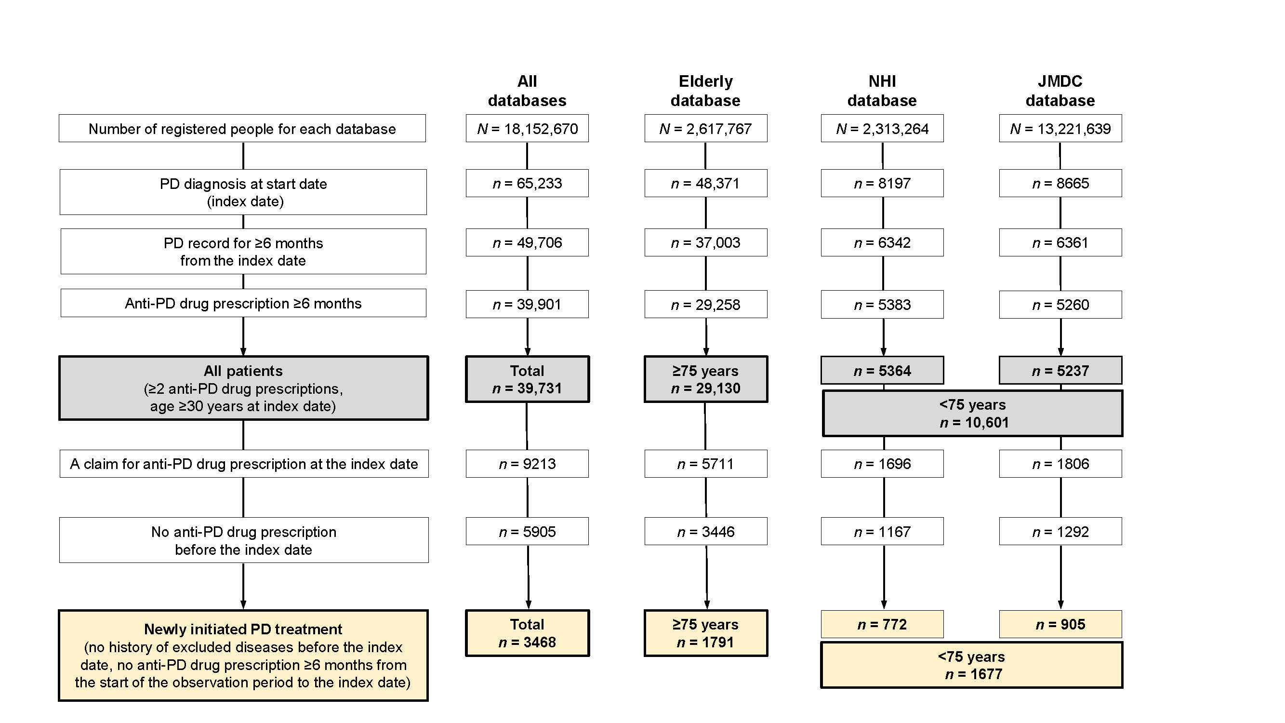
NHI, National Health Insurance; PD, Parkinson’s disease.

SUPPLEMENTARY FIGURE 2 Maximum levodopa doses prescribed by age group during the observation period (All patients and those who newly initiated PD treatment).
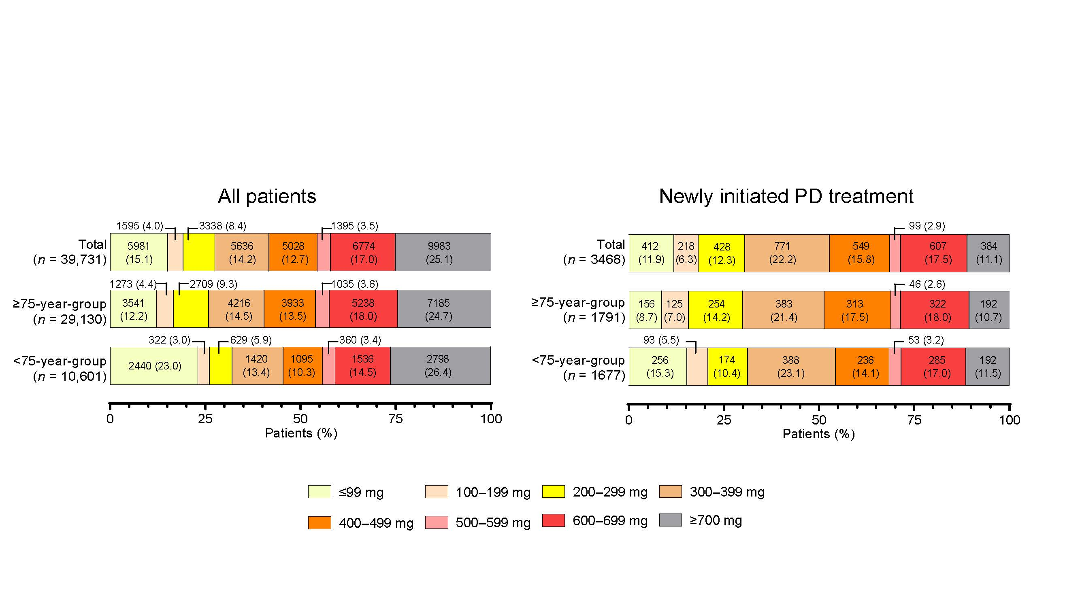
PD, Parkinson’s disease.

SUPPLEMENTARY FIGURE 3 Longitudinal analysis of the type and combinations of anti-PD drugs prescribed during the observation period: Patients Total (N = 39,731), patients 65–74 years (N = 5,312), and patients ≥85 years (N = 8,162). The number of nodes and arrows in patients Total (11 and 15, respectively), 65–74 years (13 and 18, respectively), and ≥85 years (8 and 13, respectively).
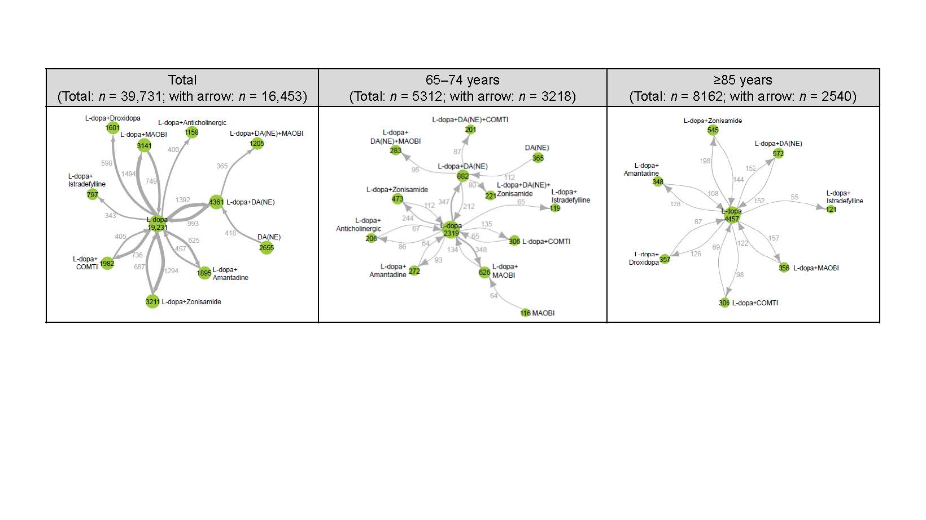 COMTI, catechol-O-methyltransferase inhibitor; DA, dopamine agonist; L-dopa, levodopa; MAOBI, monoamine oxidase type B inhibitor; NE, non-ergot; PD, Parkinson’s disease.

SUPPLEMENTARY FIGURE 4 Duration of non-ergot DA monotherapy in patients who newly initiated PD treatment with a first prescription for non-ergot DA monotherapy (N = 267).
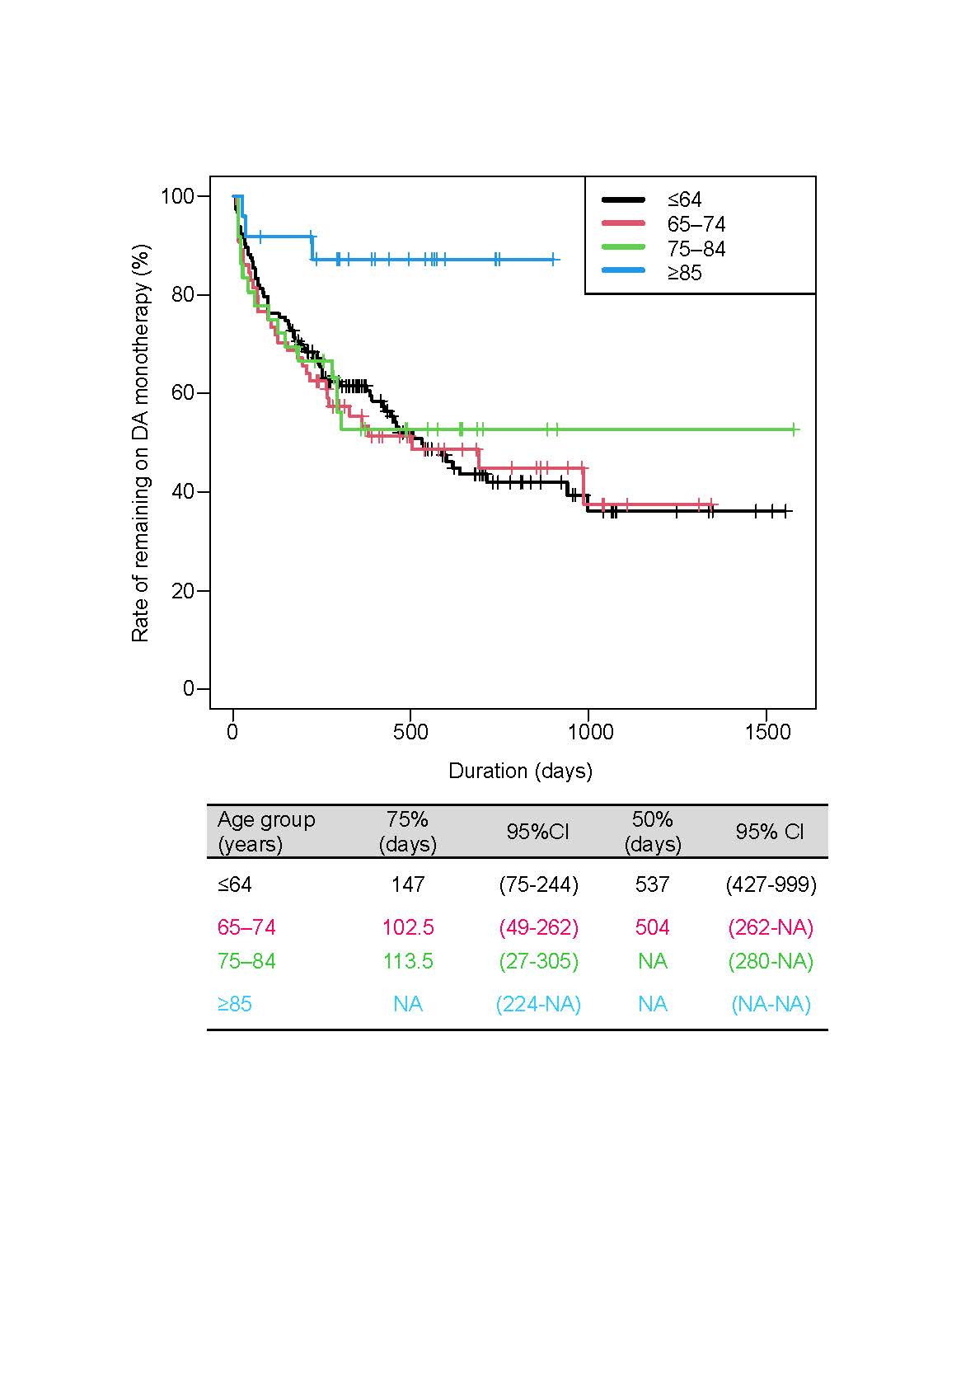
CI, confidence interval; DA, dopamine agonist; PD, Parkinson’s disease.

SUPPLEMENTARY FIGURE 5 Treatment modalities and drug prescriptions when patients who increased their levodopa dose to ≥300 mg. (A) Total, (B) ≥75-year-group, and (C) <75-year-group.
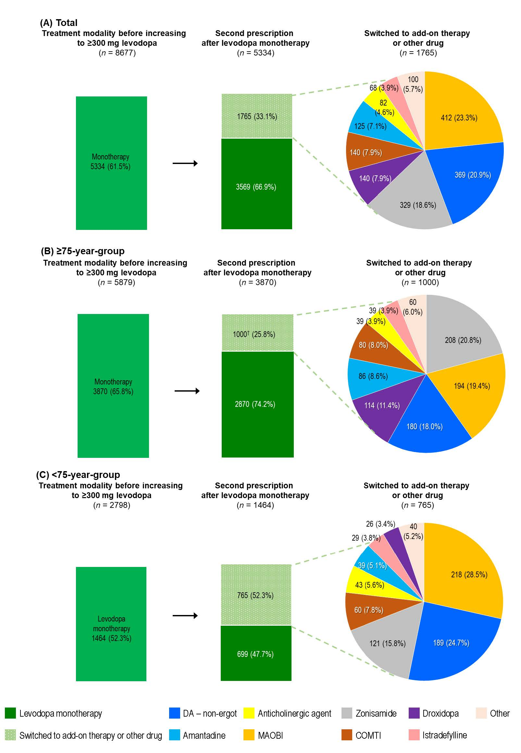 COMTI, catechol-O-methyltransferase inhibitor; DA, dopamine agonist; MAOBI, monoamine oxidase type B inhibitor; PD, Parkinson’s disease.

