Supplementary Material

Groundwater as a source of phosphorus and silicate in an estuarine zone: Results from continuous monitoring of nutrients and 222Rn

Yong Hwa Oh1, Jeonghyun Kim2, Guebuem Kim3, and Tae-Hoon Kim4,*

1Department of Convergence Study on the Ocean Science and Technology, Korea Maritime and Ocean University, Busan 49112, Republic of Korea

2Department of Earth and Marine Sciences, College of Ocean Sciences, Jeju National University, Jeju 63243, Republic of Korea

3School of Earth and Environmental Sciences/RIO, Seoul National University, Seoul 08826, Republic of Korea

4Department of Oceanography, Faculty of Earth Systems and Environmental Sciences, Chonnam National University, Gwangju 61186, Republic of Korea

**\* Correspondence:**Tae-Hoon Kim (e-mail: thkim80@jnu.ac.kr)

**Contents of this file:**

This supplementary material contains two supplementary figures (S1 and S2) referred to in the article text.

**Figure S1.** Plots of daily average nutrient concentrations versus wind speed during the entire measurement period. The solid lines represent the regression lines.

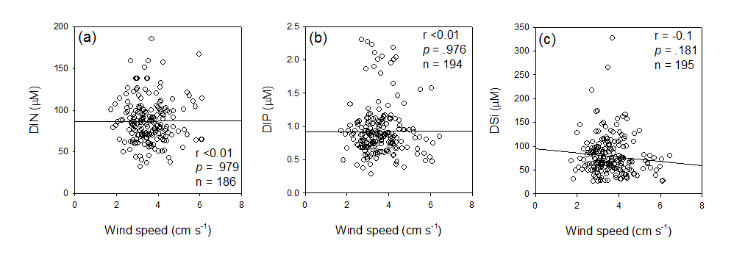

**Figure S2.** Plots of daily average nutrient concentrations vesus salinity (a,b,c) and wind speed (d,e,f) during the low river water discharge period (16 December 2014 – 10 March 2015). The solid lines represent the regression lines.

