Supplementary Material

Ultra-High Photo Responsivity and Self-Powered Photodetector in Broad Spectral Range Based on Non-Layered MnSe/WSe2 Heterojunction

**Shuting Zhao, Xiurong Ma, Xuanhao Cao, Zehong Lei, Yibin Yang*, Lili Tao, Zhaoqiang Zheng, Xing Fengand Yu Zhao\***

Guangdong Provincial Key Laboratory of Information Photonics Technology, Guangdong Provincial Key Laboratory of Functional Soft Condensed Matter, School of Materials and Energy, Guangdong University of Technology, Guangzhou 510006, China

*Corresponding Authors: yangyibin@gdut.edu.cn, zhaoyu@gdut.edu.cn

# E:\广工大工作\科研\论文\赵舒婷\赵舒婷初稿\S1.png

**FIGURE S1** The illustration of the fabrication process of MnSe/WSe2 heterojunction.

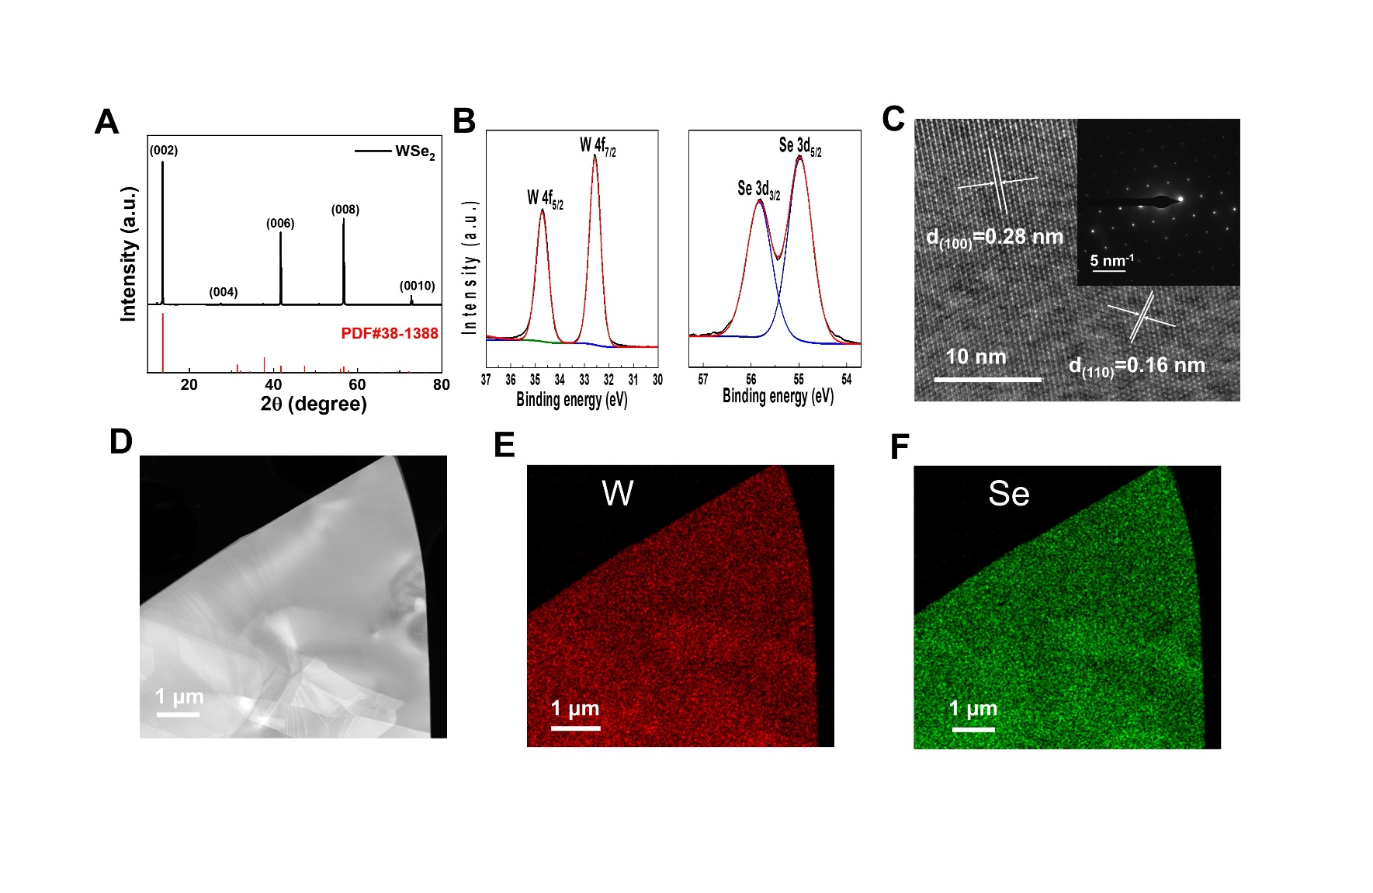

**FIGURE S2** **(A)** XRD pattern. **(B)** XPS patterns. **(C)** HRTEM image with the inset of SAED pattern. **(D)** TEM image. EDS patterns of **(E)** W and **(F)** Se in the exfoliated WSe2 flakes.

**Figure S2A** shows the XRD patterns of WSe2 with diffraction peaks at 2θ = 13.6, 27.5, 41.7, 56.8, and 72.8 degree, respectively, which correspond to the (002), (004), (006), (008), and (0010) faces of WSe2 (PDF no.38-1388). The peaks at binding energies of 34.75 and 32.55 eV in **Figure S2B** are represented as W 4f5/2 and W 4f3/2 states, respectively. The two peaks at 55.85 and 55 eV represent Se 3d3/2 and Se 3d5/2 states of WSe2, respectively. HRTEM plot shows spacings of 0.16 and 0.28 nm, corresponding to the (100) and (110) faces of WSe2, as shown in **Figure S2C**.The clear hexagonal shape of the SAED pattern in the inset indicates its single crystal nature. **Figure S2D-F** visualize the uniform distribution of W and Se elements in raw WSe2 nanosheets.

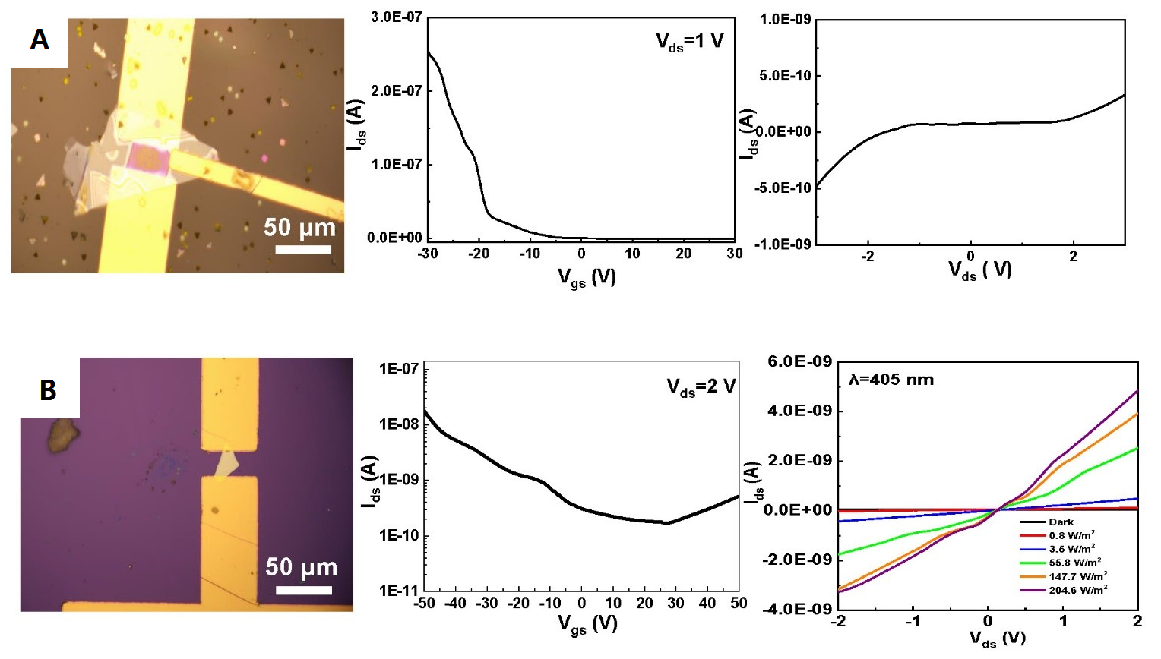

**FIGURE S3** **(A)** Optical micrograph of device using MnSe nanosheets as channel materials and its transfer curve at Vds=1V and Ids-Vds curve in the dark. **(B)** Optical micrograph of device using WSe2 nanosheet as channel material and its transfer curve at Vds=2V in the dark, and Ids-Vds curves at different optical powers of 405 nm laser.

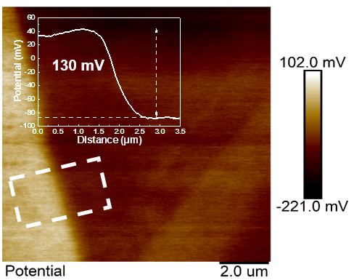

**FIGURE S4** The SPD MnSe and WSe2 with an inset of the potential height profile near the interface of the MnSe/WSe2 heterojunction.

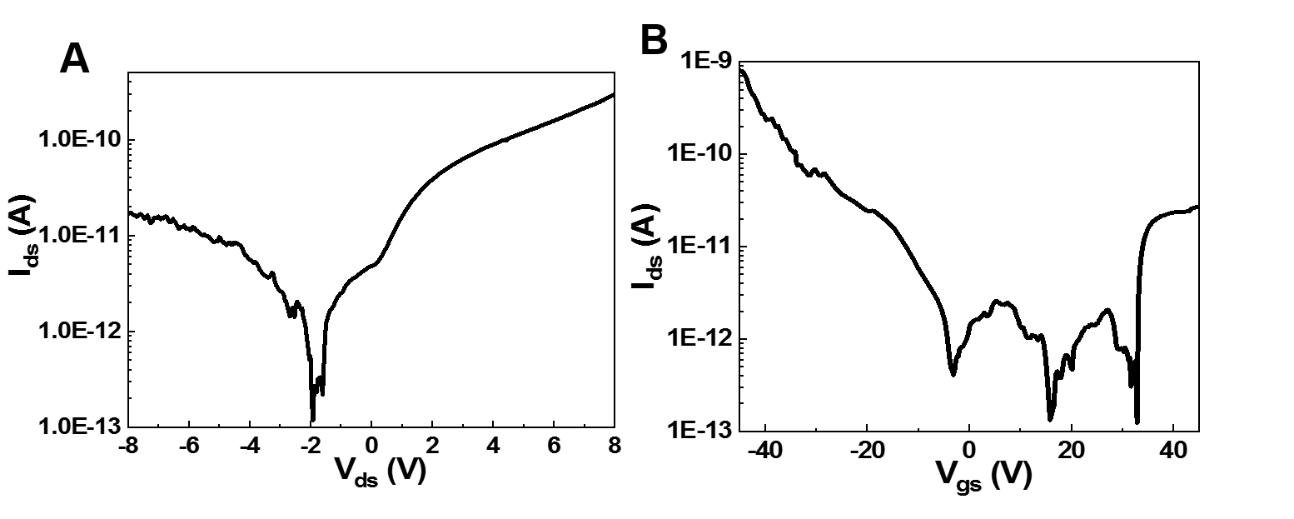

**FIGURE S5** The semi-logarithmic curves for **(A)** the I-V and **(B)** the transfer characteristics.

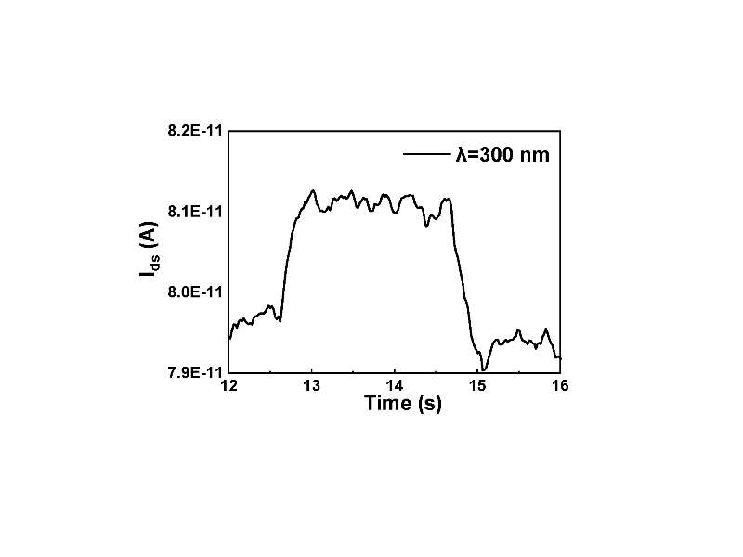

**FIGURE S6** Optical response of MnSe/WSe2 heterojunction at Vds = 5 V and Vg = 0 V for one cycle under 300 nm laser irradiation.

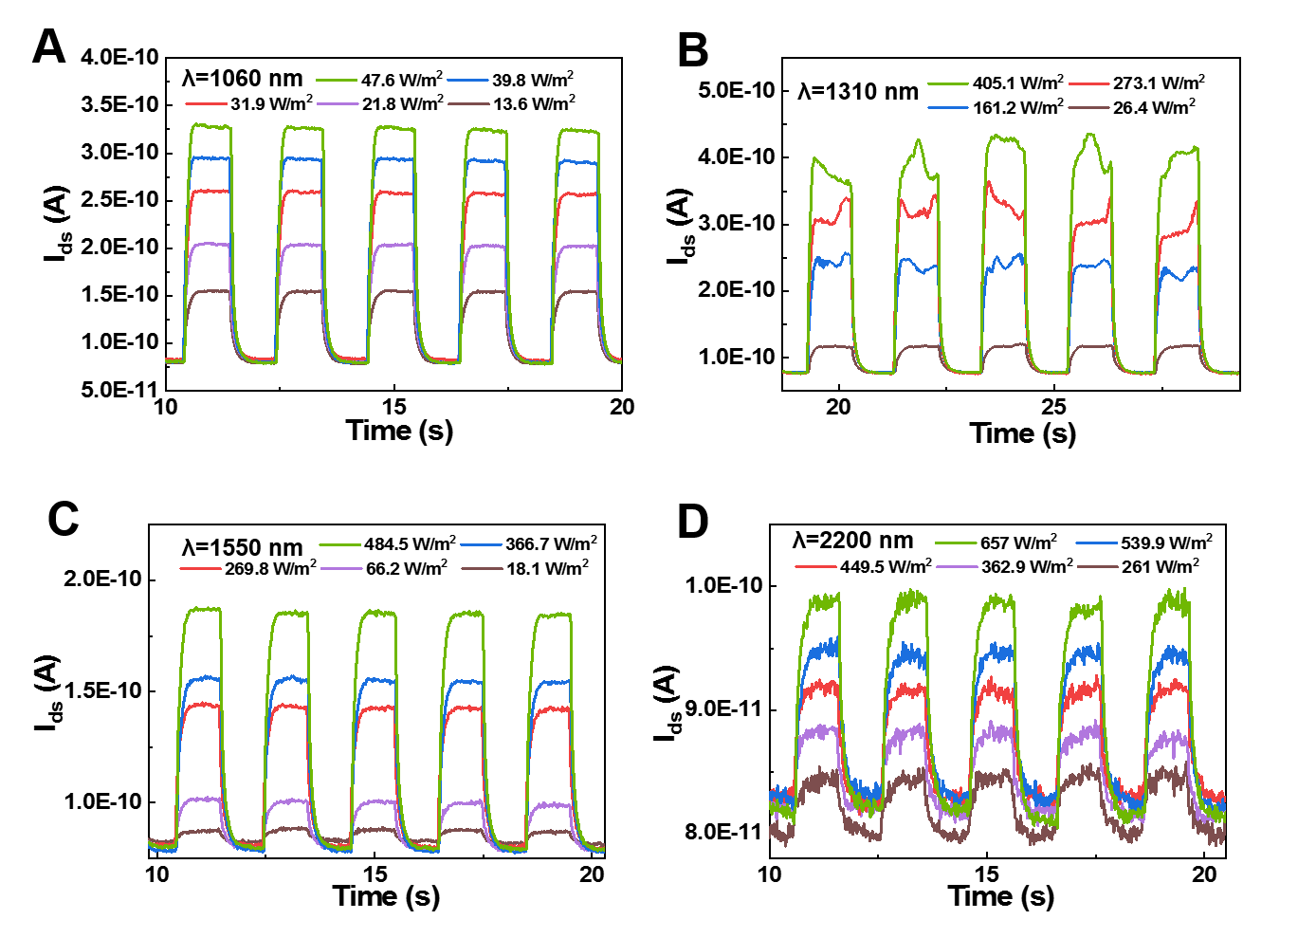

**FIGURE S7** The photoresponse of the MnSe/WSe2 heterojunction at Vds = 5 V and Vg = 0 V under the irradiation of **(A)** 1060 nm, **(B)** 1310 nm, **(C)** 1550 nm and **(D)** 2200 nm laser respectively with different light power intensities.

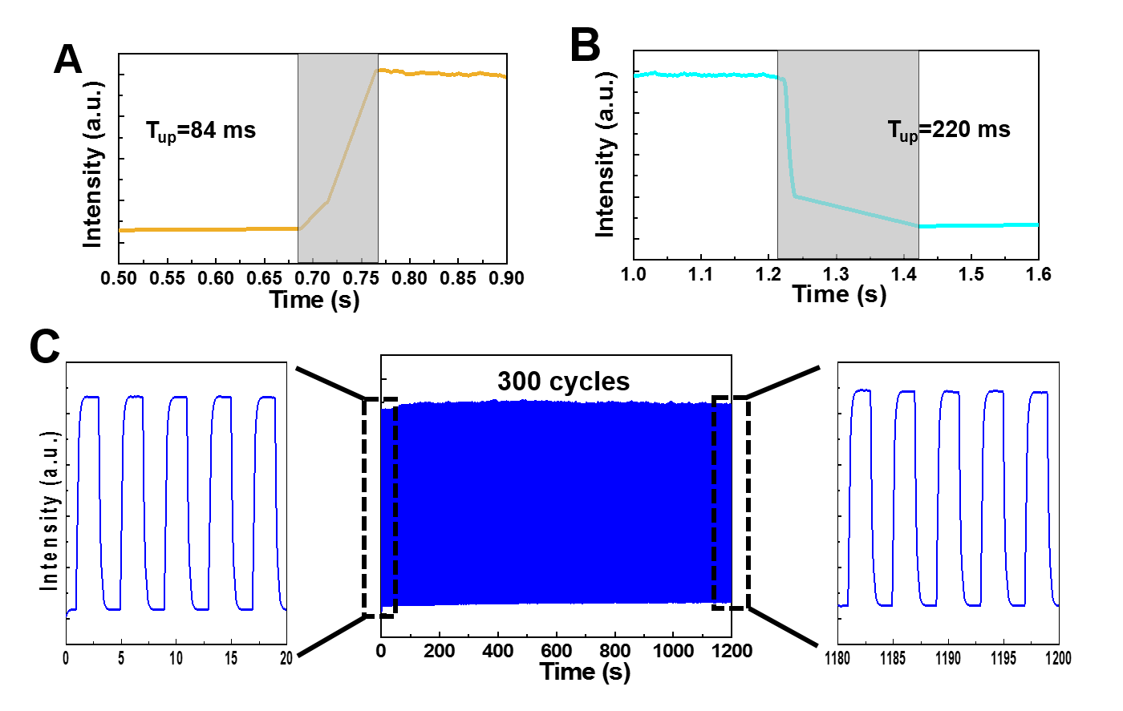

**FIGURE S8** **(A)** The rise and **(B)** fall time of the MnSe/WSe2 heterojunction under the irradiation of 405 nm laser. **(C)** Optical opening characteristics of MnSe/WSe2 heterojunction for 300 consecutive cycles of irradiation (405 nm laser).

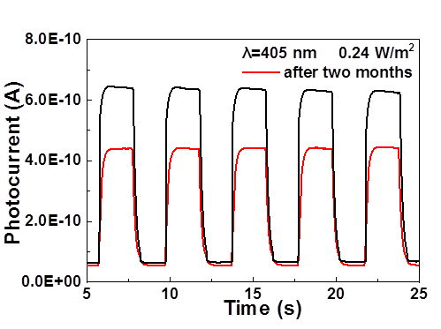

**FIGURE S9** The photoresponse of the MnSe/WSe2 heterojunction on the first day and after two months.

**TABLE** **S1** The self-powered performance of photodetector based on 2D heterojunctions.

|  |  |  |  |  |  |
| --- | --- | --- | --- | --- | --- |
| Heterojunction | Wavelength [nm] | Responsivity [mA/W] | EQE [%] | Detectivity [jones] | Reference |
| AsP/InSe | 532 | 6 | 1.5 | - | [1] |
| We2/MoS2 | 514 | 44 | 12 | - | [2] |
| WSe2/ WSe2 | 532 | 11.2 | 2.6 | 4.4×1010 | [3] |
| MoS2/FePS3 | 532 | 52 | 12 | 1.4×1010 | [4] |
| MoTe2/MoS2 | 473 | 64 | - | 1.6×1010 | [5] |
| GaSe/MoSe2 | White light | 5.5 | 0.12 | - | [6] |
| Graphene/WSe2/Fe3GeTe2 | 650 | 116.38 | - | 3.4×1010 | [7] |
| MnSe/WSe2 | 405 | 148 | 45.4 | 2.74×1010 | This work |

[1] Wu, F., Xia, H., Sun, H. D., Zhang, J. W., Gong, F., Wang, Z., et al. (2019). AsP/InSe Van der Waals Tunneling Heterojunctions with Ultrahigh Reverse Rectification Ratio and High Photosensitivity. *Adv. Funct. Mater.* 29 (12), 1900314. doi:10.1002/adfm.201900314

[2] Cheng, R., Li, D. H., Zhou, H. L., Wang, C., Yin, A. X., Jiang, S., et al. (2014). Electroluminescence and Photocurrent Generation from Atomically Sharp WSe2/MoS2 Heterojunction p-n Diodes. *Nano Lett.* 14 (10), 5590-5597. doi:10.1021/nl502075n

[3] Tan, C. Y., Wang, H. H., Zhu, X. D., Gao, W. S., Li, H., Chen, J. W., et al. (2020). A Self-Powered Photovoltaic Photodetector Based on a Lateral WSe2-WSe2 Homojunction. *ACS Appl. Mater. Interfaces* 12 (40), 44934-44942. doi:10.1021/acsami.0c11456

[4] Duan, J. M., Chava, P., Ghorbani-Asl, M., Lu, Y. F., Erb, D., Hu, L., et al. (2022). Self-Driven Broadband Photodetectors Based on MoSe2/FePS3 van der Waals n-p Type-II Heterostructures. *ACS Appl. Mater. Interfaces* 14 (9), 11927-11936. doi:10.1021/acsami.1c24308

[5] Wang, F., Yin, L., Wang, Z. X., Xu, K., Wang, F. M., Shifa, T. A., et al. (2016). Configuration-Dependent Electrically Tunable Van der Waals Heterostructures Based on MoTe2/MoS2. *Adv. Funct. Mater.* 26 (30), 5499-5506. doi:10.1002/adfm.201601349

[6] Li, X. F., Lin, M. W., Lin, J. H., Huang, B., Puretzky, A. A., Ma, C., et al. (2016). Two-dimensional GaSe/MoSe2 misfit bilayer heterojunctions by van der Waals epitaxy. *Sci. Adv.* 2 (4), 10. doi:10.1126/sciadv.1501882

[7] Xu, G. L., Liu, D. M., Li, J. Z., Li, J. J., Ye, S. S. (2022). Self-powered and bipolar photodetector based on a van der Waals metal-semiconductor junction: Graphene/WSe2/Fe3GeTe2 heterojunction. *Sci. China Technol. Sci.* 65 (6), 1263-1272. doi:10.1007/s11431-022-2031-7