Table S1. Quality Assessment Checklist (1 point per criterion for fully satisfied, 0.5 for partially satisfied, 0 for otherwise)
Category 1: Subjects Score (0/0.5/1)
1. Patients were evaluated prospectively, specific diagnostic criteria (American College of Rheumatology criteria for fibromyalgia) were applied, and demographic data were reported.
2. Healthy subjects were evaluated prospectively, and psychiatric and medical illnesses were excluded.
3. Important variables (such as age, gender, illness duration, onset time, medication status, comorbidity, and severity of illness) were reported, either by stratification or statistically.
4. Sample size per group > 10.
Category 2: Methods for image acquisition and analysis
5. Magnet strength ≥1.5T.
6. MRI slice thickness ≤2 mm.
7. The whole-brain analysis was automatically calculated with no prior regional selection.
8. Coordinates were reported in a standard space.
9. The imaging technique processing was described clearly enough to be reproducible.
10. Measurements were described clearly enough to be reproducible.
Category 3: Results and conclusions
11. Statistical parameters were provided.
12. Conclusions were consistent with the results obtained and the limitations were discussed.
TOTAL /12

Table S2. Sensitivity analysis of VBM meta-analysis
 | Increased GM volume Regions |  |  |  | Decreased GM volume Regions
Studies | R postcentral gyrus | L angular gyrus |  |  | R cingulate gyrus, paracingulate gyrus | L cerebellum, hemispheric lobule IV/V | L gyrus rectus
Kuchinad et al 2007 | yes | yes |  |  | yes | yes | yes
Schmidt-Wilcke et al 2007 | yes | yes |  |  | yes | yes | yes
Wood et al 2009 | yes | yes |  |  | yes | no | no
Hsu et al 2009 | yes | yes |  |  | yes | yes | yes
Ceko et al 2013 (1) | yes | yes |  |  | yes | yes | yes
Ceko et al 2013 (2) | yes | yes |  |  | yes | yes | yes
Fallon et al 2013 | no | yes |  |  | yes | yes | yes
Diaz-Piedra et al 2015 | yes | yes |  |  | yes | yes | no
Pomares et al 2016 | no | no |  |  | no | yes | yes
Sundermann et al 2019 | yes | yes |  |  | yes | yes | yes
Boehme et al 2020 | yes | yes |  |  | yes | no | no
Muller et al 2021 | yes | yes |  |  | yes | yes | yes
Baker et al 2022 | yes | yes |  |  | yes | yes | yes
Abbreviations: GM, gray matter; L, left; R, right; VBM, voxel-based morphometry.

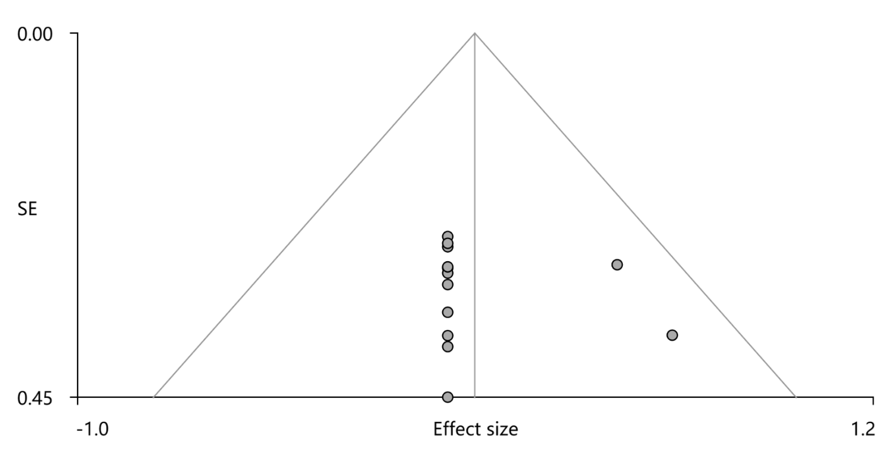
Figure S1. Funnel plots of VBM studies.

