Suppl.Image

Figure S1A- Principal component analysis of pre-merger data

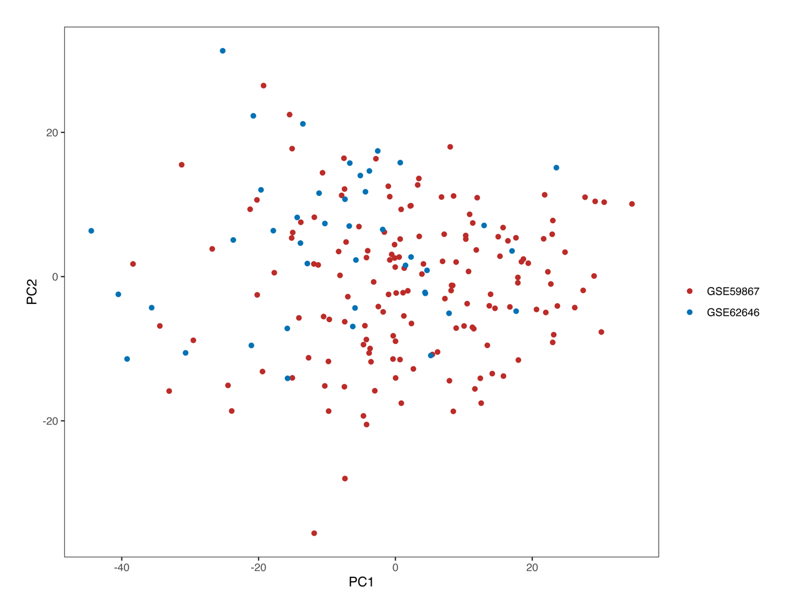

Figure S1B- Principal component analysis for the combined data

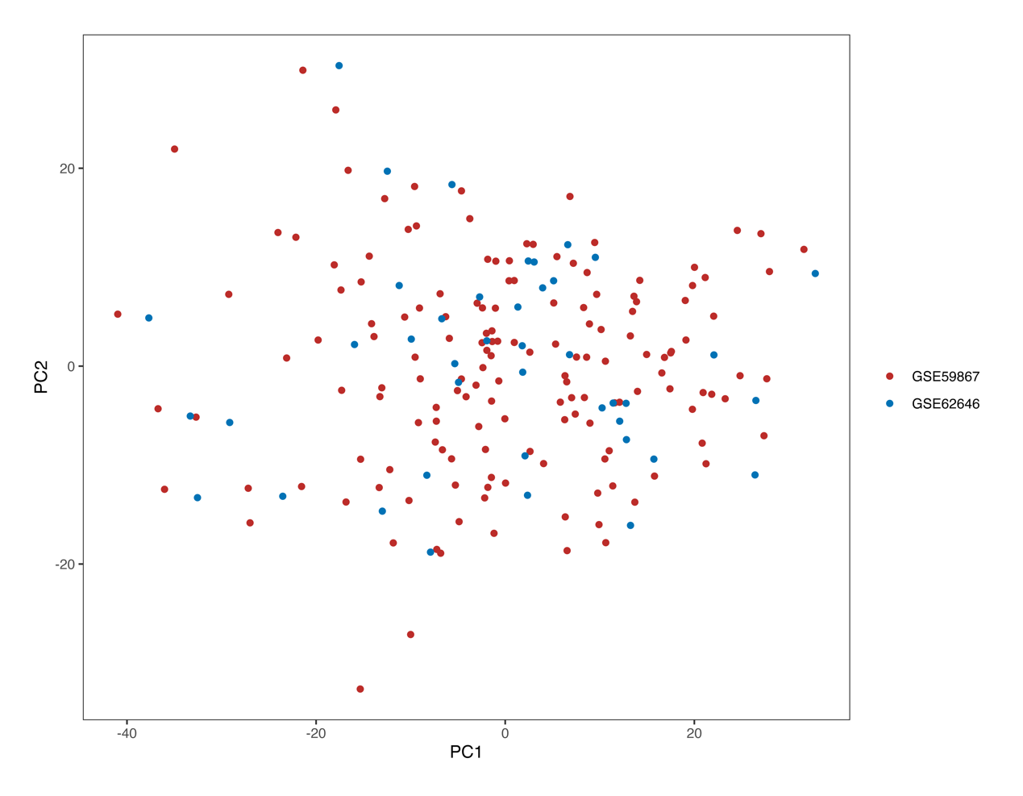

Figure S2- The bootstrap of logistic regression model



Figure S3- The ROC of models

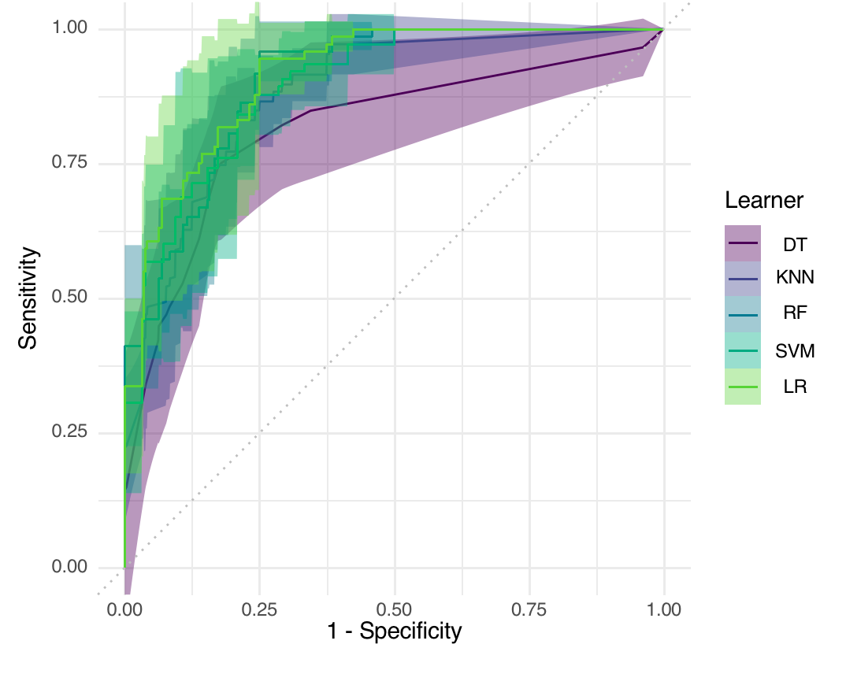

Figure S4- The AUC of different models

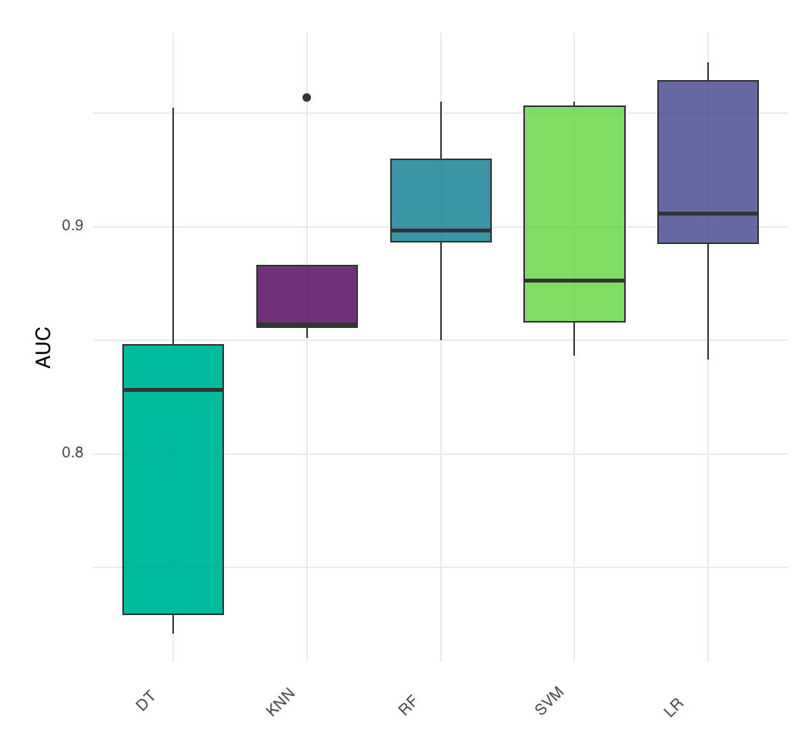

Table S1 10 fold cross-validation of logistic regression model

|  |  |
| --- | --- |
| Iteration | AUC |
| 1 | 0.844 |
| 2 | 0.964 |
| 3 | 0.920 |
| 4 | 0.845 |
| 5 | 0.967 |
| 6 | 0.934 |
| 7 | 0.952 |
| 8 | 0.934 |
| 9 | 0.972 |
| 10 | 0.814 |
| Average | 0.915 |