Supplementary appendices

Efficacy and safety of monoclonal antibody in patients with Neuromyelitis Optica spectrum disorder: A systematic review and network meta-analysis

Saharat Aungsumart, PhD, Sitaporn Youngkong, PhD*, Charungthai Dejthevaporn, PhD, Usa Chaikledkaew, PhD, Kunlawat Thadanipon, MSc, Amarit Tansawet, MD, Jedsada Khieukhajee, MD, John Attia, PhD, Gareth J. McKay, PhD, Ammarin Thakkinstian, PhD
*Correspondance: Sitaporn Youngkong: sitaporn.you@mahidol.edu
(All figures and tables in the supplementary appendices are created by the authors)

Online Supplementary Content

Contents

Appendix 1 Search results 1
eTable 1.1 MEDLINE database search result 1
eTable 1.2 SCOPUS database search result 3
Appendix 2 Risk of Bias assessment 5
eFigure 2.1 Risk of bias asseessment 5
Appendix 3 Results of Mixed effect parametric survival model using difference distribution 6
eTable 3.1 Mixed effect parametric survival model using difference distribution 6
Appendix 4 Funnel plots for each treatment comparison from NMA 7
eFigure 4.1 Funnel plots for each treatment comparison from NMA on time to relapse 7
eFigure 4.2 Funnel plots for each treatment comparison from NMA on post-treatment annualized relapse rate 8
eFigure 4.3 Funnel plots for each treatment comparison from NMA on expanded disability status score change …………………………………………… ……………… 9
eFigure 4.2 Funnel plots for each treatment comparison from NMA on serious adverse events ………………………………………………………………………………………..10
Appendix 5 Individual study data use for analysis……………………………………...11
eTable 5.1 Individual study data use for analysis……………………………………. 11

Appendix 1 Search results

eTable 1.1 MEDLINE database search result
 | Search number | Query | Results
P | 1 | neuromyelitis optica | 5,083
 | 2 | "Neuromyelitis Optica"[Mesh] | 3,397
 | 3 | NMO | 2,304
 | 4 | NMOSD | 1,563
 | 5 | Devic's disease | 5,127
 | 6 | #1 OR #2 | 5,083
 | 7 | #1 OR #3 | 5,399
 | 8 | #1 OR #4 | 5,123
 | 9 | #1 OR #5 | 5,127
 | 10 | #1 OR #3 OR #4 | 5,437
 | 11 | #1 OR #3 OR #4 OR #5 | 5,480
I | 12 | azathioprine | 23,726
 | 13 | "Imuran" | 340
 | 14 | #12 OR #13 | 23,800
 | 15 | mycophenolate mofetil | 14,176
 | 16 | MMF | 5,568
 | 17 | "Cellcept" | 207
 | 18 | #15 OR #16 | 15,738
 | 19 | #15 OR #17 | 14,219
 | 20 | #15 OR #16 OR #17 | 15,779
 | 21 | "Myfortic" | 67
 | 22 | #20 OR #21 | 15,786
 | 23 | cyclosporine | 60,084
 | 24 | "Sandimmun*" | 662
 | 25 | "Neoral" | 1,279
 | 26 | #23 OR #24 | 60,098
 | 27 | #23 OR #25 | 60,349
 | 28 | #23 OR #24 OR #25 | 60,360
 | 29 | cyclophosphamide | 76,337
 | 30 | "Endoxan" | 480
 | 31 | #29 OR #30 | 76,397
 | 32 | methotrexate | 56,506
 | 33 | immunosuppressive | 565,587
 | 34 | rituximab | 26,196
 | 35 | "Mabthera" | 197
 | 36 | #34 OR #35 | 26,208
 | 37 | tocilizumab | 4,827
 | 38 | "Actemra" | 67
 | 39 | #37 OR #38 | 4,831
 | 40 | satralizumab | 38
 | 41 | "Enspryng" | 3
 | 42 | #40 OR #41 | 38
 | 43 | inebilizumab | 58
 | 44 | "Uplizna" | 3
 | 45 | #43 OR #44 | 58
 | 46 | eculizumab | 2,075
 | 47 | "Soliris" | 57
 | 48 | #46 OR #47 | 2,077
 | 49 | monoclonal antibody | 344,567
 | 50 | #14 OR #20 OR #22 OR #28 OR #31 OR #32 OR #33 OR #36 OR #39 OR #42 OR #45 OR #48 OR #49 | 916,183
O | 51 | relapse | 654,059
 | 52 | disability | 385,924
 | 53 | "Expanded Disability Status Scale" | 4,693
 | 54 | EDSS | 5,023
 | 55 | #52 OR #53 | 385,924
 | 56 | #52 OR #54 | 386,839
 | 57 | "adverse event*" | 182,044
 | 58 | "adverse effect*" | 1,938,438
 | 59 | "adverse reaction*" | 68,570
 | 60 | "adverse drug reaction*" | 23,503
 | 61 | "infusion related reaction" | 141
 | 62 | #53 OR 54 OR #56 OR #57 OR #58 OR #59 OR #60 OR #61 | 2,443,598
P&I | 63 | #11 AND #50 | 1,089
P&I&O | 64 | #11 AND #50 AND #62 | 387
The search term with gray paint color box were excluded because there was no additional information found.

eTable 1.2 SCOPUS database search result
 | Search NO | Query | Results (title abstract keyword)
P | 1 | "neuromyelitis optica" | 5520
 | 2 | NMO | 5837
 | 3 | NMOSD | 1569
 | 4 | "Devic's disease" | 375
 | 5 | #1 OR #2 OR #3 | 9226
 | 6 | #1 OR #2 OR #3 OR #4 | 9301
I | 7 | azathioprine | 92105
 | 8 | Imuran | 2778
 | 9 | #7 OR #8 | 92179
 | 10 | "mycophenolate mofetil" | 26198
 | 11 | MMF | 10148
 | 12 | Cellcept | 3092
 | 13 | #10 OR #11 OR #12 | 33780
 | 14 | "mycophenolic acid" | 45383
 | 15 | Myfortic | 641
 | 16 | #14 OR #15 | 45394
 | 17 | #13 OR #16 | 66385
 | 18 | c?closporin* | 152109
 | 19 | Sandimmun* | 5841
 | 20 | Neoral | 4728
 | 21 | #18 OR #19 | 152122
 | 22 | #18 OR #20 | 152139
 | 23 | #18 OR #19 OR #20 | 152148
 | 24 | cyclophosphamide | 215416
 | 25 | Endoxan | 4811
 | 26 | #24 OR #25 | 215614
 | 27 | methotrexate | 171131
 | 28 | immunosuppress* | 323822
 | 29 | rituximab | 64102
 | 30 | Mabthera | 2068
 | 31 | #29 OR #30 | 64114
 | 32 | tocilizumab | 11983
 | 33 | Actemra | 580
 | 34 | #32 OR #33 | 12045
 | 35 | satralizumab | 87
 | 36 | Enspryng | 5
 | 37 | #35 OR #36 | 87
 | 38 | inebilizumab | 136
 | 39 | Uplizna | 4
 | 40 | #38 OR #39 | 136
 | 41 | eculizumab | 4233
 | 42 | Soliris | 520
 | 43 | #41 OR #42 | 4237
 | 44 | "monoclonal antibody" | 325619
 | 45 | #9 OR #17 OR #23 OR #26 OR #27 OR #28 OR #31 OR #34 OR #35 OR #38 OR #43 OR #44 | 1002833
O | 46 | relapse | 201019
 | 47 | disability | 409193
 | 48 | "Expanded Disability Status Scale" | 9119
 | 49 | EDSS | 5828
 | 50 | #47 OR #48 | 409193
 | 51 | #47 OR #49 | 410219
 | 52 | adverse PRE/3 ( event* OR effect* OR reaction* ) | 897683
 | 53 | "infusion related reaction" | 4013
 | 54 | #46 OR #51 OR #52 OR #53 | 1478514
P&I | 55 | #6 AND #45 | 1849
P&I&O | 56 | #6 AND #45 AND #54 | 924
The search term with gray paint color box were excluded because there was no additional information found.

Appendix 2 Risk of Bias assessment

eFigure 2.1 Risk of bias assessment

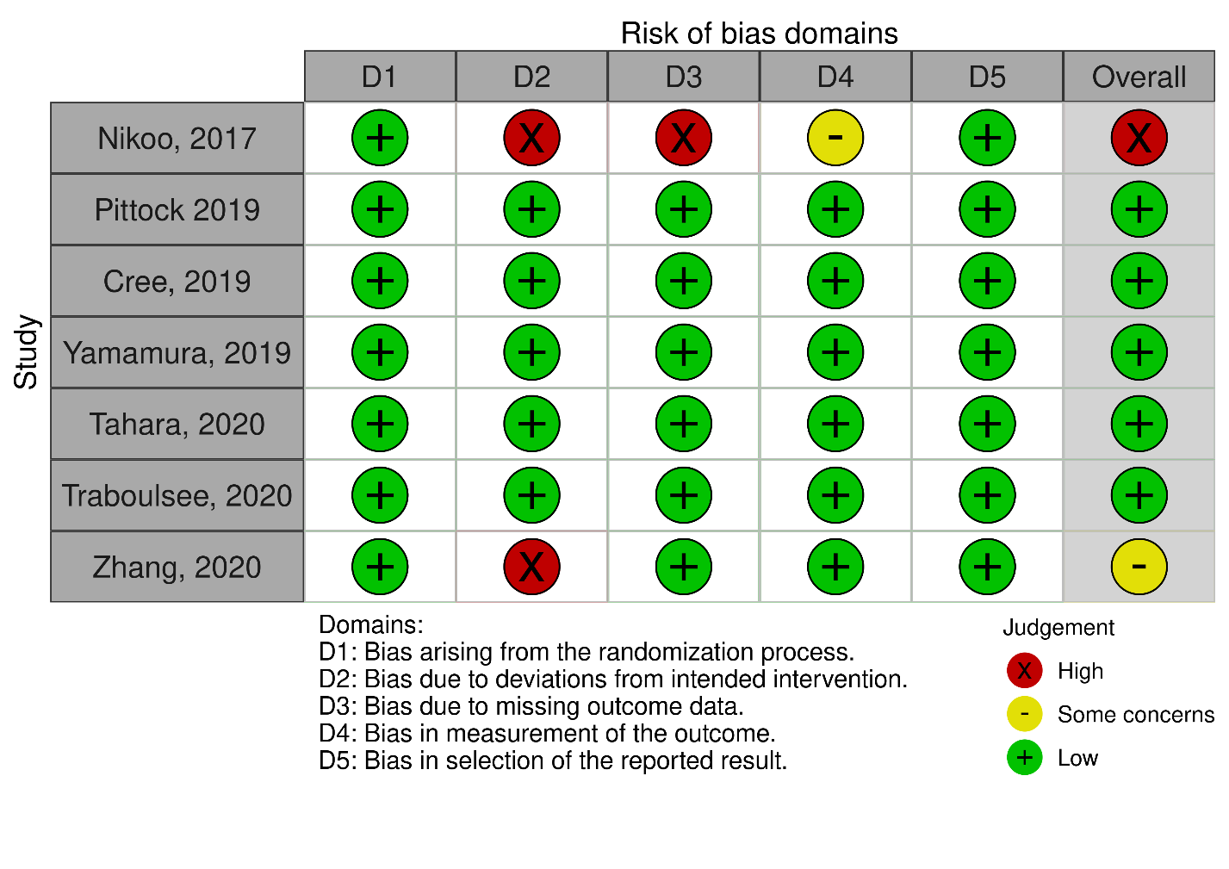

Appendix 3 Results of Mixed effect parametric survival model using difference distribution
eTable 3.1 Mixed effect parametric survival model using difference distribution
Survival distribution | Log likelihood | AIC | BIC
Log-normal* | -858.97 | 1729.95 | 1757.31
Weibull | -863.36 | 1738.72 | 1766.09
Exponential | -865.17 | 1740.37 | 1763.18
Gamma | -864.00 | 1739.99 | 1767.36
Log-logistic | -860.04 | 1732.09 | 1759.45
* Log-normal distribution consider as final model in the analysis of hazard ratio and median time to relapse

Appendix 4 Funnel plots for each treatment comparison from NMA
eFigure 4.1 Funnel plots for each treatment comparison from NMA on time to relapse
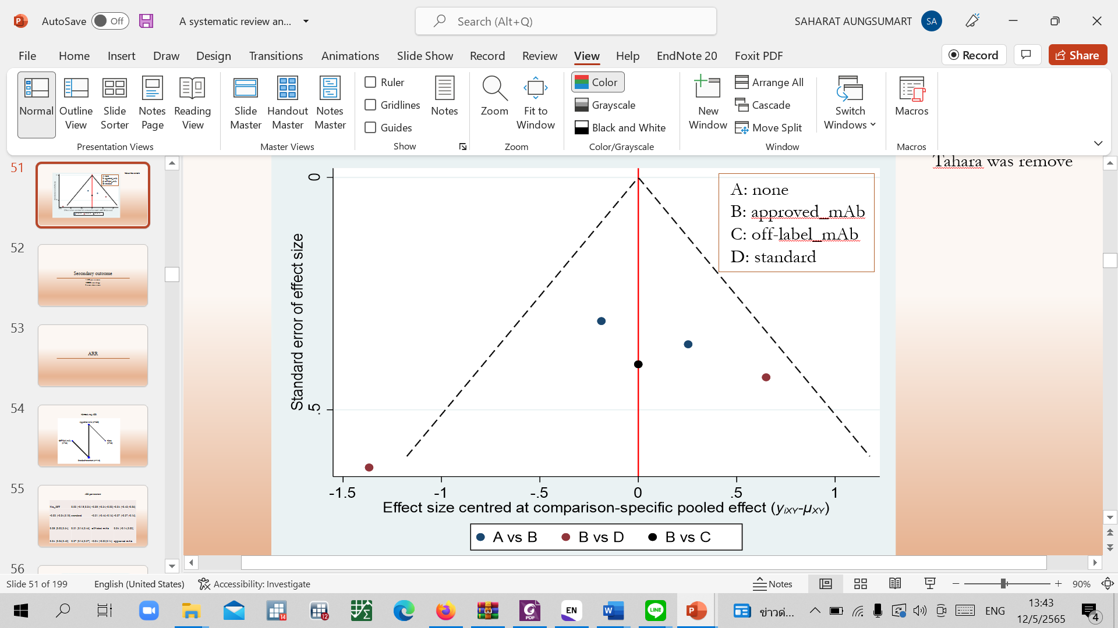

eFigure 4.2 Funnel plots for each treatment comparison from NMA on post-treatment annualized relapse rate
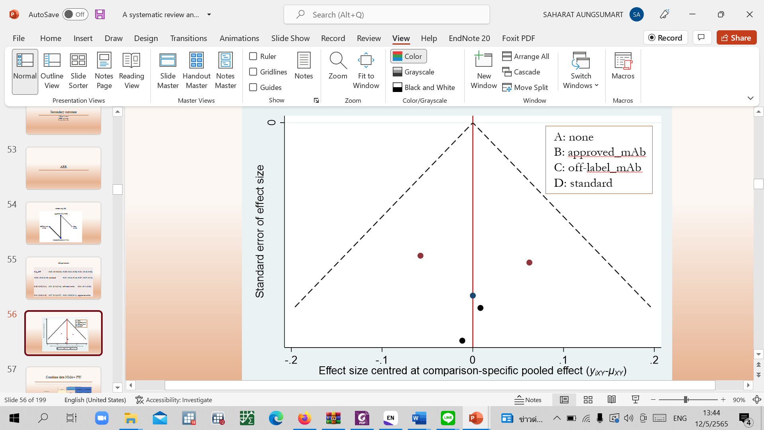

eFigure 4.3 Funnel plots for each treatment comparison from NMA on expanded disability status score change

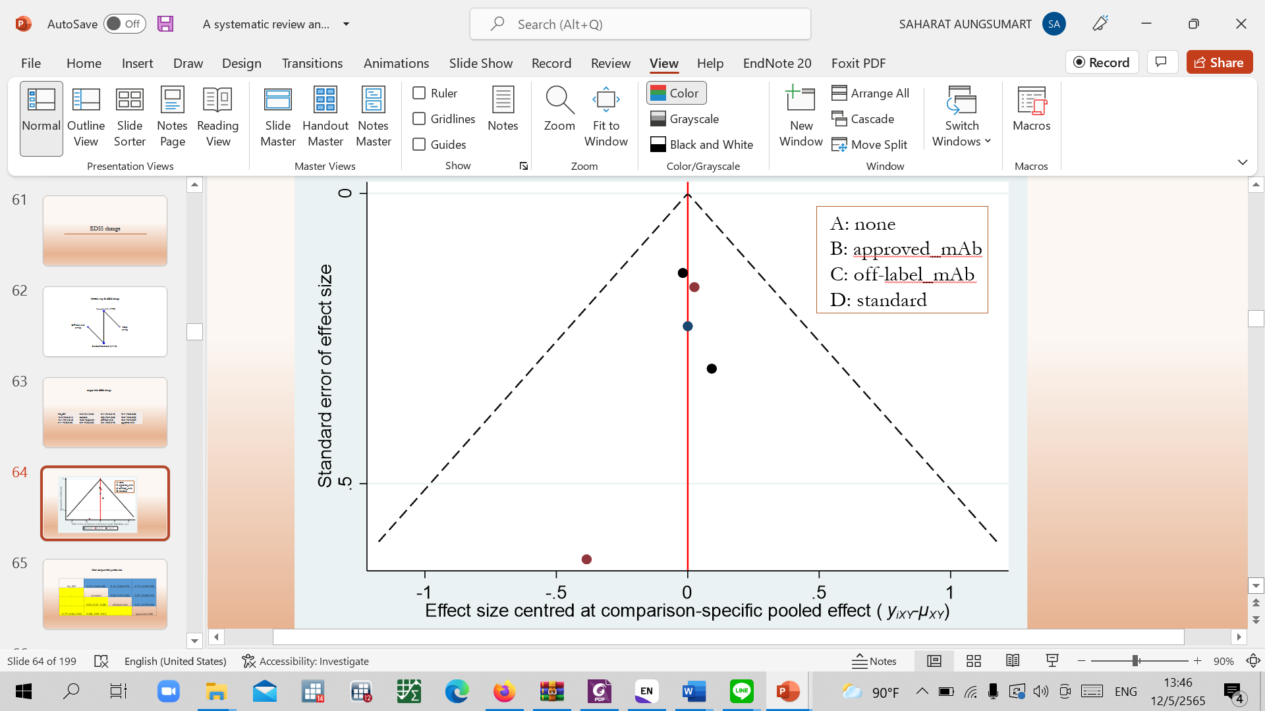

eFigure 4.4 Funnel plots for each treatment comparison from NMA on serious adverse events
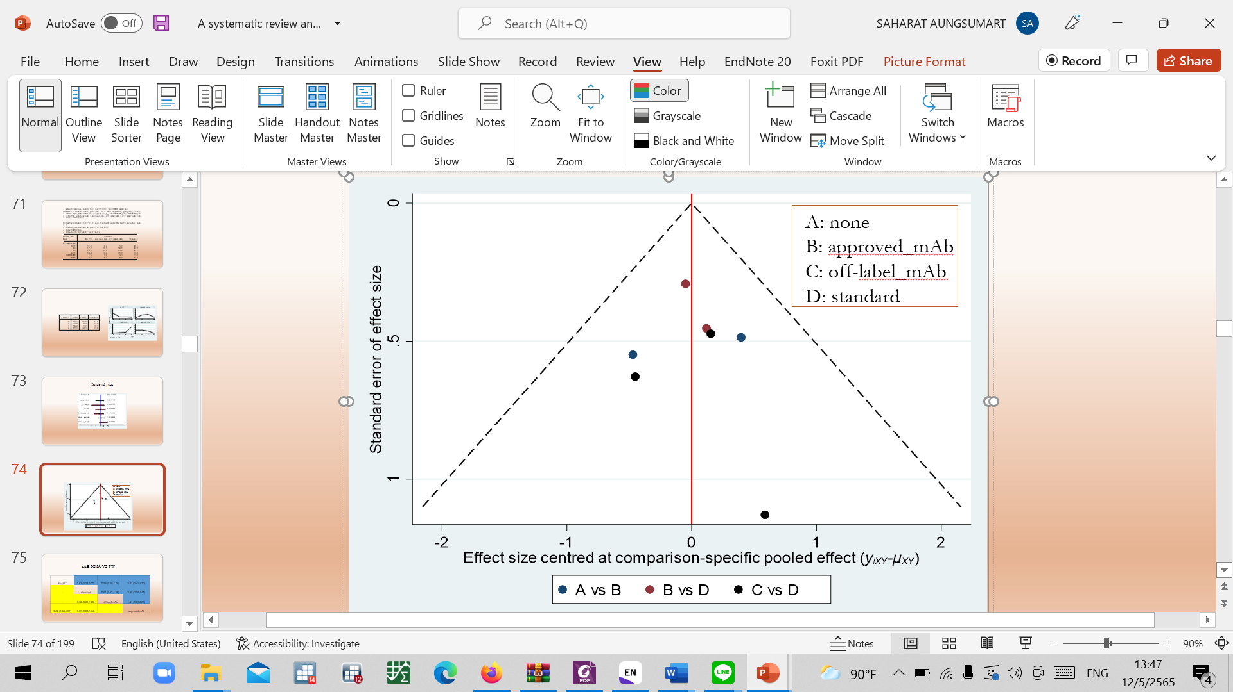

Appendix 5 Individual study data use for analysis
eTable 5.1 Individual study data use for analysis
id | author | sample | treatment code | treatment group | N each arm | age (years) | % female | base line ARR | base line EDSS | AQP4 positivity | ARR post treatment | SD ARR post treatment | EDSS change | SD EDSS change | SAE
1 | Z.Nikoo | 35 | azathioprine | standard | 35 | 32.4 | 80.0 | 1.00 | 2.40 | 57 | 0.51 | 0.55 | -0.49 | 0.59 | 3
 | Z.Nikoo | 33 | rituximab | off_label_mAb | 33 | 35.3 | 87.9 | 1.30 | 3.55 | 39 | 0.21 | 0.42 | -0.44 | 0.54 | 1
2 | S.J. Pittock | 143 | eculizumab | approved_mAb | 96 | 43.9 | 92.0 | 1.94 | 4.00 | 100 | 0.02 | 0.05 | -0.18 | 0.81 | 25
 | S.J. Pittock | 143 | mixed_ITS | standard | 47 | 45.0 | 89.0 | 2.07 | 4.00 | 100 | 0.35 | 0.52 | 0.12 | 0.95 | 13
3 | B. Cree | 231 | inebilizimab | approved_mAb | 175 | 43.0 | 91.0 | 1.73 | 3.81 | 92 | NA | NA | NA | NA | 8
 | B. Cree | 231 | none | none | 56 | 42.6 | 89.0 | 1.57 | 4.91 | 93 | NA | NA | NA | NA | 5
4 | T.Yamamura | 83 | satralizumab | approved_mAb | 41 | 40.8 | 90.0 | 1.50 | 3.83 | 66 | 0.11 | 0.19 | -0.10 | 2.15 | 7
 | T.Yamamura | 83 | mixed_ITS | standard | 42 | 43.4 | 95.0 | 1.40 | 3.63 | 67 | 0.32 | 0.42 | -0.21 | 3.46 | 9
5 | M.Tahara | 38 | rituximab | off_label_mAb | 19 | 51.5 | 90.0 | 1.70 | 3.88 | 100 | 0.00 | 0.00 | -0.32 | 0.67 | 4
 | M.Tahara | 38 | corticosteroid | standard | 19 | 49.0 | 100.0 | 1.10 | 4.00 | 100 | 0.32 | 0.44 | -0.26 | 1.13 | 4
6 | A.Traboulsee | 95 | satralizumab | approved_mAb | 63 | 45.3 | 73.0 | 1.40 | 3.90 | 65 | 0.17 | 0.28 | -0.34 | 1.13 | 12
 | A.Traboulsee | 95 | none | none | 32 | 40.5 | 97.0 | 1.50 | 3.70 | 72 | 0.41 | 0.49 | -0.17 | 1.01 | 5
7 | C. Zhang | 59 | tocilizumab | off_label_mAb | 59 | 48.1 | 93.0 | 1.71 | 4.50 | 85 | NA | NA | NA | NA | 6
 | C. Zhang | 59 | azathioprine | standard | 59 | 45.3 | 90.0 | 1.68 | 4.50 | 90 | NA | NA | NA | NA | 11

Abbreviations: AQP4, Aquaporin4; ARR, Annualized relapse rate; EDSS, expanded disability status score; mAb, monoclonal antibody; NA, not available; SAEs, serious adverse events; SD, standard deviation.

