Supplementary Material

**Genomic Characterization of the NAC Transcription Factors, Directed at Understanding Their Functions Involved in Endocarp Lignification of Iron Walnut (*Juglans sigillata* Dode)**

**Anmin Yu1†, Hanyu Zou1†, Ping Li1,** **Xiaowei** **Yao1, Zekun Zhou1, Xu Gu1, Rui Sun****1****, Aizhong Liu1\***

**\* Correspondence:** Aizhong Liu: liuaizhong@mail.kib.ac.cn

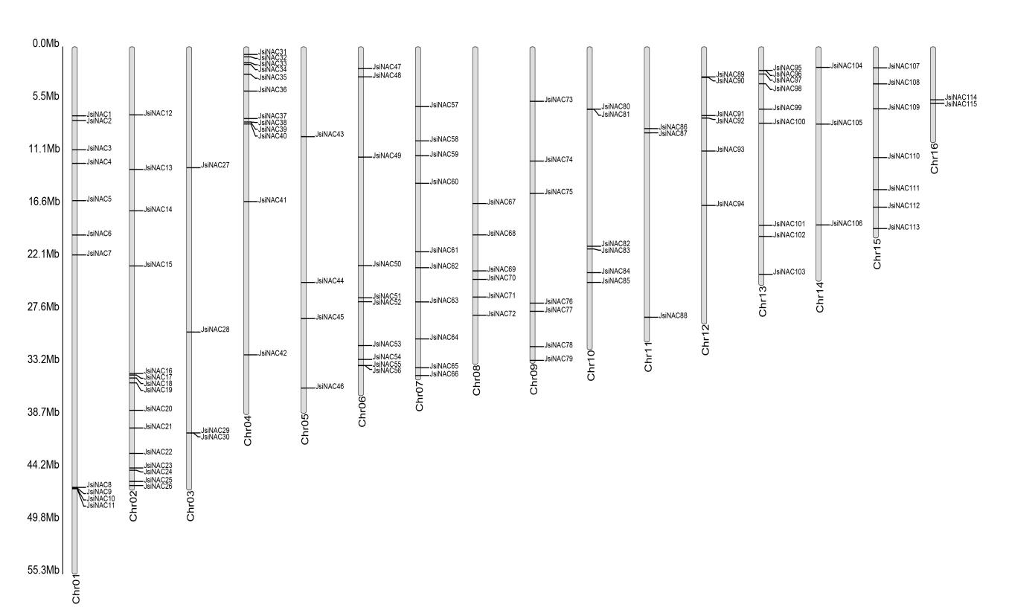**Supplementary Figure 4. The Distribution of *JsiNAC* Gene on Chromosomes.** The 115 *Jsi*NAC genes are distributed on 16 chromosomes, the gray vertical bars indicate chromosomes, the chromosome number is at the bottom of each chromosome, and the scale on the left represents the chromosome length (Mb).