Figure 1 Tradeoffs in complexity for in vitro models. Figure courtesy of AstraZeneca

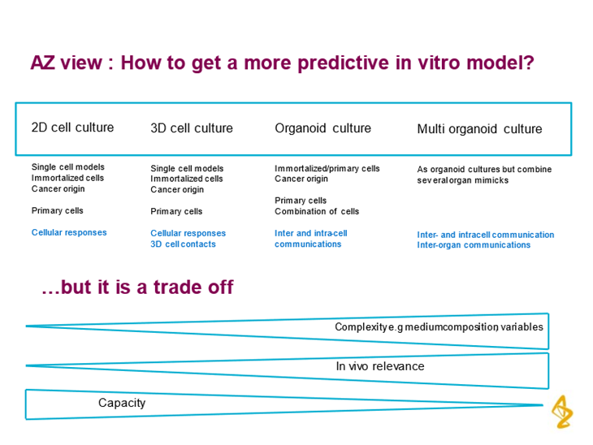

Figure 2 HUMIMIC Chip exploded view (Author: TissUse GmbH, License: CC BY-ND 4.0).

Figure 3 Diclofenac Drug Toxicity illustrated by IC50 results for different assays

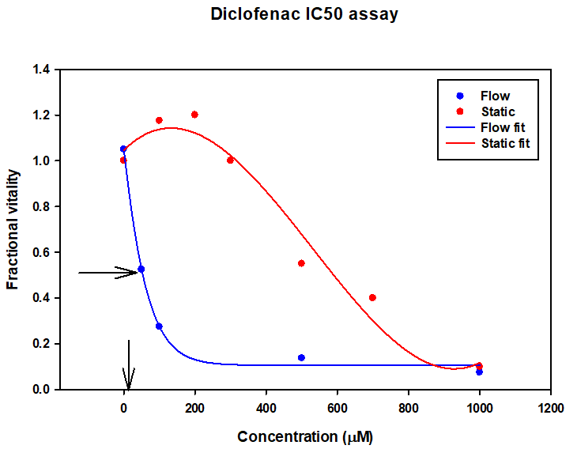

Figure 4 IC50 values for Liver models

|  |  |  |  |  |
| --- | --- | --- | --- | --- |
| * Model | * Flow rate | * Chamber volume | * Metabolism | * Diclofenac IC50 |
| * Static (no flow) | * N/A | * 0.2mL | * CYP down regulated | * 590uM |
| * Lee et al | * 10nL/min | * 0.01mL | * low | * 334uM |
| * Tonon & Giobbe |  | * 0.007mL | * CYP3A4 varies | * No data |
| * Tomlinson |  | * 4.5mL | * CYP3A4 * Physiological |  |
| * Vozzi | * 100uL/min | * 1.5mL | * CYP3A4 up regulated | * 50uM |
| * Vinci | * 250uL/min | * 1.5ml | * CYP3A4 up regulated |  |
| * Clinical Data | * N/A | * N/A | * Physiological | * 4.2uM |

Figure 5 Comparison of TissUse GmbH, and Kirkstall Ltd., and Emulate Inc. OOAC Features

|  |  |  |  |
| --- | --- | --- | --- |
| **Developer** | **TissUse** | **Kirkstall** | **Emulate** |
| Chamber size | 24 well | 24 well | Customised |
| Plate size | Thicker plate | Standard well plate | Custom design |
| Tube diameter/height | 300um | 1mm to 2mm | 0.75mm |
| Pump | Custom pneumatic | peristaltic | unknown |
| Optical clarity | good | good | poor |
| Manufacture | machining | 3D print and injection moulding | PDMS mould |
| Chamber to chamber distance | 2cm | 3cm | Single chamber |
| Chamber volume | 1.5mL | 0.5mL to 2.5mL | 0.02mL |
| Medium reservoir | 2mL | 2ml to30mL | None |

Figure 6 Sensitivity vs Specificity for Assays