Supplementary Material

**Increased captures of the Critically Endangered leatherback turtle (*Dermochelys coriacea*) around New Zealand: The contribution of warming seas and changes in fisher behavior**

**Matthew R. Dunn1, Brittany Finucci1, Matthew H. Pinkerton1, Philip Sutton1, Clinton A.J. Duffy2**

**\* Correspondence:**

Matthew R. Dunn  
[matt.dunn@niwa.co.nz](mailto:matt.dunn@niwa.co.nz)

**Figure S1. Distribution of fisher-reported leatherback turtle captures (red dots), with shaded cells indicating the distribution of fishing effort (as thousands of surface longline hooks, scaled to quartiles; with maximum number of hooks reported in bottom left-hand corner), for New Zealand waters above 40°S for the 2021 fishing year and during the months of January-March (Season 1, S1). Fishing year labelled as year-ending (i.e., 2021 indicates the 2020–21 fishing year).**

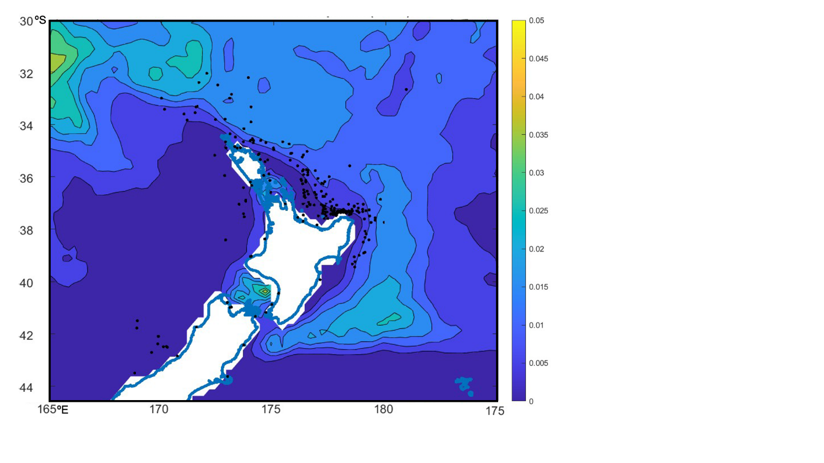

**Figure S2. Mean eddy kinetic energy (EKE) around northern New Zealand waters for the period 1 October 2007 to 30 September 2021.**

**Table S1. The variables considered in analyses of leatherback turtle capture probability for the surface longline fishery. Form in generalised additive model (GAM) is either as a categorical factor, or as a continuous variable fitted with a cubic spline smoother. AVISO2 data were at a 0.25-degree latitude and longitude resolution. The Roemmich and Gilson Argo climatology were at a 1-degree latitude and longitude resolution (Roemmich & Gilson, 2009).**

|  |  |  |
| --- | --- | --- |
| Variable label | Source | Description |
| *chla* | Chlorophyll-a concentration between 1997–2021 (monthly, 9 km) produced by blending SeaWiFS (NASA, 2018a) and MODIS-Aqua (NASA, 2018b) observations using the overlap period (Pinkerton et al. 2021; Gall et al., 2022). | Open ocean chlorophyll-a (mg/m3). This will be dubious close to the shore (within ~5 km). Correlation with *kd490*. |
| *SST OI v2.1* | Optimal-interpolation ocean product (OI-SST v2.1; Reynolds et al., 2007; Huang et al., 2021) at 0.25°lat x 0.25°lon, monthly | Sea surface temperature (°C) |
| *SST4-monthly* | MODIS-Aqua default *sst* product at 4 km (NASA OBPG 2020; Kilpatrick et al., 2015, 2019) | Sea surface temperature (°C) |
| *SST4-climatology* | See Gall et al., 2022 | Monthly climatological SST4 (i.e. average January, February etc) (°C) |
| *SST4-anomaly* | See Gall et al., 2022 | Monthly anomaly in SST4 (i.e., difference between SST4-monthly and SST4-climatology) (°C) |
| *kd490* | Open-ocean Kd490 product from MODIS-Aqua and SeaWiFS (Clark, 1997) (9km, monthly) blended as Pinkerton et al., 2021; Gall et al. 2022 | Diffuse attenuation at 490 nm (proxy for water clarity) (m-1). Excluded from final models as no data for 2021. |
| *par* | Open-ocean PAR product (9km, monthly) from MODIS-Aqua and SeaWiFS (Frouin & Pinker, 1995; Frouin et al., 2012) blended as Pinkerton et al., 2021; Gall et al. 2022 | Average daily incident irradiance at sea surface (Einstein/m2/d). Correlated with *temp*. |
| *vgpm* | Vertically Generalised Production Model (VGPM, Behrenfeld & Falkowski 1997) based on MODIS-Aqua and SeaWiFS (sourced from Oregon State University1, 9km, monthly) and blended as Pinkerton et al. (2021). | Model of primary production (mgC/m2/d). *Chla* preferred in final models. Correlated with *eppley* and *mld*. |
| *café* | Carbon, Absorption, and Fluorescence Euphotic-resolving model (CAFE, Silsbe et al., 2016). based on MODIS-Aqua and SeaWiFS (sourced from Oregon State University1, (9km, monthly) and blended as Pinkerton et al. (2021). | Models of primary production (mgC/m2/d). *Chla* preferred in final models |
| *cbpm* | Carbon Based Production Model (CBPM, Behrenfeld et al., 2005; Westberry et al. 2008) based on MODIS-Aqua and SeaWiFS (sourced from Oregon State University1, 9km, monthly) and blended as Pinkerton et al. (2021). | Models of primary production (mgC/m2/d). *Chla* preferred in final models |
| *eppley* | Eppley-modified VGPM (Eppley, 1972; Behrenfeld & Falkowski 1997) based on MODIS-Aqua and SeaWiFS (sourced from Oregon State University1, 9km, monthly)) and blended as Pinkerton et al. (2021). | Models of primary production (mgC/m2/d). *Chla* preferred in final models |
| *SSTgrad* | Magnitude of the 2-dimensional spatial gradient of OI-SST v2.1 (Reynolds et al., 2007; Huang et al., 2021) | Spatial gradient in *SST* as indicative of fronts (because this was calculated from data on a lat-lon grid it will have biases across large areas but may be useful). Inclusion resulted in reduced data set. Excluded from final models because reduced LBT occurrences by *n* = 15. |
| *mld0p030* | Depth at which there is potential density difference of 0.030 kg m-3 from the surface. Based on GLBu0.08 hindcast results (using hycom, fnmoc, soda, tops: Metzger et al., 2007; Chassignet et al. 2007; Wallcraft et al. 2009) sourced from Oregon State University ocean productivity (9km, monthly) | Mixed layer depth (m) on two different criteria for changes in potential density (0.03 kg/m3 and 0.125 kg/m3). Correlated with other mld, and vgpm. |
| *mld0p125* | As for *mld0p030* but with potential density difference of 0.125 kg/m3 from the surface (9km, monthly) | Mixed layer depth (m) on two different criteria for changes in potential density (0.03 kg/m3 and 0.125 kg/m3). Correlated with other *mld*, and *vgpm*. |
| *temp100m* | Roemmich and Gilson Argo climatology | Temperature at 100m. Correlated with other temp. |
| *temp200m* | Roemmich and Gilson Argo climatology | Temperature at 200m. Correlated with other temp. |
| *TimeVaryingEastwardCurrents* | AVISO | Zonal current (u) (time-varying eastward currents). Positive values indicate stronger to the east. |
| *TimeVaryingNorthwardCurrents* | AVISO | Meridional current (v) (time varying northward currents). Positive values indicate stronger to the north. |
| *EKE* | AVISO | Eddy Kinetic Energy, calculated as 0.5(u2 + v2) |
| *TimeVaryingSpeed* | AVISO | Time varying speed |
| *MeanEastwardCurrent* | AVISO | Mean u (mean eastward current); variable over space but not time |
| *MeanNorthwardCurrent* | AVISO | Mean v (mean northward current); variable over space but not time |
| *TimeVaryingDynamicHeight* | AVISO | Time-varying dynamic height. Correlated with temperature. |
| *MeanDynamicHeight* | AVISO | Mean dynamic height. Correlated with mean temperature. Variable over space but not time |
| *Seabed depth* | Ministry for Primary Industries | Seabed depth recorded at the start of the longline set |
| *Hook number* | Ministry for Primary Industries | Reported number of hooks per set |
| *Vessel length* | Ministry for Primary Industries | Registered total vessel length (m) |
| *Vessel power* | Ministry for Primary Industries | Registered vessel power (kW) |
| *Target species* | Ministry for Primary Industries | Reported target species |
| *Day of year* | Ministry for Primary Industries | 1st January = 1 |
| *Month* | Ministry for Primary Industries | Calendar month |
| *Latitude* | Ministry for Primary Industries | Start latitude, full resolution |
| *Longitude* | Ministry for Primary Industries | Start longitude, full resolution |

1. Oregon State University Ocean Productivity project, <http://sites.science.oregonstate.edu/ocean.productivity/index.php>.
2. AVISO gridded products: <http://www.aviso.oceanobs.com/en/data/products/sea-surface-height-products/global/index.htm>

# References

Behrenfeld, M.J., Boss, E., Siegel, D.A., Shea, D.M. (2005). Carbon-based ocean productivity and phytoplankton physiology from space. *Glob. Biogeochem. Cycles* 19. [doi.org/10.1029/2004GB002299](https://doi.org/10.1029/2004GB002299).

Chassignet, E.P., Hurlburt, H.E., Smedstad, O.M., Halliwell, G.R., Hogan, P.J., Wallcraft A.J., Baraille, R., Bleck, R. (2007). The HYCOM (HYbrid Coordinate Ocean Model) data assimilative system. J. Mar. Systems 65, 60–83. [doi.org/10.1016/j.jmarsys.2005.09.016](https://doi.org/10.1016/j.jmarsys.2005.09.016).

Clark, D.K. (1997). MODIS Algorithm Theoretical Basis Document – Bio-optical algorithms – Case I waters. *NASA.* https://oceancolor.gsfc.nasa.gov/docs/technical/atbd_mod17.pdf.

Frouin, R., McPherson, J., Ueyoshi, K., Franz, B.A. (2012). A time series of photosynthetically available radiation at the ocean surface from SeaWiFS and MODIS data. *Remote Sens. Environ.* 852519, 234–245. doi.org/10.1117/12.981264.

Frouin, R., Pinker, T.R. (1995). Estimating photosynthetically active radiation (PAR) at the earth’s surface from satellite observations. *Remote Sens. Environ.* 51, 98–107. [doi.org/10.1016/0034-4257(94)00068-X](https://doi.org/10.1016/0034-4257(94)00068-X).

Eppley, R.W. (1972). Temperature and phytoplankton growth in the sea. *Fish. Bull.* 70, 1063–1085.

Gall, M.P., Pinkerton, M.H., Steinmetz, T., Wood, S. (2022). Satellite remote sensing of coastal water quality in New Zealand. *N. Z. J. Mar. Freshwater Re*s. 56, 585–616. [doi.org/10.1080/00288330.2022.2113410](https://doi.org/10.1080/00288330.2022.2113410).

Huang, B., Liu, C., Freeman, E., Graham, G., Smith, T., Zhang, H.M. (2021) Improvements of the Daily Optimum Interpolation Sea Surface Temperature (DOISST) Version 2.1. *J. Climate* 34, 2923–2939. doi.org/10.1175/JCLI-D-20-0166.1.

Metzger, J., Hurlburt, H., Wallcraft, A., Smedstad, O.M., Kara, B., Shriver, J., Smedstad, L., Franklin, D., Schmitz, Jr., B., Thoppil, P. (2007). 1/12° Global HYCOM Evaluation and Validation. 11th HYCOM Consortium Meeting 24-26 April 2007, Stennis Space Center, MS. Available (April 2019): <https://hycom.org/attachments/079_7_Metzger.pdf>.

NASA Goddard Space Flight Center; Ocean Ecology Laboratory; Ocean Biology Processing Group (2018a). SeaWiFS Ocean Color Reprocessing 2018.0 <https://oceancolor.gsfc.nasa.gov/reprocessing/r2018/seawifs/>.

NASA Goddard Space Flight Center; Ocean Ecology Laboratory; Ocean Biology Processing Group (2018b). MODIS/Aqua Ocean Color Reprocessing 2018.0 https://oceancolor.gsfc.nasa.gov/reprocessing/r2018/aqua/.

Pinkerton, M.H., Boyd, P., Deppeler, S., Hayward, A., Hofer, J., Moreau, S. (2021). Evidence for the impact of climate change on primary producers in the Southern Ocean. *Front. Ecol. Evol.* 9, 592027. doi.org/10.3389/fevo.2021.592027.

Reynolds, R.W., Smith, T.M., Liu, C., Chelton, D.B., Casey, K.S., Schlax, M.G. (2007). Daily High-Resolution-Blended Analyses for Sea Surface Temperature. *J. Climate* 20, 5473–5496. doi.org/10.1175/2007JCLI1824.1.

Silsbe, G.M., M.J. Behrenfeld, K.H. Halsey, A.J. Milligan, T. Westberry (2016). The CAFE model: A net production model for global ocean phytoplankton. *Glob. Biogeochem. Cycles* 30, 1756–1777. [doi.org/10.1002/2016GB005521](https://doi.org/10.1002/2016GB005521).

Wallcraft, A.J., Metzger, E.J., Carroll, S.N. (2009). Software Design Description for the HYbrid Coordinate Ocean Model (HYCOM), Version 2.2. *US Naval Research Laboratory report, NRL/MR/7320--09-9166.* Naval Research Laboratory.

Westberry, T., Behrenfeld, M.J., Siegel, D.A., Boss, E. (2008), Carbon-based primary productivity modeling with vertically resolved photoacclimation. *Glob. Biogeochem. Cycles* 22, GB2024, doi:10.1029/2007GB003078.